| **Department** | **Printed Name** | **Signature** | **Date** |
| --- | --- | --- | --- |
| Author | Akshitha Bolar | See electronic signature | See stamp |
| PQ | Imtiyaz Barmare | See electronic signature | See stamp |
| LSD | Prakruthi Rao | See electronic signature | See stamp |
| *PDO* | *Derek Neiman* | *See electronic signature* | *See stamp* |
| *Systems Engineering* | *William West* | *See electronic signature* | *See stamp* |
| *RA* | *Tiffany Lin* | *See electronic signature* | *See stamp* |
| *Marketing* | *Jason Knox* | *See electronic signature* | *See stamp* |
| *Medical* | *Timothy Kudelka* | *See electronic signature* | *See stamp* |
| Risk | Saravanan K | See electronic signature | See stamp |
| *Human Factors Engineering* | *Anaika Khoday* | *See electronic signature* | *See stamp* |
| *Clinical* | *Tena Griffin* | *See electronic signature* | *See stamp* |
| *SW Lead* | *Lalu Krishnan* | *See electronic signature* | *See stamp* |
| *Global Service* | *Mattia Braglia* | *See electronic signature* | *See stamp* |

*Italicized entries indicate that sign-off is not required for preliminary TCU release.*

**ABSTRACT:**

This document describes the changes to the PrisMax Assure_SW1release to include changes that will help reduce the occurrences of certain alarms, as well as bug fixes and customer requested improvements.

**Table of Contents**

1 Introduction 10

1.1 Purpose and Scope 10

1.2 Summary 10

1.3 Terms and Definitions 11

1.4 References 11

1.5 Entities Impacted 12

1.6 Individuals Involved 12

2 Change Analysis (CA) 13

2.1 Design Inputs (CA1) 13

2.1.1 Reason for Change 13

2.1.2 Description of Change 13

2.1.3 Use Case Analysis 96

2.1.4 HFE Assessment 106

2.1.5 Risk Analysis 107

2.1.6 Product Requirement Analysis 117

2.1.7 System Requirement Analysis 120

2.2 Sub-System Requirements Analysis (CA2) 127

2.2.1 Hardware Requirement Analysis 127

2.2.2 Software Requirement Analysis 127

2.2.3 Labeling Requirement Analysis 145

2.3 Software Design Specification Analysis 157

3 Change Description (CD) 175

3.1 Design Description 175

3.1.1 Defaults not set alarm(T1722) raised when defaults (syringe) were set and Thermax SST status is correctly transmitted to PrisMax [PFAL-2473][PFAL-2484] 175

3.1.2 Alarms can restart fluid priming without replacing priming solution [PFAL-2472] 179

3.1.3 Reduce occurrences of ARPS BIOT Alarms [PFAL-2477] 181

3.1.4 Reduce occurrence of B1593 alarm declared in Re-prime after air introduced in ABD[PFAL-2474] 181

3.1.5 Add additional logging for B0916 alarms[PFAL-2471] 182

3.1.6 PBP Bag empty alarm not coming up at the right time[PFAL-2470] 184

3.1.7 Alarm T2124 is not raised as soon as expected [PFAL-2475] 185

3.1.8 Unable to autochart PFR through the EMR, PFR values not resetting with same patient in EMR [PFAL-2466] 191

3.1.9 GUI Issue-Display of Portuguese “ç” Characters Font size change to display numbers [PFAL-2467] 193

3.1.10 Missing or Incomplete data display in History PFR Screen in Chinese (Simplified/ Traditional) and Korean [PFAL-2577] 197

3.1.11 Disturbances on Scales with flow rate of zero causing errors in reported [PFR PFAL-2465] 199

3.1.12 Correct the guidance in GUI/operators manual for filter clotting alarms [PFAL-2488] 200

3.1.13 Increase time taken to Latch the Signal to Backup Speaker during Total Loss of Power [PFAL-2588] 200

3.1.14 Undetermined Causes of Foam Detect Alarm T2315 [PFAL-2606] 201

3.2 Change List 201

3.2.1 Defaults not set alarm(T1722) raised when defaults (syringe) were set and Thermax SST status is correctly transmitted to PrisMax [PFAL-2473][PFAL-2484] 202

3.2.2 Alarms can restart fluid priming without replacing priming solution[PFAL-2472] 204

3.2.3 Reduce occurrences of ARPS BIOT Alarms[PFAL-2477] 205

3.2.4 Reduce occurrence of B1593 alarm declared in Re-prime after air introduced in ABD[PFAL-2474] 207

3.2.5 Add additional logging for B0916 alarms[PFAL-2471] 208

3.2.6 PBP Bag empty alarm not coming up at right time[PFAL-2470] 208

3.2.7 Alarm T2124 is not raised as soon as expected [PFAL-2475] 210

3.2.8 Unable to autochart PFR through the EMR, PFR values not resetting with same patient in EMR [PFAL-2466] 211

3.2.9 GUI Issue-Display of Portuguese “C” Characters Font size change to display numbers [PFAL-2467] 213

3.2.10 Missing or Incomplete data display in History PFR Screen in Chinese (Simplified/ Traditional) and Korean [PFAL-2577] 214

3.2.11 Disturbances on Scales with flow rate of zero causing errors in reported [PFR PFAL-2465] 214

3.2.12 Correct the guidance in GUI/operators manual for filter clotting alarms [PFAL-2488] 214

3.2.13 Increase time taken to Latch the Signal to Backup Speaker during Total Loss of Power [PFAL-2588] 215

3.2.14 Undetermined Causes of Foam Detect Alarm T2315 [PFAL-2606] 215

3.3 Labeling Update 216

3.3.1 Defaults not set alarm(T1722) raised when defaults (syringe) were set and Thermax SST status is correctly transmitted to PrisMax [PFAL-2473][PFAL-2484] 216

3.3.2 Alarms can restart fluid priming without replacing priming solution [PFAL-2472] 216

3.3.3 Reduce occurrences of ARPS BIOT Alarms[PFAL-2477] 221

3.3.4 Reduce occurrence of B1593 alarm declared in Re-prime after air introduced in ABD[PFAL-2474] 221

3.3.5 Add additional logging for B0916 Alarms[PFAL-2471] 221

3.3.6 PBP Bag empty alarm not coming up at right time[PFAL-2470] 221

3.3.7 Alarm T2124 is not raised as soon as expected [PFAL-2475] 221

3.3.8 Unable to autochart PFR through the EMR, PFR values not resetting with same patient in EMR [PFAL-2466] 221

3.3.9 GUI Issue-Display of Portuguese “C” Characters Font size change to display numbers [PFAL-2467] 222

3.3.10 Missing or Incomplete data display in History PFR Screen in Chinese (Simplified/ Traditional) and Korean [PFAL-2577] 223

3.3.11 Disturbances on Scales with flow rate of zero causing errors in reported [PFR PFAL-2465] 224

3.3.12 Correct the guidance in GUI/operators manual for filter clotting alarms 224

3.3.13 Increase time taken to Latch the Signal to Backup Speaker during Total Loss of Power [PFAL-2588] 226

3.3.14 Undetermined Causes of Foam Detect Alarm T2315 [PFAL-2606] 226

3.4 Reviews 226

3.4.1 Defaults not set alarm(T1722) raised when defaults (syringe) were set and Thermax SST status is correctly transmitted to PrisMax [PFAL-2473][PFAL-2484] 226

3.4.2 Alarms can restart fluid priming without replacing priming solution[PFAL-2472] 226

3.4.3 Reduce occurrences of ARPS BIOT Alarms[PFAL-2477] 226

3.4.4 Reduce occurrence of B1593 alarm declared in Re-prime after air introduced in ABD[PFAL-2474] 226

3.4.5 Add additional logging for B0916 Alarms[PFAL-2471] 227

3.4.6 PBP Bag empty alarm not coming up at right time[PFAL-2470] 227

3.4.7 Alarm T2124 is not raised as soon as expected [PFAL-2475] 227

3.4.8 Unable to autochart PFR through the EMR, PFR values not resetting with same patient in EMR [PFAL-2466] 227

3.4.9 GUI Issue-Display of Portuguese “C” Characters Font size change to display numbers [PFAL-2467] 227

3.4.10 Missing or Incomplete data display in History PFR Screen in Chinese (Simplified/ Traditional) and Korean [PFAL-2577] 227

3.4.11 Disturbances on Scales with flow rate of zero causing errors in reported [PFR PFAL-2465] 227

3.4.12 Correct the guidance in GUI/operators manual for filter clotting alarms 227

3.4.13 Increase time taken to Latch the Signal to Backup Speaker during Total Loss of Power [PFAL-2588] 228

3.4.14 Undetermined Causes of Foam Detect Alarm T2315 [PFAL-2606] 228

3.5 Labeling Update 228

3.6 Reviews 228

4 Change Verification (CV) 229

4.1 Software Requirement Verification 229

4.1.1 PFAL-2473 - Defaults not set alarm (T1722) raised when defaults (syringe) were set 229

4.1.2 PFAL-2484 - Ensure TherMax SST status is correctly transmitted to PrisMax 234

4.1.3 PFAL-2472 - Alarms can restart fluid priming without replacing priming solution  238

4.1.4 PFAL-2477 - Reduce occurrences of ARPS BIOT Alarms 247

4.1.5 PFAL-2474 - Reduce occurrence of B1593 alarm declared in Re-prime after air introduced in ABD 250

4.1.6 PFAL-2471 - Add additional logging for B0916 alarms 251

4.1.7 PFAL-2470 - PBP Bag empty alarm not coming up at the right time 251

4.1.8 PFAL-2475 - Alarm T2124 is not raised as soon as expected 256

4.1.9 PFAL-2466 - Unable to autochart PFR through the EMR.PFR values not resetting with same patient in EMR. 258

4.1.10 PFAL-2467 - GUI Issue- Display of Portuguese "C" character. Font size change to display numbers (in flow chart boxes of operation screen) in Korean and Chinese without truncation 260

4.1.11 PFAL-2577 - Missing or Incomplete data display in History PFR Screen in Chinese (Simplified/ Traditional) and Korean 260

4.1.12 PFAL-2660 - Update the English Master XML for SW 3.7 260

4.1.13 PFAL-2465 - Disturbances on scales with flow rate of zero causing errors in reported PFR 261

4.1.14 PFAL-2488 - Correct the guidance in GUI/operators manual for filter clotting alarms 270

4.1.15 PFAL-2495 - Update Missing / Incorrect Information in PrisMax Operator Manuals 271

4.1.16 PFAL-2588 - Fix to ensure Backup Speaker sounds during Total Loss of Power 271

*4.1.17* PFAL-2606 - Undetermined Causes of Foam Detect Alarm T2315 274

4.2 Regression Testing 275

4.2.1 Regression Analysis 275

4.2.2 Regression Test Descriptions 275

4.3 Test Execution 275

**Table of Tables**

Table1 **–** Primingalarms 15

Table 2 - Alarm Events List 75

Table 3 – Related Customer Requirement Specifications 117

Table 4 – Related Therapy Requirement Specifications 119

Table 5 – New TRS 120

Table 6 – Related PRD 120

Table 7 – Modified PRD 125

Table 8 – New PRD 127

Table 9 – Related SRS 128

Table 10 – Modified SRS 139

Table 11 – New SRS 144

Table 12 – Related LRD 145

Table 13 – Modified LRD 145

Table 14 – New LRD 147

Table 15 – Related SDS 157

Table 16 – Modified SDS 164

Table 17 – PrisMax Source Code Files[PFAL-2474][PFAL-2484] 202

Table 18 – PrisMax Unit Test Files [PFAL-2474][PFAL-2484] 204

Table 19 – PrisMax Source Code Files[PFAL-2472] 204

Table 20 – PrisMax Unit Test Files[PFAL-2472] 205

Table 21 - MATLAB Model and MATLAB Generated Code (MGC) Changes[PFAL-2477] 205

Table 22 - PrisMax Source Code Files[PFAL-2477] 205

Table 23 - Unit Test Files[PFAL-2474] 207

Table 24 - MATLAB Model and MATLAB Generated Code (MGC) Changes [PFAL-2474] 207

Table 25 - PrisMax Source Code Files [PFAL-2474] 207

Table 26 - Unit Test Files [PFAL-2474] 208

Table 27 - PrisMax Source Code Files[PFAL-2474] 208

Table 28 - PrisMax Source Code Files [PFAL-2470] 209

Table 29 - Unit Test Files [PFAL-2470] 209

Table 30 - PrisMax Source Code Files [PFAL-2475] 210

Table 31 - Unit Test Files [PFAL-2475] 210

Table 32 - PrisMax Source Code Files [PFAL-2466] 211

Table 33 - Unit Test Files[PFAL-2466] 212

Table 34 - PrisMax GUI Source Code Files [PFAL-2467] 213

Table 35 - PrisMax Source Code Files [PFAL-2467] 213

Table 36 - PrisMax Source Code Files [PFAL-2465] 214

Table 37 - PrisMax Source Code Files [PFAL-2488] 214

Table 38 - PrisMax Source Code Files [PFAL-2588] 215

Table 39 - MATLAB Model and MATLAB Generated Code (MGC) Files[PFAL-2606] 216

Table 40 - String Updates[PFAL-2472] 216

Table 41 – String Updates 222

Table 42 – Screen Updates 223

Table 43 – String Updates 223

Table 44 – Screen Updates 224

Table 45 - String Updates 224

Table 46 - Screen Updates 226

Table 17 – String Updates 228

Table 18 – Screen Updates 228

Table 20 – Regression Test Identification 275

Table 21 – Test Results 276

**Table of Figures**

Figure 1: Current Workflow -T1292 – Front Effluent Bag Incorrect Alarm 24

Figure 2: Updated Workflow -T1292 – Front Effluent Bag Incorrect Alarm 24

Figure 3: Current Workflow - T2217 – Effluent Bag Incorrect Alarm 25

Figure 4: Updated Workflow - T2217 – Effluent Bag Incorrect Alarm 25

Figure 5: Current Workflow -T1291 – Side Effluent Bag Incorrect Alarm 26

Figure 6: Updated Workflow -T1291 – Side Effluent Bag Incorrect Alarm 26

Figure 7: Current Workflow - T1347 – Dialysate Scale Weight Error Alarm 27

Figure 8: Updated Workflow - T1347 – Dialysate Scale Weight Error Alarm 27

Figure 9: Current Workflow -T1610 – Rep Scale Weight Error Alarm 28

Figure 10: Updated Workflow -T1610 – Rep Scale Weight Error Alarm 28

Figure 11: Current Workflow -T1611-PBP Scale Weight Error Alarm 29

Figure 12: Updated Workflow -T1611-PBP Scale Weight Error Alarm 29

Figure 13: Current Workflow - T1175 - Auto-effluent Bags on Wrong Scales Alarm 30

Figure 14: Updated Workflow - T1175 - Auto-effluent Bags on Wrong Scales Alarm 30

Figure 15:Current Workflow - T2125 – Bag on Wrong Scale Alarm 31

Figure 16: Updated Workflow - T2125 – Bag on Wrong Scale Alarm 31

Figure 17: Current Workflow - T1594 – Bag Not Filling Alarm 32

Figure 18: Updated Workflow - T1594 – Bag Not Filling Alarm 32

Figure 19: Current Workflow - T1714 – Return Line Misconnected Alarm 33

Figure 20: Updated Workflow - T1714 – Return Line Misconnected Alarm 33

Figure 21: Current Workflow - T1713 – Bag Not Filling Alarm 34

Figure 22: Updated Workflow - T1713 – Bag Not Filling Alarm 34

Figure 23: Current Workflow - T2224 – Bag Not Filling Alarm 35

Figure 24: Updated Workflow - T2224 – Bag Not Filling Alarm 35

Figure 25: Current Workflow - T0609 – Wrong Set Detected Alarm 36

Figure 26: Updated Workflow - T0609 – Wrong Set Detected Alarm 36

Figure 27: Current Workflow - T2131 – Line Misconnected Alarm 37

Figure 28: Updated Workflow - T2131 – Line Misconnected Alarm 37

Figure 29: Current Workflow - T2300 – TherMax bag Not Inflated Alarm 38

Figure 30: Updated Workflow - T2300 – TherMax bag Not Inflated Alarm 38

Figure 31: Reprime Screen (CRRT) – Current Screen 39

Figure 32: Reprime (TPE) Screen – Current Screen 40

Figure 33: Reprime Screen (CRRT) - Updated 41

Figure 34: Reprime Screen (TPE) - Updated 42

Figure 35: Restart Fluid Priming Process Screen 43

Figure 36: Current Screen - Portuguese EU issue Screen 50

Figure 37: Updated Screen - Portuguese EU issue Screen 50

Figure 38: Current Screen - Korean Flow Rate Font Issue – Treatment Screen 51

Figure 39: Updated Screen – Korean Flow Rate Font Issue – Treatment Screen 51

Figure 40: Current Screen - Korean Flow Rate Font Issue – Prescription Screen 52

Figure 41: Updated Screen - Korean Flow Rate Font Issue – Prescription Screen 52

Figure 42: Current Screen - Simplified Chinese Flow Rate Font Issue - Treatment Screen 53

Figure 43: Updated Screen - Simplified Chinese Flow Rate Font Issue - Treatment Screen 53

Figure 44: Current Screen - Simplified Chinese Flow Rate Font Issue – Prescription Screen 54

Figure 45: Updated Screen - Simplified Chinese Flow Rate Font Issue – Prescription Screen 54

Figure 46: Current Screen - Traditional Chinese Flow Rate Font Issue - Treatment Screen 55

Figure 47: Updated Screen - Traditional Chinese Flow Rate Font Issue - Treatment Screen 55

Figure 48: Current Screen - Traditional Chinese Flow Rate Font Issue – Prescription Screen 56

Figure 49: Updated Screen - Traditional Chinese Flow Rate Font Issue – Prescription Screen 56

Figure 50: Current Screen - Korean Language Issue – 2 rows of missing PFR data 57

Figure 51: Updated Screen - Korean Language Issue – PFR data Font Updated 58

Figure 52: Current Screen - Simplified Chinese Language Issue – 2 rows of missing PFR data 58

Figure 53: Updated Screen - Simplified Chinese Language Issue – PFR data Font Updated 59

Figure 54: Current Screen - T0822 Flow Problem Alarm - Instruction text color Issue 60

Figure 55: Updated Screen - T0822 Flow Problem Alarm - Instruction text color 60

Figure 56: Current Screen - T1720 PBP Weight Change Alarm - Instruction text color Issue 61

Figure 57: Updated Screen - T1720 PBP Weight Change Alarm - Instruction text color 61

Figure 58: Current Screen - T1719 Dia Weight Increase Alarm - Instruction text color Issue 62

Figure 59: Updated Screen - T1719 Dia Weight Increase Alarm - Instruction text color 62

Figure 60: Current Screen - T1717 Rep Weight Increase Alarm – Discard Set Instruction Missing 63

Figure 61: Updated Screen - T1717 Rep Weight Increase Alarm – Discard Set Instruction Removed 63

Figure 62: Current Screen - T1718 Rep2 Weight Increase Alarm – Discard Set Instruction Missing 64

Figure 63: Updated Screen - T1718 Rep2 Weight Increase Alarm – Discard Set Instruction Removed 64

Figure 64: Current Screen - Translation Limit Code Dialog - PfHCT text to be Updated 65

Figure 65: Updated Screen - Translation Limit Code Dialog - PfHCT text Updated 65

Figure 66: Current Screen - T1144 Priming Pause Time Exceeded Alarm – Instructions Missing 66

Figure 67: Updated Screen - T1144 Priming Pause Time Exceeded Alarm – Instructions Added 66

Figure 68: Current Screen - T0610 PBP Line Attached to Rep Bag/Container - Spell Issue 67

Figure 69: Updated Screen - T0610 PBP Line Attached to Rep Bag/Container Text Updated 67

Figure 70: T0610 PBP Line Attached to Rep Bag/Container Alarm Message Display Text Updated 68

Figure 71: Current Screen - T2329 PBP Hardware Failure Alarm - Redundant text Issue 68

Figure 72: Updated Screen - T2329 PBP Hardware Failure Alarm - Redundant text Removed 69

Figure 73: T2329 PBP Hardware Failure Alarm Message Display Name Updated 69

Figure 74: Current Screen - Confirm Patient Connections – Instruction text color code Mismatch 70

Figure 75: Updated Screen - Confirm Patient Connections – Instruction text color code Updated 70

Figure 76: Current Screen - Prepare Prime - Instructions Unclear 71

Figure 77: Updated Screen - Prepare Prime - Instructions Updated 71

Figure 78: Current Screen - Prepare Prime - CitCal - Instruction Unclear 72

Figure 79: Updated Screen - Prepare Prime - CitCal - Instruction Updated 72

Figure 80: Current Screen - Remove Air Help Screen 73

Figure 81:Updated Screen - Remove Air Help Screen 74

Figure 82: T1277 - Open Clamp Instruction Missing 74

Figure 83: T1277 - Open Clamp Instruction Added 75

Figure 84: T2255, T2275 T2284 and T2285 - Alarm Message Names Updated 76

Figure 85: T2291 T2296 and T2307 - Alarm Message Names Updated 77

Figure 86: Current Screen - Korean language - Operation Screen Dose Value Cropped 78

Figure 87: Updated Screen - Korean language - Operation Screen Dose Value Cropped 78

Figure 88:Current Screen - Simplified Chinese - Operation Screen Dose Value Cropped 79

Figure 89: Updated Screen - Simplified Chinese - Operation Screen Dose Value Fixed 79

Figure 90: Existing alarm screen for T0782 – TMP Pressure Excessive alarm 85

Figure 91: Proposed alarm screen for T0782 – TMP Excessive Alarm 85

Figure 92: Existing alarm screen for T0938 – Membrane Pressure Excess alarm 86

Figure 93: Proposed alarm screen for T0938 – Filter Clotted 86

Figure 94: Existing Alarm Screen for T0786 – Membrane Pressure Rising Alarm 87

Figure 95: Proposed alarm screen for T0786 – Filter is Clotting Alarm 87

Figure 96: Existing alarm screen for T2308 - TMPa Pressure Rising alarm 88

Figure 97: Proposed alarm screen for T2308 – TMPa Rising alarm 88

Figure 98: Existing alarm screen for T0783 - TMPa Pressure Excessive alarm 89

Figure 99: Proposed alarm screen for T0783 TMPa Excessive alarm 89

Figure 100: Existing alarm screen for T0787 - Membrane Pressure Rising alarm 90

Figure 101: Proposed alarm screen for T0787 – Filter is Clotting alarm 90

Figure 102: Existing alarm screen for T0779 - Membrane Pressure Excessive alarm 91

Figure 103: Proposed alarm screen for T0779 – Filter Clotted alarm 91

Figure 104: Existing alarm screen for T0780 – Membrane Pressure Excess alarm 92

Figure 105: Proposed alarm screen for T0780 – Filter Clotted 92

Figure 106: Existing Alarm Screen for T0788 – Membrane Pressure Rising Alarm 93

Figure 107: Proposed alarm screen for T0788 – Filter is Clotting Alarm 93

Figure 108: T0591 Current Workflow Calcium Syringe Not Detected 94

Figure 109: T0591 Updated Workflow Calcium Syringe Not Detected 95

Figure 110: RF separation distance to be removed 153

Figure 111: T2295 and T2298 Alarm Override button Instruction to be added 154

Figure 112: HF20 Flow Rates Minimum Range to be Updated 154

Figure 113: T2255 Alarm Override button Instruction to be added 155

Figure 114: T2288 Alarm Title to be Updated 155

Figure 115: Warning text to be updated 156

Figure 116: T2329 PBP Hardware Failure Alarm 157

Figure 117: System Defaults Reload before T1722 Alarm Active 176

Figure 118: TherMax Pair Data Reload before T2259 Alarm Active 176

Figure 119: Syringe Selection Tables 177

Figure 120: Syringe Selection Tables 177

Figure 121: CRRT Citrate Solution Edit 178

Figure 122: CRRT Citrate Solution Deletion 178

Figure 123: CRRT Citrate Solution After Delete 179

Figure 124: Prepare to Reprime screen 180

Figure 125: Restart Fluid Priming Sequence Diagram 180

Figure 126:additional logging for B0916 alarms Sequence diagram 184

Figure 127: PBP Bag Empty Alarm Sequence Diagram 185

Figure 128: Unsuitable Ca Solution Alarm Sequence Diagram 189

Figure 129: Unsuitable Ca Solution Alarm Class Diagram 190

Figure 130 PFR History GUI diagram 191

Figure 131 EMR Chart diagram 192

Figure 132 EMR params 100, 458 and 459 issue Sequence diagram 193

Figure 133: special character issue in Portuguese (before) 194

Figure 134: special character issue in Portuguese (after) 195

Figure 135: Flow Rates overlap with other labels in Ops screen (before) 195

Figure 136: Flow Rates overlap with other labels in Ops screen (after) 196

Figure 137: Dose Issue in Ops Screen (Before) 196

Figure 138: 133 Dose Issue in Ops Screen (After) 197

Figure 139: History PFR table screen in Chinese. 198

Figure 140: History PFR table screen in Korean. 199

# Introduction

## Purpose and Scope

The purpose of this CADV report is to clearly document the Customer improvements, bug fixes and Alarm reduction changes incorporated into the PrisMax Assure _SW1.

This CADV report summarizes the reason for the change, description of the change, the impact to patient risks and requirements (including labeling). The detailed description of each change including design modifications, detailed implementation documentation and verification definition is contained in the CD and CV sections of this document. The detailed description of each change is contained in the referenced PrisMax Formal Anomaly List (PFAL) records.

*Note: This CADV document only identifies and describes the changes being applied. Where necessary additional background material will be provided.*

## Summary

The issues resolved were selected based on using the following criteria:

· Benefit – either addressed a significant cause of customer complaints or improved usability.

· Ease/risk of implementation – issues where the resolution could be clearly identified and impacted a well-defined and contained area of the code base.

The modifications documented in this CADV are listed in the table below:

| **Issue ID** | **Modification ID** | **Change Summary** |
| --- | --- | --- |
| PFAL-0155  PFAL-2251 | PFAL-2473 | Defaults not set alarm (T1722) raised when defaults (syringe) were set |
| PFAL-2378 | PFAL-2484 | Ensure TherMax SST status is correctly transmitted to PrisMax |
| PFAL-2301 | PFAL-2472 | Alarms can restart fluid priming without replacing priming solution |
| PFAL-2476 | PFAL-2477 | Reduce occurrences of ARPS BIOT Alarms |
| PFAL-2290 | PFAL-2474 | Reduce occurrence of B1593 alarm declared in Re-prime after air introduced in ABD |
| PFAL-0529 | PFAL-2471 | Add additional logging for B0916 alarms |
| PFAL-2342 | PFAL-2470 | PBP Bag empty alarm not coming up at the right time |
| PFAL-2302 | PFAL-2475 | Alarm T2124 is not raised as soon as expected |
| PFAL-2388  PFAL-2573 | PFAL-2466 | Unable to autochart PFR through the EMR  PFR values not resetting with same patient in EMR |
| PFAL-2185 | PFAL-2467 | GUI Issue- Display of Portuguese "C" character  Font size change to display numbers (in flow chart boxes of operation screen) in Korean and Chinese without truncation |
| PFAL-2574 | PFAL-2577 | Missing or Incomplete data display in History PFR Screen in Chinese (Simplified/ Traditional) and Korean |
| PFAL-2490  PFAL-2491  PFAL-1465  PFAL-2679  PFAL-2611 | PFAL-2660 | Update the English Master XML for SW 3.7 |
| PFAL-2580 | PFAL-2662 | Update the Translation XML for SW3.7 |
| PFAL-2379 | PFAL-2465 | Disturbances on scales with flow rate of zero causing errors in reported PFR |
| PFAL-2271 | PFAL-2488 | Correct the guidance in GUI/operators manual for filter clotting alarms |
| [PFAL-2482](https://jira-rnd.internal.vantive.com/browse/PFAL-2482)  [PFAL-2440](https://jira-rnd.internal.vantive.com/browse/PFAL-2440) | [PFAL-2495](https://jira-rnd.internal.vantive.com/browse/PFAL-2495) | Update Missing / Incorrect Information in PrisMax Operator Manuals |
| PFAL-2560 | PFAL-2588 | Fix to ensure Backup Speaker sounds during Total Loss of Power |
| PFAL-2479 | PFAL-2606 | Undetermined Causes of Foam Detect Alarm T2315 |

## Terms and Definitions

| **Term** | **Definition** |
| --- | --- |
| ABD | Air-Bubble Detector |
| ARPS | Automatic Reposition System |
| BIOT | Built In Ongoing Tests |
| CADV | Change Analysis, Description, and Verification |
| EMR | Electronic Medical Record |
| PFR | Patient Fluid Removal |

## References

| **No** | **ID** | **Title** |
| --- | --- | --- |
| R1 | RACT8000 | Risk Assessment and Control Table for PrisMax System, TherMax BWU, AE, AEE and 5L Bag |
| R2 | CRS8001 | Customer Requirements Specification |
| R3 | TRS8001 | Therapy Requirements Specification, PrisMax System V3 |
| R4 | PRD8002 | Product Requirements Document, PrisMax Monitor V3 |
| R5 | SRS8001 | Software Requirements Specification, PrisMax V3 |
| R6 | SDS8001 | Software Design Specification, PrisMax V3 |
| R7 | SAD8001 | Software Architecture Document, PrisMax V3 |
| R8 | HFP8005 | Human Factors Engineering Plan, Assure SW1 |
| R9 | HSHA-AE-THERAPIES | Acute Extracorporeal Therapies Hazardous Situation and Harm Analysis |
| R10 | ER9334 | EBR Review_Failure to raise T2124 alarm (Unsuitable CA Solution) |
| R11 | AW8081 | Communication Programmer’s Guide |
| R12 | AW8046 | PrisMax Operator’s Manual |
| R13 | LRD8001 | Labeling Requirements Document, PrisMax System V3 |
| R14 | PSR8001 | PrisMax Service Requirement |

## Entities Impacted

This section contains a list of documents impacted by the change.

| **Document** | **Yes** | **No** | **Comments** |
| --- | --- | --- | --- |
| RCM |  | x | Updates to RCMs (Refer to section 2.1.5) |
| TRS | x |  | Refer to Section 2.1.6.2 |
| CRS |  | x | No CRS changes are included in this CADV |
| PRD | x |  | Refer to Section 2.1.7 |
| HRD |  | x | No hardware changes are included in this CADV |
| SRS | x |  | Refer to Section 2.2.2 |
| PDD |  | x | No changes to PDD |
| SDS | x |  | Refer to Section 2.2.2 |
| Operator’s Manual | x |  | From changes in PFAL-2472 and PFAL-2495 |
| Service Manual | x |  | From changes in PFAL-2472, PFAL-2488 and potential impact from PFAL-2495 |
| Code | x |  | Refer to CD section |
| Licensing |  | x | No changes to licensing. |
| Labeling | x |  | Refer to Section 2.2.3 |
| Error Code List |  | x | No new alarms are introduced |
| Test Protocols | x |  | Refer to CV section |
| Other: | x |  | Communication Programmer’s Guide – AW8081: From changes in PFAL-2476 |

## Individuals Involved

The names of the primary individuals involved in the creation of this document are as follows:

| **Name** | **Section (CA, CD, or CV)** |
| --- | --- |
| Akshitha Bolar | CA1, CA2 |
| Prakruthi Rao | CA1, CA2 |
| Jerry Prindle | CA1 |
| Lokesh Kumar | CA1 |
| Lalu Krishnan | CA2 |
| Reddy Annarapu, Jayasimha  Ahmed, Shahbaaz | CD |
| Shilpa Dwarakinatha | CV |

# Change Analysis (CA)

## Design Inputs (CA1)

### Reason for Change

The resolutions of the anomalies described by this CADV are implemented to either eliminate instances where the requirements were not met, to improve the functionality and/or performance of the system, or to improve the maintainability of the system.

For each individual change, refer to section 2.1.2 for a description of the specific issue being addressed as well as a description of the change itself*.*

### Description of Change

#### Ensure default settings are configured prior to use [PFAL-2473]

The system configuration is left incomplete at the manufacturing facility and the organization responsible must select default settings, appropriate to the clinical policies. The “Defaults Not Set” alarm (T1722) is typically raised when a default setting is missing or not set.

With version 3.2 software onwards, there have been numerous instances where, upon startup, defaults that were previously set and saved on the system memory, like the syringe settings (list of syringe brands, etc.) are not loaded. It appears like this issue occurs randomly- some occurrences follow system configuration updates, while others happen between power cycles, indicating that defaults were not loaded and are consequently not available when attempting to start treatment. However, it is important to note that this issue occurs immediately after booting the system and cannot happen while in treatment.

**To reduce the occurrence of these alarms, this change will:**

* Update the software to retry database loading and then wait for a fixed amount of time (~10 seconds), before raising the alarm. This is to address the problem where default settings are not saved.
* Fix a related issue, where defaults table reloads before the previous load request is completed.
* The system will log the information on which defaults were not set as part of alarm logging.

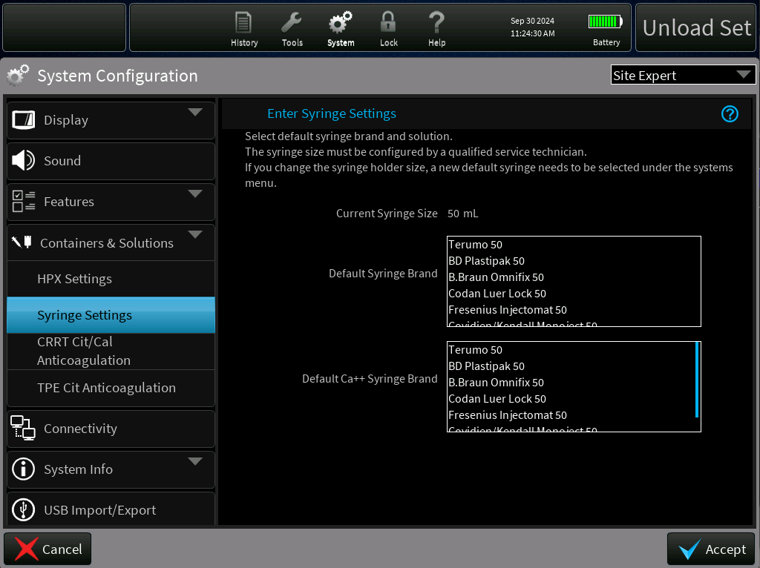

Syringe Settings Screen

This fix will ensure that the default settings are reliably retained upon startup, regardless of system configuration changes or transition between treatment sessions and will thereby prevent inappropriate triggering of T1722 “Defaults Not Set” alarm. The proposed change will enhance system reliability by ensuring that the syringe settings and default settings are consistently retained and will also correct inconsistencies in syringe holder size updates, preventing incomplete information in the syringe settings list.

#### Ensure correct status of TherMax SST is transmitted to PrisMax [PFAL-2484]

There have been several instances in the field with PrisMax SW 3.x/TherMax SW 1.04 where the T2259 has been raised, even though logged data indicate that no SST failures have been reported by TherMax.

The T2259 alarm (Call Service) is raised if any one of the following conditions are true:

* The stored TherMax SST and Calibration results have failures or are incomplete, which could mean that the TherMax is not properly installed or not properly configured or not correctly paired with the PrisMax system.
* The serial number of the TherMax device does not match the serial number of the device in the stored TherMax SST and Calibration result.

The following points highlight the existing implementations related to the generation of the T2259 alarm in the PrisMax SW 3.x/Thermax SW 1.04 system. It describes how the system currently manages the transmission of the serial number from Non-Volatile Memory (NVM) to PrisMax system and process for hash reporting.

1. Serial Number Transmission from NVM: The TherMax Software stores and transmits the serial number from NVM to the PrisMax system. The unit specific Electronic Serial Number is available in the HW/SW Configuration Data (U’ message- Unit) transmitted upon POST completion and optionally transmitted upon the request from PrisMax. (Refer to ER7007 for more details on the ‘U’ message).
2. Hash Reporting: The TherMax software transmits the overall SST status upon request from the PrisMax, consisting of the completion time/date for each SST and the current authentication data value. The TherMax software computes an authentication data value (SHA-256 hash), that can be used to verify the integrity of the SST/ calibration data.

**To reduce the occurrences of T2259 alarm, this change will:**

* Update the software to retry database loading and then wait for a fixed amount of time (~10 seconds), before raising the alarm.
* Ensure the pairing table reloads when the pairing table does not show corresponding hash value or serial number.
* The system will log the information on which defaults were not set as part of alarm logging.

#### Priming alarms update for alarms that triggers restart of the priming process [PFAL-2472]

After the filter set is loaded and all pre-prime tests have passed, the fluid priming sequence begins. Fluid priming removes air from the disposable set, fills, and rinses the filter, fluid lines, and Blood lines with priming solution. In most cases, if a fault occurs, the operator will be required to connect a new priming fluid bag and restart fluid priming. When this happens, it has been identified that the priming process restarts from the beginning of the fluid prime step, instead of resuming from the point of interruption. This means that the available priming fluid is not sufficient to go through the entire priming process again. This means that due to inadequate priming solutions in the priming bag to complete the priming, it can lead to air being pulled into the set, again propagating to another priming failure.

This is specific to alarms detected by the priming model for the fluid priming steps, leading to delays in completing the priming process, which in turn delays initiation of treatment. Refer to Table1 **–** Primingalarms below for list of impacted fluid prime alarms.

Table1 **–** Primingalarms

|  |  |  |  |  |
| --- | --- | --- | --- | --- |
|  |  |  |  |  |
|  |  |  |  |  |
|  |  |  |  |  |
|  |  |  |  |  |
|  |  |  |  |  |
|  |  |  |  |  |
|  |  |  |  |  |
|  |  |  |  |  |
|  |  |  |  |  |
|  |  |  |  |  |
|  |  |  |  |  |
|  |  |  |  |  |
|  |  |  |  |  |
|  |  |  |  |  |
|  |  |  |  |  |
|  |  |  |  |  |
|  | | | | |

| **S.NO** | **Alarm ID** | **Alarm Title** | **User Interface Control Update** | **User Interface Action** |
| --- | --- | --- | --- | --- |
| 1 | T1292 | Front Effluent Bag Incorrect  Note: Alarm shall be generated in the fluid priming step if the measured weight on the front effluent scale is less than 69g. | Change ‘Continue’ to ‘Reprime’ button | Clicking on the ‘Reprime’ button displays the ‘Reprime Workflow’ |
| 2 | T2217 | Effluent Bag Incorrect Note: Alarm shall be generated in the fluid priming step if the measured weight on the front effluent scale is less than 69g. Applies to CRRT without AE, CRRT with AE being reused, and TPE/HP, and to either the 5L or 9L bags. | Change ‘Continue’ to ‘Reprime’ button | Clicking on the Reprime button displays the ‘Reprime Workflow’ |
| 3 | T1291 | Side Effluent Bag Incorrect Note: Alarm shall be generated in the fluid priming step if AEE is enabled, and the measured weight on the rear effluent scale is less than 20g. | Change ‘Continue’ to ‘Reprime’ button | Clicking on the Reprime button displays the ‘Reprime Workflow’ |
| 4 | T1347 | Dialysate Scale Weight Error Note: Alarm shall be generated during fluid priming while the dialysate pump is commanded to run in the clockwise direction if the total expected mass flow exceeds the actual mass flow by over 10g. | Change ‘Continue’ to ‘Reprime’ button | Clicking on the Reprime button displays the ‘Reprime Workflow’ |
| 5 | T1610 | Rep Scale Weight Error Note: Alarm shall be generated during fluid priming while the replacement pump is commanded to run in the clockwise direction if the total expected mass flow exceeds the actual mass flow by over 10g. | Change ‘Continue’ to ‘Reprime’ button | Clicking on the Reprime button displays the ‘Reprime Workflow’ |
| 6 | T1611 | PBP Scale Weight Error Note: Alarm shall be generated during fluid priming while the preblood pump is commanded to run in the clockwise direction if the total expected mass flow exceeds the actual mass flow by over 10g | Change ‘Continue’ to ‘Reprime’ button | Clicking on the Reprime button displays the ‘Reprime Workflow’ |
| 7 | T1175 | Auto-effluent Bags on Wrong Scales Note: Alarm shall be declared if AE is enabled and not reused and any of the following conditions are met:  During the fluid prime step the pinch valves are set to fill into the front bag, and a weight increase of more than 50g is observed on the rear effluent scale;  During the fluid prime step the pinch valves are set to fill into the rear bag, and a weight increase of more than 50g is observed on the front effluent scale;  During either manual or blood priming, a weight increase of more than 50g is observed on the rear effluent scale. | Change ‘Continue’ to ‘Reprime’ button | Clicking on the Reprime button displays the ‘Reprime Workflow’ |
| 8 | T2125 | Bag on wrong scale Note: Alarm shall be declared if AE is disabled; the system is performing either the fluid prime step, manual/blood prime operation, or a rinse(flush) operation; and a weight increase of more than 50g is observed on the rear effluent scale.  Typically indicates that a bag was hung on the rear scale when no bag should be there. | Change ‘Continue’ to ‘Reprime’ button | Clicking on the Reprime button displays the ‘Reprime Workflow’ |
| 9 | T1594 | Bag Not Filling Note: Alarm shall be generated if AE is enabled and the total change in weight on the configured effluent bag(s) is less than the specified value of threshold T1 for the circuit set defined in SDS-2550.  The weight change on the effluent scale is measured over the last 30 second period  with the blood pump running of the first priming cycle. | Change ‘Continue’ to ‘Reprime’ button | Clicking on the Reprime button displays the ‘Reprime Workflow’ |
| 10 | T1714 | Return Line Misconnected Note: Alarm shall be generated if AE is enabled and being reused and the change in weight on the front effluent bag is less than the specified value of threshold T1 for the circuit set defined in SDS-2550.  The weight change on the effluent scale is measured over the last 30 second period  with the blood pump running of the first priming cycle. | Change ‘Continue’ to ‘Reprime’ button | Clicking on the Reprime button displays the ‘Reprime Workflow’ |
| 11 | T1713 | Bag Not Filling Note: For CRRT, the alarm shall be generated if AE is disabled and the change in weight on the front effluent bag is less than the specified value of threshold T1 for the circuit set defined in SDS-2550.  The weight change on the effluent scale is measured over the last 30 second period  with the blood pump running of the first priming cycle.  For HP, the alarm is raised while fluid prime is active, and the measured increase of the effluent bag over a 4 second period is less than 50% of the commanded blood flow rate. | Change ‘Continue’ to ‘Reprime’ button | Clicking on the Reprime button displays the ‘Reprime Workflow’ |
| 12 | T2224 | Bag Not Filling Note: Alarm shall be generated in TPE and the change in weight on the front effluent bag is less than the specified value of threshold T1 for the circuit set defined in SDS-2550.    The weight change on the effluent scale is measured over the last 30 second period  with the blood pump running of the first priming cycle. | Change ‘Continue’ to ‘Reprime’ button | Clicking on the Reprime button displays the ‘Reprime Workflow’ |
| 13 | T0609 | Wrong Set Detected Note: For a high flow set, alarm shall be generated if the total change in weight in the configured effluent bag(s) is in the range specified by the thresholds T1 and T2 specified for the circuit set, as defined in SDS-2550.    For a low flow set, alarm shall be generated if the total change in weight in the configured effluent bag(s) is greater than the threshold T2 specified for the circuit set, as defined in SDS-2550.    The weight change on the effluent scale is measured over the last 30 second period  with the blood pump running of the first priming cycle. | Change ‘Continue’ to ‘Reprime’ button | Clicking on the Reprime button displays the ‘Reprime Workflow’ |
| 14 | T2131 | Line Misconnected Note: Alarm shall be declared if AE is enabled and being reused; the system is performing either the fluid prime step, manual/blood prime operation; or a rinse(flush) operation; and a weight increase of more than 50g is observed on the rear effluent scale.  Typically indicates that return was connected to the AE set, instead of to the additional effluent bag hung on the effluent scale. | Change ‘Continue’ to ‘Reprime’ button | Clicking on the Reprime button displays the ‘Reprime Workflow’ |
| 15 | T2281 | Thermax Bag Not Connected to Set Note During fluid priming if Thermax is selected the software performs a test to determine if the TherMax disposable is present. | NA  [This alarm has Reprime button, the UI action for this button should be updated to display Reprime Workflow] | Clicking on the Reprime button displays the ‘Reprime Workflow’ |
| 16 | T2300 | TherMax Bag Not Inflated Note: At the start of fluid priming (initial prime and reprime) with Thermax in use the venous clamp is closed until the Return pressure reaches 250 mmHg.    Alarm is raised if the pressure has not reached 250 mmHg before the arps pump is commanded or if >200 ml of priming solution has been used since the start of the test. | Change ‘Continue’ to ‘Reprime’ button | Clicking on the Reprime button displays the ‘Reprime Workflow’ |
| Refer to screenshots for instructional text update for each of the alarms (1 to #16) | | | | |

Additionally, operators are unaware that priming is restarting and that a new priming bag needs to be hung to complete the priming sequence successfully.

In the current implementation, on pressing the ‘Continue’ button, there is no indication to the operator that the fluid priming step will be restarted from the beginning instead of simply resuming from the point of interruption and consequently that a new priming bag needs to be hung to complete the priming sequence successfully.

**The change implemented will:**

* Enhance operator workflow: Update the workflow to change the ‘Continue’ button to ‘Reprime’ button. On pressing the ‘Reprime’ button from these alarms and initiating repriming, modify the workflow to include the already existing workflow that instructs the operator to hang a new priming bag, the first-time priming begins.
* Rename Continue Button: Where repriming is needed, rename the ‘Continue’ button to ‘Reprime’ to clearly indicate that fluid priming is being restarted, not resumed from the point of interruption.

The proposed change will allow the operator to be aware of the preventive actions to reduce the occurrence of such events.

##### **Priming alarms Impacted**

The UI workflow update for each of the above listed alarms are highlighted in the screenshots below: -

1. T1292 – Front Effluent Bag Incorrect Alarm

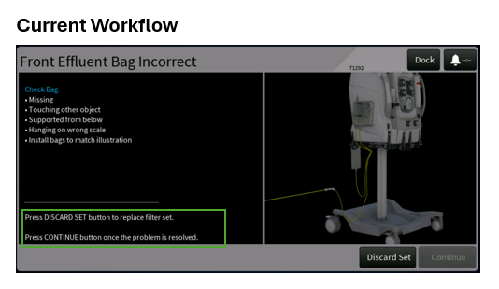

Figure 1: Current Workflow -T1292 – Front Effluent Bag Incorrect Alarm

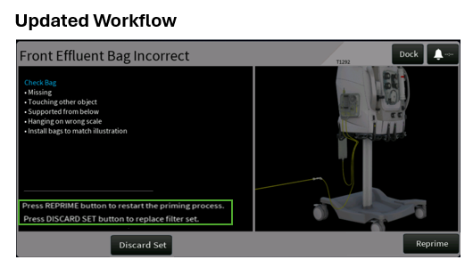

Figure 2: Updated Workflow -T1292 – Front Effluent Bag Incorrect Alarm

1. T2217 – Effluent Bag Incorrect Alarm

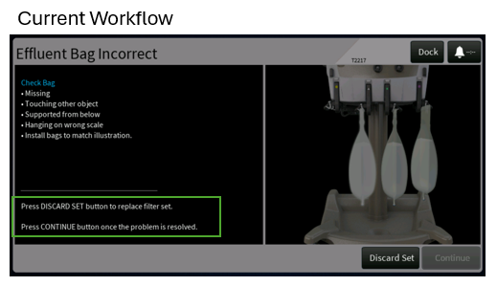

Figure 3: Current Workflow - T2217 – Effluent Bag Incorrect Alarm

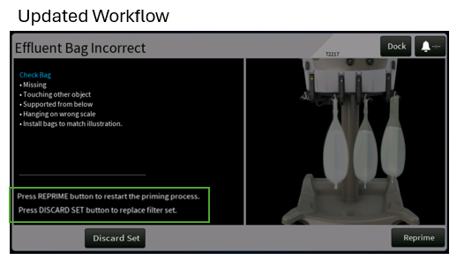

Figure 4: Updated Workflow - T2217 – Effluent Bag Incorrect Alarm

1. T1291 – Side Effluent Bag Incorrect Alarm

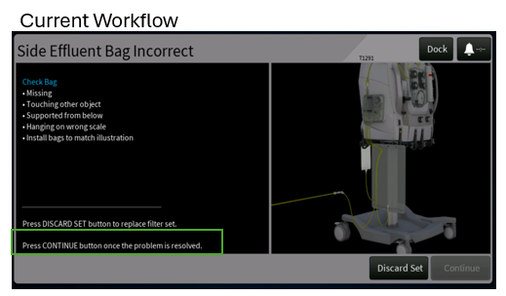

Figure 5: Current Workflow -T1291 – Side Effluent Bag Incorrect Alarm

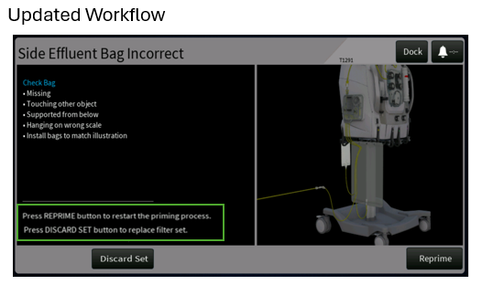

Figure 6: Updated Workflow -T1291 – Side Effluent Bag Incorrect Alarm

1. T1347 – Dialysate Scale Weight Error Alarm

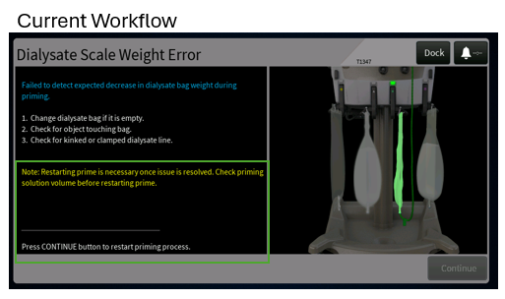

Figure 7: Current Workflow - T1347 – Dialysate Scale Weight Error Alarm

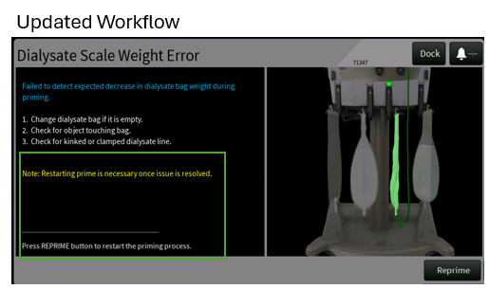

Figure 8: Updated Workflow - T1347 – Dialysate Scale Weight Error Alarm

1. T1610 – Rep Scale Weight Error Alarm

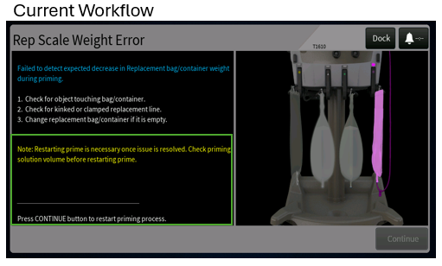

Figure 9: Current Workflow -T1610 – Rep Scale Weight Error Alarm

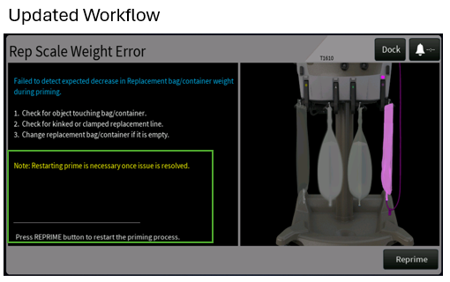

Figure 10: Updated Workflow -T1610 – Rep Scale Weight Error Alarm

1. T1611-PBP Scale Weight Error Alarm

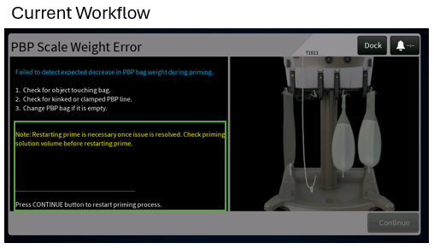

Figure 11: Current Workflow -T1611-PBP Scale Weight Error Alarm

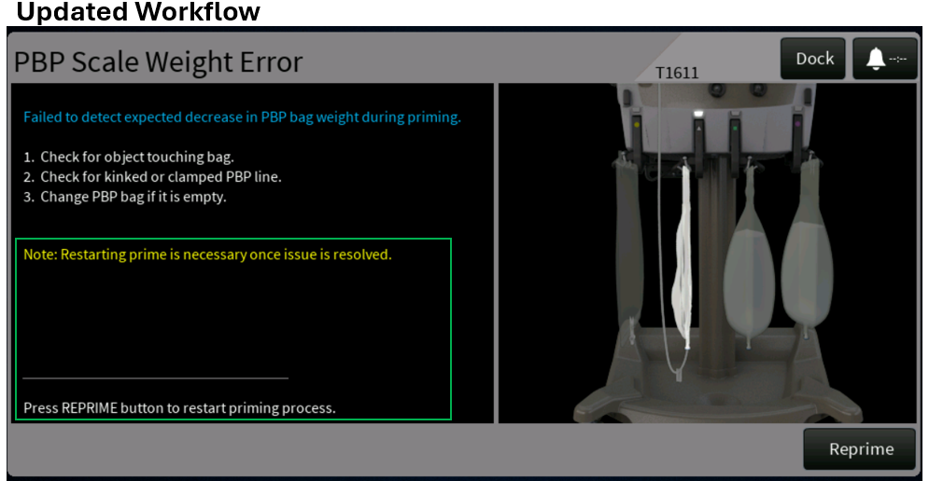

Figure 12: Updated Workflow -T1611-PBP Scale Weight Error Alarm

1. T1175 - Auto-effluent Bags on Wrong Scales Alarm

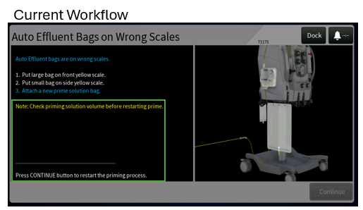

Figure 13: Current Workflow - T1175 - Auto-effluent Bags on Wrong Scales Alarm

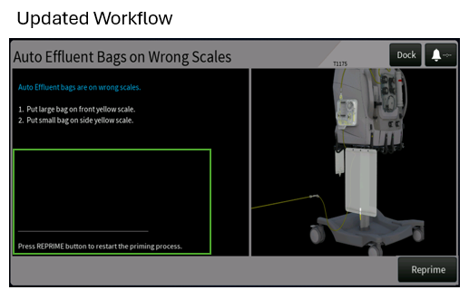

Figure 14: Updated Workflow - T1175 - Auto-effluent Bags on Wrong Scales Alarm

1. T2125 – Bag on Wrong Scale Alarm

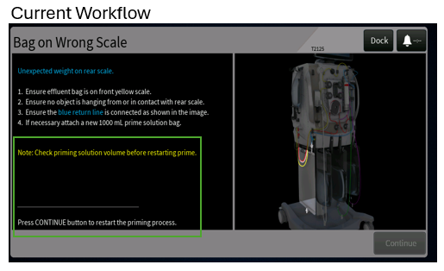

Figure 15:Current Workflow - T2125 – Bag on Wrong Scale Alarm

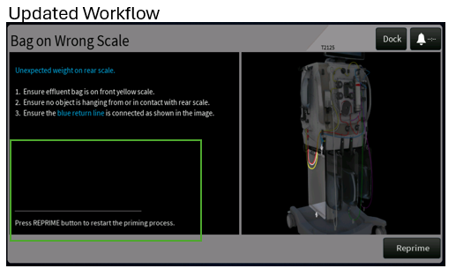

Figure 16: Updated Workflow - T2125 – Bag on Wrong Scale Alarm

1. T1594 – Bag Not Filling Alarm

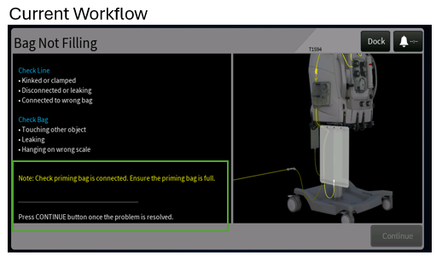

Figure 17: Current Workflow - T1594 – Bag Not Filling Alarm

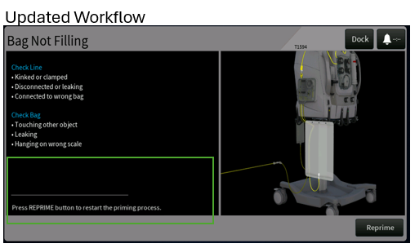

Figure 18: Updated Workflow - T1594 – Bag Not Filling Alarm

1. T1714 – Return Line Misconnected Alarm

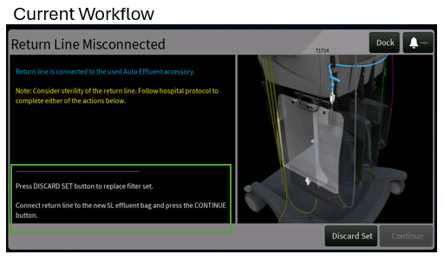

Figure 19: Current Workflow - T1714 – Return Line Misconnected Alarm

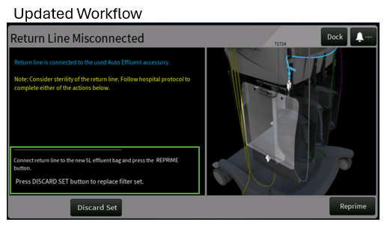

Figure 20: Updated Workflow - T1714 – Return Line Misconnected Alarm

1. T1713 – Bag Not Filling Alarm

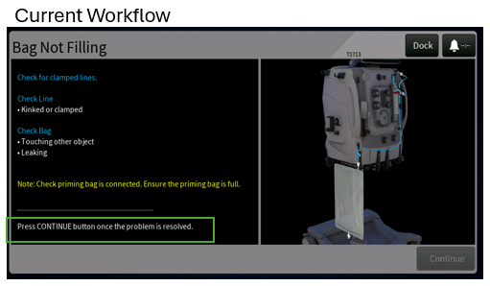

Figure 21: Current Workflow - T1713 – Bag Not Filling Alarm

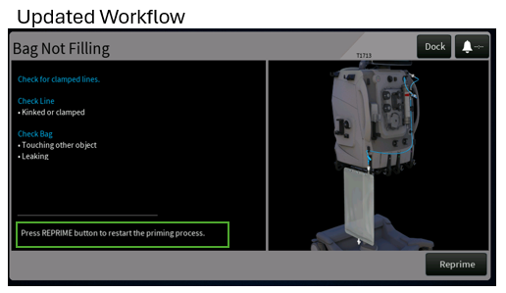

Figure 22: Updated Workflow - T1713 – Bag Not Filling Alarm

1. T2224 – Bag Not Filling Alarm

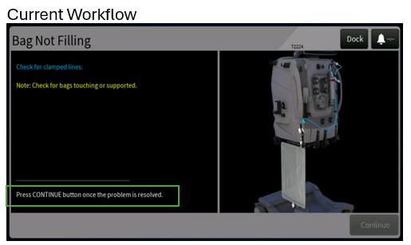

Figure 23: Current Workflow - T2224 – Bag Not Filling Alarm

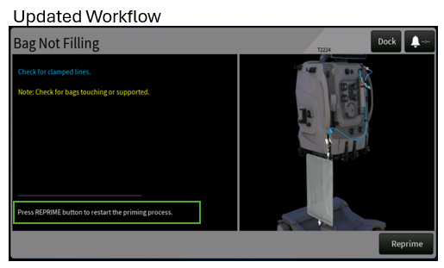

Figure 24: Updated Workflow - T2224 – Bag Not Filling Alarm

1. T0609 – Wrong Set Detected Alarm

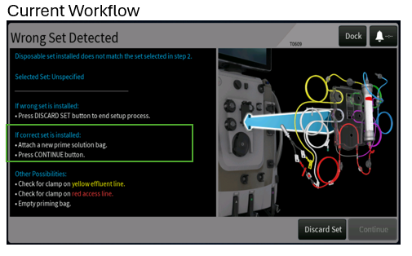

Figure 25: Current Workflow - T0609 – Wrong Set Detected Alarm

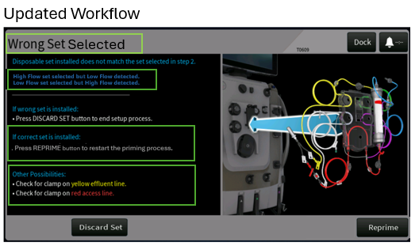

Figure 26: Updated Workflow - T0609 – Wrong Set Detected Alarm

14.. T2131 – Line Misconnected Alarm

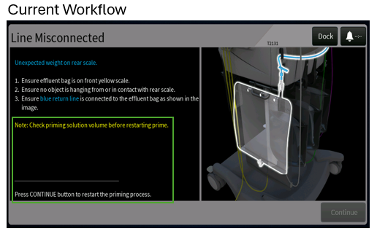

Figure 27: Current Workflow - T2131 – Line Misconnected Alarm

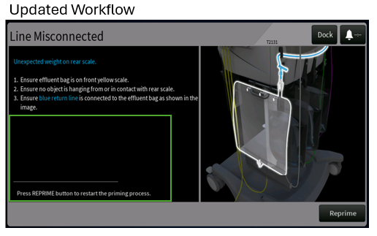

Figure 28: Updated Workflow - T2131 – Line Misconnected Alarm

15.T2300 – TherMax Bag Not Inflated Alarm

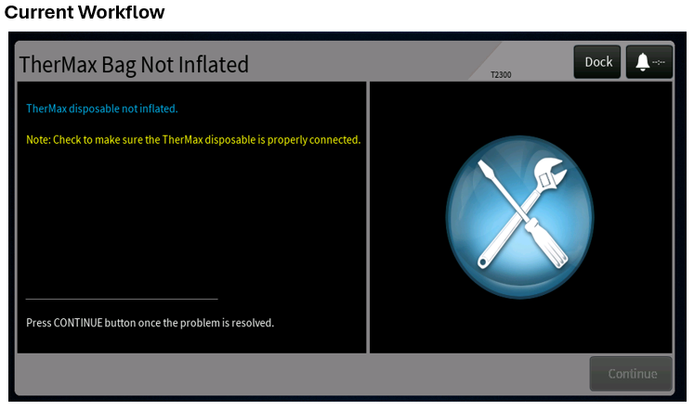

Figure 29: Current Workflow - T2300 – TherMax bag Not Inflated Alarm

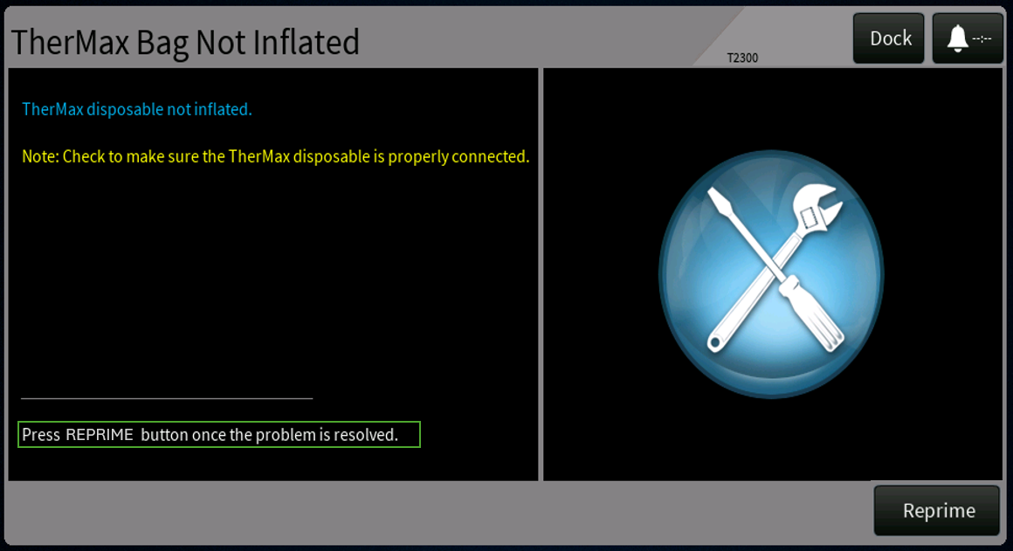

Figure 30: Updated Workflow - T2300 – TherMax bag Not Inflated Alarm

##### 2.1.2.3.2 Reprime Workflow

On clicking **Reprime** button on the alarms listed in Table1 **–** Primingalarms, the system will display the Reprime screen as displayed below –

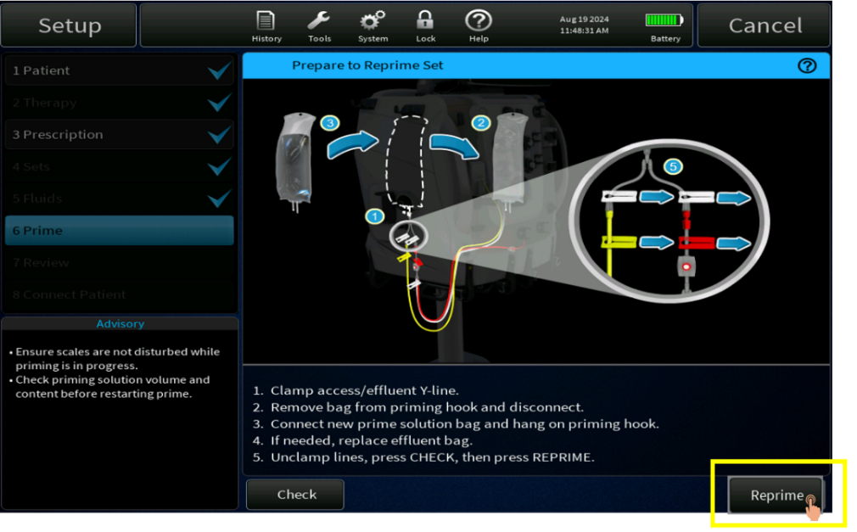

Figure 31: Reprime Screen (CRRT) – Current Screen

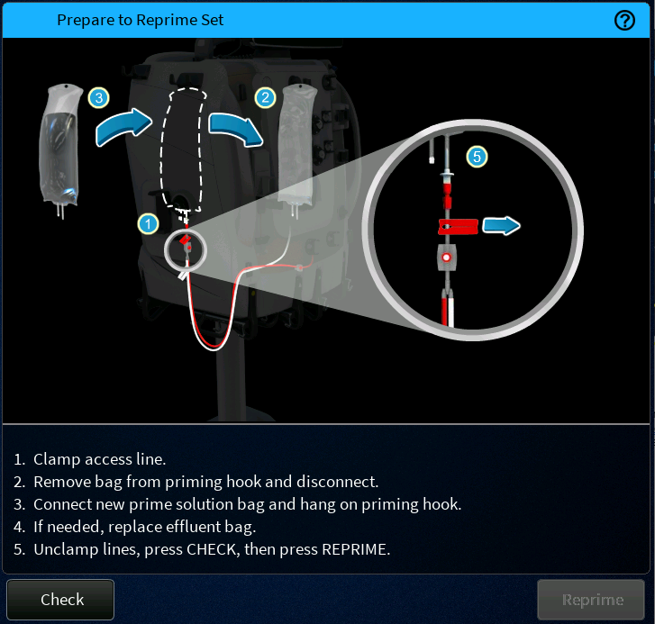

Figure 32: Reprime (TPE) Screen – Current Screen

As a part of the Formative study conducted for Assure SW1, feedback was received on the arrows indicating the direction for clamping the access/effluent line. The direction of arrows are incorrect and when followed would unclamp the lines rather than clamp them. Subsequent to this feedback, the screen was updated to remove the blue arrows (for point 5) as shown in the Figure below.

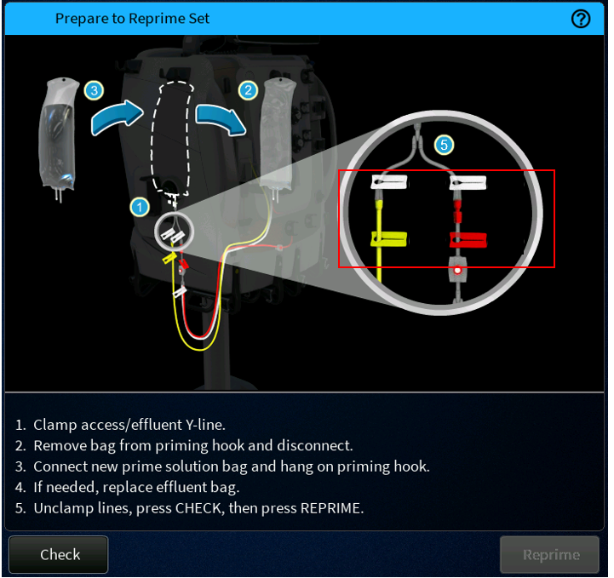

Figure 33: Reprime Screen (CRRT) - Updated

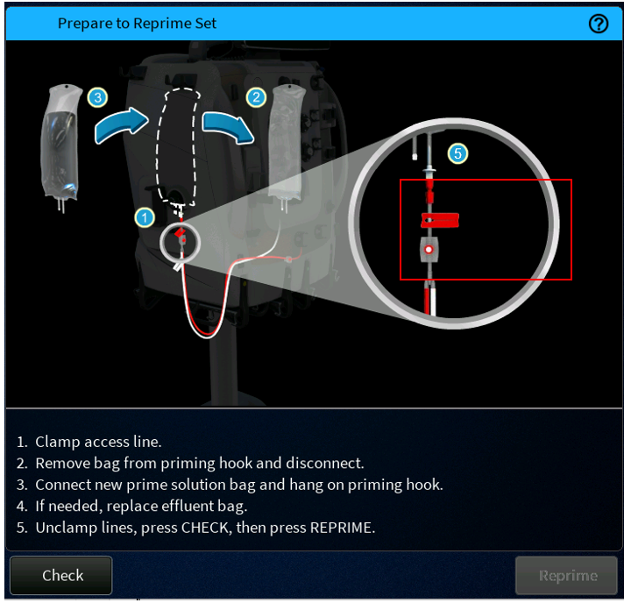

Figure 34: Reprime Screen (TPE) - Updated

On Clicking the ‘Reprime’ button on the **Figure 33: Reprime** , the system will restart the fluid priming process (sample screen displayed below) –

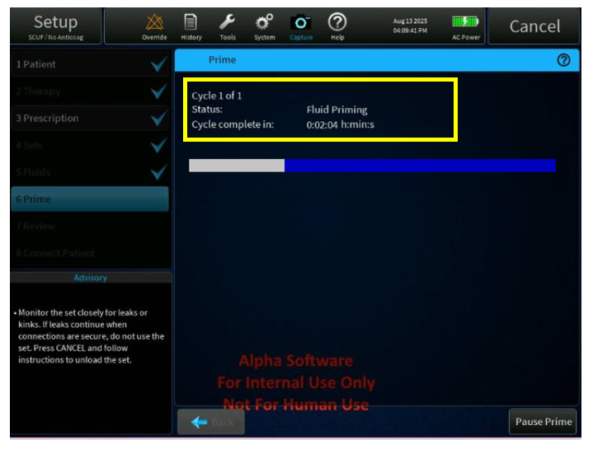

Figure 35: Restart Fluid Priming Process Screen

#### Reduce occurrences of ARPS BIOT alarms [PFAL-2477]

There have been reports of frequent (possibly false positive) occurrences of the following ARPS BIOT Alarms in the field. BIOT alarms typically halt treatment and bring the system to a safe state. Frequent false alarms lead to user inconvenience and potential risks associated with treatment delays.

**ARPS BIOT Alarms:**

1. ARPS System Failed ARPS Leak [B1273]
2. ARPS System Failed ARPS Self-Test fail alarm[B1215]
3. Call Service Return pressure self-test failure [B1116]
4. Call Service Access pressure pod reposition failure[B1539]
5. Call Service Filter pressure pod reposition failure[B1540]
6. Call Service Effluent pressure pod reposition failure [B1541]

* To reduce false occurrence of these alarms, it is proposed to Reduce the frequencies of those BIOT occurrences through parameter tuning. There are predefined design parameters, or thresholds, in the ARPS algorithm which affect the conditions whether or when a BIOT is raised. The method is to fine tune relevant design parameters in the ARPS algorithm so that the algorithm is less likely to raise BIOTs
* Improve overall detection logic of ARPS BIOT alarms so that they are less strict than the criteria in SST
* Improve logging for future analysis of these BIOT’s:
* For B1215, fix the issue that logged EventData 1(“arpsSelfTestState”) is always 0.
* For B1539, B1540, and B1541, fix the issue that logged “arpsPressureFail” is always 0.
* For B1116, B1539, B1540 and B1541, add “StateID” and “PStateID” to event data.
* For B1273, Add “LLState” and “mmHgReturn” to the event data when PodReposition BIOT happens.Add FilteredPressure for access, filter, effluent, return, and ARPS to periodic log data.

| BIOT | Trigger Conditions and Proposed change |
| --- | --- |
| B1273  ARPS_PRESSURE_FAIL | 1. Timeout: Pressurize_Tubing module inside ARPS_SELF_TEST model cannot complete in 60 seconds. 2. Timeout: ComplianceTest module inside ARPS_SELF_TEST model cannot complete in 180 seconds. 3. Timeout: EqualizeToReturn module inside LiquidLevel model cannot complete in 60 seconds.   **Proposed change: Add new log data for B1273. Add “LLState” and “mmHgReturn” to the LOG file for future analysis.** |
| B1215  ARPS_TEST_FAIL | 1. ARPS_CAN_STOP test fails. ARPS pressure drops more than 50 mmHg after ARPS pump stops. 2. ARPS_HOLDS_PRESSURE test fails. ARPS pressure increases more than 50 mmHg in 10 seconds after ARPS pump stops. 3. ARPS_REVERSED test fails. ARPS pressure is increasing while it is expected to decrease when ARPS pump is running. 4. B1273 trigger conditions are met.   **Proposed change will remove this condition** |
| B1116:  RET_PRESS_SENSOR_FAIL | 1. Timeout: Any reason that return pod fails to complete reposition sequence within 4 minutes. 2. Sensors Measurement Mismatch: Return pressure and ARPS pressure are not within 20mmHg when the solenoid is open.   **Proposed change- Increasing to 30mmHg** |
| B1539:  ACCESS_POD_REPOS_FAILURE | 1. Timeout: Any reason that access pod fails to complete repositioning sequence within 4 minutes 2. Sensors Measurement Mismatch: Access pod pressure sensor and ARPS pressure sensor are not within 20mmHg during repositioning sequence when the solenoid is open. **Proposed change- Increasing to 30mmHg** |
| B1540  FILTER_POD_REPOS_FAILURE | 1. Timeout: Any reason that filter pod fails to complete repositioning sequence within 4 minutes 2. Sensors Measurement Mismatch: Filter pod pressure sensor and ARPS pressure sensor are not within 20mmHg during repositioning sequence when the solenoid is open.   **Proposed change- Increasing to 30mmHg** |
| B1541  EFFLUENT_POD_REPOS_FAILURE | 1. Timeout: Any reason that effluent pod fails to complete repositioning sequence within 4 minutes 2. Sensors Measurement Mismatch: Effluent pod pressure sensor and ARPS pressure sensor are not within 20mmHg during repositioning sequence when the solenoid is open.   **Proposed change- Increasing to 30mmHg** |

#### Reduce occurrences of Call Service Return Pressure Sensor Prime Test Failed [B1593] alarm declared during priming [PFAL-2474]

The Call Service Return Pressure Sensor Prime Test Failed [B1593] alarm is triggered when the Return Pressure Sensor Prime Test fails. This occurs if the system cannot equalize the ARPS pressure to the return pressure, or if effluent pressure cannot be adjusted to the desired target during fluid priming or post-prime. This alarm can occur during the fluid prime step or the post-prime test.

However, instances have been reported where the Call Service Return Pressure Sensor Prime Test Failed [B1593] alarm is erroneously initiated. False B1593 alarms interrupt treatments unnecessarily, leading to potential treatment initiation delays.

To reduce occurrences of nuisance B1593 it is proposed to make the following improvements:

* Increase controller gain to better compensate for permeability of the silicone ARPS tubing.
* Improve overall detection logic of B1593 alarm so that it is less strict than the criteria in SST.
* Update logged variables for future diagnostics:
  1. B1593 during PostPrimeCmd[1], event data should include: **[returnPressure, arpsPressure, PostPrimeStatus[1], clampOpen,primeStep]**.
  2. B1593 during PostPrimeCmd[2], event data should include: **[returnPressure, arpsPressure, effluentPressure, PostPrimeStatus[2], primeStep]**. Add addition logging by printing out the variable **StdAtmVolToEff**.

|  |  |
| --- | --- |
| **BIOT** | **Trigger Conditions** and Proposed change |
| **B1593**  PRTST_RETURN_PRESSURE_FAIL | 1. During ReturnPressureSensorCheck: Any reason that ARPS pressure cannot be driven to be within 10mmHg from return pressure within 30 seconds when solenoid is closed. 2. During ReturnPressureSensorCheck: Return pressure and ARPS pressure are not within 10mmHg when the solenoid is open.   **Proposed change- increasing to 12mmHg)**   1. When pushing effluent pod out, ARPS pressure cannot be driven to be within 10mmHg from effluent pod pressure within 45 seconds when effluent solenoid is closed.   **Proposed change- increasing to 15mmHg)**   1. When pushing effluent pod out, ARPS is unable to create more than 350mmHg within 45 seconds when effluent solenoid is open**.**   **Note: Proposed change- increasing to 60 seconds)**   1. When pulling effluent pod in, ARPS pressure cannot be driven to be within 10mmHg from effluent pod pressure within 30 seconds when effluent solenoid is closed.   **Note: Proposed change- increasing to 15mmHg and 45 seconds**   1. When pulling effluent pod in, ARPS is unable to drive effluent pod pressure to be within 10mmHg from return pressure within 45 seconds when effluent solenoid is open**.**   **Note: Proposed change- increasing to 15mmHg and 90 seconds** |

#### Include additional logging for B0916 alarm occurrence [PFAL-2471]

There have been several occurrences of the Call Service Internal error [B0916] alarm in the field, with no known cause. The root cause of the Call Service Internal error [B0916] alarm is currently undetermined because the necessary data is not captured in the log files. This lack of detailed logging makes it nearly impossible to trace the origin of these occurrences in the field, limiting our ability to identify and resolve the issue effectively.

**The following fix will be considered:**

* Enable logging of information like filenames, line numbers, exception codes in log DB file from system exception handler to narrow down B0916 causes from past machine faults.

#### PBP Bag empty alarm not coming up at the right time (PFAL-2470)

The PBP bag empty threshold can be calculated incorrectly, causing the bag empty alarm to not being raised at the right time. The software logic needs to be updated to correctly calculate the bag empty threshold enabling the bag empty alarm to be raised at the right time. The following causes could be attributed to this issue:

Cause#1 - Race Condition Between SW modules:

If the user changes the citrate solution in setup, the system publishes an event to inform the other SW modules that the solution changed. However, this event is published before all relevant data has been updated, resulting in SW using "stale" parameters (the data from the previously selected solution), including the configured bag weight for the defined citrate solution. So, the bag empty threshold for the PBP Citrate bag will be calculated using the incorrect parameter and this leads to the bag empty alarm declaring sooner or later than expected.

Cause #2 - Missing Logic Condition:

When a system is configured to use a Citrate PBP bag along with an external calcium pump, the system uses the wrong parameter to calculate the bag empty weight. There is a check on the anticoagulation type to determine if we are using PBP Citrate or regular PBP. If the configuration is using citrate, the bag size is determined using the configured citrate parameters. If it is using regular PBP, the bag size is determined using the configured PBP bag size parameter. However, with an external calcium pump the system incorrectly uses the PBP bag size vs. the citrate bag size. This can lead to the bag empty alarm declaring sooner or later than expected.

Both issues have the same effect (incorrectly calculated PBP bag empty threshold) but the causes are not related.

**The following fix will be considered:**

Cause 1:

Fix a race condition by ensuring all relevant data is updated before publishing the solution change event. This prevents modules from using outdated parameters, ensuring correct calculation of the bag empty threshold and proper alarm timing.

Cause 2:

Fix missing logic to correctly select the bag size parameter when using a Citrate PBP bag with an external calcium pump. Previously, the system incorrectly used the regular PBP bag size instead of the citrate-specific parameter, leading to inaccurate bag empty threshold calculations and incorrect alarm timing.

#### Alarm T2124 is not raised at the right time [PFAL-2475]

The Unsuitable Calcium Solution [T2124] alarm is not triggering immediately after a configuration change, even when it should indicate an incorrect calcium solution. Additionally, the alarm may occasionally activate unexpectedly, making it challenging to accurately identify real issues.

Higher level software will be updated to include all solution type changes that were previously omitted. This will ensure that the prescription data is sequenced correctly and processed as expected.

**The following fix will be considered:**

* Update the internal handling of software event sequencing so the alarm raises as soon as the configuration change (Calcium solution concentration) is made

There was an observation made that the Alarm T2124 is raised 1mmol/L earlier than the Calculated minimum and Maximum Ca Concentration limits and a PFAL-2620 was raised to track this. The PFAL-2620 will not be resolved as a part of Assure SW1 (SW 3.7) as an offset of Calcium concentration by 1mmol/L does not impact patient safety or does not introduce any risks.

#### Enable autochart PFR & Address issue of not resetting of PFR values with same patient in EMR systems [PFAL-2466]

EMR (Electronic Medical Record) autocharting refers to the automated process of generating clinical documentation within an EMR system, often triggered by specific events or data inputs. This feature streamlines the charting process, saving time and reducing manual effort for healthcare providers.

Issue 1: The message formatting of the PrisMax serial port messages to the hospital EMR systems was not implemented in a way that allowed EMR vendors to write drivers or clinicians to accurately chart the amount of cumulative patient fluid removed in the previous period. Additionally, the PFR value being sent to the EMR system, was erroneously not getting to reset to 0 when New patient was selected. EMR vendors are unable to reliably record the amount of PFR over the charting period and therapy, leading to discrepancies between EMR systems and PrisMax on screen values, vendors are using EMR message parameters 458 or 459 and attempting to calculate what the previous cumulative PFR charting value was. Similarly, EMR message parameter 100 is being used for the total PFR when same patient is selected.

**The following fix will be considered:**

Update parameter IDs 100, 458, 459 and corresponding descriptions in the communication programmers guide to accurately reflect the Total PFR for same patient and cumulative PFR value over the charting period/ 24 hours to fix the PFR charting problems.

Details of Parameters mentioned below:

* Parameter 100: Change to include PFR from previous disposable sets if SAME PATIENT is used. Reset to 0 when NEW PATIENT is chosen. Current implementation only includes the current disposable set.
* Parameter 458: Change to, cumulative value for the last completed charting period for PFR. This value shall be the same as the last completed charting period value displayed on the History PFR screen.
* Parameter 459: Change to cumulative of 24h period up to the last completed charting period for PFR. This value shall be the same as last completed 24 hr value up to the last completed charting period.
* Update AW8081 – Communication Programmer’s Guide document. Based on the implementation of above changes EMR version will be updated (only minor version will be incremented).
  + The EMR revision will be updated from 3.0.0.0 to 3.0.0.1
  + The communication programmer’s guide will be updated to provide clarity on the criteria that define the minor version numbers for the EMR revision.

Note: The EMRrevision field and the PrisMax Software Version Number contains a revision number that has the following structure:

* A.B.C.D: Where A, B, C, and D are integers.

Encoding is explained in the following example- If the "EMRrevision" for PrisMax is 3.0.0.0, this is encoded as "0x00 2D C6 C0". Thus,   
· A = 3  
· B = 0  
· C = 0  
· D = 0

Issue 2: When significant effluent volume is collected over a treatment session and treatment is restarted with same patient, the PFR values sent through the EMR are negative PFR values. The parameters which are giving negative values are 417, 418 and 419 in EMR message.

**The following fix will be considered:**

Refresh the parameters 417, 418 and 419 in EMR message for every start of treatment for the same patient.

During the testing of EMR message after restarting therapy for the same patient, the following parameters shall be observed to match the correct functionality along with the above-mentioned parameters.

| **Parameter ID** | **Parameter ID name** | **Description** |
| --- | --- | --- |
| 94 | IO_HIST_PRE_REPL_WITH-OUT_PBP_TOT | Actual cumulated volume for replacement pre delivered (excluding PBP) |
| 95 | IO_HIST_POST_REPL_TOT | Total replacement volume post delivered  Includes the volume from previous filter sets if the option Same patient has been used, Selecting New Patient resets this value to 0 |
| 97 | IO_HIST_DIAL_TOT | Actual cumulated volume for dialysate |
| 98 | IO_HIST_PBP_TOT | Actual cumulated volume for pre-blood |
| 99 | IO_HIST_EFFL_TOT | Actual cumulated volume for effluent |
| 418 | DB_TOT_VOL_REMOVED | AS_1HR_SLIDING (IO_HIST_PFR_1) |
| 419 | DB_TOT_VOL_REMOVED | AS_24HR_SLIDING (IO_HIST_PFR_24) |
| 420 | DB_UFR_VOL | AS_1HR_SLIDING (IO_HIST_UF_1) |
| 421 | DB_UFR_VOL | AS_24HR_SLIDING (IO_HIST_UF_24) |
| 423 | DB_UFR_VOL | AS_1HR_SLIDING_UFRDOSE ( IO_HIST_UF_DOSE_1) |
| 424 | DB_UFR_VOL | AS_24HR_SLIDING_UFRDOSE (IO_HIST_UF_DOSE_24 ) |
| 426 | DB_REP_PBP_VOL | AS_1HR_SLIDING (IO_HIST_TOT_REPL_WITH_PBP_1) |
| 427 | DB_REP_PBP_VOL | AS_24HR_SLIDING (IO_HIST_TOT_REPL_WITH_PBP_24) |
| 429 | DB_REP_PBP_VOL | AS_1HR_SLIDING_DOSE (IO_HIST_TOT_REPL_WITH_PBP_DOSE_1) |
| 430 | DB_REP_PBP_VOL | AS_24HR_SLIDING_DOSE (IO_HIST_TOT_REPL_WITH_PBP_DOSE_24) |
| 432 | DB_PRE_REP_PBP_VOL | AS_1HR_SLIDING (IO_HIST_PRE_REPL_WITH_PBP_1) |
| 433 | DB_PRE_REP_PBP_VOL | AS_24HR_SLIDING (IO_HIST_PRE_REPL_WITH_PBP_24) |
| 435 | DB_PRE_REP_PBP_VOL | AS_1HR_SLIDING_DOSE (IO_HIST_PRE_REPL_WITH_PBP_DOSE_1) |
| 436 | DB_PRE_REP_PBP_VOL | AS_24HR_SLIDING_DOSE (IO_HIST_PRE_REPL_WITH_PBP_DOSE_24) |
| 438 | DB_POST_REP_VOL | AS_1HR_SLIDING (IO_HIST_POST_REPL_1) |
| 439 | DB_POST_REP_VOL | AS_24HR_SLIDING (IO_HIST_POST_REPL_24) |
| 441 | DB_POST_REP_VOL | AS_1HR_SLIDING_DOSE (IO_HIST_POST_REPL_DOSE_1) |
| 442 | DB_POST_REP_VOL | AS_24HR_SLIDING_DOSE (IO_HIST_POST_REPL_DOSE_24) |
| 444 | DB_EFF_VOL | AS_1HR_SLIDING (IO_HIST_EFFL_1) |
| 445 | DB_EFF_VOL | AS_24HR_SLIDING (IO_HIST_EFFL_24) |
| 446 | DB_EFF_VOL | AS_1HR_SLIDING_DOSE (IO_HIST_EFFL_DOSE_1) |
| 447 | DB_EFF_VOL | AS_24HR_SLIDING_DOSE (IO_HIST_EFFL_DOSE_24) |
| 448 | DB_PBP_VOL | AS_1HR_SLIDING (IO_HIST_PBP_1) |
| 449 | DB_PBP_VOL | AS_24HR_SLIDING (IO_HIST_PBP_24) |
| 450 | DB_DIAL_VOL | AS_1HR_SLIDING (IO_HIST_DIAL_1) |
| 451 | DB_DIAL_VOL | AS_24HR_SLIDING (IO_HIST_DIAL_24) |
| 452 | DB_REP_VOL | AS_1HR_SLIDING (IO_HIST_TOT_REPL_1) |
| 453 | DB_REP_VOL | AS_24HR_SLIDING (IO_HIST_TOT_REPL_24) |
| 455 | DB_SYRINGE_VOL | AS_1HR_SLIDING (IO_HIST_SYRINGE_1) |
| 456 | DB_SYRINGE_VOL | AS_24HR_SLIDING (IO_HIST_SYRINGE_24HR) |

#### GUI Issue- Display of Portuguese "C" character, font size display of numbers in Korean and Chinese screens [PFAL-2467]

##### **Issue 1: EU Portuguese Character Rendering**

The character “ç” does not align with the baseline when rendered on-screen at the “small”/”medium” font sizes. To address this in PrisMax SW version 3.1, most text containing this character was adjusted to either medium or tiny font sizes. However, for text where font size changes were not feasible, only the individual word was modified, resulting in inconsistent visual appearance. This issue likely affects all languages but primarily impacts Traditional Portuguese. The fix would attempt to ensure that the character “ç”, is adjusted to appropriate font sizes to enable it to render properly on the screen.

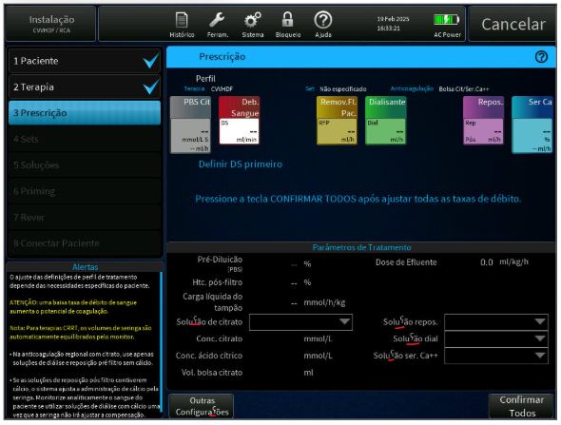

Figure 36: Current Screen - Portuguese EU issue Screen

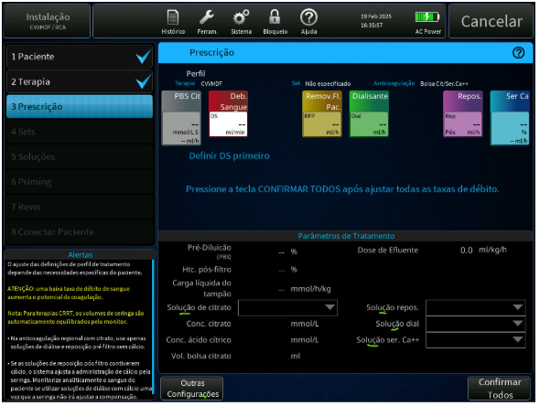

Figure 37: Updated Screen - Portuguese EU issue Screen

##### **Issue 2: Font Display Inconsistency for Korean and Chinese**

The Korean and Chinese fonts appear slightly taller than non-CJK (Chinese, Japanese, Korean) fonts, leading to visual inconsistency in multilingual interfaces. To address this issue the code will be modified to allow the font size to be changed from the xml. These changes are specific and restricted to the operation and prescription screen. However, this adjustment does not fully resolve the height discrepancy, and the fonts still appear slightly taller than their non-CJK counterparts.

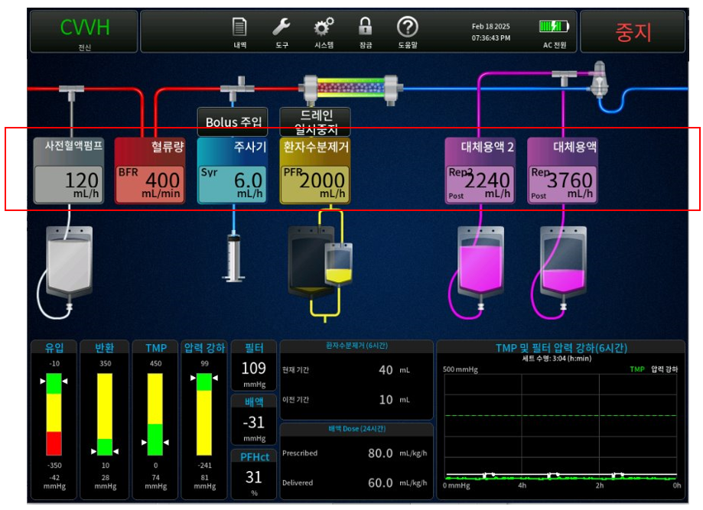

Figure 38: Current Screen - Korean Flow Rate Font Issue – Treatment Screen

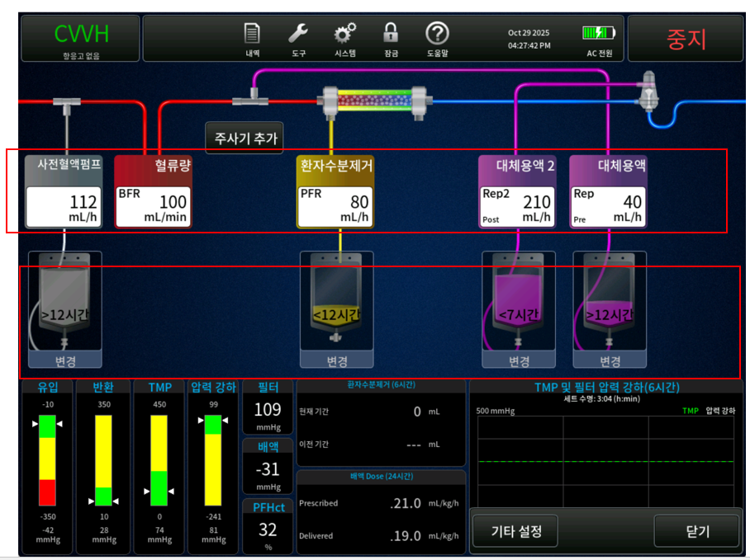

Figure 39: Updated Screen – Korean Flow Rate Font Issue – Treatment Screen

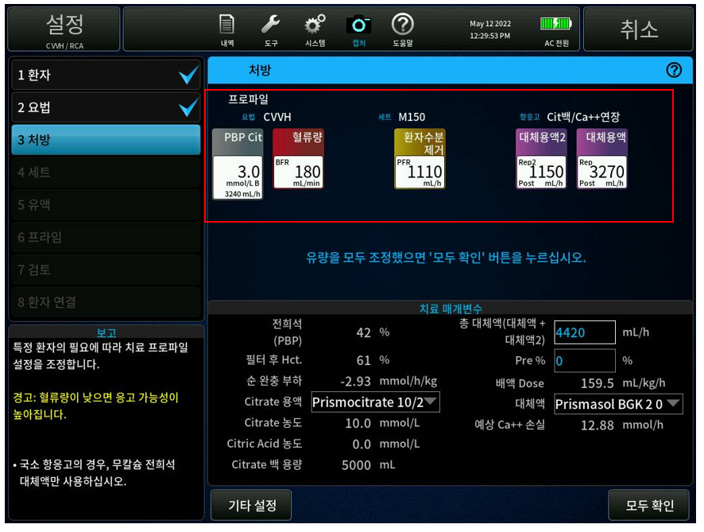

Figure 40: Current Screen - Korean Flow Rate Font Issue – Prescription Screen

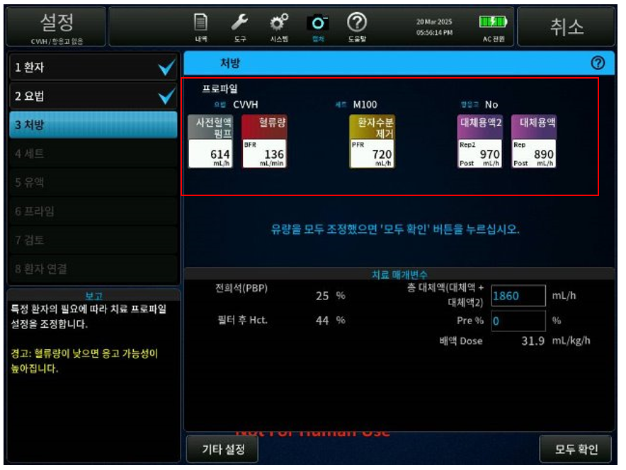

Figure 41: Updated Screen - Korean Flow Rate Font Issue – Prescription Screen

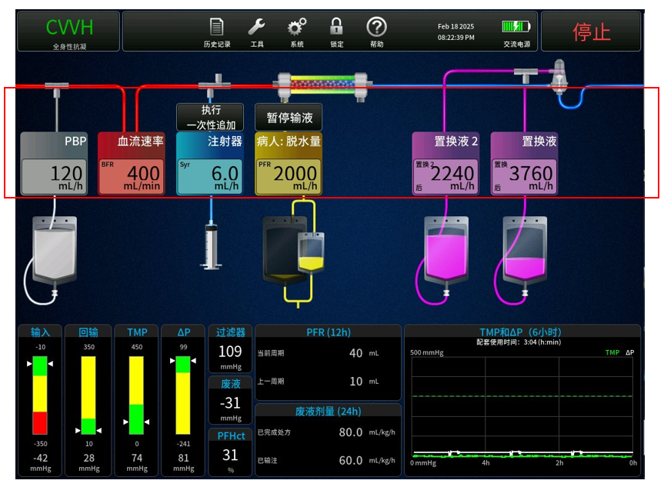

Figure 42: Current Screen - Simplified Chinese Flow Rate Font Issue - Treatment Screen

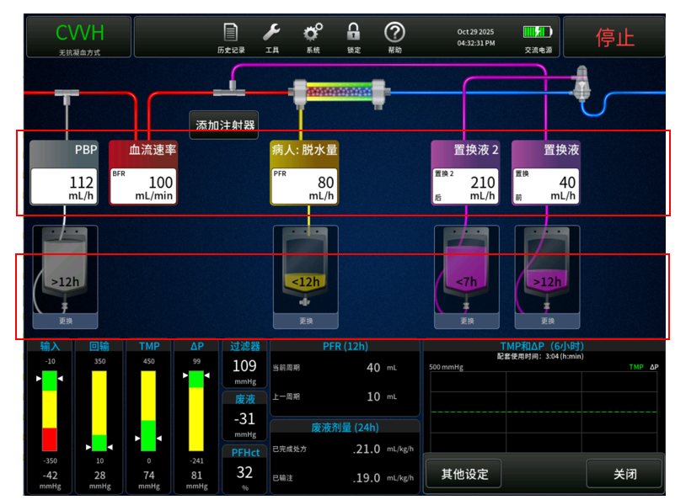

Figure 43: Updated Screen - Simplified Chinese Flow Rate Font Issue - Treatment Screen

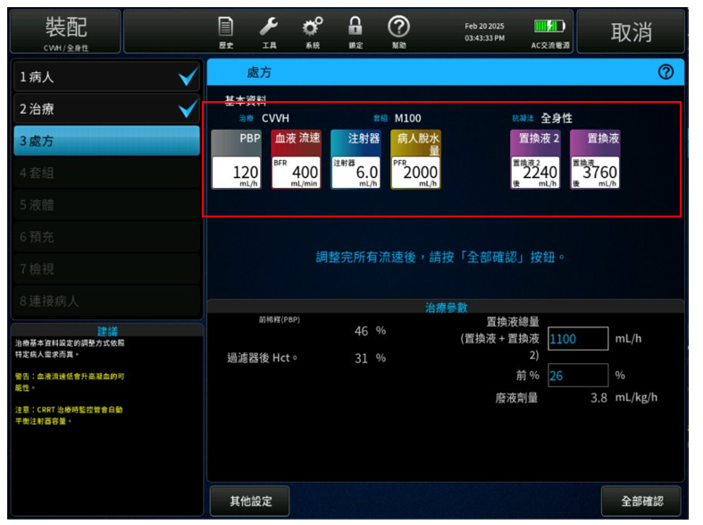

Figure 44: Current Screen - Simplified Chinese Flow Rate Font Issue – Prescription Screen

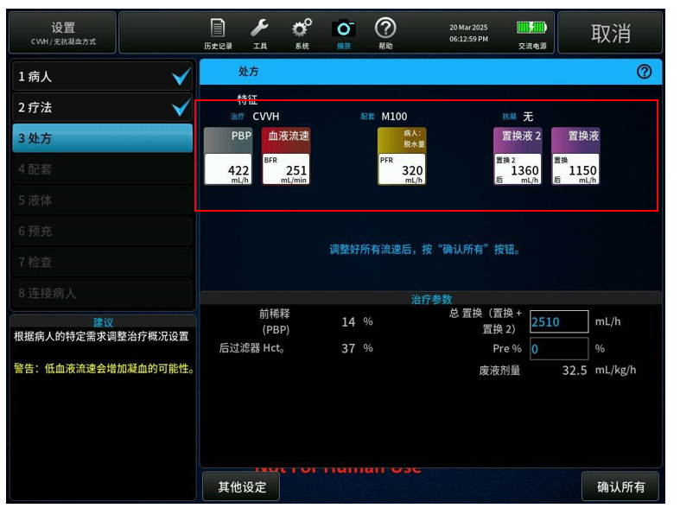

Figure 45: Updated Screen - Simplified Chinese Flow Rate Font Issue – Prescription Screen

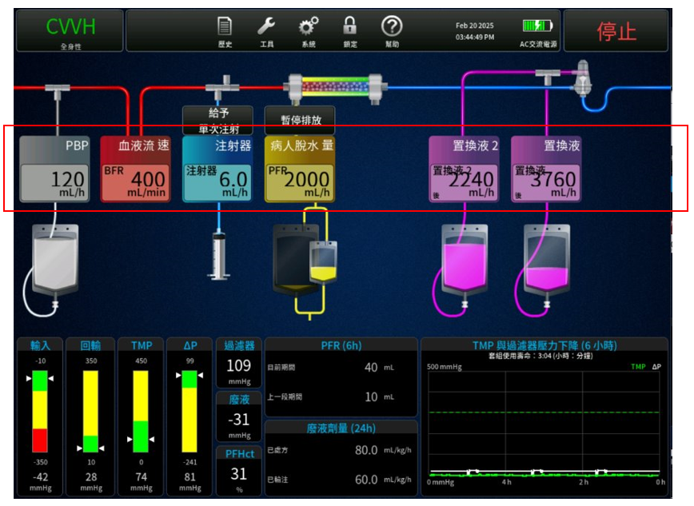

Figure 46: Current Screen - Traditional Chinese Flow Rate Font Issue - Treatment Screen

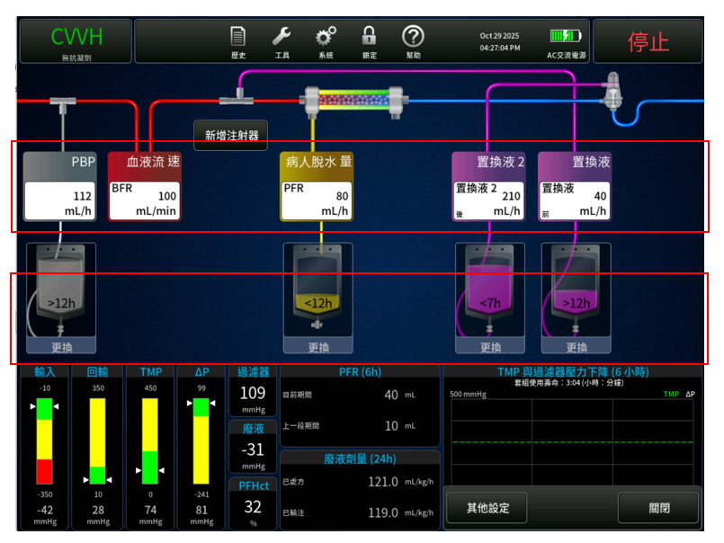

Figure 47: Updated Screen - Traditional Chinese Flow Rate Font Issue - Treatment Screen

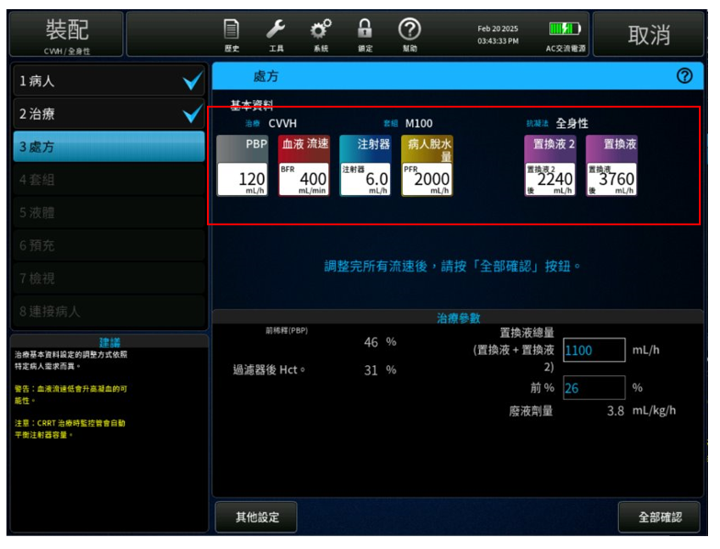

Figure 48: Current Screen - Traditional Chinese Flow Rate Font Issue – Prescription Screen

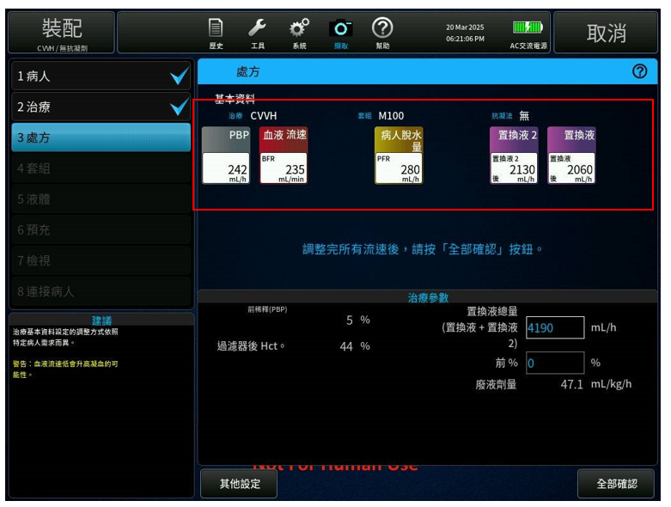

Figure 49: Updated Screen - Traditional Chinese Flow Rate Font Issue – Prescription Screen

#### Missing or Incomplete Data Display in History PFR Screen observed in Korean and Simplified Chinese [PFAL-2577]

.In the **History PFR** screen, the entries for PFR charting intervals are missing 2 rows from being displayed, due to the nature of the tall font in CJK languages. For non-Latin languages font size for history PFR screen will be changed from small to tiny. This font size change will now be managed through the XML file configuration instead of being hard-coded in the Software.

For Missing or Incomplete Data Display in History PFR Screen, below are the screen references:

* Figure 51: Korean Language Issue – 2 rows of missing PFR data
* Figure 53: Simplified Chinese Language Issue – 2 rows of missing PFR data

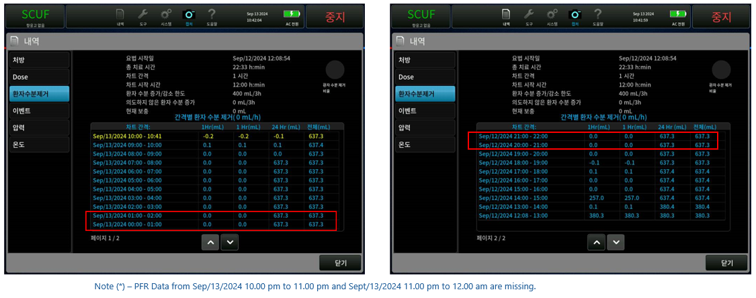

Figure 50: Current Screen - Korean Language Issue – 2 rows of missing PFR data

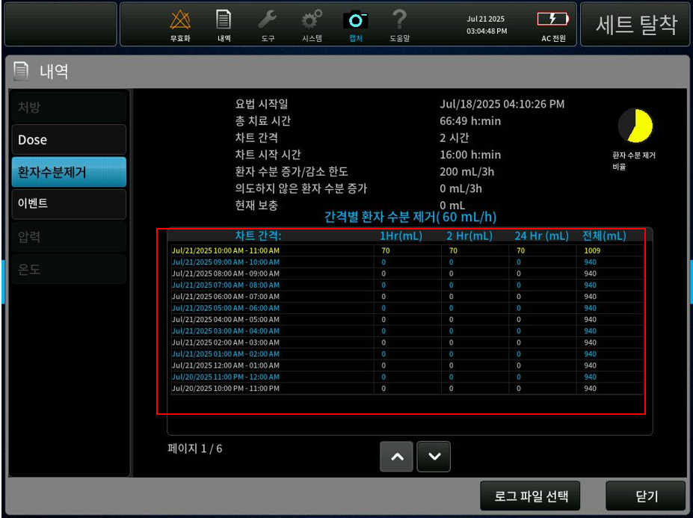

Figure 51: Updated Screen - Korean Language Issue – PFR data Font Updated

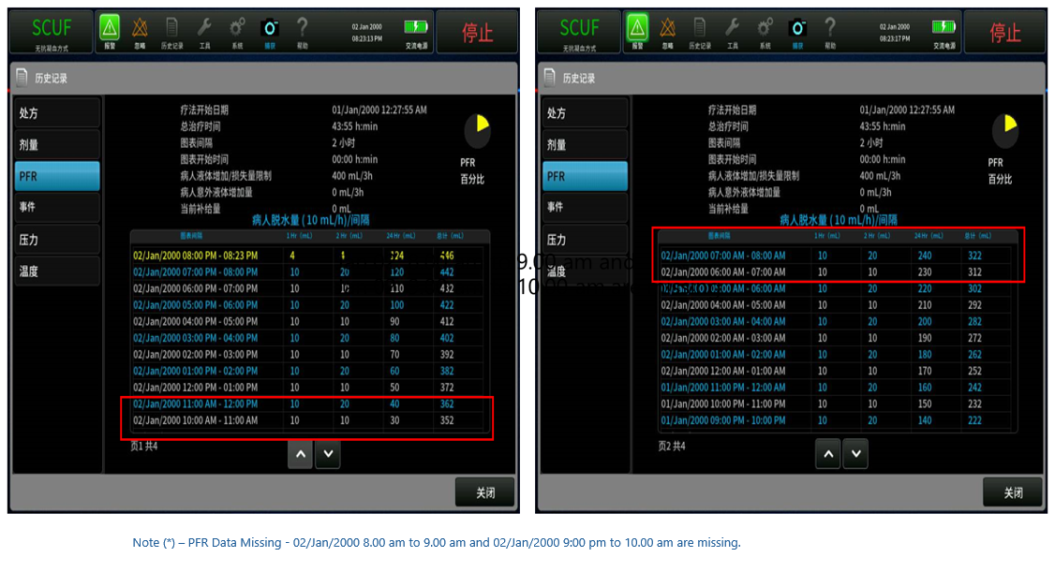

Figure 52: Current Screen - Simplified Chinese Language Issue – 2 rows of missing PFR data

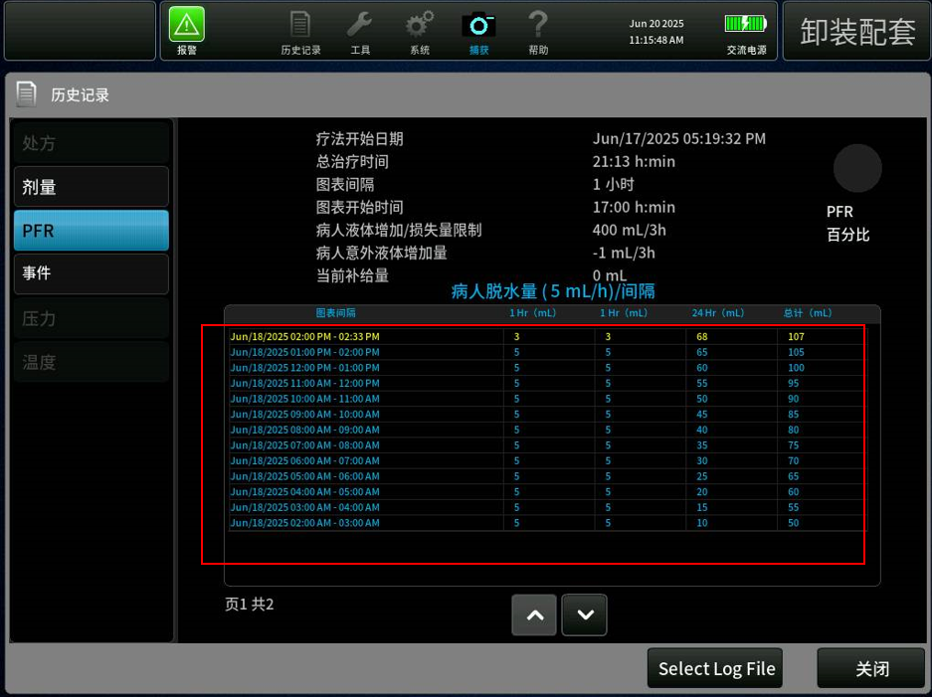

Figure 53: Updated Screen - Simplified Chinese Language Issue – PFR data Font Updated

#### Update the English Master XML for SW 3.7[PFAL-2660]

Resolved text formatting, spelling, and content inconsistencies in the XML file. Updated instructions and removed redundant text for improved clarity and uniformity.

SID referred in this section refers to the string ID of the English Master XML file for SW 3.7.

###### T0822 Flow Problem Alarm - Instruction text color Issue:

SID: 5307 to be updated to display the highlighted instruction in white color.

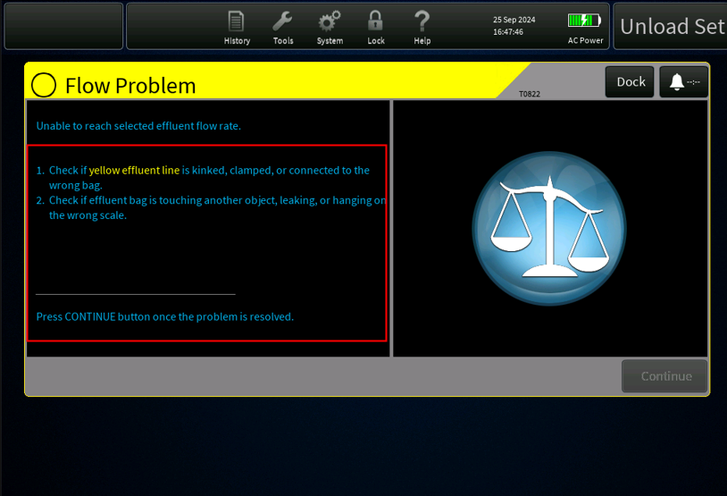

Figure 54: Current Screen - T0822 Flow Problem Alarm - Instruction text color Issue

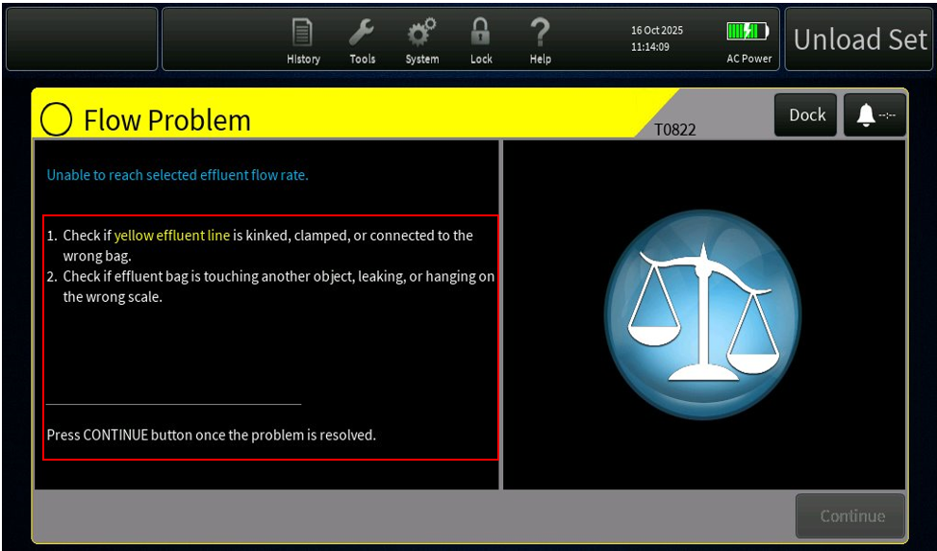

Figure 55: Updated Screen - T0822 Flow Problem Alarm - Instruction text color

###### T1720 PBP Weight Change Alarm - Instruction text color Issue

SID: 7706 to be updated to display the highlighted instruction in white color.

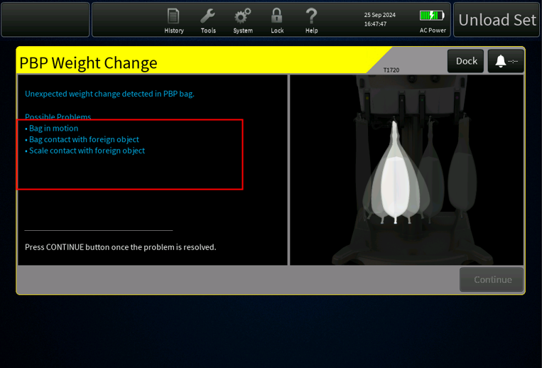

Figure 56: Current Screen - T1720 PBP Weight Change Alarm - Instruction text color Issue

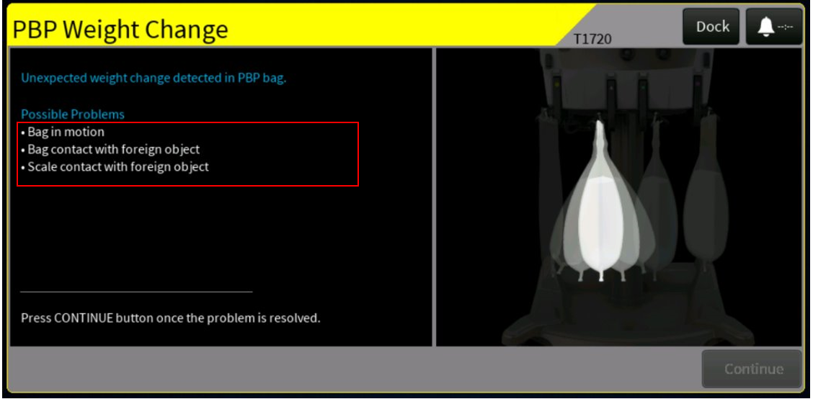

Figure 57: Updated Screen - T1720 PBP Weight Change Alarm - Instruction text color

###### T1719 Dia Weight Increase Alarm - Instruction text color Issue

SID: 7772 to be updated to display the highlighted instruction in white color.

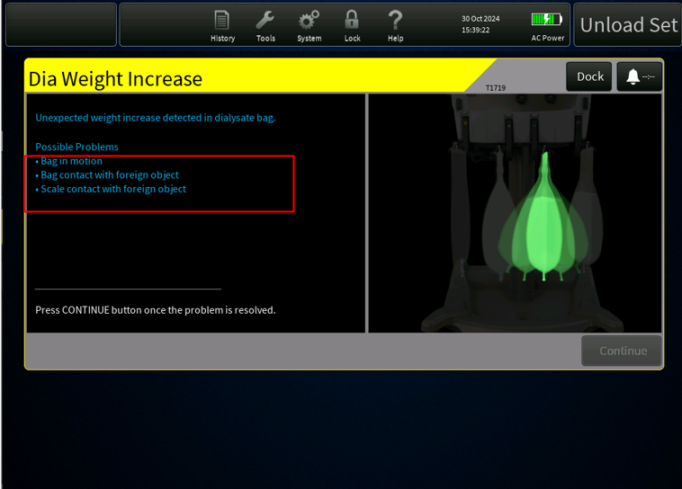

Figure 58: Current Screen - T1719 Dia Weight Increase Alarm - Instruction text color Issue

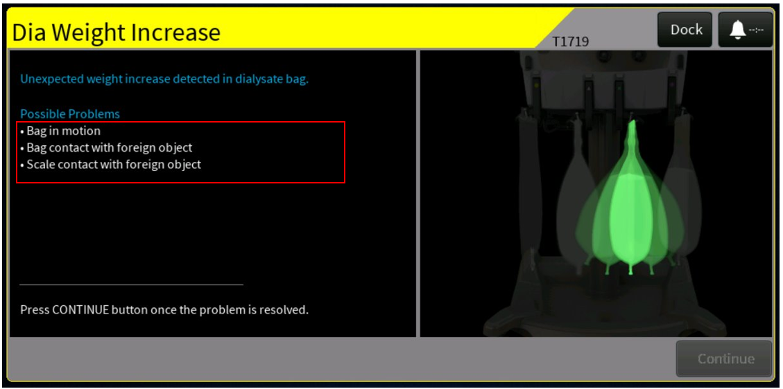

Figure 59: Updated Screen - T1719 Dia Weight Increase Alarm - Instruction text color

###### T1717 Rep Weight Increase Alarm – Discard Set Instruction to be removed

SID: 7753 updated to delete highlighted instruction as DISCARD SET button is unavailable on this alarm window.

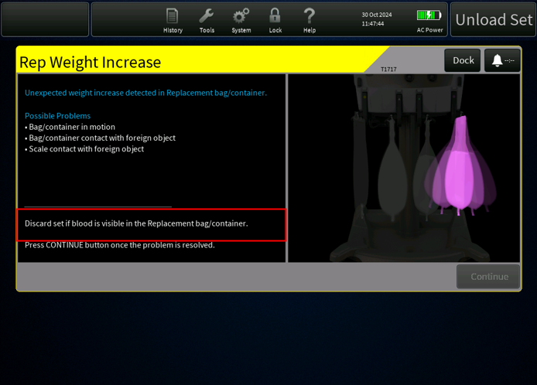

Figure 60: Current Screen - T1717 Rep Weight Increase Alarm – Discard Set Instruction Missing

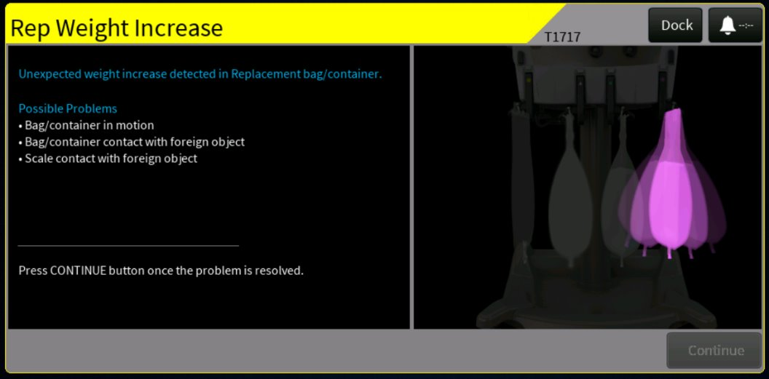

Figure 61: Updated Screen - T1717 Rep Weight Increase Alarm – Discard Set Instruction Removed

###### T1718 Rep2 Weight Increase Alarm – Discard Set Instruction to be removed

SID: 7768 to be updated to delete highlighted instruction as DISCARD SET button is unavailable on this alarm window.

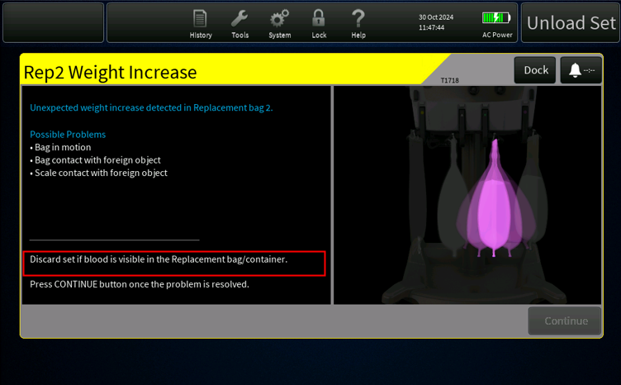

Figure 62: Current Screen - T1718 Rep2 Weight Increase Alarm – Discard Set Instruction Missing

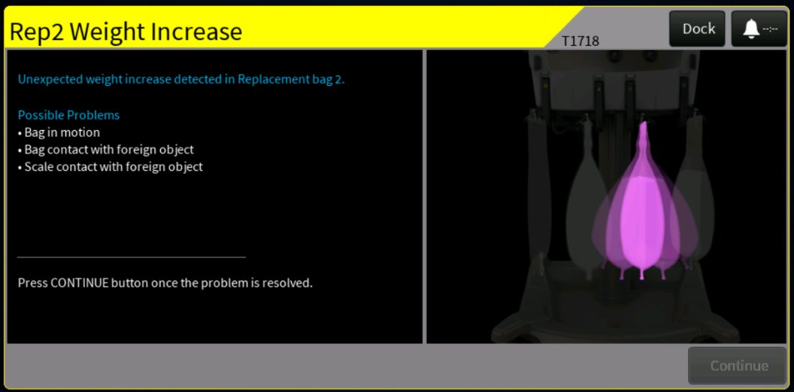

Figure 63: Updated Screen - T1718 Rep2 Weight Increase Alarm – Discard Set Instruction Removed

###### Translation Limit Code Dialog - PfHCT text to be Updated

SID: 81123 to be updated to replace PBP with PfHCT text.

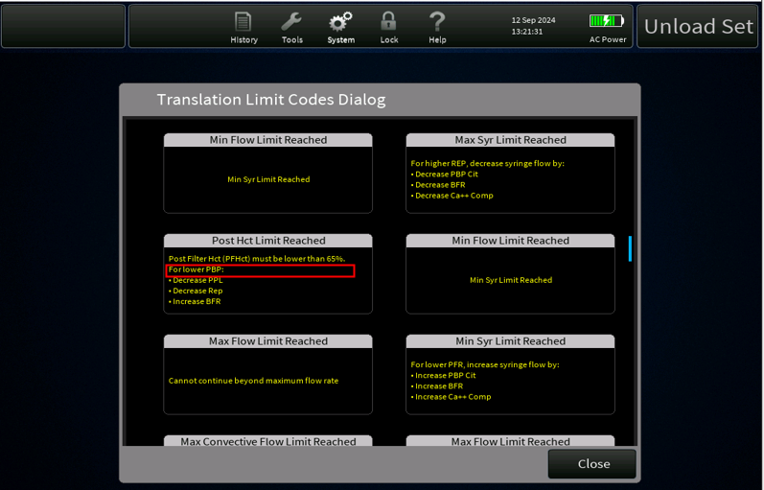

Figure 64: Current Screen - Translation Limit Code Dialog - PfHCT text to be Updated

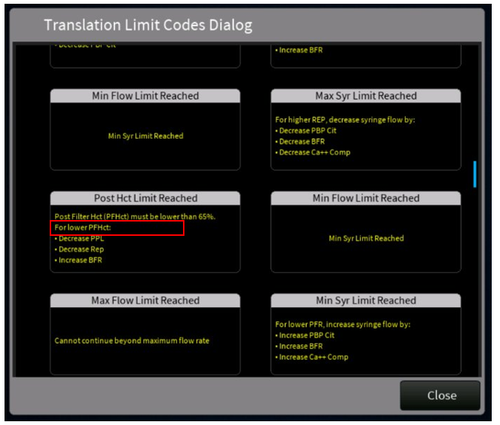

Figure 65: Updated Screen - Translation Limit Code Dialog - PfHCT text Updated

###### T1144 Priming Pause Time Exceeded Alarm – Instructions Missing

SID: 7493 to be updated to add instructions for Reprime and Flush buttons as there are no instructions to guide the user.

.

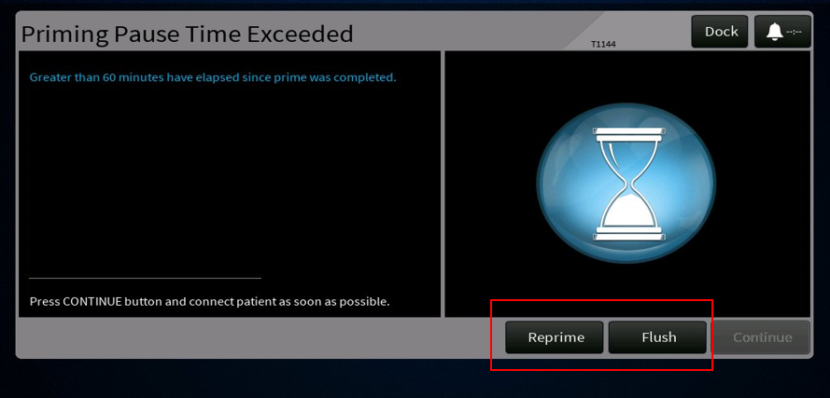

Figure 66: Current Screen - T1144 Priming Pause Time Exceeded Alarm – Instructions Missing

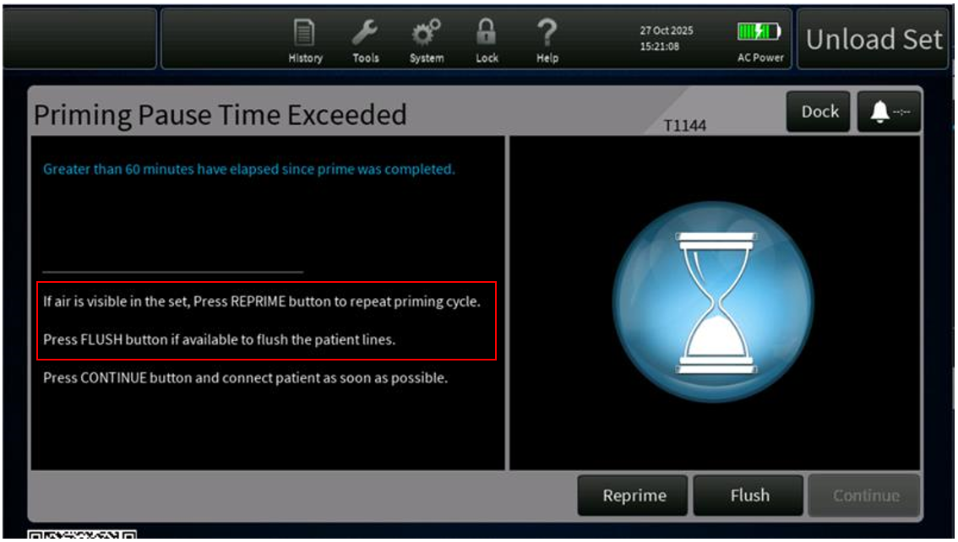

Figure 67: Updated Screen - T1144 Priming Pause Time Exceeded Alarm – Instructions Added

###### T0610 PBP Line Attached to Rep Bag/Container - Spell Issue

SIDs - 3403 and 4494 to be updated to correct the spelling issue in both Alarm Display and Message Display Names.

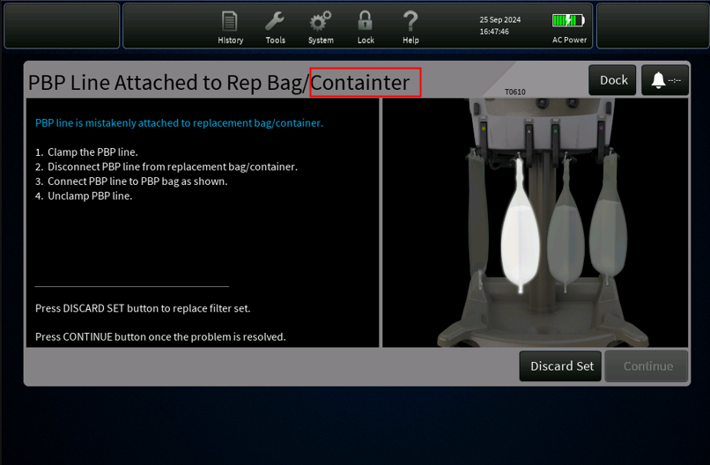

Figure 68: Current Screen - T0610 PBP Line Attached to Rep Bag/Container - Spell Issue

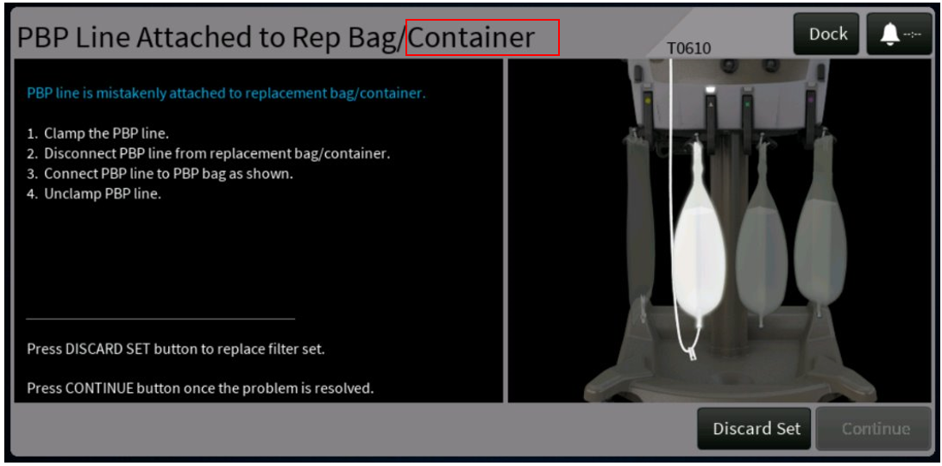

Figure 69: Updated Screen - T0610 PBP Line Attached to Rep Bag/Container Text Updated

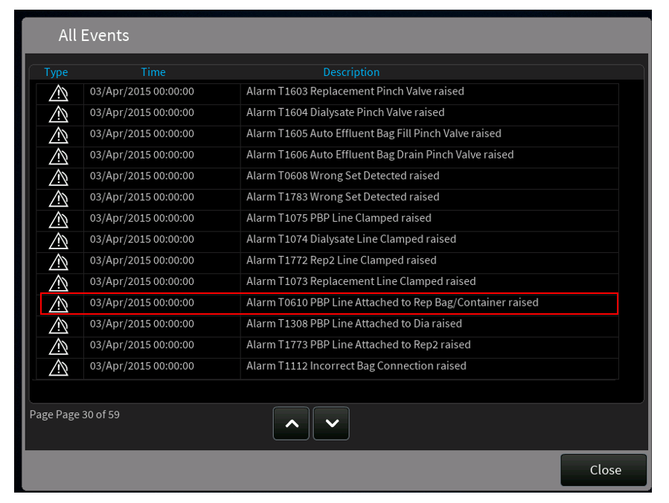

Figure 70: T0610 PBP Line Attached to Rep Bag/Container Alarm Message Display Text Updated

###### T2329 PBP Hardware Failure Alarm - Redundant text Issue

SIDs - 80516, 80522, 80510 to be updated to remove redundant text from Alarm Display Name, Alarm Instructions and Message Display Names.

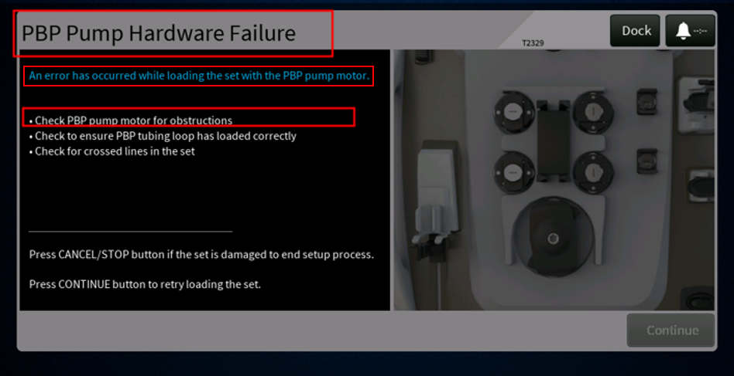

Figure 71: Current Screen - T2329 PBP Hardware Failure Alarm - Redundant text Issue

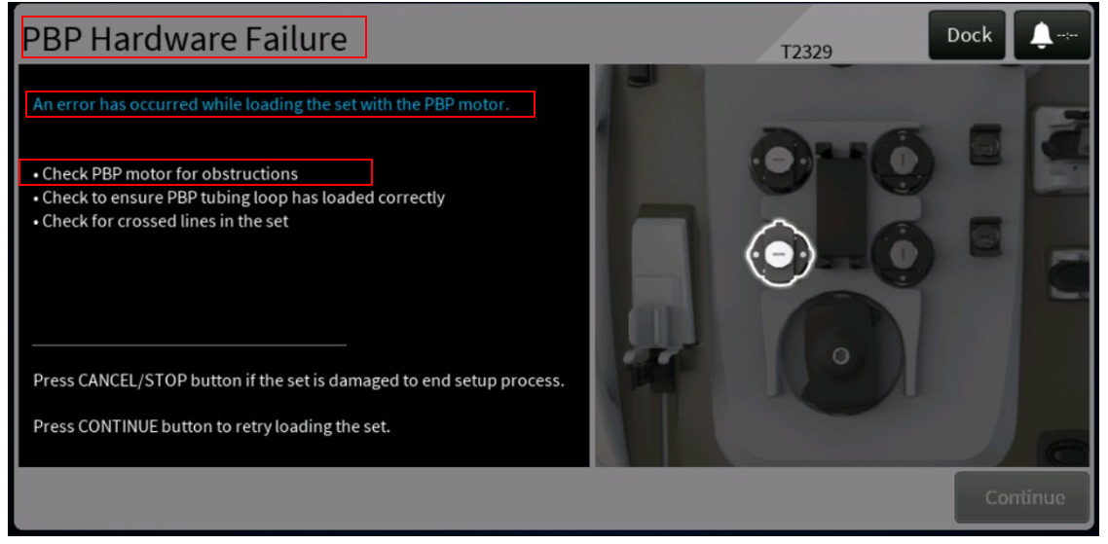

Figure 72: Updated Screen - T2329 PBP Hardware Failure Alarm - Redundant text Removed

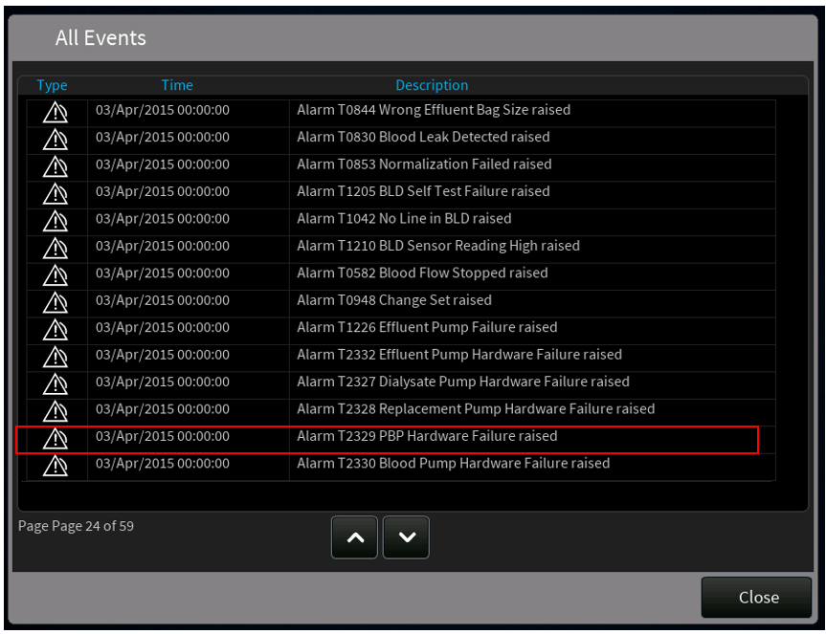

Figure 73: T2329 PBP Hardware Failure Alarm Message Display Name Updated

###### Confirm Patient Connections – Instruction text color code Mismatch

SID 5038 to be updated with the correct color codes for the highlighted text.

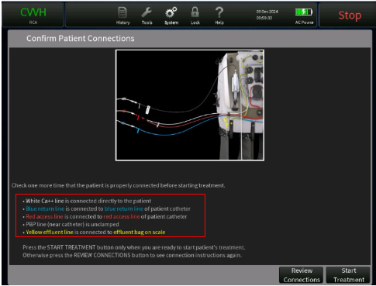

Figure 74: Current Screen - Confirm Patient Connections – Instruction text color code Mismatch

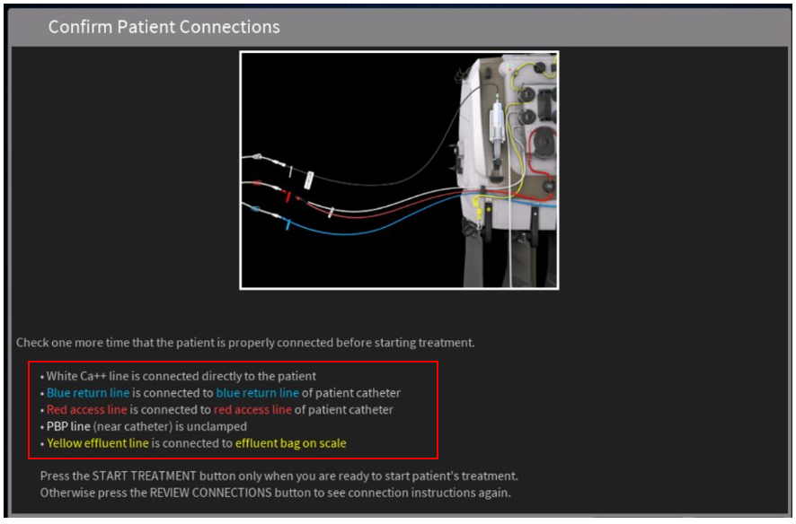

Figure 75: Updated Screen - Confirm Patient Connections – Instruction text color code Updated

###### Prepare Prime - Instructions Unclear

SID: 3302 to be updated as per the highlighted text in the screens below –

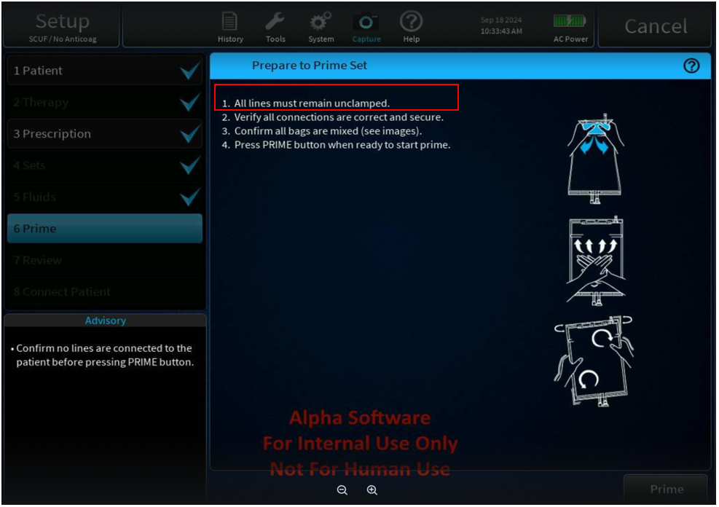

Figure 76: Current Screen - Prepare Prime - Instructions Unclear

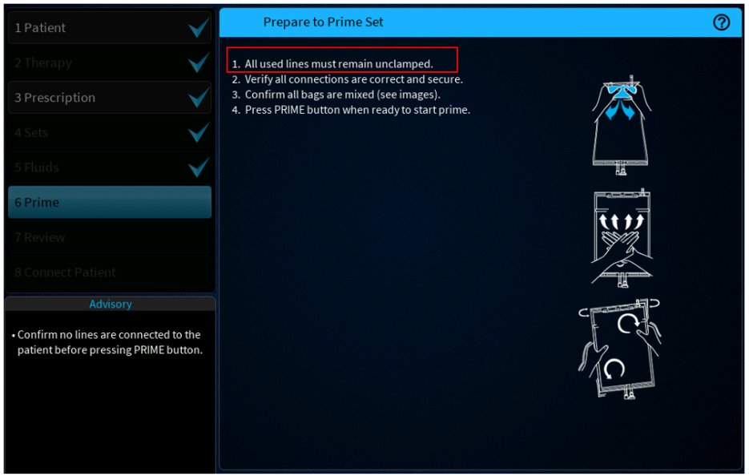

Figure 77: Updated Screen - Prepare Prime - Instructions Updated

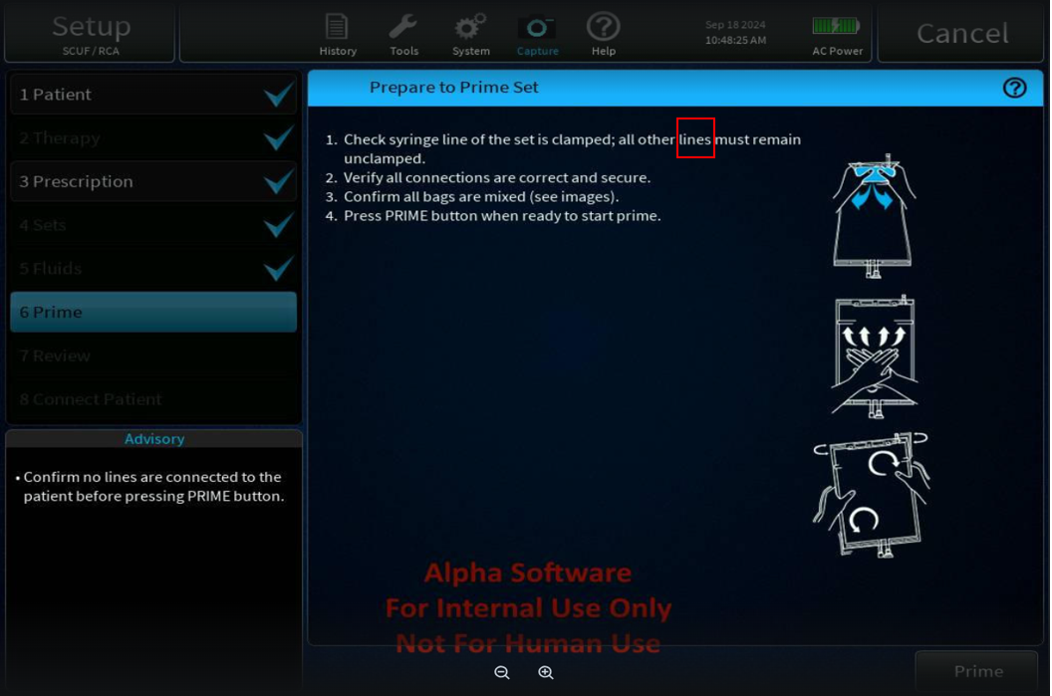

Figure 78: Current Screen - Prepare Prime - CitCal - Instruction Unclear

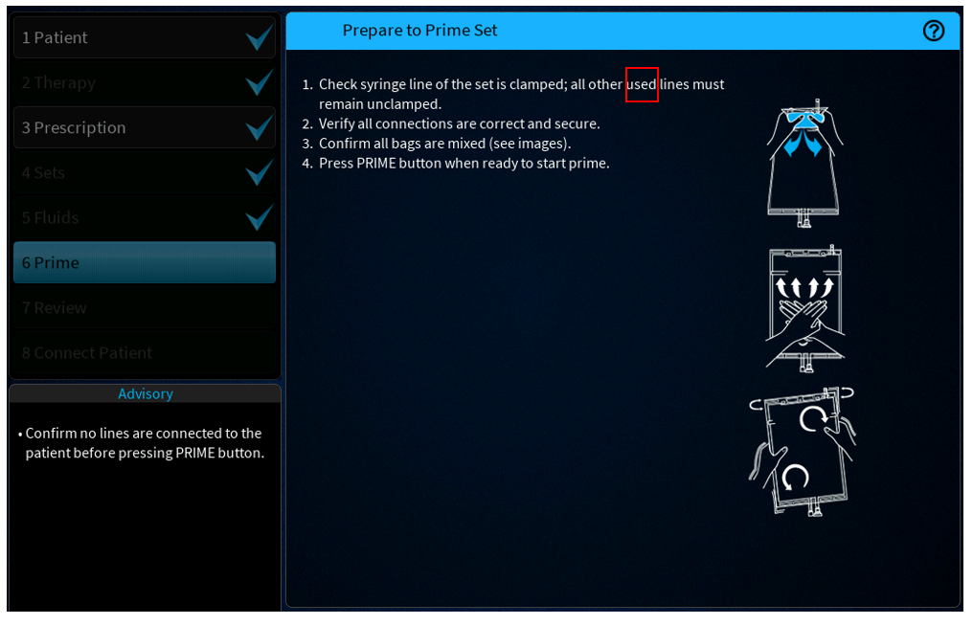

Figure 79: Updated Screen - Prepare Prime - CitCal - Instruction Updated

###### **Help Screen – Remove Air Needle gauge size update**

SID – 5035 to be updated to correct the needle size from 20-guage to 21-guage​.

The recommended needle size for air removal is 20 gauge where the correct value for air removal to align with Operator's manual correction should be 21 gauge for removing from sample site of the disposable.

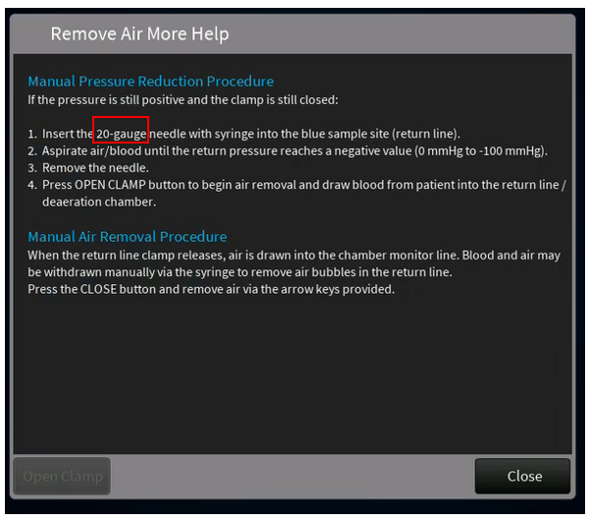

Figure 80: Current Screen - Remove Air Help Screen

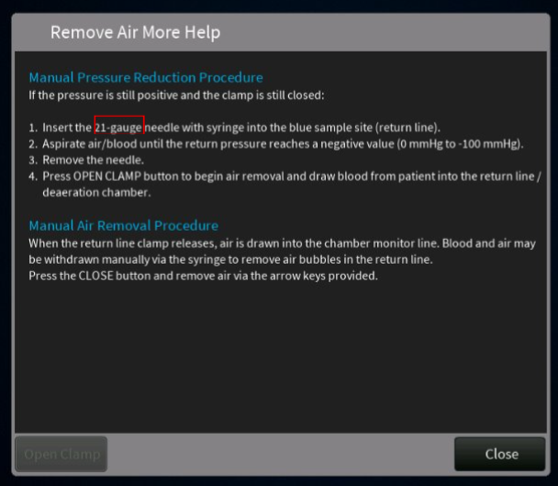

Figure 81:Updated Screen - Remove Air Help Screen

###### **T1277 Return Barrier May Be Wet Alarm – Instruction Update**

SID: 3958 to be updated to add the highlighted instruction for Open Clamp button as there are no instructions to guide the user.

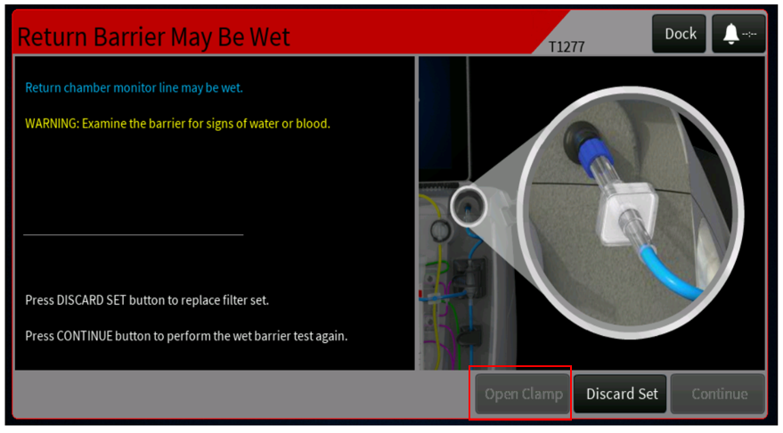

Figure 82: T1277 - Open Clamp Instruction Missing

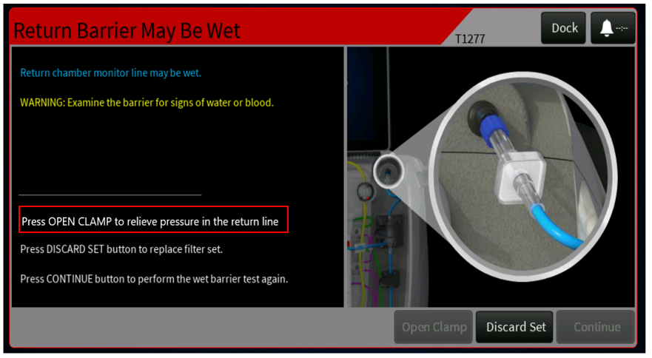

Figure 83: T1277 - Open Clamp Instruction Added

###### **Alarm Message Names Mismatch Issue:**

The alarm "message name" used in the event history window and the "more alarms" window does not always match the title displayed on the alarm window for below listed alarms:

Table 2 - Alarm Events List

| **S.NO** | **Alarm ID** | **Alarm Display Name on Alarm screen** | **Message Display Name on Events screen** |
| --- | --- | --- | --- |
| 1 | T2291 | Return Blood Temperature Low | Blood Return Temperature Unattainable |
| 2 | T2255 | PrisMax - TherMax Communication Lost | TherMax Communication Lost |
| 3 | T2307 | TherMax Cover Open | TherMax Side Lock Open |
| 4 | T2285 | TherMax Disposable Leak | TherMax Blood Leak |
| 5 | T2296 | TherMax Disposable Not Locked | TherMax Disposable Unlocked |
| 6 | T2284 | TherMax Disposable Not Inserted | TherMax Disposable Not Installed |
| 7 | T2275 | Thermax Cover Open | TherMax Open |

The string IDs (SID): 72165, 72100, 72082, 72177, 72111,72061, 72067 to be updated to match the ‘Message Display Name’ as per the ‘Alarm Display Name’ mentioned in Table 2 - Alarm Events List.

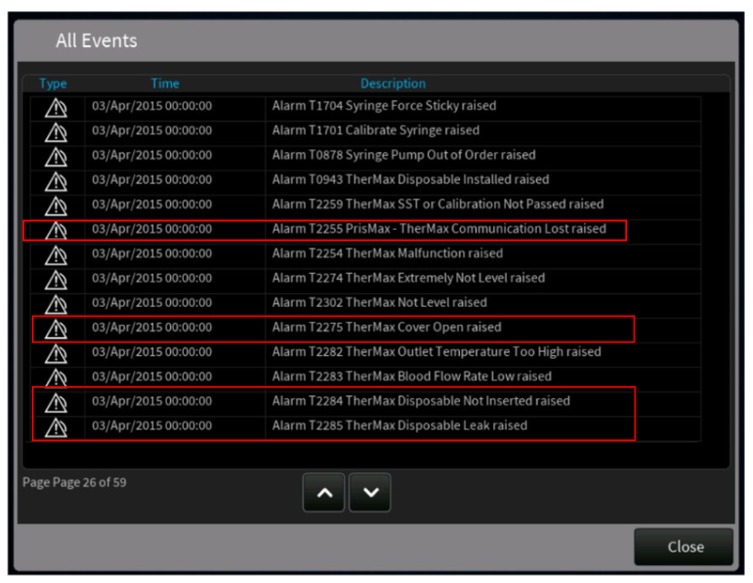

Figure 84: Updated Screen - T2255, T2275 T2284 and T2285 - Alarm Message Names Updated

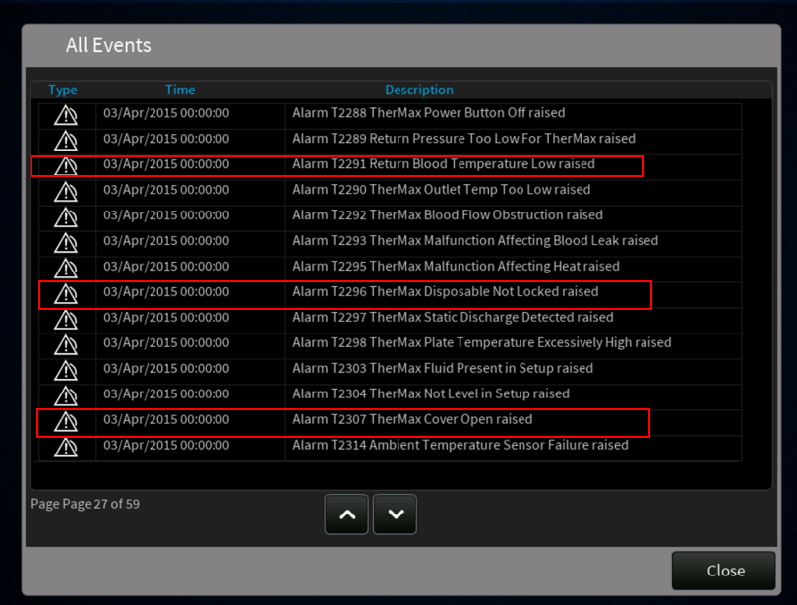

Figure 85: Updated Screen - T2291 T2296 and T2307 - Alarm Message Names Updated

###### Connect and Hang Bags Screen Instruction updates

SID: 3206 to be updated to move the highlighted instruction from point #1 to point #3.

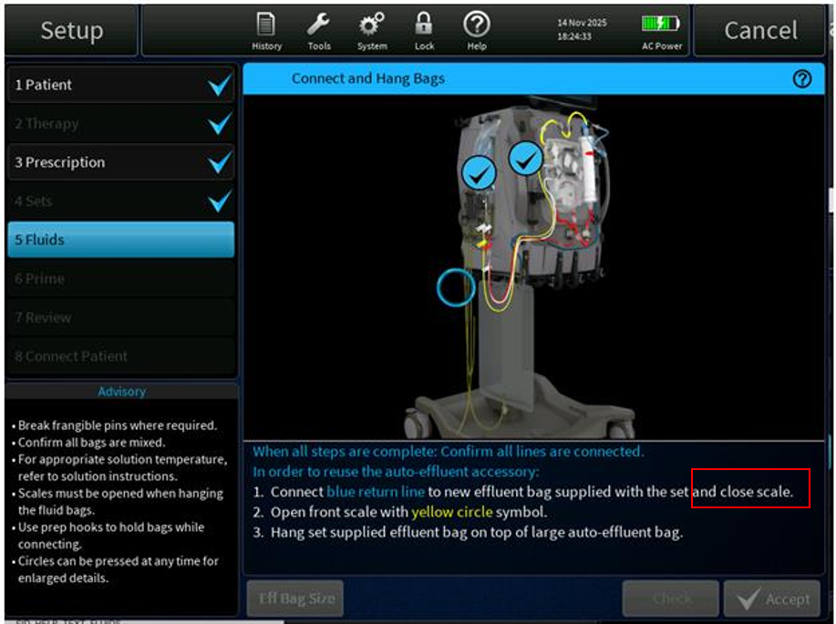

Figure 86: Current Screen - Connect and Hang Bags - Instruction update

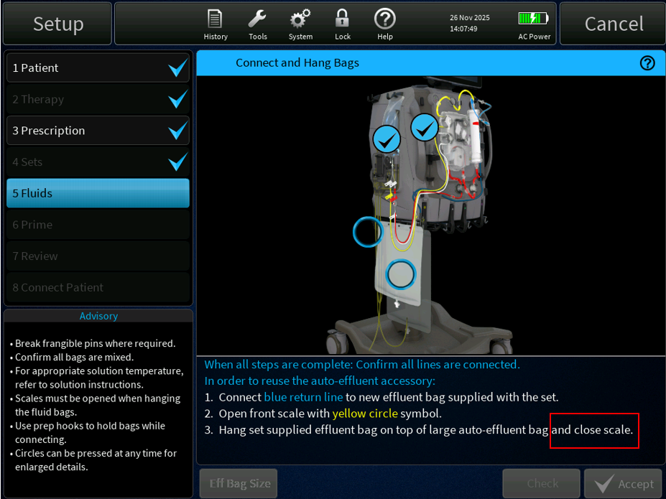

Figure 87: Updated Screen - Connect and Hang Bags - Instruction update

###### T0593 Bolus Interrupted Alarm - Instruction update

SID: 3977 to be updated to change the highlighted text from “Change Screen” to “Operation Screen”.

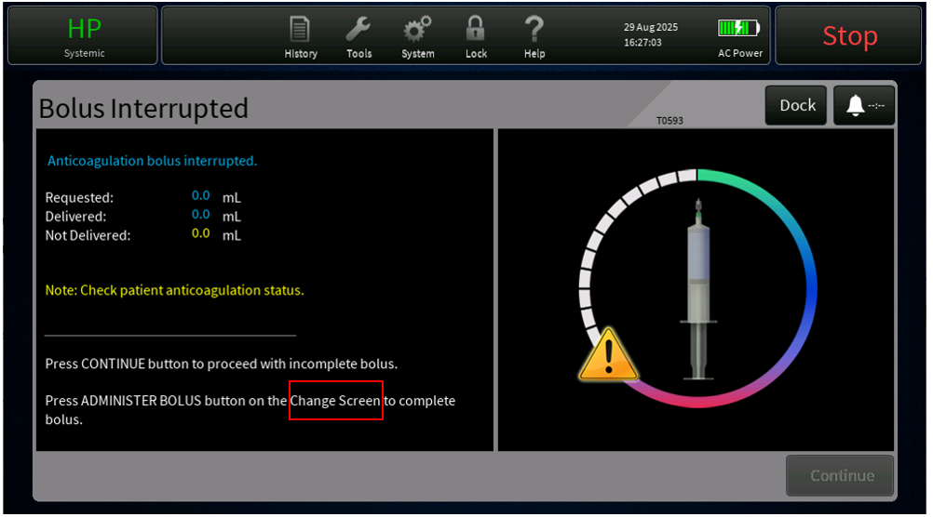

Figure 88: Current Screen – T0593 Bolus Interrupted Alarm - Instruction Update

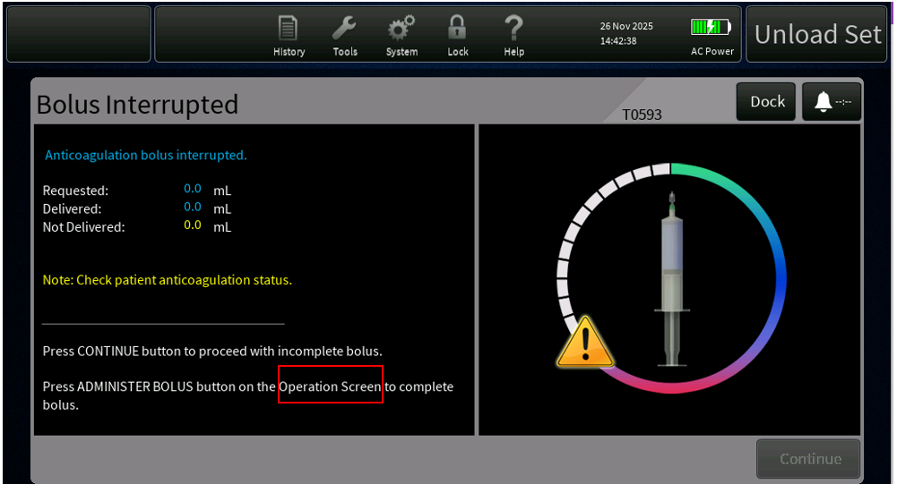

Figure 89: Updated Screen - T0593 Bolus Interrupted Alarm - Instruction Update

#### Update the Translation XML for SW 3.7[PFAL-2662]

**Issue description: Cropped Dose Value Displayed in Korean and Simplified Chinese Languages**

In the Operation screen, the Effluent Dose value gets cropped when displayed in Korean and Simplified Chinese languages while displaying a three-digit number. To address this issue the code will be modified to ensure the complete effluent dose value is fully visible.

​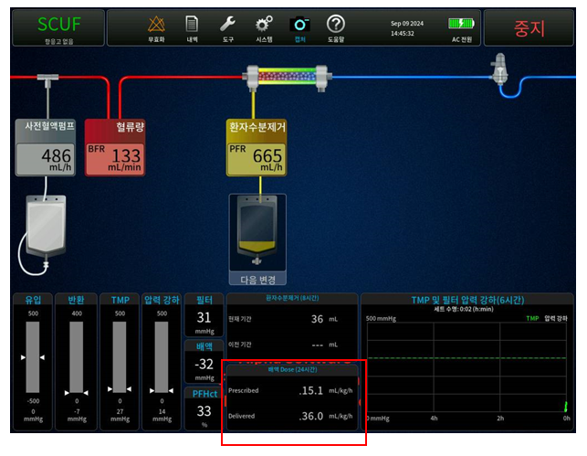

Figure 90: Current Screen - Korean language - Operation Screen Dose Value Cropped

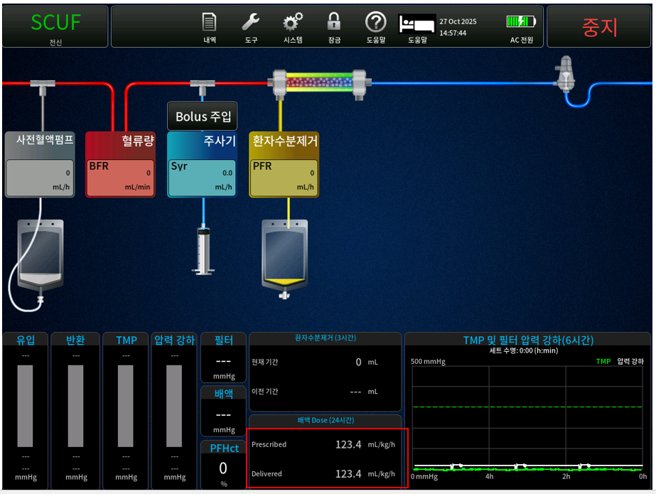

Figure 91: Updated Screen - Korean language - Operation Screen Dose Value Cropped

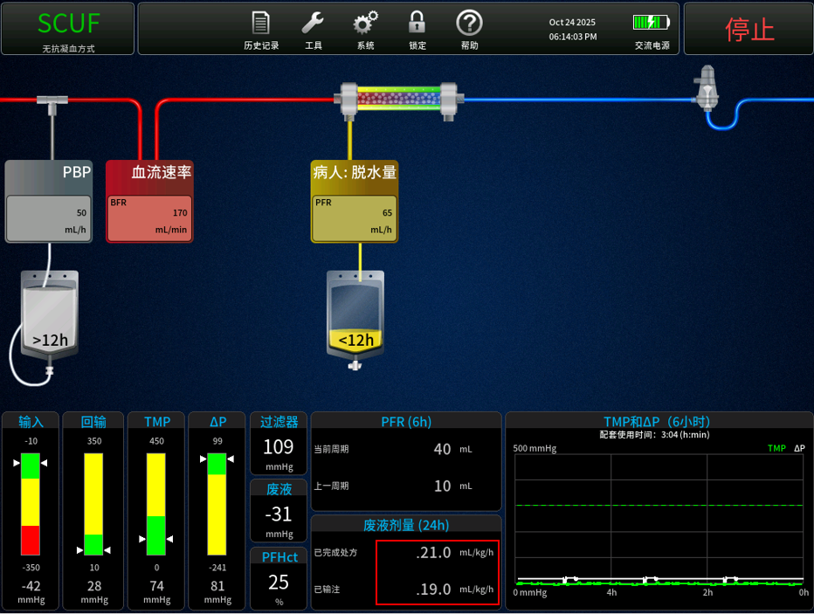

Figure 92:Current Screen - Simplified Chinese - Operation Screen Dose Value Cropped

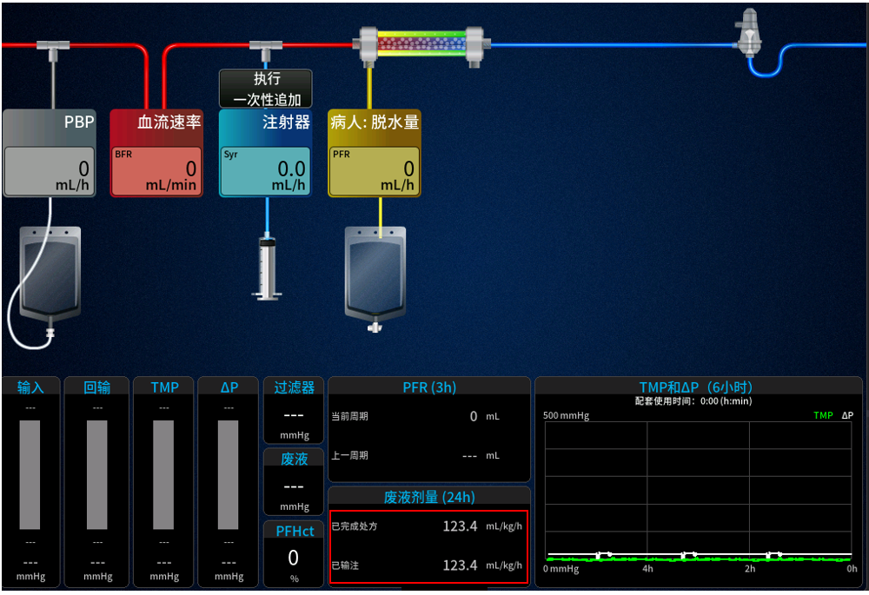

Figure 93: Updated Screen - Simplified Chinese - Operation Screen Dose Value Fixed

#### Error in reported PFR when disturbances occur on scales with flow of 0ml/hr [PFAL-2465]

Log file analysis indicated that disturbances on unused scales (Bags hanging on the scale but flow rate set to 0ml/hr) are affecting the calculated PFR value as well as the reported error for that scale, thus leading to the reported PFR for the chart periods as well as the calculation of unintended PFR being affected.

When running a treatment that has flow rates set to 0 ml/hr, the system can include inadvertent disturbance (like tube slippage causing a bag to move) in the PFR calculation that is not possible because the pumps are not running. This can lead to an error in the reported PFR, possibly leading to the operators making treatment decisions on incorrect data. Furthermore, if the variance on the "unused" scale is large enough, it could lead to a gain/loss limit alarm processing not functioning correctly (either being raised incorrectly or not raising when it should).

The fix will include updating the fluid pump controller to ignore disturbances on scales with zero flow rate when calculating the PFR. Note, the scales will still be monitored for flow errors, to account for potential leaking or non-occlusive pumps.

#### Correct the guidance in GUI/operators manual for filter clotting alarms (PFAL- 2488)

The guidance (on the GUI/in the operator’s manual) provided to the operator when a filter clotting or fouling alarm occurs, is incorrect, or inconsistent:

* Between the onscreen instructions and the operator’s manual.
* Some alarm titles and troubleshooting instructions are too technical or not clear enough, therefore becoming confusing to the user.

The alarms associated with filter clotting alarms face an issue with the way they are resolved if the onscreen/Operator Manual instructions are followed. Fixing the alarm titles and/or troubleshooting instructions, will cause a Labeling impact as the GUI/ Operator Manual needs to be updated accordingly. Along with the string changes to the troubleshooting instructions, the XML is to be updated for TITLE and MSG strings.

The following pressure alarms have been identified to improve the wording or pictures of the information in the alarm window. No changes to the alarm limits or thresholds are being made.

| **No.** | **Alarm ID** | **Alarm Name** | **Precondition &Trigger condition** | **Clearing Condition** |
| --- | --- | --- | --- | --- |
| 1 | T0782   Medium Priority | TMP pressure Excessive | Alarm shall be generated when the TMP > Maximum TMP Limit for the filter set for 5 seconds.  For filter sets M60, ST60, M100, ST100, M150, ST150, or Oxiris; the Maximum TMP Limit is 450 mmHg.  For filter sets HF20, HF1000, or HF1400; the Maximum TMP Limit is 500 mmHg." | "The CONTINUE button shall be enabled when the TMP < Maximum TMP Limit for the filter set for 2.0 seconds.  The Alarm shall be cleared when the CONTINUE button is pressed.". |
| 2 | T0786  Medium Priority | Membrane Pressure Rising | In CRRT, alarm shall be declared if either of the following conditions are true for more than 5 seconds:   * the change in the filter pressure drop is greater than the maximum value defined for the set; * the change in the TMP is greater than the maximum value defined for the set." Return pressure OP is >= 10 mmHg OR < 15 mmHg. | Alarm shall be cleared if the change in the filter pressure drop is less than the maximum value defined for the set for more than 2 seconds, and the change in the TMP is less than the maximum value defined for the set.  Alarm shall be cleared if the Filter Clotting Override is active. | |
| 3 | T0938  Medium Priority | Membrane Pressure Excessive | In CRRT, alarm shall be declared if any of the following conditions is true for more than 5 seconds:  Filter pressure drop is greater than the maximum value defined for the set;  Both of the following conditions are true:  TMP is greater than the maximum value defined for the set;  Change in the TMP is greater than the maximum value defined for the set or the change in the filter pressure drop is greater than the maximum value defined for the set. | The CONTINUE button is enabled when all of the following conditions are true:   * Filter pressure drop is less than the maximum value defined for the set for 2 seconds; * TMP is less than the maximum value defined for the set; * Change in the TMP is less than the maximum value defined for the set for 2 seconds; * Change in the filter pressure drop is less than the maximum value defined for the set for 2 seconds.   The Alarm shall be cleared when the CONTINUE button is pressed. |
| 4 | T2308  Info Priority | TMPa Pressure Rising | Alarm is declared if the TMPa > 100 mmHg for 5.0 seconds | Continue is immediately enabled. |
| 5 | T0783  Medium Priority | TMPa Pressure Excessive | Alarm shall be declared if the TMPa value is greater than  • 0.50 x "Max TMPa Limit" during the TPE startup phase  • "Max TMPa Limit" after the TPE startup phase  for more than 5 seconds, where the TPE startup phase is defined as the time interval from the start of treatment and with the duration of:  TPEStartupDuration = Filter Volume / Blood flow rate + 8 minutes  - For TPE1000: "Max TMPa Limit" = -0.001346 * Qb² + 1.002 * Qb + 53.3 [mmHg]  - For TPE2000: "Max TMPa Limit" = -0.000450 * Qb² + 0.645 * Qb + 60.0 [mmHg]  where Qb is in ml/min. | The CONTINUE button shall be enabled when:  During the TPE startup phase, TMP < 0.5 * Max TMPa Limit for the filter set for 2.0 seconds.  After the TPE startup phase, TMP < Max TMPa Limit for the filter set for 2.0 seconds.  The Alarm shall be cleared when the CONTINUE button is pressed. |
| 6 | T0787  Low Priority | Membrane Pressure Rising | In TPE, alarm shall be declared if the change in the filter pressure drop is greater than the maximum value defined for the set for more than 5 seconds. | Alarm shall be cleared if the change in the filter pressure drop is less than the maximum value defined for the set for more than 2 seconds.  Alarm shall be cleared if the Filter Clotting Override is active. |
| 7 | T0779  Medium Priority | Membrane Pressure Excessive | In TPE, alarm shall be declared if any of the following conditions is true for more than 5 seconds:  Filter pressure drop is greater than the maximum value defined for the set;  Both of the following conditions are true:   * TMPa is greater than the maximum value defined for the set; * Change in the TMPa is greater than the maximum value defined for the set or the change in the filter pressure drop is greater than the maximum value defined for the set. | The continue action is enabled when all of the following conditions are true:   * Filter pressure drop is less than the maximum value defined for the set for 2 seconds; * TMPa is less than the maximum value defined for the set; * Change in the TMPa is less than the maximum value defined for the set for 2 seconds; * Change in the filter pressure drop is less than the maximum value defined for the set for 2 seconds. |
| 8 | T0780 | Membrane Pressure Excessive | In HP, alarm shall be declared if filter pressure drop is greater than the maximum value defined for the set for more than 5 seconds.  In HP alarm shall be declared when the filter pressure is greater than the filter-specific Filter Clotted Alarm Limit for more than 5 seconds | The continue action is enabled when the filter pressure drop is less than the maximum value defined for the set for more than 2 seconds. | |
| 9 | T0788 | Membrane Pressure Rising | In HP, alarm shall be declared if the change in the filter pressure drop is greater than the maximum value defined for the set for more than 5 seconds. | Alarm shall be cleared if the change in the filter pressure drop is less than the maximum value defined for the set for more than 2 seconds.  Alarm shall be cleared if the Filter Clotting Override is active. | |

**CRRT**

**T0782 – TMP Pressure Excessive alarm**

**Current:**

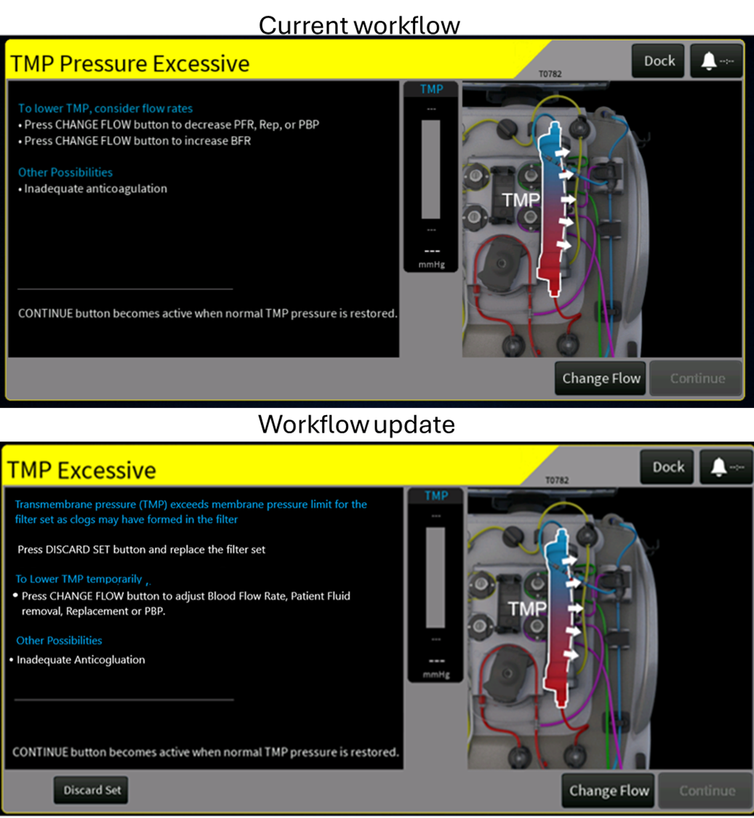

Figure 90: Existing alarm screen for T0782 – TMP Pressure Excessive alarm

**Proposed:**

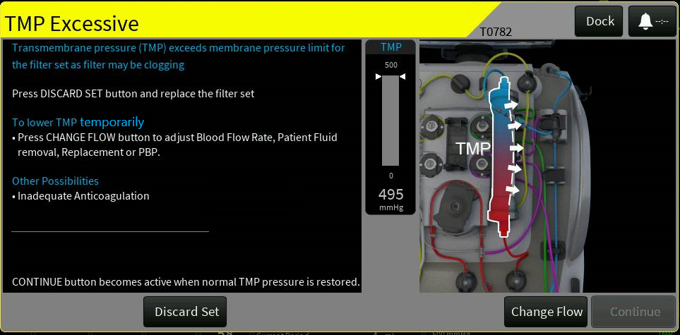

Figure 91: Proposed alarm screen for T0782 – TMP Excessive Alarm

The following updates are made to the Alarm screen (Refer to attached screenshot):

* Updated the alarm title to remove redundant “Pressure” term
* Added text to alarm body “Transmembrane pressure (TMP) exceeds membrane pressure limit for the filter set as filter may be clogging”.
* Added temporary steps which can be taken to lower TMP.
* Rephrased the solution and added the abbreviations to align with button names on the therapy screen and updated the ‘Other Possibilities’ section to include the most common possibility.
* Added ‘Discard Set’ Button on the alarm screen

**T0938 – Membrane Pressure Excess alarm**

**Current:**

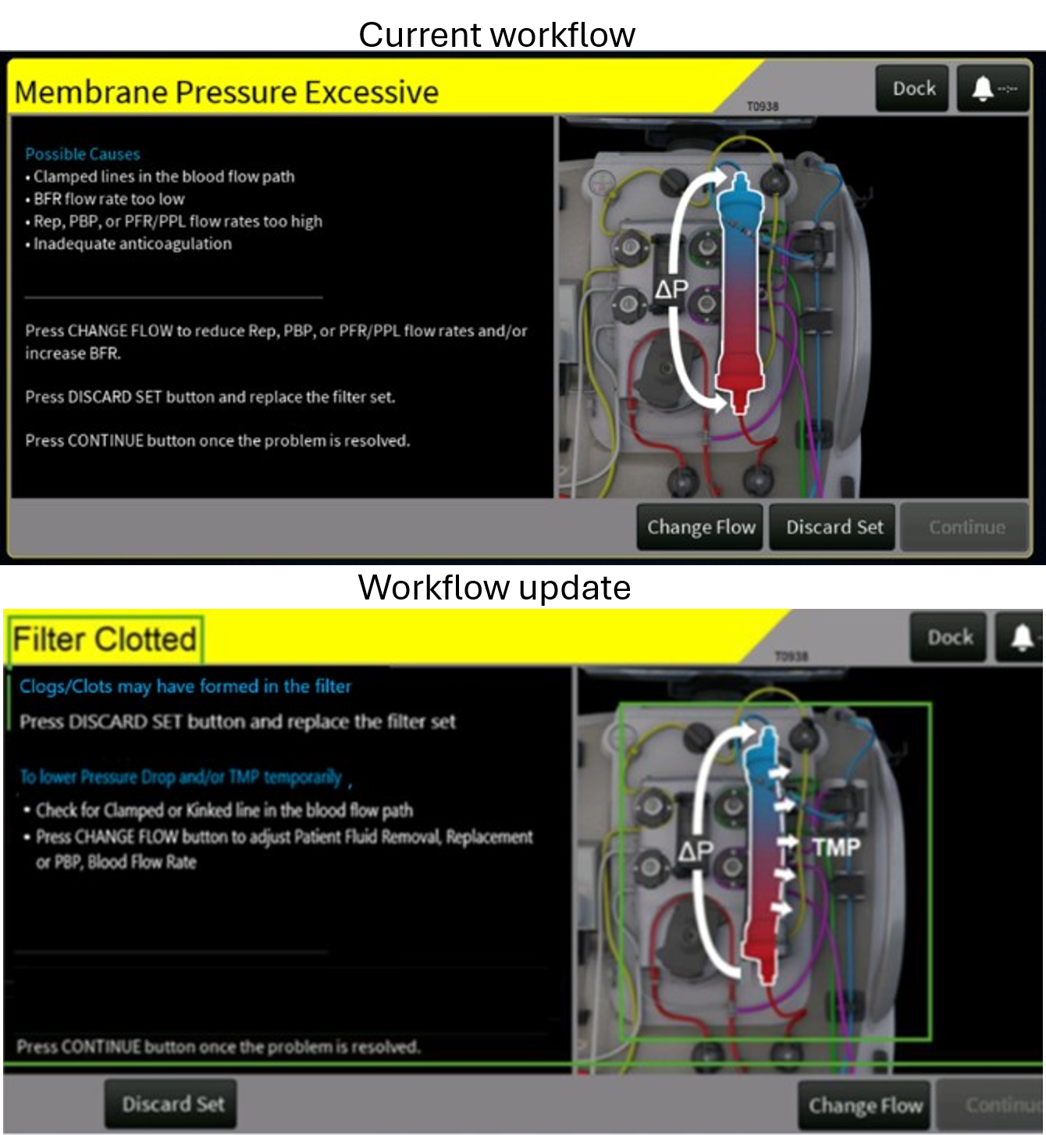

Figure 92: Existing alarm screen for T0938 – Membrane Pressure Excess alarm

**Proposed:**

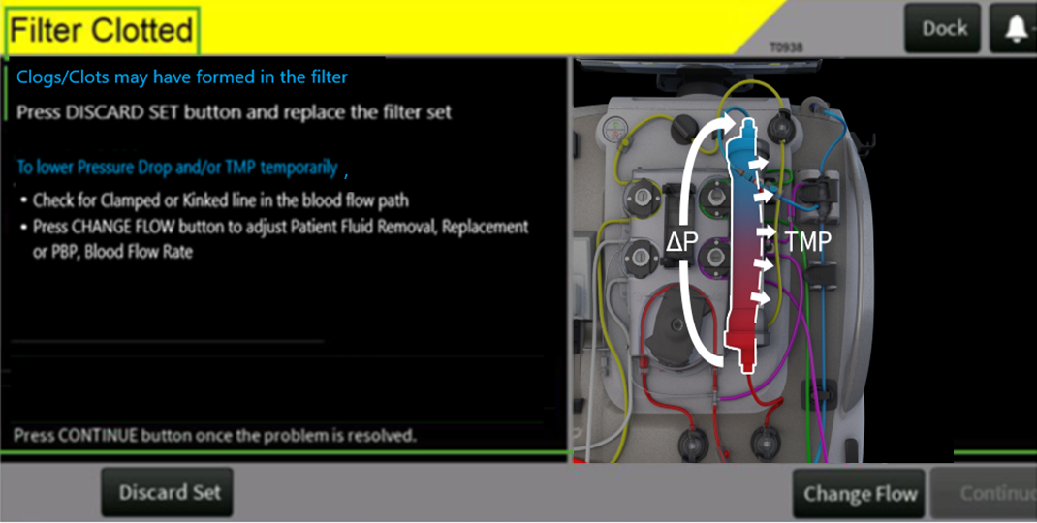

Figure 93: Proposed alarm screen for T0938 – Filter Clotted

The following updates are made to the Alarm screen (Refer to attached screenshot):

* Updated the alarm title to match the PrismaFlex title which explains the alarm better and renamed the title to “Filter Clotted” from “Membrane Pressure Excessive”.
* Added details for the triggering conditions for the alarm
* Added the abbreviations to align with button names on the therapy screen
* Rephrased the ‘Possible Causes to Lower Pressure Drop and/or TMP temporarily’ and added corresponding recommendations. Anticoagulation will be left in the operator’s manual.
* Re-arranged the ‘Discard Set’ and ‘Change Flow’ buttons so that order in which the buttons are called out in the instructions match
* The illustration is updated to remove the bidirectional arrow of ‘ΔP’ to unidirectional arrow of ‘ΔP’ in an upward direction and add the effect of ‘TMP’ along with ‘ΔP’.
* Removed “PPL” from list of Change Flow values, as this alarm is applicable in CRRT only.

**T0786 – Membrane Pressure Rising alarm**

**Current:**

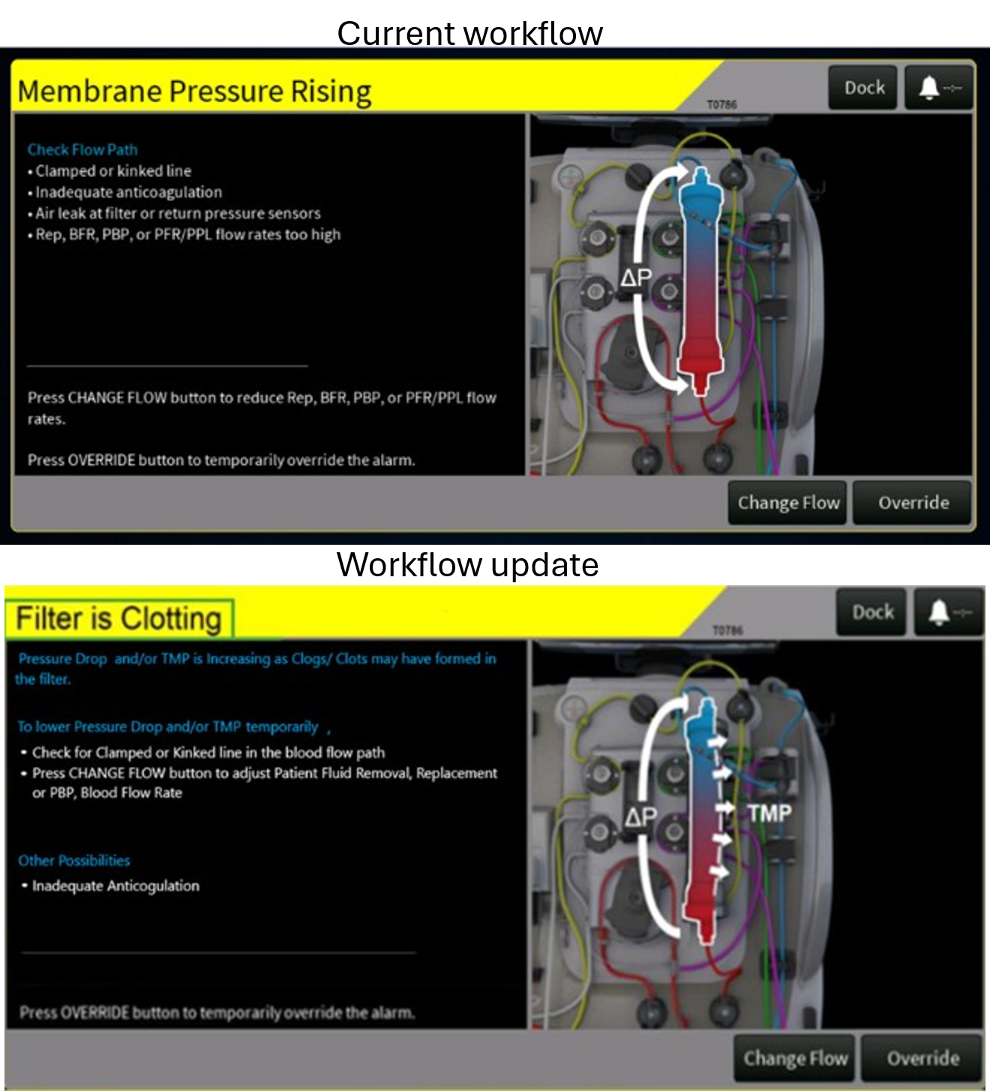

Figure 94: Existing Alarm Screen for T0786 – Membrane Pressure Rising Alarm

**Proposed:**

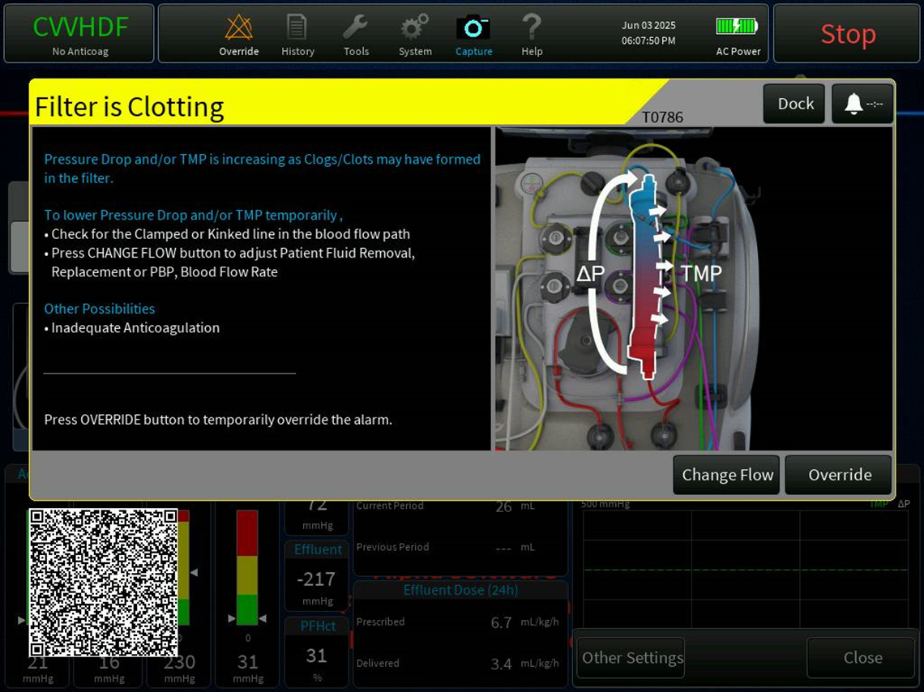

Figure 95: Proposed alarm screen for T0786 – Filter is Clotting Alarm

The following updates are made to the Alarm screen (Refer to attached screenshot):

* Updated the alarm title to match the PrismaFlex title which explains the alarm better
* Added details for the triggering conditions for the alarm.
* Added the abbreviations to align with button names on the therapy screen.
* Added temporary steps which can be taken to lower Pressure drop and/or TMP. Anticoagulation will be left in the operator’s manual.’

The illustration is updated to remove the bidirectional arrow of ‘ΔP’ to unidirectional arrow of ‘ΔP’ in an upward direction and add the effect of ‘TMP’ along with ‘ΔP’.

**T2308 - TMPa Pressure Rising alarm;**

**Current:**

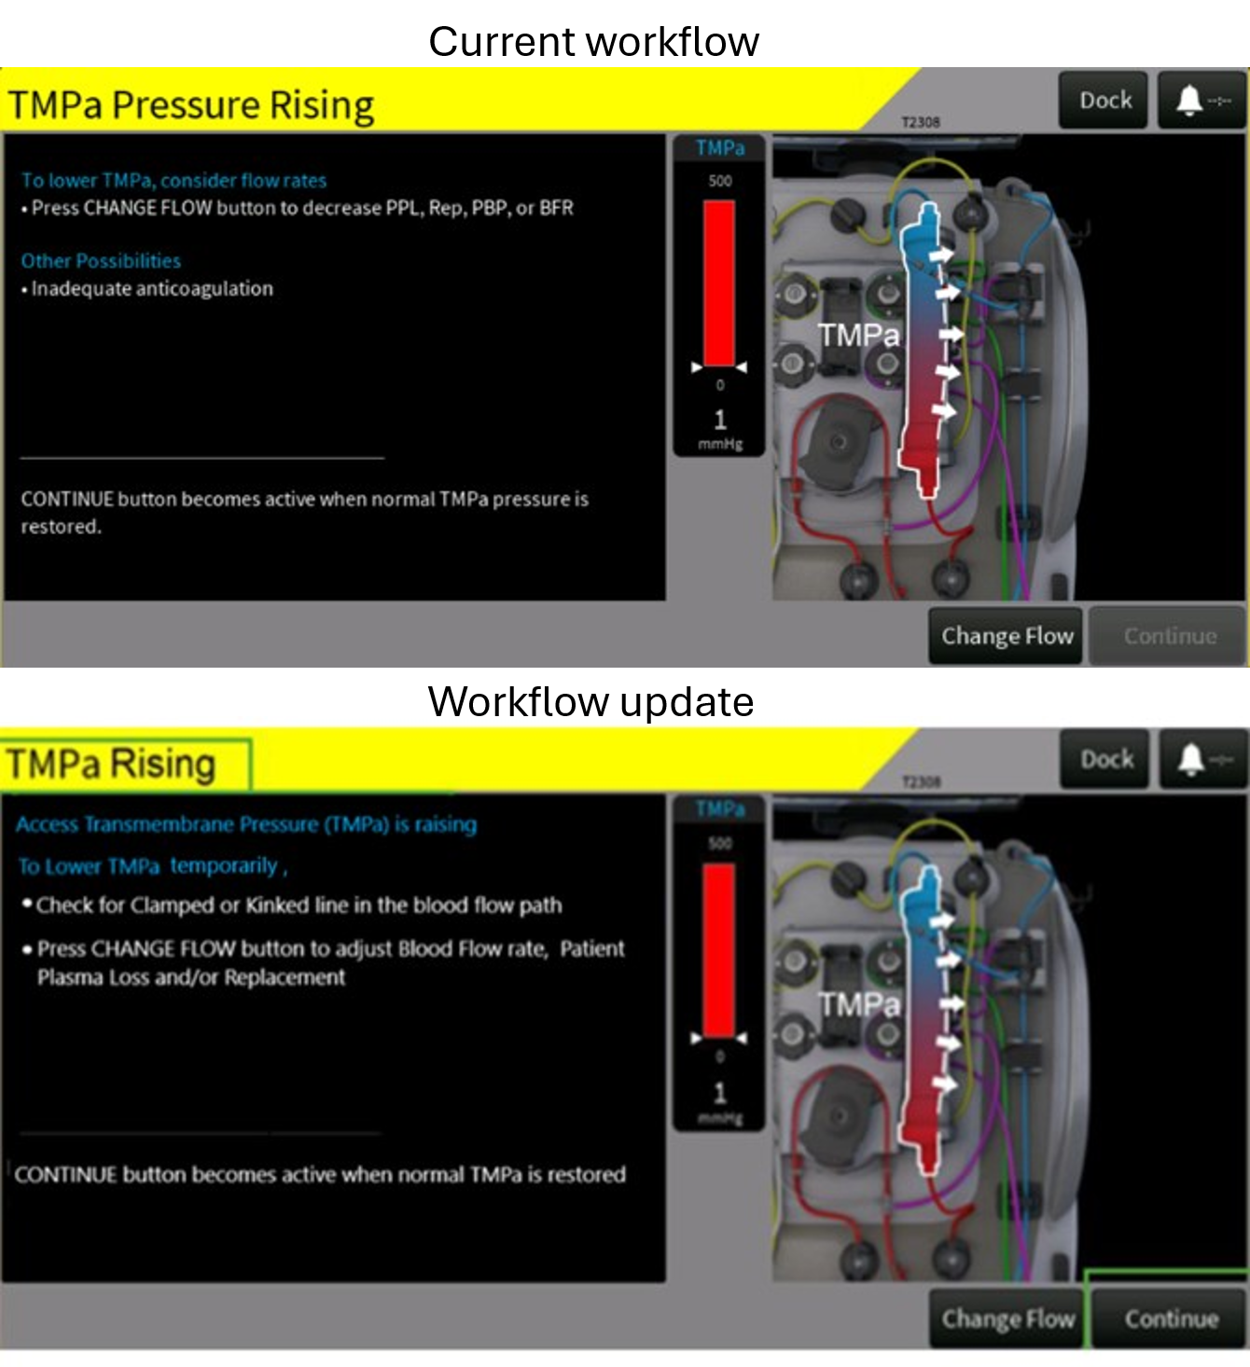

Figure 96: Existing alarm screen for T2308 - TMPa Pressure Rising alarm

**Proposed:**

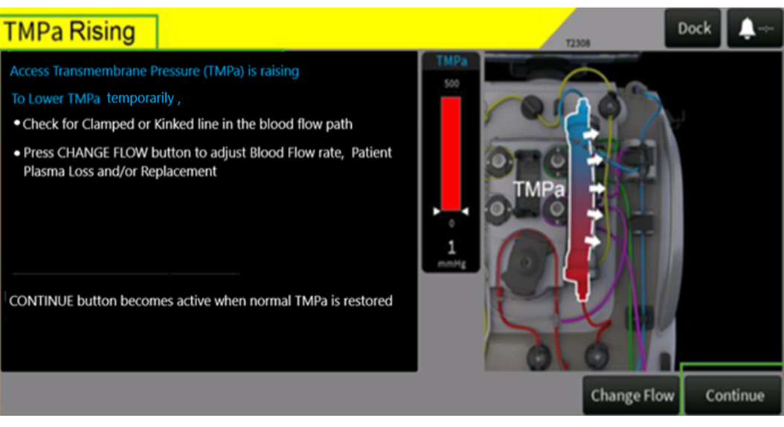

Figure 97: Proposed alarm screen for T2308 – TMPa Rising alarm

The following updates are made to the Alarm screen (Refer to attached screenshot):

* Updated the alarm title to remove redundant pressure term
* Added details for the triggering conditions for the alarm

Rephrased the Title of the solution add the abbreviations to align with button names on the therapy screen. PBP is removed as it won’t impact the state of the alarm. Anticoagulation will be left in the operator’s manual.

**T0783 - TMPa Pressure Excessive alarm.**

**Current:**

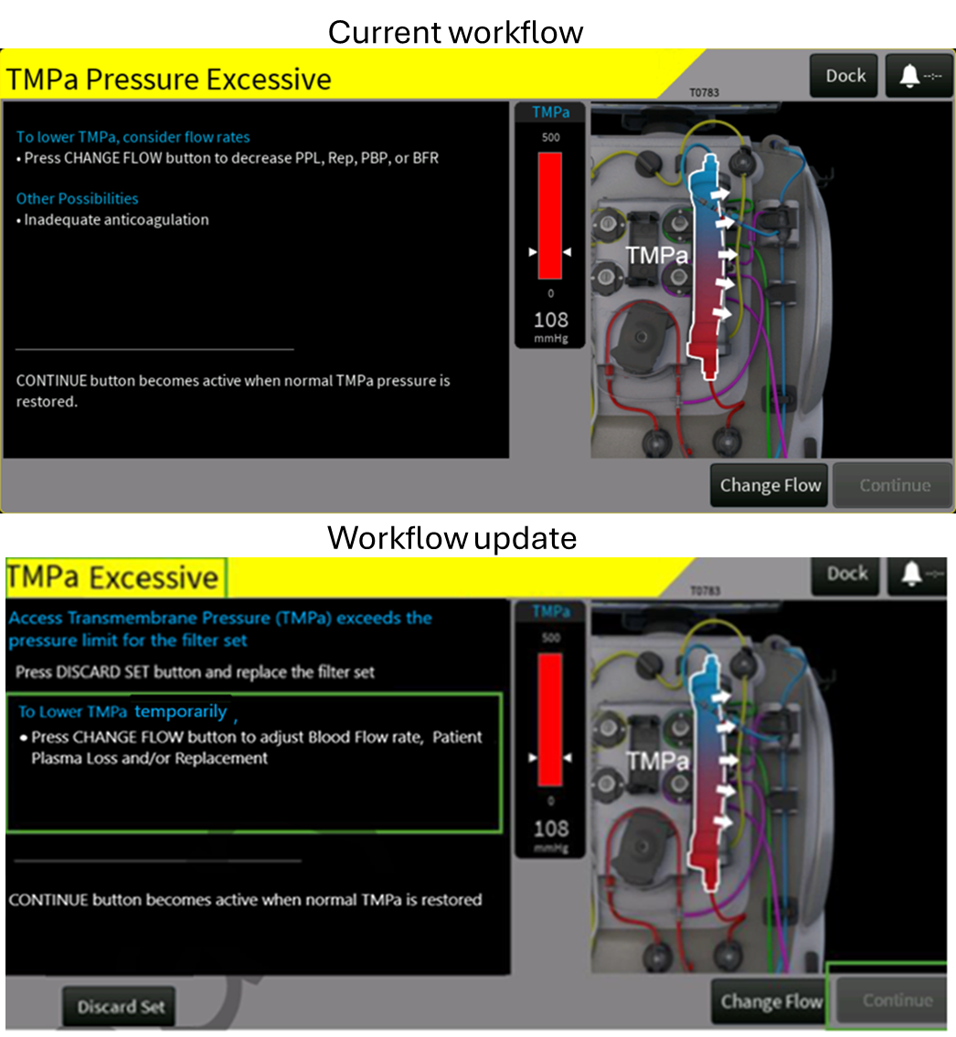

Figure 98: Existing alarm screen for T0783 - TMPa Pressure Excessive alarm

**Proposed:**

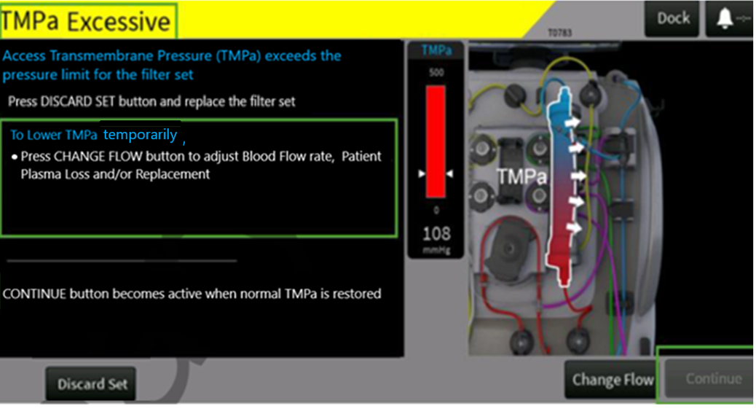

Figure 99: Proposed alarm screen for T0783 TMPa Excessive alarm

The following updates are made to the Alarm screen (Refer to attached screenshot):

* Updated the alarm title to remove redundant pressure term
* Added details for the triggering conditions for the alarm
* Added temporary steps which can be taken to lower TMPa, added the abbreviations to align with button names on the therapy screen. PBP is removed as it won’t impact the state of the alarm. Anticoagulation will be left in the operator’s manual.
* Added Discard Set Button.

**T0787 - Membrane Pressure Rising alarm;**

**Current:**

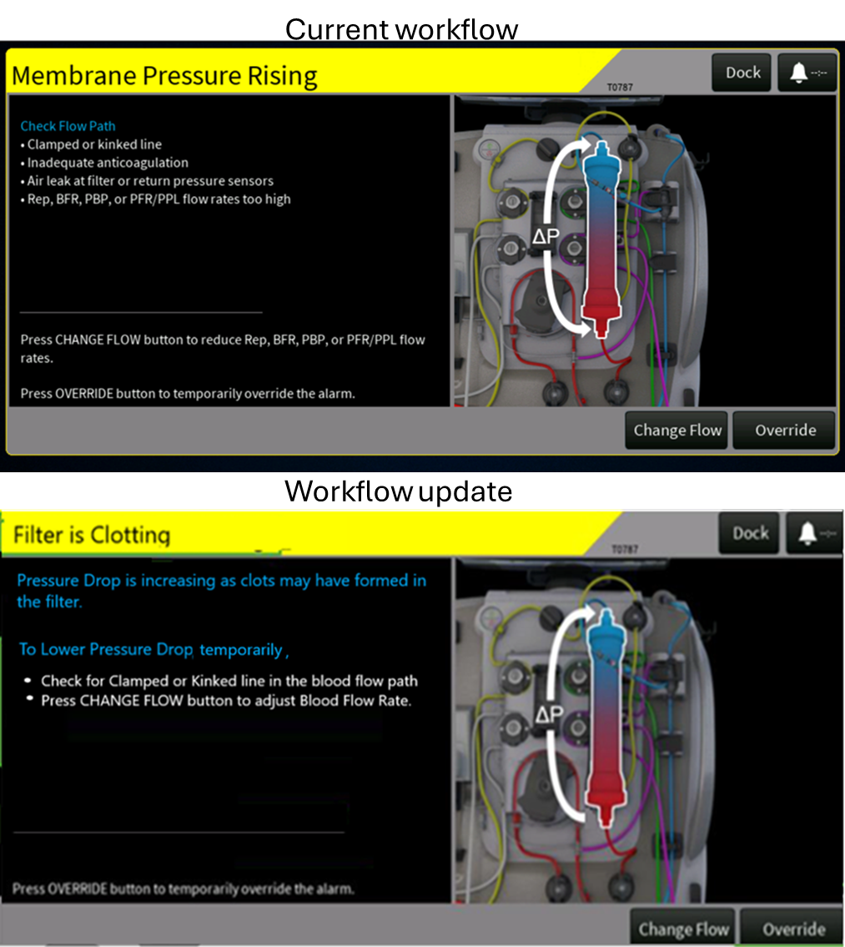

Figure 100: Existing alarm screen for T0787 - Membrane Pressure Rising alarm

**Proposed:**

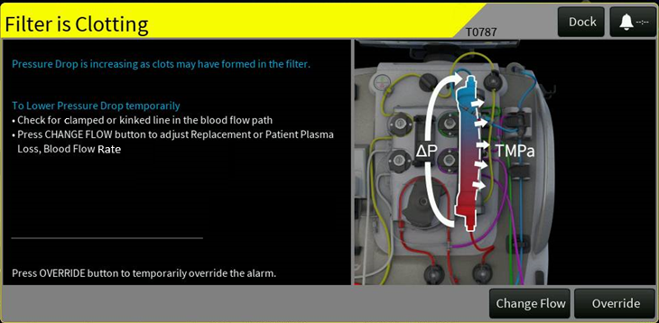

Figure 101: Proposed alarm screen for T0787 – Filter is Clotting alarm

The following updates are made to the Alarm screen (Refer to attached screenshot):

* Updated the alarm title to match the PrismaFlex title which explains the alarm better
* Added details for the triggering conditions for the alarm
* Added temporary steps which can be taken to lower pressure drop. Anticoagulation & Air leaks will be left in the operator’s manual while flow rates except BFR won’t have an impact on this alarm
* Added the abbreviation for BFR to align with button names on the therapy screen.
* The illustration is updated to remove the bidirectional arrow of ‘ΔP’ to unidirectional arrow of ‘ΔP’ in upward direction and add the effect of ‘TMPa’ along with ‘ΔP’.

**T0779 - Membrane Pressure Excessive alarm;**

**Current:**

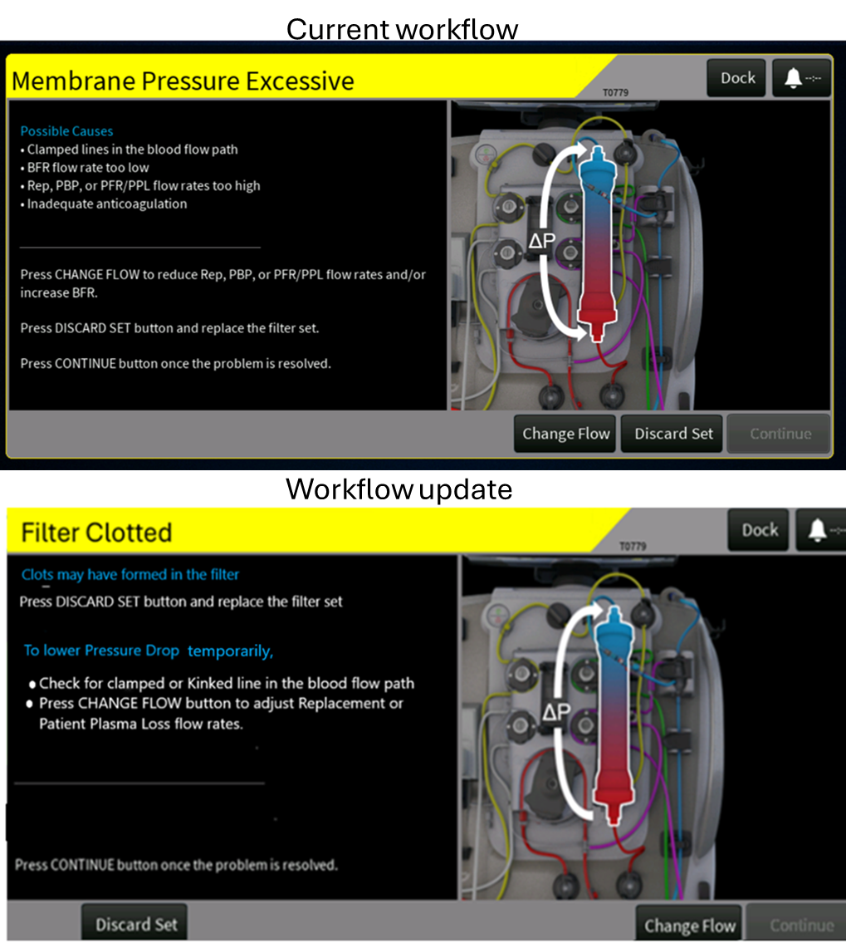

Figure 102: Existing alarm screen for T0779 - Membrane Pressure Excessive alarm

**Proposed:**

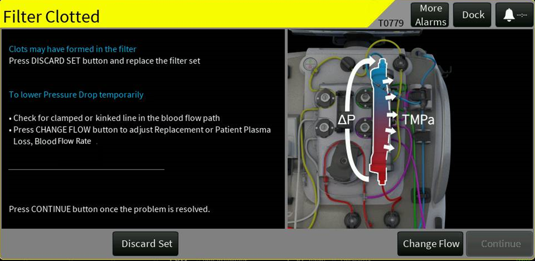

Figure 103: Proposed alarm screen for T0779 – Filter Clotted alarm

The following updates are made to the Alarm screen (Refer to attached screenshot):

* Updated the alarm title to match the Prismaflex title which explains the alarm better
* Added details for the triggering conditions for the alarm
* Added the abbreviations to align with button names on the therapy screen
* Added temporary steps which can be taken to lower pressure drop. Anticoagulation will be left in the operator’s manual while PBP won’t have an impact on this alarm
* Re-arranged the ‘Discard Set’ and ‘Change Flow’ buttons so that order in which the buttons are called out in the instructions match.
* The illustration is updated to remove the bidirectional arrow of ‘ΔP’ to unidirectional arrow of ‘ΔP’ in upward direction and add the effect of ‘TMPa’ along with ‘ΔP’.

**T0780 – Membrane Pressure Excessive alarm**

**Current:**

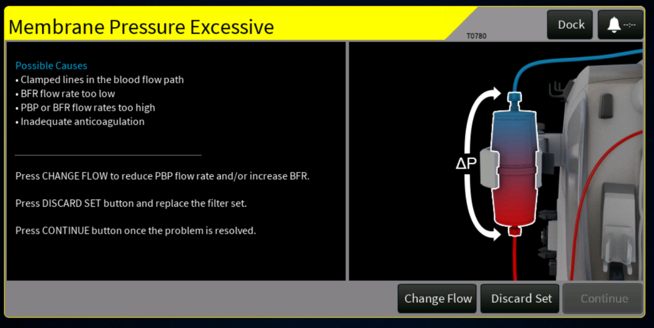

Figure 104: Existing alarm screen for T0780 – Membrane Pressure Excess alarm

**Proposed:**

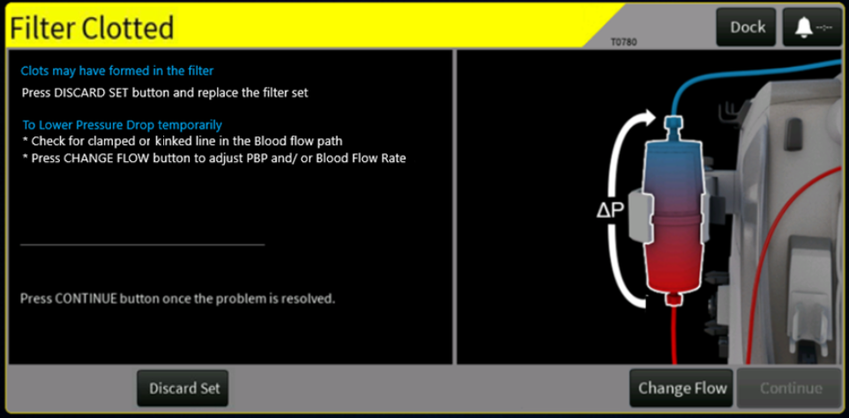

Figure 105: Proposed alarm screen for T0780 – Filter Clotted

The following updates are made to the Alarm screen (Refer to attached screenshot):

* Updated the alarm title to match the PrismaFlex title which explains the alarm better and renamed the title to “Filter Clotted” from “Membrane Pressure Excessive”.
* Added details for the triggering conditions for the alarm
* Added the abbreviations to align with button names on the therapy screen
* Rephrased the ‘Possible Causes to Lower Pressure Drop temporarily’ and added corresponding recommendations. Anticoagulation will be left in the operator’s manual.
* Re-arranged the ‘Discard Set’ and ‘Change Flow’ buttons so that order in which the buttons are called out in the instructions match
* The illustration is updated to remove the bidirectional arrow of ‘ΔP’ to unidirectional arrow of ‘ΔP’ in an upward direction.

**T0788 – Membrane Pressure Rising alarm (HP)**

**Current:**

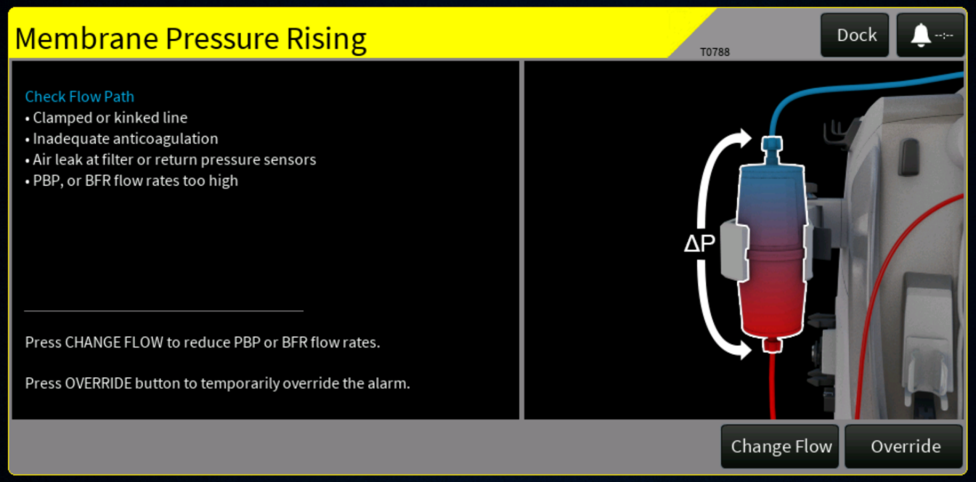

Figure 106: Existing Alarm Screen for T0788 – Membrane Pressure Rising Alarm

**Proposed:**

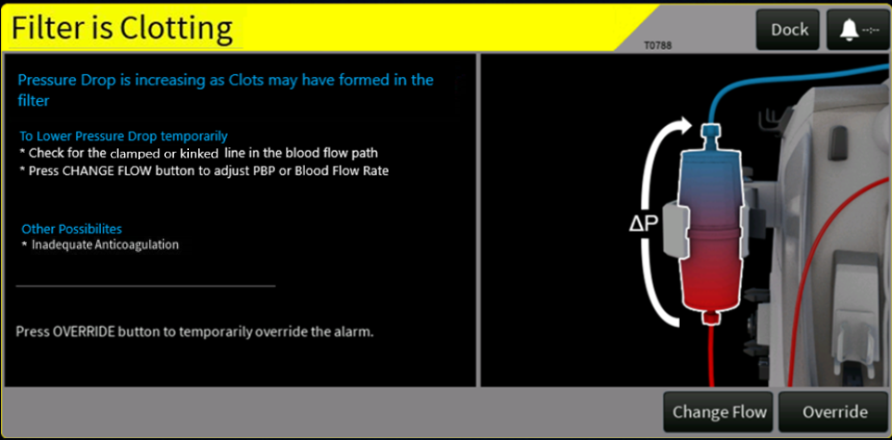

Figure 107: Proposed alarm screen for T0788 – Filter is Clotting Alarm

The following updates are made to the Alarm screen (Refer to attached screenshot):

* Updated the alarm title to match the PrismaFlex title which explains the alarm better
* Added details for the triggering conditions for the alarm.
* Added the abbreviations to align with button names on the therapy screen.
* Added temporary steps which can be taken to lower Pressure drop. Anticoagulation will be left in the operator’s manual.’

The illustration is updated to remove the bidirectional arrow of ‘ΔP’ to unidirectional arrow of ‘ΔP’ in an upward direction.

#### Missing / Incorrect Information in PrisMax Operator Manuals ([PFAL-2495)](https://jira-rnd.internal.vantive.com/browse/PFAL-2495)

Potential improvements and corrections to the PrisMax Operator manual AW8046, Rev E, were identified as part of an internal analysis. A select group of these issues, based on impact to patient safety, risk and labelling, will be resolved by making modifications to the Operator Manual AW8046. A technical review of these changes will be conducted and documented in ER9587 [Note – ER9587 yet to be released in TCU].

Issues reported from R&D, customers, service and other cross functional teams. The description lists several issues with the operator's manual where the current contents are incorrect/out of date.

Details listed in **‘**Operator’s manual updates**’** section**.**

**Update T0591 alarm instructions to include ‘Change Syringe’ button action**

While reviewing the updates to the operator manual, it was also found that the alarm T0591 is missing troubleshooting instructions for the Change Syringe button. This is an xml change and will warranty updates to the operator manual, as may be applicable.

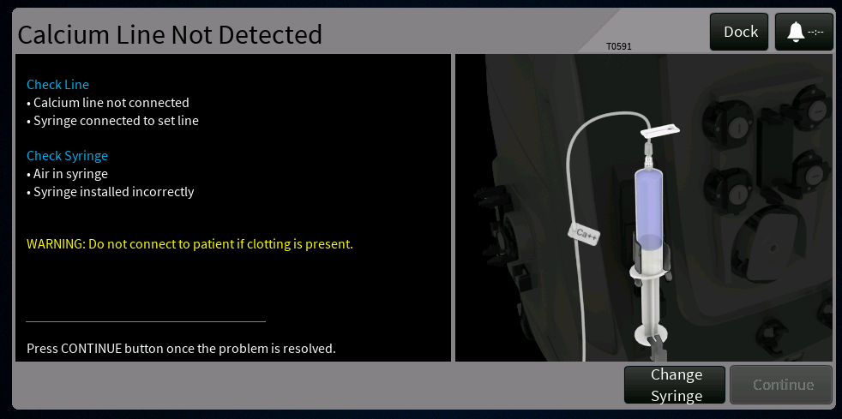

Figure 108: T0591 Current Workflow Calcium Syringe Not Detected

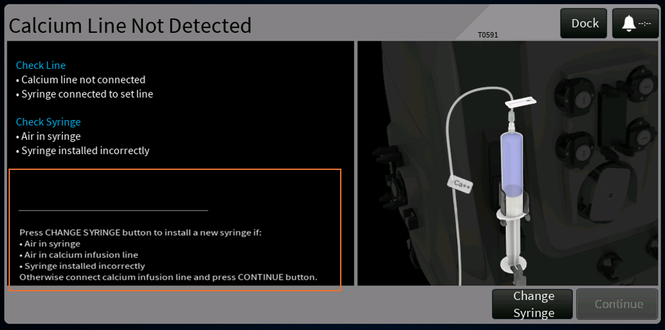

Figure 109: T0591 Updated Workflow Calcium Syringe Not Detected

#### Increase time taken to Latch the Signal to Backup Speaker during Total Loss Of Power (PFAL-2588)

The system is designed to sound the backup speaker anytime the system is powered off unexpectedly (not user initiated) and a patient is attached. This functionality of sounding backup speaker is achieved through a signal TLP_LATCH_SET in hardware which is driven through software logic. This logic is tested while Performing SST.

In manufacturing it was observed that while performing Power Board SST, page no 9/10 Step no 3 had repeated failures. This step verifies the latching of Total Loss of power signal to backup speaker circuit. An investigation was carried out to identify the reason for failure.

During the investigation, it was found that the PSC only commands the backup speaker [with the help of nTLP_LATCH_SET signal] for 8us. Due to potential part to part variations of the Mosfet that controls this signal, it was identified that the signal needed to be latched upto 15us, which maybe causing PrisMax to not sound the backup speaker.

The proposed solution to this issue is to increase the time taken to latch the signal to the backup speaker.

#### Undetermined Causes of Foam Detect Alarm T2315 [PFAL-2606]

The foam detect alarm has been observed to trigger falsely under specific conditions, even when no foam or fluid is present at the foam detector. Reports indicate frequent occurrences shortly after the start of treatment, particularly following priming, where small droplets of liquid may remain on the foam sensor surface and cause false positive detections. This behavior has been noted with both the legacy and the new LLS sensor, as the foam detection component remains the same.

During V3.4 validation with the new LLS sensor, false foam detect alarms were observed under the same conditions, confirming that the issue persists with the updated hardware. Additionally, during V3.5 validation, several false alarms occurred when testing with low flow sets. In these cases, the liquid level was verified to be well below the foam detector, and the system’s UI indicated no foam presence, yet alarms were raised.

These findings suggest that the issue is not sensor-specific but is likely associated with residual droplets on the foam detector during priming and/or sensitivity of the detection logic in low-flow conditions. Further investigation and potential improvement of the detection mechanism may be required if frequent occurrences continue with the new sensor implementation

New data has revealed that the algorithm to detect blood/liquid mixture at the foam detector has a high probability of detecting false positives when the signal is heavily aliased. While the above circumstances could also contribute to T2315 foam detected alarms, the sensitivity of the current algorithm to aliasing is most likely the leading cause of T2315 alarms. For this reason, the algorithm to detect blood/liquid mixture at the foam detector will be updated for Assure SW1 to be less susceptible to aliasing while preserving the existing detection criterion. This approach will attempt to eliminate the most likely root cause of T2315 and will in most probability require only algorithm simulation verification.

### Use Case Analysis

The following actors are common to several of the use case definitions:

* Operator – typically a nurse, who either initiates self-tests, performs manual adjustments of the liquid level, enables or disables automatic leveling, and responds to alarms raised by the monitor.
* Service Tech – Vantive trained technician for maintaining/troubleshooting/repairing machines
* PrisMax monitor – the PrisMax system, in particular the User Interface and components such as pumps, loaders, etc.

The following PFALs do not have applicable Use Cases:

1. PFAL-2477: Reduce occurrences of ARPS BIOT Alarms

No impact on use cases. The fix is an update to the ARPS and Liquid Levelalgorithm to make it more robust to hardware variations and degradations and less eager to raise BIOTs.

1. PFAL-2474: Reduce occurrence of B1593 alarm declared in Re-prime after air introduced in ABD

No impact on use cases. This is a software bug fix..

1. PFAL-2465: Errors in Reported PFR when disturbances occur on scales with flow rate of 0ml/hr

No impact to use cases. This is an improvement to the calculated PFR value to better take into account scales with zero flow rate.

1. PFAL-2495: Missing/Incorrect information in Prismax Operator Manual. No impact to use cases. All changes to operator manual will be verified and/or validated based on the impacted labeling requirements.
2. PFAL- 2606: Undetermined Causes of Foam Detect Alarm T2315. No impact to use cases. This is an improvement to the existing algorithm to better reject aliased data.

#### Ensure default settings are configured prior to use [PFAL-2473]

| Name | Preconditions | Sequence | Variations | Expected Outcome |
| --- | --- | --- | --- | --- |
| Import and Export of System Configuration Files | System is in Service mode | System menu -> USB Import/Export page | 1. Import SysConfig 2. Export SysConfig | 1. Only configuration files that meet system integrity requirement are successfully imported. 2. Exported configuration files are compatible with the current and future software versions, as applicable. Backward compatibility is not supported. |
| Verify default system configuration post Software installation | System in previous release software and in service mode. | Install Assure_SW1 -> Allow system to complete installation and reboot | 1. After reboot, Verify that that system has loaded default configuration settings.  2. Power cycle the device, Re-verify that default settings are retained after the power cycle | 1. The system configuration is reset to factory default values upon installation  2.All default settings remain intact after a power cycle |
| Perform software upgrade from Assure_SW1 to a newer Assure_SW1 version | System is already running Assure _SW1 | Software install | N/A | The existing System configuration is retained. |

#### Ensure the correct status of TherMax SST is transmitted to PrisMax [PFAL-2484]

| Name | Preconditions | Sequence | Variations | Expected Outcome |
| --- | --- | --- | --- | --- |
| Perform software upgrade from Assure_SW1 to a newer Assure_SW1 version | System on software Assure _SW1 | Software install | N/A | TherMax pairing table retained. |

#### Priming alarms popup update for alarms that triggers restart of the priming process [PFAL-2472]

| Name | Preconditions | Sequence | Variations | Expected Outcome |
| --- | --- | --- | --- | --- |
| Priming alarm popup update | System is performing priming process, and pre-prime tests are completed.  or  System is performing fluid priming process; | System triggers the alarm listed in section **Priming alarms update for alarms that triggers restart of the priming process [PFAL-2472]** | NA | Verify that the alarm popup is updated with new workflow as mentioned in the section:  **Priming alarms update for alarms that triggers restart of the priming process [PFAL-2472]**  On Clicking the ‘Reprime’ button on the **Figure 33: Reprime** , the system will restart the fluid priming process |

#### Include additional logging for B0916 alarm occurrence [PFAL-2471]

| Name | Preconditions | Sequence | Variations | Expected Outcome |
| --- | --- | --- | --- | --- |
| Verify additional logging for B0916 alarm | System is in Service mode | Trigger B0916 alarm condition | B0916 alarm is displayed | Verify additional log items are added for B0916 alarm to include  filenames, line numbers, exception codes in log DB file from system exception handler |

#### PBP Bag empty alarm not coming up at the right time (PFAL-2470)

| Name | Preconditions | Sequence | Variations | Expected Outcome |
| --- | --- | --- | --- | --- |
| Change PBP scale personality from PBP bag volume of 5000mL to Citrate bag | Sysconfig is setup with multiple Citrate solutions; System is in setup Therapy screen; User selects Non-RCA treatment with using regular PBP bag; | Change therapy type and use PBP Scale for Citrate bag. Start treatment | 1)CRRT or CRRT+ECCOR  2)TPE | 1)System uses bag volume configured for CRRT-Citrate bag to trigger PBP bag empty alarm. 2) System uses bag volume configured for TPE-Citrate bag to trigger PBP bag empty alarm. |
| Change PBP scale personality from Citrate bag to PBP bag volume of 5000ml | System is in setup Therapy screen; User selects RCA treatment with using PBP bag for citrate; | Change therapy type and use PBP Scale for selected therapy (Non- Citrate bag). Start treatment | 1)CRRT or CRRT+ECCOR 2) TPE | System uses bag volume configured (5000ml) to trigger PBP bag empty alarm. |
| Change Citrate solution | Sysconfig is setup with multiple Citrate solutions with different bag volumes; Select Citrate solution; | Select different Citrate solution. Start treatment | 1)CRRT. 2) TPE | 1)System uses latest selected CRRT -citrate solution volume to trigger PBP bag empty alarm.  2) System uses latest selected CRRT -citrate solution volume to trigger PBP bag empty alarm. |
| Using External calcium pump along with PBP citrate. | System is in setup. Select RCA treatment using PBP bag for citrate and External calcium pump | Select a Citrate solution. Start treatment | 1)CRRT. 2) TPE | System uses latest selected citrate solution volume to trigger PBP bag empty alarm. |
| Same Patient | Select Citrate solution. Complete NEW PATIENT treatment | Start same patient treatment. | NA | System triggers PBP bag empty based on the Citrate solution selection. |
| Profile | Save profile with selected citrate solution | Use previously save profile. | NA  User changes the Citrate Solution selection and proceeds to Treatment | System triggers PBP bag empty based on the Citrate solution selection.  System uses latest selected citrate solution volume to trigger PBP bag empty alarm. |

#### Alarm T2124 is not raised at the right time [PFAL-2475]

| Name | Preconditions | Sequence | Variations | Expected Outcome |
| --- | --- | --- | --- | --- |
| T2124 alarm after solution change | System is preconfigured with multiple CA solutions. | User changes out of range Citrate or Calcium solution in prescription window. | User changes out of range Patient Weight during setup for a particular Citrate or Calcium solution | As soon as prescription is committed Alarm is raised each time without fail. |
| T2124 alarm after solution change | System is preconfigured with multiple CA solutions. | User changes Citrate or Calcium solution. | User changes Patient Weight during setup for a particular Citrate or Calcium solution within the range | Alarm is not raised. |
| CA solution Range for each patient weight T2124 | For patient weight of 8kg.  Set Minimum CA solution value  Set any intermediate CA solution  value  Set Maximum CA solution value | In the Prescription window select Minimum, Intermediate and Maximum CA solution values | Check for different patient ranges. | Alarm is raised for Minimum & Maximum CA solution value  Alarm is not raised for any intermediate CA solution value |
| T2124 alarm raised appropriately for same patient | System is configured with the applicable Calcium concentration.  System currently running in CRRT mode with Citrate  Bag/Ca++ Syringe for some time. | 1. End treatment.  2. Restart the therapy for the same patient for which the treatment was stopped.  3. Change the Calcium Concentration solution out of range value for the entered patient weight. | After end treatment. Restart the Prismax system. | As soon as prescription is committed Alarm is raised each time without fail. |

#### Enable to autochart PFR & Address not resetting of PFR values with same patient with EMR systems [PFAL-2466]

| Name | Preconditions | Sequence | Variations | Expected Outcome |
| --- | --- | --- | --- | --- |
| EMR parameter 100 | Assure _SW1 outputting EMR data | Setup therapy mode and EMR data outputted for a New patient | N/A | 1. Actual cumulated PFR volume for patient fluid removal. This value is set to zero before starting on a new patient. This EMR output value shall match the onscreen value. |
| Same Patient | 2. Actual cumulated PFR volume for patient fluid removal. Including the volume from previous filter sets. This EMR output value shall match the onscreen value. |
| EMR parameter 458 | Assure _SW1 outputting EMR data | last completed charting period value set to default time value  Therapy running in CRRT mode  EMR data outputted | Set the last completed charting period value to different time intervals | Cumulative value for the last completed charting period for PFR.  This output EMR value shall be the same as the last completed charting period value displayed on the History PFR screen.  Observe the PFR resetting after the set last charting period time value both in Prismax machine and EMR data. |
| Therapy running in TPE mode |
| EMR parameter 459 | Assure _SW1 outputting EMR data | last completed charting period value set to default time value  Therapy running in CRRT mode  EMR data outputted | Therapy running in TPE mode | Cumulative value of 24h period up to the last completed charting period.  This output EMR value shall be the same as the Cumulative value of 24h charting period value displayed on the History PFR screen.  Observe the PFR resetting after the period of 24h both in Prismax machine and EMR data |
| EMR version change | Assure _SW1released | EMR vendor implementation | N/A | EMR version is updated in heading. |
| EMR parameter 417 | Assure _SW1 outputting EMR data | The patient treatment has started; therapy is run until a significant effluent volume is collected and treatment is stopped.  Restart with the same patient. EMR data outputted | N/A | The PFR details sent from PrisMax through the EMR message should match the actual PFR values in the system. |
| EMR parameter 418 | Assure _SW1 outputting EMR data | The patient treatment has started; therapy is run until a significant effluent volume is collected and treatment is stopped.  Restart with the same patient. EMR data outputted | N/A | The PFR details sent from PrisMax through the EMR message should match the actual PFR values in the system. |
| EMR parameter 419 | Assure _SW1 outputting EMR data | The patient treatment has started; therapy is run until a significant effluent volume is collected and treatment is stopped.  Restart with the same patient. EMR data outputted | N/A | The PFR details sent from PrisMax through the EMR message should match the actual PFR values in the system. |
| Observe for Additional parameters | Assure _SW1 outputting EMR data | The patient treatment has started; therapy is run until a significant effluent volume is collected and treatment is stopped.  Restart with the same patient. EMR data outputted | CRRT  TPE  HP | Observe for other parameters values such as 94-99, 418-433,435-439, 441,442,444-453,455,456. These Values should not be Reset for the same patient. These total values should also match the onscreen displayed values. |

#### GUI Issue- Display of Portuguese "C" character, font size display of numbers in Korean and Chinese screens [PFAL-2467]

| Name | Preconditions | Sequence | Variations | Expected Outcome |
| --- | --- | --- | --- | --- |
| Portuguese “ç” Character | System on software Assure _SW1 | Install Portuguese Language File | NA | Verify that the character “ç” is displayed correctly |
| Remote view with Portuguese language pack | Enable Remote view Portuguese language pack | Navigate to New patient screen from Service mode | NA | Verify that the C character is displayed correctly in the Remote View banner |
| Korean font size | System on software Assure _SW1 | Install Korean Language File | NA | Verify that the font size is updated in XML and the Korean text is displayed correctly in the GUI |
| Chinese font size | System on software Assure_SW1 | Install Chinese Language File | NA | Verify that the font size is updated in the XML and the Chinese text is displayed correctly in the GUI |
| Korean PFR Data Display | System on software Assure_SW1 | Install Korean Language File | NA | Verify that the font size is updated in the XML and all History PFR data gets displayed in the GUI |
| Chinese PFR Data Display | System on software Assure_SW1 | Install Chinese Language File | NA | Verify that the font size is updated in the XML and all History PFR data gets displayed in the GUI |

#### Missing or Incomplete Data Display in History PFR Screen observed in Korean and Simplified Chinese [PFAL-2577]

| **Name** | **Preconditions** | **Sequence** | **Variations** | **Expected Outcome** |
| --- | --- | --- | --- | --- |
| Korean PFR Data Display | System on software Assure_SW1 | Install Korean Language File | NA | Verify that the font size is updated in the XML and all History PFR data gets displayed in the GUI |
| Chinese PFR Data Display | System on software Assure_SW1 | Install Chinese Language File | NA | Verify that the font size is updated in the XML and all History PFR data gets displayed in the GUI |

#### Update the English Master XML for SW 3.7[PFAL-2660]

| **Name** | **Preconditions** | **Sequence** | **Variations** | **Expected Outcome** |
| --- | --- | --- | --- | --- |
| Alarm Screen Update | System on software Assure _SW1 | Simulate respective Alarm listed:  T0822  T1720  T1719  T1717  T1718  T1144  T0610  T2329  T1277 | NA | Verify that the Alarm Screen is updated as per the Updated Screen mentioned in section ‘2.1.2.12’ |
| Alarm Message Display Names Update | System on software Assure _SW1 | Simulate respective Alarm  Listed:  T2291  T2255  T2307  T2285  T2296  T2284  T2275  T0610  T2329 |  | Verify that the Alarm Message Display Names are updated as per the Updated Screen mentioned in section ‘2.1.2.12’ |
| Instruction update |  | Navigate to Translation Limit Code Dialog;  Navigate to Connect Patient Connection screen;  Navigate to Prepare Prime screen;  Navigate to Remove Air Help Dialog screen; | NA | Verify that the instructions are as mentioned in section ‘2.1.2.12’ |

#### Update the Translation XML for SW3.7[PFAL-2662]

| Name | Preconditions | Sequence | Variations | Expected Outcome |
| --- | --- | --- | --- | --- |
| Korean Dose Value Display | System on software Assure_SW1 | Install Korean Language File | NA | Verify that the font size is updated in the XML and the Dose Value is displayed correctly in the GUI |
| Chinese Dose Value Display | System on software Assure_SW1 | Install Chinese Language File | NA | Verify that the font size is updated in the XML and the Dose Value is displayed correctly in the GUI |
| Lithuanian  Prime Solution Display | System on software Assure_SW1 | Install Lithuanian  Language File | NA | Verify that Prime solution is displayed correctly when Glucose is selected |
| Vietnamese  Prime Solution Display | System on software Assure_SW1 | Install Vietnamese  Language File | NA | Verify that Prime solution is displayed correctly when Glucose is selected |

#### Error in reported PFR when disturbances occur on scales with flow of 0ml/hr [PFAL-2465]

| Name | Preconditions | Sequence | Variations | Expected Outcome |
| --- | --- | --- | --- | --- |
| PFR Reporting Error during Scale disturbances at 0 ml/hr | PrisMax in CRRT treatment  Set treatment in CVVHDF and flow rate of 0ml/hr for scales mentioned in the Sequence section | Add weight (40-45 gram) to replacement scale (Realistic weight change) | Non zero replacement flow rate | Weight error alarm T0823 occurs  PFR error increases by 40-45 gram and then slowly decays |
| Zero replacement flow rate | No alarm  No significant PFR error change |
| Add 60 gram or larger weight to replacement scale (Non-realistic weight change) | Non zero replacement flow rate | No alarm  No significant PFR error change |
| Zero replacement flow rate | No alarm  No significant PFR error change |
| Repeat above with Dialysate and PBP | | |

#### Correct the guidance in GUI/operators manual for filter clotting alarms (PFAL- 2488)

| Name | Preconditions | Sequence | Variations | Expected Outcome |
| --- | --- | --- | --- | --- |
| Filter Clotting Alarms (T0782, T0938, T0786, T2308, T0783, T0787, T0779, T0780,  T0788) | The system is in Operator mode, Disposable set loaded and actively running respective Therapy/Treatment | Simulate respective Alarm | NA | * Alarm is raised and title and text match the expected as detailed in Section 2.1.2.14. * Alarm message in message center displays the correct text as detailed in Section 2.1.2.15 * The order and location of the buttons (‘Discard Set’, ‘Continue’ or ‘Override’…) match the expected as detailed in Section 2.1.2.15 * Alarm graphic matches the expected as detailed in Section 2.1.2.15 * Alarm title should match the correct text as detailed in Section 2.1.2.15 when Alarm Override’s active button pressed. * Alarm title should match the correct text as detailed in Section 2.1.2.15 when Alarm Override’s active button pressed. * Observe Alarm title matches the new title proposed in section 2.1.2.15 in the Events History page. |
| Filter Clotting Alarms (T0782, T0938, T0786, T2308, T0783, T0787, T0779,  T0780,  T0788) | The system is in Operator mode, Disposable set loaded and actively running respective Therapy/Treatment | * Simulate respective Alarm * Simulate any other alarm * Click on More Alarms | Observe the alarm Title in Events page is matching the Proposed Alarm title as per CADV | * Observe Alarm title matches the new title proposed in section 2.1.2.15 in the selection pane of More alarms. |

#### Increase time taken to Latch the Signal to Backup Speaker during Total Loss Of Power (PFAL-2588)

| Name | Preconditions | Sequence | Variations | Expected Outcome |
| --- | --- | --- | --- | --- |
| Check the functionality of Backup speaker in Power board SST. | The Prismax System installed with PSC HW board which demonstrated silent shutdown behavior or had failed this use case with previous Firmware.  The system is in Service mode  Power Board SST selected and at PAGE 9 of 10 (Replaceable PCBA) | Run all the tests in PAGE 9 of Power board SST. | N/A | * Step No 3 of Page 9 of Power board SST is PASS. |
| Check for assertion of TLP signal 1 | The Prismax System installed with PSC HW board which demonstrated silent shutdown behavior or had failed this use case with previous Firmware.  .  The system is running in Therapy mode and system running treatment without any active alarms. | Remove the Power Cord.  Continue the Therapy until battery drains. | CRRT  TPE  HP | * The system Powers off automatically and backup speaker is annunciated for greater than or equal to 1 minute. * Reboot the System and Observe the B2222 alarm is annunciated |
| Check for assertion of TLP signal 2 | The Prismax System installed with PSC HW board which demonstrated silent shutdown behavior or had failed this use case with previous Firmware.  The system is running in Therapy mode and system running treatment without any active alarms. | Remove battery and then remove Power cord. | CRRT  TPE  HP | * The system Powers off automatically and backup speaker is annunciated for greater than or equal to 1 minute. * Reboot the System and Observe the B2222 alarm is annunciated |
| Check for assertion of TLP signal 3 | The Prismax System installed with PSC HW board which demonstrated silent shutdown behavior or had failed this use case with previous Firmware. | Remove the Red communication wire of Battery.  Power on the system with power cord inserted. | N/A | The backup speaker is annunciated for greater than or equal to 1 minute.  Reboot the System and Observe the B2222 alarm is annunciated |
| Perform PSC upgrade | System running in service mode | Perform PSC upgrade and Component programming. | N/A | upgrade and verify PSC version is updated correctly. |

### HFE Assessment

For the change implemented for the below listed PFALs in this CADV there are no modifications to the GUI.

* PFAL-0155 & PFAL-2251 (Issue) >> PFAL-2473 (Modification)
* PFAL-2378 (Issue) >>PFAL- 2484 (Modification)
* PFAL-2476 (Issue) >> PFAL-2477 (Modification)
* PFAL-2290 (Issue) >> PFAL-2474 (Modification)
* PFAL-0529 (Issue) >> PFAL-2471 (Modification)
* PFAL-2302 (Issue) >> PFAL-2475 (Modification)
* PFAL-2388 (Issue)& PFAL-2573 >> PFAL-2466 (Modification)
* PFAL-2185 (Issue) >> PFAL-2467 (Modification)
* PFAL-2574 (Issue) >> PFAL-2577 (Modification)
* PFAL-2379 (Issue) >> PFAL-2465 (Modification)
* PFAL-2342 (Issue) >> PFAL-2470 (Modification)
* PFAL-2482 & PFAL-2440 (Issue) >> PFAL-2495 (Modification)
* PFAL-2490 (Issue), PFAL-2491 (Issue), PFAL-2679(Issue), PFAL-1465 (Issue, PFAL-2611 (Issue)) >> PFAL-2660 (Modification)
* PFAL-2580 (Issue) >> PFAL-2662(Modification)
* PFAL-2560 (Issue) -> PFAL-2588 (Modification)

#### PFAL- 2479 (Issue) -> PFAL-2606 (Modification)PFAL-2301 (Issue) >> PFAL-2472 (modification)

These will be analyzed with respect to impact on the user interface, use related risk, and human factors activities will be planned accordingly. The full scope of potential human factors deliverables is detailed in the **Human Factors Engineering Plan, Assure SW1** (HFP8005). Activities and deliverables will include; Input to use specification, user interface specification, use related risk analysis, and human factors formative studies/reports. The user-related risk assessment will help inform whether a summative validation study may be needed.

#### PFAL-2271 (Issue) >> PFAL-2488 (modification)

The specific changes in this CADV were to address a significant cause of customer complaints or improve usability. These will be analyzed with respect to impact on the user interface, use related risk, and human factors activities will be planned accordingly. The full scope of potential human factors deliverables is detailed in the **Human Factors Engineering Plan, Assure SW1** (HFP8005). Activities and deliverables will include: Input to use specification, user interface specification, use related risk analysis, human factors formative studies/reports, human factors summative study/report, and a human factors summary report.

### Risk Analysis

#### PFAL-0155 & PFAL-2251 (Issue) >> PFAL-2473 (Modification)

Existing Risks

No new Risks (Hazards, Hazardous Situations and/or Sequence of Events) were introduced with the change outlined herein. Defaults not set alarm (T1722)will arise when Installation is incomplete or a default setting is missing. This issue occurs immediately upon startup, even before setup starts. In the worst case scenario this will leads to difficulty setting up therapy. Based on HSHA, If the delay is less than 1 hour it will not lead to any hazardous situation and hazard

New Risks

As stated above, no anticipated new risks are associated with this issue. as the issue occurs immediately prior to setting up a treatment, therefore there is no patient involvement/risk.

Existing RCMs

There is no associated risk control measure.

New/Modified/Deleted RCMs

No anticipated new, modified or deleted RCMs are associated with the proposed change.

#### PFAL-2378 (Issue) >> PFAL-2484 (Modification)

Existing Risks

T2259 Call Service alarm will rise if the configured treatment specifies TherMax usage and communications are established, and either serial number of the TherMax device does not match the serial number of the device in the stored TherMax SST and Calibration result or the stored TherMax SST and Calibration results have failures or are incomplete. The alarm is cleared by ending the treatment session, or by changing the therapy configuration to not use the TherMax. This happen during priming, prior to patient involvement. There is no new or increased risk associated with the event

New Risks

No new Risks (Hazards, Hazardous Situations and/or Sequence of Events) were introduced with the change outlined herein.

Existing RCMs

There is no associated risk control measure. The TherMax BWU is inspected for damage and/or faulty functionality during installation of the TherMax BWU on the PrisMax monitor or during replacement. This risk mitigation is implemented through training of the Service Technician to perform functional testing of the TherMax and inspect for damage during service calls.

New/Modified/Deleted RCMs

No anticipated new, modified or deleted RCMs are associated with the proposed change.

#### PFAL-2301 (Issue) >> PFAL-2472 (Modification)

Existing Risks

The patient risk is delay in therapy due to delays in completion of priming preventing initiation of therapy. This is covered in current RACT8000 documentation with Hazard HS.AET.5.1, “Delay in Therapy” with Hazardous Situation “Patient experiences a delay in the initiation of therapy (> 1 hour < 12 hours)” and Sequence of Events “Incorrect priming results in delay in starting the therapy” (PMX-RACT-209). The event of air in line due to incorrect priming is covered in current RACT8000 documentation under lines: PMX-RACT-101, PMX-RACT-120, PMX-RACT-124, PMX-RACT-128.

New Risks

No new Risks (Hazards, Hazardous Situations and/or Sequence of Events) were introduced with the change outlined herein.

Existing RCMs

* **RCM-1784** - Information for safety instructs about correct step by step actions for the correct set-up sequences.
* **RCM-1893** - Information for safety reminds for REPRIME and MANUAL PRIME option in specified screens.
* **RCM-2937** - Software verifies during priming that the return line is connected to the effluent bag and takes protective action if not.
* **RCM-1770** - Software automatically executes priming operation that is customized for the loaded disposable set to provide adequate priming and rinsing volume.
* **RCM-1720** - Software automatically verifies correct pod setting at during setup and prime tests, and takes protective action if verification fails.

In the event that air remains in the fluid path after priming due to an empty priming fluid bag, the following Risk Control Measures are in place to ensure no air reaches the patient:

* **RCM-1906 -** Information for safety reminds the Operator to visual check for air in set before patient connection.
* **RCM-1840 -** Software monitors the Air Bubble Detector (ABD) sensor status and takes protective action if air in blood is detected during specified modes.

New/Modified/Deleted RCMs

No anticipated new, modified or deleted RCMs are associated with the proposed change.

#### PFAL-2476 (Issue) >> PFAL-2477 (Modification)

Existing Risks

ARPS BIOT alarms- B1273, B1215, B1116, B1541, B1540 and B1539 - The protective system performs BIOT to verify functionality of the ARPS/ pressure sensors. The alarm is a risk mitigation to notify the user that intervention is required, and the system will default to a safe state. The user will be instructed to discontinue treatment and call service. The service person will replace any pressure assembly that fails or Replace ARPS motor. As part of Pressure pod reposition failures, the service person will replace the pressure transducer, pressure Pod or replace the safety board.

Based on the description, If the alarm raised incorrectly exist under the hazards delay in therapy, Interruption of Therapy and Bodily Fluid Loss.

Coverage of this issue exist under the hazards,

1. “Bodily Fluid Loss” with Hazardous Situations “Patient experiences bodily fluid loss ((> 0% to <= 15%) or (>15% to <= 30%) or loss (> 30% to <= 40%) or (loss (> 40% ) of their total blood volume).
2. “Delay in Therapy” with Hazardous Situations “Patient experiences a delay in the initiation of therapy” ( (> 1 hour < 12 hours) or (> 12 hours <24 hours)).
3. “Interruption of Therapy ” with Hazardous Situation “Patient experiences an interruption of therapy (> 1 hour < 12 hours).

Coverage of this issue exists under the risk IDs (PMX-RACT-251, 250, 249, 248, 247, 636, 252) in RACT8000

New Risks

No new Risks (Hazards, Hazardous Situations and/or Sequence of Events) were introduced with the change outlined herein.

Existing RCMs

* **RCM-2983** - Information for safety reminds the Operator if alarm occurs repeatedly, to not use the machine until repairs are made.
* **RCM-3121** - Labelling warns the operator that hazardous situations may result from repeatedly overriding alarms.
* **RCM-1787** - Software monitors the return pressure and takes protective actions if the return pressure falls outside specified alarm limit(s).
* **RCM-1789** - Software provides a ‘Cancel’ soft key in ‘Disconnect Patient’ screen if not disconnecting from an alarm screen.
* **RCM-1851 -** Information for safety instructs when and how an alarm may be temporary overridden.
* **RCM-3177**: Alarms that halt the system are not cleared without the user resetting the system/reset of the system.

New/Modified/Deleted RCMs

No anticipated new, modified or deleted RCMs are associated with the proposed change.

#### PFAL-2290 (Issue) >> PFAL-2474 (Modification)

Existing Risk:

Call Service alarm B1593 will rise due Return pressure sensor prime test failure. The protective system performs BIOT to verify functionality of the ARPS/ pressure sensors. The alarm is a risk mitigation to notify the user that intervention is required, and the system will default to a safe state. The user will be instructed to discontinue treatment and call service.

Based on the description, If the alarm raised incorrectly due to solenoid delay issue will leads to delay in initiation of therapy. Coverage of this issue exists under the hazard “Delay in Therapy” with Hazardous Situations “Patient experiences a delay in the initiation of therapy” ( (> 1 hour < 12 hours) or (> 12 hours <24 hours)) due to the sequence of event "Unresolved alarm results in delay in starting the therapy".

New Risks

No new Risks (Hazards, Hazardous Situations and/or Sequence of Events) were introduced with the change outlined herein.

Existing RCM:

The service person will replace any pressure assembly that fails or Replace ARPS motor.

* **RCM-2983**: Information for safety reminds the Operator if alarm occurs repeatedly, to not use the machine until repairs are made.
* **RCM-3177:** Alarms that halt the system are not cleared without the user resetting the system/reset of the system.

By incorporating a retry mechanism, the system can attempt to clear the conditions triggering the alarms, thereby reducing the frequency of false alarms and minimizing treatment disruptions.

After the applied resolution, there is no additional patient risk due to this anomaly.

New/Modified/Deleted RCMs

No anticipated new, modified or deleted RCMs are associated with the proposed change.

#### PFAL-0529 (Issue) >> PFAL-2471 (Modification)

Existing Risks

Coverage of this issue exists under Hazard HS.AET.18.1 “Interruption of Therapy” with Hazardous Situation “Patient experiences an interruption of therapy (> 1 hour < 12 hours)” with Foreseeable Sequence of Events “System halt results in an interruption of therapy” (PMX-RACT-798), “Software malfunction results in an in process therapy being interrupted” (PMX-RACT-160), and “Hardware malfunction results in an in process therapy being interrupted” (PMX-RACT-236). If manual blood return is not possible the blood in the set will be lost. This existing risk/hazard is captured with Hazard: HS.AET.3.1, “Bodily Fluid Loss” with Hazardous Situation, “Patient experiences bodily fluid loss (> 0% to <= 15% of their total blood volume)”.

New Risks

No new Risks (Hazards, Hazardous Situations and/or Sequence of Events) were introduced with the change outlined herein.

Existing RCMs

* **RCM-1789** - Software provides a ‘Cancel’ soft key in ‘Disconnect Patient’ screen if not disconnecting from an alarm screen.
* **RCM-2925** - The SP is hosted on an independent processor and monitors all activity of the CP and CP Protective System and trigger a general safe state if the CP Protective System does not act on a hazard by bringing the monitor to a safe state.
* **RCM-3109** - GUI informs the operator when previous treatment was unexpectedly or unintentionally terminated
* **RCM-3112** - Information for safety instructs that the service technician shall validate the hardware and software are compatible after updating hardware or software components.

New/Modified/Deleted RCMs

No anticipated new, modified or deleted RCMs are associated with the proposed change.

#### PFAL-2342 (Issue) >> PFAL-2470 (Modification)

Existing Risks

This Hazard, *Air or Gas in System,* (HS.AET.1.1, HS.AET.1.2, HS.AET.1.3 and HS.AET.14) with Foreseeable Sequence of Events, *Empty bag results in air in the fluid path* is addressed in RACT8000 on lines PMX-RACT-102, PMX-RACT-121, PMX-RACT-125, PMX-RACT-129. When the risk control measures activate, specifically RCM-1840, the system’s protective action will result in an interruption of therapy due to air or gas in the system. This Hazard, *Interruption of Therapy,* (HS.AET.18.1) with Foreseeable Sequence of Events, *Air / gas introduced into the system* results in an interruption of therapy is addressed in RACT8000 in line PMX-RACT-541.

In the case where the alarm in place from RCM-1733 (see below in Existing RCM section) is repeatedly overridden, an air-foam combination could form in the deaeration chamber beyond the capability of the system to remove the air resulting in a discontinuation of treatment and a lost set. Hazards listed in the HSHA applicable to this scenario are as follows: HS.AET.18.1, Interruption of Therapy with Hazardous Situation, Patient experiences an interruption of therapy (> 1 hour < 12 hours) and HS.AET.3.1, Bodily Fluid Loss with Hazardous Situation, Patient experiences bodily fluid loss (> 0% to <= 15% of their total blood volume). It is also worth noting that RCM-3121 states that Information for safety warns user of hazardous situations associated with repeatedly overriding alarm.

New Risks

No new risks associated with this change.

Existing RCMs

The following risk control measures are directly related to the case that air enter the fluid path from an empty bag:

* **RCM-1872:** Software monitors the scales and takes protective action if any scale weight falls below the specified tare weight (not valid for Effluent).
* **RCM-1733:** Software monitors the actual weight change for each scale and compares measurement with the expected weight change over a specified time period. Protective action is taken if the difference is greater than specified tolerance. Protective action is also taken if the difference error occurs repeatedly outside of specification.
* **RCM-1840:** Software monitors the Air Bubble Detector (ABD) sensor status and takes protective action if air in blood is detected during specified modes.
* **RCM-1852:** Information for safety reminds the Operator to prevent air from entering the blood circuit after priming is started.

Due to the issue summarized in PFAL-2342, the RCM-1872 is not active for the PBP scale/bag. Since the other RCMs listed above remain active, no new risk/hazard is expected to result from this issue. Note that the RCM-1872 still remains active for the dialysate/replacement scales/bags.

New/Modified/Deleted RCMs

The proposed change outlined herein is intended to ensure that RCM-1872 is active for the PBP scale/bag and is functioning according to intended design therefore there are no new, modified or deleted RCMs resulting from this change.

#### PFAL-2302 (Issue) >> PFAL-2475 (Modification)

Existing Risks

The risk to the patient is no greater than that already accounted for in the HSHA and RACT8000 for Delay in Therapy or Interruption of Therapy. The unsuitable prescription cannot be entered, nor can an incorrect prescription be administered per existing product requirements and RCMs. If the issue occurs prior to the start of therapy when the operator is setting up the therapy (as occurred in the complaint summarized herein), the operator may experience confusion and delay the initiation of therapy because they have difficulty setting up the therapy. If the issue occurs during therapy when the operator attempts to adjust the prescription and pauses therapy, the operator may experience confusion, and patient may experience an interruption of therapy because the operator is having difficulty adjusting the therapy parameters.

Coverage of this issue exists under Hazard HS.AET.18.1 “Interruption of Therapy” with Hazardous Situation “Patient experiences an interruption of therapy (> 1 hour < 12 hours)” with Foreseeable Sequence of Events “The user has difficulty adjusting therapy parameters.” (PMX-RACT-832), and Hazard HS.AET.5.1 “Delay in Therapy” with Hazardous Situation “Patient experiences a delay in the initiation of therapy (> 1 hour < 12 hours) with Foreseeable Sequence of Events “The user has difficulty setting up the device for therapy.” (PMX-RACT-203).

**Reference NCR 2689406 and ER9334 [R10] EBR Review_Failure to raise T2124 alarm (Unsuitable CA Solution) for additional information. For additional detail see ER9334/B.

New Risks

No new Risks (Hazards, Hazardous Situations and/or Sequence of Events) were introduced with the change outlined herein.

Existing RCMs

* **RCM-2422** - Information for safety instructs to change calcium solution selection in case the selected solution is not compatible with syringe operating range or accuracy.
* **RCM-2981** - Information for safety instructs that all operation, maintenance and calibration procedures for the control unit must be performed according to this operator’s manual, onscreen instructions, the service manual, and the disposable set and solution instructions. All procedures must be performed by authorized clinicians or service technicians.

New/Modified/Deleted RCMs

No anticipated new, modified or deleted RCMs are associated with the proposed change.

#### PFAL-2388 (Issue) >> PFAL-2466 (Modification)

Existing Risks

PFR charting on the device is correct. The issue relates how we transmit PFR information to the hospital EMR system and the way they handle PFR and is not related to any existing patient risks/hazards.

New Risks

No new Risks (Hazards, Hazardous Situations and/or Sequence of Events) were introduced with the change outlined herein.

Existing RCMs

PFR charting on the device is correct and an active risk control measure exists requiring information for safety to remind the operator that transmitted data is not a substitute for clinical verification or judgment.

* **RCM-2978** - Information for safety instructs when external devices is used for storage and logging of treatment parameters, the transmitted data is not a substitute for clinical verification or judgment. It is the physician’s responsibility to verify all data before prescribing any therapeutic or pharmacological action for the patient

New/Modified/Deleted RCMs

No anticipated new, modified or deleted RCMs are associated with the proposed change.

#### PFAL-2185 (Issue) >> PFAL-2467 (Modification) and PFAL-2574 (Issue) >> PFAL-2577 (Modification)

Existing Risks

Related to all three issues driving this change, the GUI description and is correct and the machine functionality is unaffected. These are GUI formatting updates with no patient hazard/risk.

New Risks

No new Risks (Hazards, Hazardous Situations and/or Sequence of Events) were introduced with the change outlined herein.

Existing RCMs

As stated above, the proposed changes are GUI formatting updates with no patient hazard/risk and therefore no associated risk control measures.

New/Modified/Deleted RCMs

No anticipated new, modified or deleted RCMs are associated with the proposed change.

#### PFAL-2379 (Issue) >> PFAL-2465 (Modification)

Existing Risks

As were identified in the Initial and Formal risk assessments in PFAL-2379, there are three potential outcomes that could result from a disturbance on a scale with the flow rate set to zero where the fluid balance becomes affected:  
 1) The reported PFR values cause the operator to make an incorrect treatment decision.  
 2) The gain/loss limit alarm is incorrectly raised.  
 3) The gain/loss limit alarm fails to be raised when it is supposed to be raised.

Applicable RACT8000 items related to the above scenarios include: Hazard “Insufficient Therapy” with Hazardous Situation “Patient receives less therapy than intended (net fluid removal)” (HS.AET.16.1) and Foreseeable Sequence of Events “Inaccurate weight measurement results in removing less fluid than intended.” (PMX-RACT-253) and Hazard “Excessive Therapy” with Hazardous Situation “Patient receives more therapy than intended (net fluid removal)” (HS.AET.10.1) and Foreseeable Sequence of Events “Inaccurate weight measurement results in excessive therapy.” (PMX-RACT-255).

New Risks

No new Risks (Hazards, Hazardous Situations and/or Sequence of Events) were introduced with the change outlined herein.

Existing RCMs

The following Risk Control Measures are related to mitigating risk from this issue:

* **RCM-1760** - Information for safety instructs to perform periodic charting of fluid volumes and states the importance of blood pressure monitoring during renal therapies.
* **RCM-1830** - Information for safety reminds to periodically weigh the patient.
* **RCM-1833** - Software measures total patient fluid removal deviation. If maximum allowed deviation limit (set by the Operator during setup) is reached during a specified time range, protective action is taken and suspends the therapy.
* **RCM-1834** - The PrisMax software accumulates errors associated with flow problem alarms that occur during a single treatment and takes protective actions when the error becomes excessive.
* **RCM-1854** - Information for safety instructs to carefully monitor patient fluid balance/ plasma balance levels in the Status and History screens.
* **RCM-1874** - Information for safety reminds to verify that bags are hanging freely without touching other bag or stand and to not disturb the scales and bags e.g. not to compromise the scale weight by foreign objects.
* **RCM-1875** - Information for safety informs the Operator of possible flow problem alarm causes and how to correct the problem.
* **RCM-2196** - Default value of the ‘Patient Fluid Loss/Gain Limit’ is pre-defined by software according to patient body weight.
* **RCM-2975** - Information for safety instructs that a fluid balance deviation can exceed a low-weight patient tolerance even if the deviation is within the control unit allowed deviation specification.

New/Modified/Deleted RCMs

No anticipated new, modified or deleted RCMs are associated with the proposed change.

#### PFAL-2271 (Issue) >> PFAL-2488 (Modification)

Existing Risks

Related to issues driving this change, the GUI description and is correct and the machine functionality is unaffected, however the wording could be improved to better meet customer needs/understanding. These are GUI formatting updates with no patient hazard/risk.

New Risks

No new Risks (Hazards, Hazardous Situations and/or Sequence of Events) were introduced with the change outlined herein.

Existing RCMs

As stated above, the proposed changes are GUI formatting updates with no patient hazard/risk and therefore no associated risk control measures.

New/Modified/Deleted RCMs

No anticipated new, modified or deleted RCMs are associated with the proposed change.

#### PFAL-2482 & PFAL-2440 (Issue) >> PFAL-2495 (Modification)

Existing Risks

The functionality of PrisMax features highlighted herein are unaffected, therefore there is no anticipated new/increased risk/hazard to patient. Op Man should be updated for correctness, completeness and clarity to avoid operator confusion.

New Risks

No new Risks (Hazards, Hazardous Situations and/or Sequence of Events) associated with Op Man updates.

Existing RCMs

As stated above, the proposed changes are Operator Manual updates with no patient hazard/risk and therefore no associated risk control measures.

New/Modified/Deleted RCMs

No anticipated new, modified or deleted RCMs are associated with the proposed change.

#### PFAL-2560 (Issue) >> PFAL-2588 (Modification)

Existing Risks

the PSC only commands the backup speaker for 8uS, instead of the necessary (per hardware needs) 15uS. Due to this PrisMax might not sound the backup speaker after a total power loss.

RACT8000 was reviewed for this issue and listed with the following the sequence of events related to power failure.

1) (PMX-RACT-534) - Loss of power results in the loss of the extracorporeal blood circuit (Bodily Fluid Loss - HS.AET.3.1).

2) (PMX-RACT-264) - Loss of power results in difficulty setting up for therapy (HS.AET.5.1).

3) (PMX-RACT-342) - Loss of power results in interruption of therapy( HS.AET.18.1)

4) Loss of power results in insufficient therapy (HS.AET.16.1, HS.AET.16.2 , HS.AET.16.3, HS.AET.16.4, HS.AET.16.5, HS.AET.16.6, HS.AET.16.7, HS.AET.16.8). The sequence of event "Loss of power results in insufficient therapy is not mapped with Insufficient therapy related hazards and HS. This needs to be mapped

New Risks

If the silent shut down happens and the PrisMax is connected to an external calcium syringe, which would keep going, even though PrisMax stopped delivering citrate. This will lead to the sequence of event "External Calcium Pump is not stopped". this will lead to the below hazard and HS,

(PMX-RACT-569) - Patient receives more therapy than intended (regional citrate) (HS.AET.10.3)

Existing RCMs

The existing Risk control measures for the Power failure,

**• RCM-1801:** Software retains its previous mode and settings after a power failure in accordance with specifications

• **RCM-1802:** Software establishes safe state according to specification in case of an extended power failure.

• **RCM-2356:** Software monitors the mains power supply voltage and takes protective action if mains power failure. Control unit design allows for treatment continuation with back-up batteries for a specified period of time.

• **RCM-1803:** If the mains power fails during treatment, and after the back-up batteries are depleted, software protective action is taken by activating an audible alarm that will last for at least the specified time.

• **RCM-3103:** In Citrate - Calcium, External Pump, Information for safety instructs the Operator to stop calcium infusion.

New/Modified/Deleted RCMs

No anticipated new, modified or deleted RCMs are associated with the proposed change.

#### PFAL-2479(Issue) >> PFAL- 2606 (Modification)

Existing Risks

The protective system monitors the Liquid Level Sensor (LLS) for foam and triggers alarm T2315 upon detection in the deaeration chamber. The operator must press the disable button to halt automatic leveling and resume treatment manually, with continuous monitoring of the liquid level sensor and manual adjustments as needed.

If the fluid barrier becomes wet, it impedes air flow due to pressure changes in the chamber. PrisMax continuously checks for fluid barrier wetting; if detected, the set must be changed.

If air reaches the Air Bubble Detector (ABD), the system halts all pumps, issues an air-in-blood warning, and closes the return clamp, resulting in therapy interruption.

Once foam clears, automatic leveling can be reactivated. All associated risks are documented in existing risk documents.

New Risks

There is no new or increased risk associated with this event.

Existing RCMs

* **RCM-2576:** Software periodically verifies the deaeration chamber level and foam sensors for correct functionality according to specified verification intervals.
* **RCM-3086:** Design to prevent compromised return pressure monitoring due to introduced foam in system.
* **RCM-1841**: In the case of air detected, Software brings the device to a safe state according to specification.
* **RCM-2233:** The deaeration chamber is located upstream of the Air Blood Detector (ABD) to trap residual air in the blood circuit set.
* **RCM-1701:** Information for safety instructs the Operator to change disposable set in case of fluid barrier damage (wetting).
* **RCM-2970:** Information for safety reminds about the pressure monitoring effects from a pod diaphragm leakage, or wetting of the monitor line fluid barrier.
* **RCM-1884:** Preventive measures are taken to prevent wetting of the fluid barrier in specified normal conditions.

#### PFAL-2580 (Issue) >> PFAL-2662 (Modification)

Existing Risks

**Issue 1: Cropped Dose Value Displayed in Korean and Simplified Chinese Languages**

The Effluent Dose value is cropped and has a dot at the prefix of the prescribed dose and delivered dose. In worst case scenario, this may lead to patient receives more therapy than intended (net fluid removal/regional citrate/systemic heparin) - (HS.AET.10.1, HS.AET.10.3, HS.AET.10.4).

**Issue 2: Incorrect Label Mapping in Lithuanian and Vietnamese translations**

It may impact usage of Priming solution as the correct solution is not displayed on the screen during Priming. This will only lead to user confusion and delay in setting up therapy less than 1 hour. However, the "Advisory" clearly mentioned about "Glucose" in the same screen.

New Risks

There is no new or increased risk associated with this event.

Existing RCMs

* RCM-3295 : Software computes and correctly displays the Prescribed and delivered dose in the specified screens.
* RCM-3296 : Software computes and correctly displays the cumulative fluid volumes in the specified screens.

#### *PFAL-2490*, *PFAL-2491*, *PFAL-2580,* PFAL-1465 (Issue) >> PFAL-2660 (Modification)

Existing Risks

Issue 1, 2 & 3 (Instruction text color Issue) - the GUI description and is correct and the machine functionality is unaffected. These are GUI formatting updates with no patient hazard/risk

Issue 4 & 5 (Discard Set Instruction to be removed) - Discard set if blood is visible in the Replacement bag/container incorrect data in GUI. The instruction is not clear to the user. This will lead to interruption of therapy (RACT ID - PMX-RACT-149).

Issue 6 (Translation Limit Code Dialog - PfHCT text to be Updated) - The unclear information will lead to Interruption of therapy (RACT ID - PMX-RACT-149).

Issue 7 (T1144 Priming Pause Time Exceeded Alarm – Instructions Missing) - This will lead to delay in setting up therapy (RACT ID - PMX-RACT-117)

Issue 8 & Issue 9 (Spell issue & Redundant text Issue) – The spell issue and the redundant text Issue will not lead to any patient safety risks.

Issue 10, 11 & 13 (Prepare Prime – Instructions, Unclear Confirm Patient Connections & T1277 Return Barrier May Be Wet Alarm – Instruction Update) – These issues will lead to difficulty setting up the product for therapy (RACT ID - PMX-RACT-117)

Issue 14 (Alarm Message Names Mismatch Issue) - The names displayed in the message center and event history windows for various TherMax alarms are not identical to the titles displayed when the alarms are raised. Potential impact to patient is Treatment delay due to operator confusion when reviewing course of events (RACT ID - PMX-RACT-149). The titles displayed when the actual alarms are raised are correct.

New Risks

No new Risks (Hazards, Hazardous Situations and/or Sequence of Events) were introduced with the change outlined herein.

Existing RCMs

**RCM-3163 :** The IFU includes instructions for the use of the product or provides users to a location where these instructions are provided.

**RCM-2981 :** Information for safety instructs that all operation, maintenance and calibration procedures for the control unit must be performed according to this operator’s manual, onscreen instructions, the service manual, and the disposable set and solution instructions. All procedures must be performed by authorized clinicians or service technicians.

**RCM-3163 :** The IFU includes instructions for the use of the product or provides users to a location where these instructions are provided.

**RCM-3164 :** The IFU contains warnings and cautions.

New/Modified/Deleted RCMs

No anticipated new, modified or deleted RCMs are associated with the proposed change.

### Product Requirement Analysis

#### Customer Requirement Specifications impact

There are no modifications, deletions or additions to the CRS8001[R2] *The related* customer requirements are listed in Table 3. There are no related requirements for Section 2.1.2.6 and Section 2.1.2.

Table 3 – Related Customer Requirement Specifications

| **ID** | **Requirement Text** | **Rationale** |
| --- | --- | --- |
| **Ensure default settings are configured prior to use [PFAL-2473]** | |  |
| CRS-136 | PrisMax shall provide the capability to allow the user to customize default system parameters, only when in system configuration. | The SW is updated to ensure default settings are correctly applied before use |
| **Ensure correct status of TherMax SST is transmitted to PrisMax [PFAL-2484]** | |  |
| CRS-144 | PrisMax shall provide step-by-step guidance to support the user in setting up the disposable set, including the TherMax Blood Warmer Accessory | The SW is updated to ensure TherMax SST status is correctly sent to PrisMax |
| **Priming alarms update for alarms that triggers restart of the priming process[PFAL-2472]** | |  |
| CRS-33 | PrisMax shall inform the user of the alarm cause and provide a guideline for alarm resolution and the ability to take action. | Reprime workflow and alarm instructions are updated for priming alarms that restart fluid priming process |
| CRS-11 | PrisMax shall present appropriate alarms and provide the user guidance on how to resolve |
| **Enable autochart PFR and address not resetting PFR values with same patient [PFAL-2466]** | |  |
| CRS-219 | PrisMax shall output to the Digital Communication Module, the following, in near real time:   * EMR data and additional event, alarm, and monitor status * PrisMax UI Image data | To support consistent and accurate PFR data recording for the same patient through EMR. |
| CRS-220 | PrisMax shall be compatible with the following EMR and middleware systems:  • Sharesource Connect  • Capsule Tech  • Cerner iBus  • Philips  • Draeger  • iMD Soft  • GE  • NantHealth  via an integration kit to allow the appropriate third party to create compatible drivers |
| **Reduce occurrences of ARPS BIOT alarm [PFAL-2477] and Return Pressure Sensor Prime test failed B1593 [PFAL-2474]** | |  |
| CRS-155 | PrisMax should minimize the number of interruptions or alarms that occur during therapy. | Reduces false ARPS BIOT and Return Pressure Sensor Prime Test failed alarms through improved algorithm tuning and event logging. |
| **PBP bag empty alarm not coming up at the right time [PFAL-2470]** | |  |
| CRS-32 | PrisMax shall be able to monitor the treatment, alert the user through audible and visual alarms, if abnormal situations occur. | Corrects PBP bag empty alarm timing by resolving race conditions and ensuring accurate threshold calculations. |
| **Alarm T2124 is not raised at the right time [PFAL-2475]** | |  |
| CRS-110 | PrisMax shall provide the capability to create the following custom solution parameters:  - Solution name  - Citrate Concentration (citrate solutions only)  - Citric Acid Concentration (citrate solutions only)  - Calcium Concentration (calcium or replacement solutions only)  Note: Edit capability does not apply to predefined solutions. | Corrects T2124 alarm timing by refining event sequencing to trigger promptly on calcium concentration changes. |
| **Correct the guidance in GUI/operators manual for filter clotting alarms [PFAL-2488]** | |  |
| CRS-250 | PrisMax should monitor set performance and alert the user of occurrence or risk of filter failures, such as clotting | Updates applied to alarm titles, instructions, and associated images for improved clarity and usability. |
| **GUI Issue- Display of Portuguese "C" character, font size display of numbers in Korean and Chinese screens [PFAL-2467]** | |  |
| CRS-210 | PrisMax shall support the display of non-Western font types, including CJK fonts | To ensure accurate display of all language characters, improving readability and usability. |

#### Therapy Requirement Specifications impact

* There are no modifications or deletions to TRS8001 [R3].
* The Related requirements from TRS8001 [R3] are detailed in Table 4. There are no related requirements for Section 2.1.2.1, Section 2.1.2.2, Section 2.1.2.4 to Section 2.1.2.6, Section 2.1.2.9 to Section 2.1.2.11 and Section 2.1.2.13
* The additions to TRS8001 [R3] are detailed in Table

Table 4 – Related Therapy Requirement Specifications

| **ID** | **Requirement Text** | **Rationale** |
| --- | --- | --- |
| **Priming alarms update for alarms that triggers restart of the priming process[PFAL-2472]** | | |
| TRS-107 | The PrisMax system shall perform automatic priming where no user interaction is required aside feeding of priming solution if additional priming solution is required.  Note: HP therapy may require user interaction during the priming phase e.g. to connect or de-aerate cartridges. | Reprime workflow added for priming alarms that restart the fluid priming process |
| TRS-110 | The PrisMax system shall provide for on-line instructions to the operator for all handling steps (e.g. setup, priming, patient connection, bag changes, troubleshooting of alarms, blood return, recirculation, patient disconnection, circuit disposal) |
| TRS-111 | The PrisMax system shall detect the following use errors:   * setup errors: failure to install circuit components which interface with monitor panel * not connected bags for priming or during therapy * clamped lines for priming or during therapy (for the clamps present on the disposable set and accessories) * mixing of lines with respective bag during priming |
| **PBP Bag empty alarm not coming up at the right time (PFAL-2470)** | | |
| TRS-123 | The PrisMax system shall alert the operator and suspend therapy if any of the solution bags are empty or if the effluent bag is full. | This update corrects PBP bag empty alarm timing by fixing race conditions and ensuring proper bag size parameter selection for accurate threshold calculations. |
| **Alarm T2124 is not raised at the right time [PFAL-2475]** | | |
| TRS-90 | In RCA with internal calcium pump, the PrisMax system shall allow the operator to select the calcium solution. | Alarm to check the limits of Calcium solution concentration range for a particular patient weight is updated. |
| TRS-289 | In RCA with calcium syringe pump, the PrisMax system shall allow for calcium solutions with concentrations in the range of 80-1000 mmol/l. |
| **Correct the guidance in GUI/operators manual for filter clotting alarms [PFAL-2488]** | | |
| TRS-95 | In CRRT and CRRT+ECCO2R therapies, the PrisMax system shall monitor TMP and filter pressure drop to diagnose clotting/clogging. | Filter is Clotting & Filter Clotted Alarm GUI updated for CRRT therapy |
| TRS-261 | In CRRT and CRRT+ECCO2R therapies, the PrisMax system shall monitor TMP to prevent risk of filter fiber rupture. | TMP Excessive Alarm GUI Updated. |
| TRS-96 | In TPE therapy, the PrisMax system shall monitor TMPa and filter pressure drop to diagnose clotting/clogging. | Filter is Clotting & Filter Clotted Alarm GUI updated for TPE therapy |
| TRS-262 | In TPE therapy, the PrisMax system shall monitor TMPa to prevent risk of hemolysis. | TMPa Excessive Alarm is Updated. |
| TRS-97 | In HP and standalone ECCO2R therapies, the PrisMax system shall monitor filter pressure drop to diagnose clotting. | Filter is Clotting & Filter Clotted Alarm GUI updated for HP therapy |
| TRS-268 | In TPE, HP and standalone ECCO2R therapies, the PrisMax system shall take into account the pressure drop of additional devices connected in series to the blood circuit of the disposable set when calculating and displaying the actual pressure drop over the TPE plasma filters or HP and ECCO2R devices.  Note: Additional devices can be but are not limited to blood warmers. |  |

Table 5 – New TRS

|  |  |  |
| --- | --- | --- |
| **ID** | **Original text** | **Rationale** |
| **Ensure default settings are configured prior to use [PFAL-2473]** | | |
| TRS-385 | The PrisMax system shall allow to configure the default therapy settings in System configuration | New requirement for default setting in system configuration |

### System Requirement Analysis

The related and modified Product Requirements, PRD8002[R4] for the relevant PFAL are listed in Table 6 and Table 7.

The new Product Requirements, PRD8002[R4] for the relevant PFAL are listed in Table 8.

Table 6 – Related PRD

| **ID** | **Requirement Text** | **Allocating Requirement** | **Rationale** |
| --- | --- | --- | --- |
| **Ensure default settings are configured prior to use [PFAL-2473]** | | | |
| PRD-3008 | The Monitor shall provide the capability for users to modify the configuration settings of the system, including default settings. | CRS-135  CRS-136  CRS-209 | The SW is updated to ensure default settings are correctly applied before use by adding retries with delay, preventing overlapping reloads, and enhancing alarm logging for clearer diagnostics |
| PRD-4713 | The Monitor shall require the user to select the calcium solution from the list of calcium solutions defined in the system configuration during RCA/Syringe setup. | TRS-90 |
| PRD-2007 | The Monitor shall provide the user the capability to select from a predefined list of 50 ml syringes for the infusion of calcium during RCA/Syringe. | RCM-1681 |
| PRD-2011 | The Monitor shall require the user to select the citrate solution from the list of citrate solutions defined in the system configuration during RCA setup. | TRS-89 |
| PRD-3788 | A default citrate dose shall be defined in System Configuration. | RCM-2169 |
| **Ensure correct status of TherMax SST is transmitted to PrisMax [PFAL-2484]** | | | |
| PRD-4075 | The Monitor shall provide the capability to display the serial number of the TherMax blood warmer. | PSR-2 | The SW is updated to ensure TherMax SST status is correctly sent to PrisMax by adding retries, fixing pairing reloads, and improving alarm logging to reduce T2259 alarms |
| PRD-4854 | The Monitor shall provide the capability to display the status and date executed for each TherMax SST or calibration. | PSR-2 |
| PRD-4853 | The Monitor shall verify the reported calibration authentication of the attached TherMax device with a stored value before using the TherMax in treatment. | RCM-3117 |
| PRD-4850 | The Monitor shall update the stored TherMax calibration authentication computed by the TherMax after successful execution of TherMax SST or calibration. | RCM-3117 |
| PRD-4849 | The Monitor shall provide the Service Technician the ability to update the stored calibration authentication without requiring TherMax SST/Calibration tests to be executed. | RCM-3117 |
| **Priming alarms update for alarms that triggers restart of the priming process [PFAL-2472]** | | | |
| PRD-1965 | The Monitor shall automatically detect if any lines/tubes are not connected to the proper corresponding solution bag, during priming, where feasible. | CRS-10  CRS-13  TRS-111  RCM-2937 | Reprime workflow and alarm instructions are updated for priming alarms that restart fluid priming process |
| PRD-1966 | The Monitor shall verify that the blood pump disposable set tubing segment size (high flow or low flow) corresponds to the user selected disposable set, during priming. | CRS-10  RCM-1770 |
| PRD-1967 | The Monitor shall verify that there are no clamped lines during priming, where feasible. | TRS-111  RCM-2200  RCM-2937 |
| PRD-1971 | The Monitor shall perform prime tests to verify the system is configured correctly before connecting a patient, where feasible. | CRS-13  RCM-1720 |
| PRD-3535 | The Monitor shall prime the system using the fluid volumes defined for the specific filter set being used. | TRS-107  ICD-1366  ICD-1371  ICD-1745  ICD-1750  ICD-1853  ICD-1859  ICD-3155 |
| PRD-4800 | The Monitor shall ensure that the TherMax Blood Warmer Disposable (BWD) is inflated properly during the priming of the circuit set when the TherMax warmer is in use. | TRS-107 |
| PRD-3758 | During priming the Protective System (CP) shall detect that the return line is connected to the effluent bag and declare a misconnection if it is not. | RCM-2937 |
| PRD-4070 | The Monitor shall test the connection of the TherMax disposable to the filter set lines. | RCM-2998  RCM-3000  RCM-3071 |
| PRD-3379 | The Monitor shall provide the capability to notify the user that a flush or new prime is needed, if the time between end of prime and the beginning of therapy exceeds 1 hour. | CRS-2  CRS-14  CRS-158  CRS-269  CRS-275  TRS-294  RCM-1901 |
| **Include additional logging for B0916 alarm occurrence [PFAL-2471]** | | | |
| PRD-2661 | The Monitor shall log the occurrence and identity of all alarms and events, including (as appropriate):  - Time and date of occurrence  - Associated alarm limits  - Alarm signal inactivation states  - Technical alarm conditions | TRS-130 | The SW update enhances diagnostics for B0916 alarms by adding detailed logging of filenames, line numbers, and exception codes to better identify root causes |
| PRD-2636 | The Monitor BIOT shall verify the following during therapy:  - SP heartbeat signal is toggled at minimum of 1 Hz  - Executable CRC  - Blood Leak Detector (BLD)  - Liquid Level Sensor (LLS)  - Liquid Leak Detector (LLD)  - System voltages and currents  - Pinch Valves (PV) for correct position  - Return clamp for correct position  - Line in return clamp  - Pressure sensors are within specified limits  - Pressure sensor calibrations signals are within specified limits  - ADC readings for freshness  - All applicable threads are operational  - Non-removable persistent storage for corruption, and available space  - Removable persistent storage for corruption, and available space  - SP, DCP, and PSC respond to RS-232 communication | RCM-1703  RCM-1791  RCM-1846  RCM-1847  RCM-1857  RCM-1888  RCM-1915  RCM-2576 |
| **Reduce occurrences of ARPS BIOT Alarms[PFAL-2477]** | | | |
| PRD-3522 | The Monitor shall monitor system pressures and take protective actions if they fall outside a pre-determined range. | CRS-278  RCM-1711  RCM-1787  RCM-1790 |  |
| PRD-3743 | The device shall annunciate an alarm for hardware failures of the pressure sensors. | CRS-11  RCM-2051 |  |
| PRD-1949 | The Monitor shall support manual user initiation of a self-test during Therapy Mode. | RCM-1889 |  |
| PRD-3823 | The automatic repositioning of all applicable pod diaphragms shall be performed at each self-test. *Note: In the case of HP or HP-X the effluent pod is not used.* | RCM-1709 |  |
| PRD-3879 | During priming, the software shall perform a pressure pod and return line self-test and alarm if there is a failure. | CRS-11  RCM-1708  RCM-1720 |  |
| PRD-3881 | The software shall monitor the correct behavior of the pressure pods and return line during self-test and alarm if there is a failure. | CRS-11  RCM-1708 |  |
| PRD-3880 | The periodic self-test shall include repositioning of pod diaphragms. | RCM-1709  RCM-1720 |  |
| **Alarm T2124 is not raised at the right time [PFAL-2475]** | | | |
| PRD-3714 | In RCA/Syringe anticoagulation method, the GUI shall instruct the Operator to change calcium solution selection in case the selected solution is not compatible with syringe operating range. | RCM-2422 | This update corrects T2124 alarm timing by refining event sequencing to trigger immediately on calcium concentration changes |
| **Enable to autochart PFR with EMR systems [PFAL-2466]** | | | |
| PRD-4786 | The Monitor shall output data per the AW8048 Communications Guide. |  | This update fixes PFR charting by correcting parameter logic and updating documentation with minor EMR revision |
| PRD-3307 | The Monitor shall output EMR data per the AW8081 Communications Guide. | CRS-216  CRS-220  TRS-237 |
| **GUI Issue- Display of Portuguese character and font size in Chinese and Korean screens[PFAL-2467]** | | | |
| PRD-4168 | The Monitor shall be able to display text in multiple languages, by using language files containing the translated version of the text to display. | CRS-202  CRS-210 |  |
| **Errors in reported PFR when disturbances occur on scales with flow rate of zero [PFAL-2465]** | | | |
| PRD-2051 | The Monitor shall trigger an incorrect weight change alarm and guide the user for resolution, if detecting a weight change on a scale that is different from the expected weight change. | CRS-161  TRS-180 | This update corrects PFR reporting by ignoring disturbances on zero‑flow scales while still monitoring for flow errors. |
| PRD-3156 | The Monitor SP shall monitor and compare the following readings to those on the CP:  1. Operational mode  2. Pressure readings during CP Self-Test (done via EIM bus)  3. ABD, reaction within 0.25 seconds (reading done via FPGA)  4. BLD during CP Self-Test (done via FPGA)  5. Return clamp Test during CP Self-Test (done via FPGA)  6. Blood pump encoder  7. Syringe pump encoder  8. Scale readings (done via independent scale hardware)  9. Fluid pump encoder readings  10. Net fluid removal (balance) | RCM-1833 |
| PRD-3503 | The Monitor fluid weight determination shall be insensitive to scale perturbations such as floor vibrations and bag swinging. | RCM-1807  RCM-2550 |
| PRD-3530 | The Monitor shall be capable of operating to specification during disturbances that excite the monitor at resonant structural frequency with sufficient magnitude to cause a 7.5 gram standard deviation of sensed scale weight over a 2 second moving window. | RCM-1807 |
| PRD-3736 | The Protective system shall monitor and compare the fluid flow values for the CP and SP and take protective action if they disagree. | CRS-11  RCM-1678 |
| PRD-3769 | The Protective System shall monitor the weight changes from the scales to ensure proper flow rates compared to expected. | TRS-180  RCM-1733 |
| PRD-3825 | The control and the protective system shall filter out unrealistic scale values, determined from physical limitations of the fluid pumps. | RCM-1867 |
| PRD-3840 | A flow control algorithm using a scale weight as feedback shall maintain proper fluid flow with non-ideal flow conditions (air bubbles, restrictions, etc.). | RCM-1877 |
| **PBP Bag empty alarm not coming up at the right time (PFAL-2470)** | | | |
| PRD-1832 | The Monitor shall trigger an alarm and stop all fluid pumps, if any of the fluid bags becomes empty (preblood/replacement/dialysate) or full (effluent). | TRS-123 | This update corrects PBP bag empty alarm timing by fixing race conditions and ensuring proper bag size parameter selection for accurate threshold calculations. |
| PRD-3739 | For the PBP, Replacement, and Dialysate scales, the Protective System (CP) shall verify the weight of each bag when changed according to the default bag volume V0 and take protective actions if the actual weight is greater than (V0 + 1000g) or less than bag empty weight. | RCM-1736 |
| PRD-3765 | The Protective System (CP) shall monitor the fluid pump scales and takes protective action if the PBP, Dialysate, and/or Replacement scale weight falls below the tare. | RCM-1872 |
| **Fix to ensure Backup Speaker sounds during Total Loss of Power[PFAL-2588]** | | | |
| PRD-2728 | The Monitor shall respond to a loss of AC power as follows:  - Display an on-screen indicator that AC power has been lost  - Declare a Low Battery alarm (if battery charge is low) per the alarm requirements  - Switch to battery backup  - Declare a Total Loss of Power (TLP) alarm, if the battery charge is insufficient to power the Monitor, then enter a safe state |  | This update improves backup speaker reliability during total power loss by increasing the signal latch time. |
| PRD-2058 | The Monitor shall, while running on battery, be able to detect if the battery pack charge is insufficient and alert the user. | CRS-36 |
| PRD-2807 | Total Loss of Power (TLP) is defined as:  - Monitor has not been powered off using the On/Standby key, AND  - No AC power is present AND  - battery is below operational range |  |
| PRD-2727 | The Monitor shall react to a loss of power (TLP) by sounding the backup speaker for greater than 1.0 minute.  See also Power Down mode for further requirements. | RCM-1803 |
| PRD-3518 | The Monitor shall enter a safe state when all power sources are insufficient to continue operating. | RCM-1802 |
| PRD-336 | The Monitor BIOT shall verify system voltages and currents during all modes, except Service Mode. | RCM-1824 |
| PRD-2637 | The Monitor shall transition to Power Down Mode if any of the following events occur:  - “Total Loss of Power” (TLP)  - Power Control Panel On/Standby key is pressed for over 2 seconds | RCM-2356 |
| **Undetermined Causes of Foam Detect Alarm T2315[PFAL-2606]** | | | |
| PRD-4065 | The LLS shall detect the presence of foam before it reaches the return pressure port. | TRS-240  RCM-3086 | This update refines the foam detect algorithm to reduce false T2315 alarms |

Table 7 – Modified PRD

| **Forked (Original) ID** | **Current Requirement Text** | **New ID** | **Proposed Requirement Text** | **Rationale** |
| --- | --- | --- | --- | --- |
| **Priming alarms update for alarms that triggers restart of the priming process [PFAL-2472]** | | | | |
| PRD-3841 | The GUI shall facilitate REPRIME and MANUAL PRIME in Priming, X of X cycles Complete. | PRD-5565 | The GUI shall facilitate REPRIME, FLUSH and MANUAL PRIME in Priming.  Note: Only the REPRIME and PRIME options will display X of X cycles Complete. | Added FLUSH option and a Note to clarify that only REPRIME and PRIME display ‘X of X cycles complete’ |
| **Missing / Incorrect Information in PrisMax Operator Manuals (PFAL-2495)** | | | | |
| PRD-3550 | Labeling shall inform the Operator not to connect additional devices between the blood access device and the return blood line because it may impede the detection of a return disconnect. | PRD-5221 | Labeling shall inform the Operator not to connect additional devices between the blood access device and the return or access blood lines as they may impede pressure monitoring and detection of disconnection events.   *Note: This is to inform about practices that could impact the ability of the system to detect a disconnection event because their use could introduce pressure dynamics that are not accounted for by the system. Pressure dynamics are impacted by restrictions such as multiport valves, stopcocks or extension lines. A dedicated access disconnection alarm is not implemented as a risk mitigation, due to that the current risk mitigations already reduce the risk to the lowest possible risk level i.e., treatment interruption/delay and blood loss amounting to the volume of the extracorporeal circuit. The related OM warning has been subject to field action FA-2020-016.* | Added ‘access’ to the blood lines  Added note for clarity |
| PRD-3622 | The GUI and Operator’s Manual shall warn the user of the potential for clotting if blood flow is too low for a given set. | PRD-5418 | The GUI and Operator’s Manual shall warn the user of the potential for clotting/clogging if flow rates are not adjusted for a given set | The GUI has been updated to not limit the flow rate adjustment to BFR only, but to other parameters |
| **Error in reported PFR when disturbances occur on scales with flow of 0ml/hr [PFAL – 2465]** | | | | |
| PRD-3766 | The system shall ensure weight stability during treatment before starting the fluid pumps after a stoppage | PRD-5554 | The system shall ensure weight stability during treatment for all scales corresponding to a pump with a non-zero prescription flow rate before starting the fluid pumps after a stoppage | Stability on scales corresponding to non-rotating pumps is not required  Added note for clarity to exclude non-rotating pumps. |
| PRD-3353 | The Monitor SP shall monitor the net Patient Fluid Removal (PFR) from the patient during CRRT.  *Note: PFR is effluent flow - (syringe flow + PBP flow + Dialysate flow + Replacement flow).* | PRD-5555 | The Monitor SP shall monitor the net Patient Fluid Removal (PFR) from the patient during CRRT. Flow detected due to disturbances on scales corresponding to pumps with zero prescription flow rate shall be excluded from the PFR calculation.  *Note: PFR is effluent flow - (syringe flow + PBP flow + Dialysate flow + Replacement flow).* | Non-rotating pumps cannot change patient fluid balance. Fault conditions that could affect fluid balance (e.g. uncommanded rotation, non-occlusive pump) are covered by other alarms. |
| PRD-3903 | The software shall monitor for any unexpected weight change on the scales. | PRD-5239 | The software shall monitor for any unexpected weight increase on the scales. | Updated requirement text to clarify to monitor only unexpected weight increase |

Table 8 – New PRD

| **ID** | **Requirement Text** | **Rationale** | **Out links** |
| --- | --- | --- | --- |
| **Alarm T2124 is not raised at the right time [PFAL-2475]** | |
| PRD-5409 | In System configuration, for RCA with internal calcium pump, the Monitor shall limit the range of the allowed calcium concentration between 80-1000 mmol/l | Existing functionality. Adding a missing requirement. | TRS-289 |
| **Priming alarms update for alarms that trigger restart of priming process** **[PFAL-2472]** | | | |
| PRD-5415 | The Monitor shall notify and guide the user when applicable, that a new priming bag is needed, when user chooses to Reprime a set  *Note: This is only applicable when Reprime is selected from the Fluid priming step and for selected priming alarms only.* | Reprime workflow added for priming alarms that restart fluid priming process | CRS-33 |
| **Correct the guidance in GUI/operators manual for filter clotting alarms [PFAL – 2488]** | | | |
| PRD-5416 | The Monitor shall be able to measure TMP with an accuracy of ±20 mmHg. | Existing functionality. Adding a missing requirement. | CRS-33 |
| PRD-5417 | The Monitor shall be able to measure TMPa with an accuracy of ±22 mmHg. | Existing functionality. Adding a missing requirement. | CRS-33 |

## Sub-System Requirements Analysis (CA2)

### Hardware Requirement Analysis

There are no modifications to the Hardware requirements because of the modifications to this CADV.

### Software Requirement Analysis

#### Software Requirement Specification Impact

* The related requirements from SRS8001[R5] are detailed in Table 9
* The modified requirements from SRS8001 [R5] are detailed in Table 10
* The new requirements to SRS8001[R5] are detailed in Table 11

Table 96 – Related SRS

| **ID** | **Requirement Text** |
| --- | --- |
| **Ensure default settings are configured prior to use [PFAL-2473]** | |
|  | **4.8.5.5.5.1 Solutions** |
| SRS-7286 | Software shall provide the Site Expert the ability to create/edit/delete custom solutions by defining the following parameters:  - Solution name  - Citrate Concentration (citrate solutions only)  - Citric Acid Concentration (citrate solutions only)  - Container size, limited to 500 to 10500 mL (citrate solutions only)  - Calcium Concentration (calcium or replacement solutions only)  - Bicarbonate Concentration (replacement or dialysate solutions) |
|  | **4.8.5.5.5.2 Syringes** |
| SRS-255 | Software shall provide the Site Expert the capability to select a default syringe brand from the list of predefined syringes which are supported and enabled.  *The syringe brands are enabled/disabled via the Features tab.* |
| SRS-8510 | The software shall support the following syringes:  Size 20 ml  - BD PLASTIPAK 20  - B. Braun (Omnifix) 20  - TERUMO 20  - Covidien / Kendall Monoject 20  Size 50 ml  - BD PLASTIPAK 50  - TERUMO 50  - B. Braun (Omnifix) 50  - B. Braun (Perfusor) 50  - Codan Luer lock 50  - Fresenius Injectomat 50  - Covidien / Kendall Monoject 50  *Note: The B. Braun (Perfusor) 50 uses the 50B syringe clip holder.* |
|  | **4.8.5.5.5.4 Regional (citrate/calcium) Anticoagulation (RCA**) |
| SRS-6489 | The software shall provide the Site Expert with the capability to define the default citrate dose in System Configuration, in the range 1.5-6.0 mmol/L blood, with the default value 3.0 mmol/L of blood) unless set by the user.  *Note: The default is used to pre-populate the citrate dose parameter in setup but may be changed by the user. See the RCA parameters for citrate dose and calcium solution concentration per therapy for Citrate dose min/max and default.* |
| **Ensure correct status of TherMax SST is transmitted to PrisMax [**PFAL-2484] | |
|  | **4.7.1.2.1 Initiating Communications with the TherMax device** |
| SRS-8322 | The software shall alarm if the TherMax has not successfully completed Calibration and SST as follows:  • The alarm is raised if the configured treatment uses the TherMax device and the TherMax device is not authenticated, has not been calibrated, has not passed SST, or has illegal TherMax software installed;  • The alarm priority is INFO;  • The alarm is cleared by changing the therapy configuration to not use TherMax; or by connecting an authenticated TherMax with legal software, passing SSTs, and passing calibrations. |
| SRS-9714 | The software shall verify that the reported TherMax serial number and authentication data matches an entry in the list of valid TherMax devices.  *This is referred to as "authenticating" the TherMax.* |
|  | **4.7.1 TherMax** |
|  | *The following requirements are applied if the specified therapy configuration includes the TherMax blood warmer.* |
| SRS-9715 | The software shall maintain a list of valid TherMax devices, with each entry containing the TherMax serial number and authentication data.  *The authentication data is a SHA-256 hash of the calibration data and SST status, computed and reported by the TherMax device*. |
| **Priming alarms update for alarms that triggers restart of the priming process[PFAL-2472]** | |
|  | **4.3.2.6 Prime Set** |
| SRS-1096 | Software shall provide a mechanism to pause/resume the fluid priming operation. |
| SRS-7545 | Software shall automatically pause fluid priming while any scale is open. |
|  | **4.3.2.6.1 Prime** |
|  | *Software has a PRIME mode which prepares connected set(s) for use (includes wetting of filters and removal of air).* |
| SRS-8355 | In HP therapy, software shall instruct the user to change the effluent bag as needed. |
| SRS-9557 | The software shall generate an alarm when prime is paused for an excessive period of time without user interaction as follows:   * Alarm is raised during if a priming operation has been paused either during or after a fluid prime operation for an excessive time; * The alarm priority is INFO; * The automatic reaction is to stop all pumps; * The alarm is cleared upon user acknowledgment.   *Note that the alarm is applicable in the attach patient state after fluid prime is complete, if treatment is not initiated in a timely manner.* |
|  | **4.3.2.6.1.2.1 Alarms** |
| SRS-8137 | The software shall generate an alarm in priming when a low-flow set has been loaded when a high-flow set was specified or vice versa as follows:   * Alarm is raised if the observed flow into the effluent bag when the blood pump is turning does not match the expected rate; * The alarm priority is INFO; * The automatic reaction is to stop priming;   The alarm is cleared upon user acknowledgment. |
| SRS-8141 | The software shall generate an alarm in priming when an incorrectly sized bag has been attached to an effluent scale as follows:   * Alarm is raised if the weight of the bag is too small to be the expected size bag; * The alarm priority is INFO; * The automatic reaction is to stop priming;   The alarm is cleared upon user acknowledgment. |
| SRS-8136 | The software shall generate an alarm in priming when any of the bags attached to the preblood, dialysate, or replacement scales is either clamper or empty as follows:   * Alarm is raised if the mass flow out of the bag is less than expected; * The alarm priority is INFO; * The automatic reaction is to stop priming;   The alarm is cleared upon user acknowledgment. |
| SRS-8138 | The software shall generate an alarm in priming with auto-effluent in use when the auto-effluent bags are reversed as follows:   * Alarm is raised if the mass flow into an effluent bag is occurring when the pinch valves are set to flow into the other bag; * The alarm priority is INFO; * The automatic reaction is to stop priming;   The alarm is cleared upon user acknowledgment. |
| SRS-8139 | The software shall generate an alarm in priming the effluent bag is attached to the rear scale as follows:   * Alarm is raised if the mass flow into the rear scale is observed; * The alarm priority is INFO; * The automatic reaction is to stop priming; * The alarm is cleared upon user acknowledgment.   *This can occur when either auto-effluent is not in use, when the auto-effluent set is being re-used, or in the flush after saline recirculation.* |
| SRS-8344 | The software shall generate an alarm in priming for the return line not connected to the effluent bag as follows:   * Alarm is raised if the change in the effluent scale weight(s) is less than the defined threshold; * The alarm priority is INFO; * The automatic reaction is to halt the prime operation; * The alarm is cleared by the operator.   *Note: there are separate alarms depending on therapy type, auto-effluent state. Also note that alarm is not applicable in TPE.* |
| SRS-8159 | The software shall generate an alarm for effluent bag not filling in TPE as follows:   * Alarm is raised if the change in the effluent scale weight is less than the defined threshold; * The alarm priority is INFO;   The alarm is cleared by the operator. |
| SRS-9555 | The software shall generate an alarm for priming bag empty in HP therapy as follows:   * Alarm is raised during fluid prime tests when the calculated amount of fluid remaining in the priming bag is too low; * The alarm priority is INFO; * The automatic reaction is to stop priming;   The alarm is cleared upon user acknowledgment. |
| SRS-8160 | The software shall generate an alarm for insufficient effluent capacity as follows:   * Alarm is raised prior to a priming operation when the remaining capacity in the effluent bag is less than the expected amount of priming fluid that that will be moved to the effluent bag; * The alarm priority is INFO; * The automatic reaction is to stop priming; * The alarm is cleared upon user acknowledgment.   *Alarm applies to fluid prime/reprime/flush operations, but not manual/blood prime. Alarm does not apply when auto-effluent is enabled and not being re-used.* |
| SRS-8161 | The software shall generate an alarm in multi-cycle CRRT and TPE therapy priming sequences when the priming bag is empty as follows:   * Alarm is raised at the appropriate points in the fluid priming sequence where it is convenient to change the bag to ensure that the bag never runs dry during the sequence; * The alarm priority is INFO; * The automatic reaction is to stop priming;   The alarm is cleared upon user acknowledgment. |
| SRS-8162 | The software shall generate an alarm if a CRRT set is loaded when a TPE therapy is selected, or a TPE set is loaded when a CRRT therapy is selected, as follows:   * Alarm is raised during setup if the return pressure fails to react as expected when the dialysate pump is rotated; * The alarm priority is INFO; * The alarm is cleared when user commands retest.   *Note: The alarm is raised after the Set loading failure alarm has been triggered once* |
|  | **4.3.2.6.2 Reprime** |
| SRS-7004 | Software shall allow the user to reprime the set after the initial prime has completed, including passing of all tests (pre-prime, during-prime, and post-prime). |
| SRS-8435 | The software shall alarm if it detects that the TherMax disposable is not properly connected to the circuit set as follows:   * Alarm is raised if the rise in return pressure per unit volume when the venous clamp is closed while the blood pump is rotating is higher than expected; * The alarm priority is INFO;   The alarm is cleared by operator acknowledgement, and the fluid prime step restarted. |
|  | **4.7.1.3 Priming** |
| SRS-8500 | The software shall raise an alarm if the system is unable to inflate the bag as follows:   * Alarm is raised if the return pressure fails to rise to the required level; * The alarm priority is INFO; * The automatic reaction is to stop the fluid prime operation;   The alarm is cleared by operator acknowledgement, and the fluid prime step restarted. |
| **Reduce occurrences of ARPS BIOT Alarms (PFAL-2477)** | |
|  | **3.5.7 ARPS** |
| **SRS-8078** | The software shall generate an alarm for a failure of the ARPS as follows:   * Alarm is raised if any of the following conditions occur with the ARPS: loss of communications, failure to achieve/maintain pressure, incorrect pressure reading; * The alarm priority is HIGH;   The automatic reaction is to halt the system. |
|  | **3.5.7.1 ARPS Self Test** |
| **SRS-3872** | To verify the ARPS System software shall execute the following steps:  1. Close All Solenoids  2. Command the ARPS motor to remove air from the ARPS tubing  3. Verify that pressure generated by the ARPS does not increase faster than 30mmHg/second  If pressure is increasing, software shall generate an ARPS/Pressure Sensor Wiring Fault  4. Command the ARPS motor to stop at -300 +/- 50 mmHg.  5. Verify that the APRS Pressure does not increase more than 50 mmHg over 10 seconds.  If pressure is increasing, software shall generate a Can't Stop ARPS fault  6. Verify that the ARPS pressure leak rate is less than 50 mmHg over 10 seconds.  If pressure is decreasing, software shall generate an ARPS Leak Fault alarm  7. Command the ARPS motor to remove air from the ARPS tubing  8. Command the ARPS motor to stop at -450 +/- 50 mmHg.  9. Command the ARPS pump to add Air to the ARPS tubing  10. Calculate the ARPS tubing compliance  11. Use the ARPS tubing compliance if it is between 3 and 6, otherwise use the compliance value from service mode.  This procedure shall be performed before any operations requiring the use of the ARPS pump are executed.  *Note 1: (50 mmHg * 6ul/mmHg) / 10 secs = 30 ul/sec = 1.8 ml/min*  *Note 2: This test is designed to verify the ARPS pump can be run and stopped, that the tubing is not leaking, and that the tubing compliance value is current.* |
|  | **3.5.1 General Alarms** |
| **SRS-8083** | The software shall generate an alarm for a failure of a pressure sensor as follows:  Alarm is raised if any of the following conditions occur with a pressure sensor: loss of communications, failure of the mux test, failure of repositioning algorithm; or incorrect pressure comparison;  The alarm priority is HIGH;  The automatic reaction is to halt the system. |
|  | **4.14.4 System Self-Test(SST)** |
|  | **4.14.4.11 ARPS** |
| **SRS-4417** | The SST software shall verify that the ARPS system back side leaks are such that pressure error is less than 40 mmHg after 60 sec under the following conditions:  1) Pressure set at +450 mmHg  2) Pressure set at -450 mmHg |
| **SRS-5959** | The SST software shall verify that the ARPS system front side leaks are such that pressure error is less than 10 mmHg after 300 sec under the following conditions:  1) Pressure set at +450 mmHg  2) Pressure set at -450 mmHg |
| **Reduce occurrence of B1593 alarm declared in Re-prime after air introduced in ABD (PFAL-2474)** | |
|  | **3.5.1 General Alarms** |
| **SRS-8083** | The software shall generate an alarm for a failure of a pressure sensor as follows:  Alarm is raised if any of the following conditions occur with a pressure sensor: loss of communications, failure of the mux test, failure of repositioning algorithm; or incorrect pressure comparison;  The alarm priority is HIGH;  The automatic reaction is to halt the system. |
| **PBP Bag empty alarm not coming up at the right time (PFAL-2470)** | |
|  | * **3.4 Scales and Bags** |
| SRS-8053 | The software shall declare an alarm if a fluid bag empties during treatment as follows:  •Alarm is raised when the amount of fluid remaining in the bag based upon the scale weight is too low;  •The priority is LOW;  •The automatic reaction is to stop all fluid pumps;  •The alarm is cleared if a bag change operation for that scale is performed or the prescription flow rate for the bag is changed to zero.  Note that this requirement doesn't apply to the TPE Replacement Container. |
| SRS-9577 | The software shall declare an alarm if the TPE Replacement Container empties during treatment as follows:  •Alarm is raised when the volume of fluid removed from the bag exceeds the volume of fluid to be delivered from the container;  •The priority is LOW;  •The automatic reaction is to stop all fluid pumps;  •The alarm is cleared if a bag change operation for that scale is performed; or if the user requests an additional amount of replacement fluid to be delivered from the container. |
| SRS-9522 | If the user requests that an additional amount of replacement fluid to be delivered from the container in response to the alarm for the TPE Replacement Container Empty, the additional amount of fluid shall be constrained to be less than or equal to the calculated maximum amount of fluid in the container. |
|  | 4.3.3 Treatment |
|  | *Software requirements related to Therapy Mode are spread throughout this document.* |
|  | *Software uses a “percentage of available volume” method for determining bag full for Effluent.* |
| SRS-7211 | During the bag change operation (except effluent bags), software shall require a that the total mass placed on the scale is > minimum change weight, where the minimum change weight is given as:   * 37g for replacement solutions in TPE;   7g + (0.0446g/mL x container size) for preblood solutions, dialysate, and replacement solutions (other than TPE replacement), where the container size is given in mL. |
|  | 4.8.5.5.4.1 Accessories |
| SRS-9704 | Software shall provide the Site Expert the capability to individually set the default bag size for preblood, dialysate, and CRRT replacement solutions which will be used during therapy.  The allowable range for the default bag size is 500 to 10500 mL, inclusive. |
|  | 4.8.2.1 Set Schematic |
| SRS-494 | Software shall show the intervention time on the schematic on the corresponding element, where the list of elements / events for which this is applicable is as follows:  - Effluent bag full  - Fluid bag empty  - Syringe Empty  *Intervention time is the time until the operator has to perform an action to change a syringe or bag/container. It is calculated by dividing the remaining mass (or volume for syringe) until the device is empty (or full for effluent), by the current flow rate of the pump.* |
| SRS-6574 | Software shall highlight the intervention time of the element with the lowest intervention time as the NEXT element needing intervention. |
| **Include additional logging for B0916 alarm occurrence [PFAL-2471]** | |
|  | **3.17 CP Processor and Driver Board** |
| SRS-8081 | The software shall generate an alarm for a failure of the CP processing as follows:  • Alarm is raised if any of the following conditions occur with the CP processing: software image integrity failure, unexpected termination of internal task, failure of periodic tasks to execute on schedule, or an internally raised assertion;  • The alarm priority is HIGH;  • The automatic reaction is to halt the system. |
| ***Alarm T2124 is not raised at the right time [PFAL-2475]*** | |
|  | 4.6.5 Citrate Bag, Calcium Syringe (Cit/Cal) |
| SRS-7548 | In RCA/Syringe anticoagulation method, software shall instruct the Operator to change calcium solution selection in case the selected solution is not compatible with syringe operating range. |
|  | ***4.8.5.5.5.1 Solutions*** |
| SRS-7286 | Software shall provide the Site Expert the ability to create/edit/delete custom solutions by defining the following parameters:  - Solution name  - Citrate Concentration (citrate solutions only)  - Citric Acid Concentration (citrate solutions only)  - Container size, limited to 500 to 10500 mL (citrate solutions only)  - Calcium Concentration (calcium or replacement solutions only)  - Bicarbonate Concentration (replacement or dialysate solutions) |
| **Enable to autochart PFR with EMR systems [PFAL-2466]** | |
|  | **4.11.1 EMR** |
| SRS-7348 | Software shall format EMR status messages as defined in PrisMax document AW8081 Communication Programmer's Guide. |
| SRS-9682 | The software shall output, at a minimum, the set of status message data necessary for the receiver to create an EMR message per AW8057. |
|  | ***4.8.2.4 I/O Summary*** |
| SRS-232 | Software shall accumulate PFR data as follows:  - Volume accumulating in the current charting period  - Volume that was accumulated in the previous charting period |
|  | **4.8.5.4.4 Patient Fluid Removal (CRRT)** |
| SRS-6014 | Software shall, in the PFR history screen display the total PFR for the treatment, and the current and all previous Patient Fluid Removal (CRRT) volumes in tabular format for the current hour, chart period (based on the Chart Interval and Start Time as defined in system configuration for the current set), and 24 hour period (based on the Chart Start Time as defined in system configuration for the current set). |
| SRS-7391 | Software shall, in the PFR screen display the following list of items as name, value, unit triples:  Therapy Start Date (date/time)  Total Treatment Time (h:min)  Chart Interval (hr) - as defined in system configuration  Chart Begin Time (h:min) - as defined in system configuration  Patient Fluid Gain/Loss Limit (ml/3h)  Unintended Patient Fluid Gain (ml/3h)  Current Makeup (ml)  For each current and previous Chart Interval:  Chart Interval (date/time)  PFR (ml)  PFR Total (ml)  *Note that there will be a row for each hour with PFR removed for that hour, the chart period, the day, and total for treatment* |
| SRS-9760 | In CRRT therapies, the software shall accumulate the PFR volume during the current charting period when treatment is being delivered. |
| SRS-9761 | The PFR charting period shall roll over based upon Chart Interval and Chart Begin Time (as defined in system configuration). |
|  | 4.8.5.4.6 Patient Plasma Loss (TPE) |
| SRS-8379 | For TPE, software shall display the current and all previous Patient Plasma Loss volumes for the current set on the History PPL screen, in tabular format based on the PPL time period (as defined by the PFR period in system configuration). |
| SRS-8380 | For TPE, software shall display the following list on the History PPL screen:  Therapy Start Date (date/time)  Total Treatment Time (h:min)  Chart Interval (hr) - as defined in system configuration  Chart Begin Time (h:min) - as defined in system configuration  For each current and previous PFR period (from System Config):  PPL Period (date/time)  PPL for Period (ml)  PPL Total (ml) |
| **Missing or Incomplete Data Display in History PFR Screen observed in Korean and Simplified Chinese [PFAL-2577]** | |
| SRS-6014 | Software shall, in the PFR history screen display the total PFR for the treatment, and the current and all previous Patient Fluid Removal (CRRT) volumes in tabular format for the current hour, chart period (based on the Chart Interval and Start Time as defined in system configuration for the current set), and 24 hour period (based on the Chart Start Time as defined in system configuration for the current set). |
| SRS-7391 | Software shall, in the PFR screen display the following list of items as name, value, unit triples:  Therapy Start Date (date/time)  Total Treatment Time (h:min)  Chart Interval (hr) - as defined in system configuration  Chart Begin Time (h:min) - as defined in system configuration  Patient Fluid Gain/Loss Limit (ml/3h)  Unintended Patient Fluid Gain (ml/3h)  Current Makeup (ml)  For each current and previous Chart Interval:  Chart Interval (date/time)  PFR (ml)  PFR Total (ml)  *Note that there will be a row for each hour with PFR removed for that hour, the chart period, the day, and total for treatment* |
| **Correct the guidance in GUI/operator’s manual for clotting alarms [PFAL- 2488]** | |
| SRS-8085 | The software shall generate an excessive TMP alarm as follows:   * Alarm is raised if the TMP exceeds the defined threshold for the set; * The alarm priority is MEDIUM; * The automatic reaction is to stop the fluid pumps;   The alarm is cleared by operator acknowledgement. |
| SRS-7886 | The software shall generate an alarm for TMPa Rising as follows:   * Alarm is raised if the TMPa exceeds the defined threshold for the set; * The alarm priority is INFO; * The alarm is cleared by operator acknowledgement. |
| SRS-8476 | The software shall generate an excessive TMPa alarm as follows:   * Alarm is raised if the TMPa the defined threshold for the set; * The alarm priority is MEDIUM; * The automatic reaction is to stop the fluid pumps;   The alarm is cleared by operator acknowledgement. |
| SRS-8480 | The software shall generate an alarm in CRRT therapies for filter clotting as follows:   * Alarm is raised if the change in the filter pressure drop or TMP exceeds the defined thresholds; * The alarm priority is LOW;   The alarm is cleared either by the filter pressure drop and TMP pressures returning to their original values; or by operator override. |
| SRS-8300 | The software shall generate an alarm in HP and standalone ECCO2R therapies for filter clotting as follows:   * Alarm is raised if the change in the filter pressure drop exceeds the defined threshold; * The alarm priority is LOW;   The alarm is cleared when the filter pressure drop is less than the defined clear threshold, or by operator action. |
| SRS-8086 | The software shall generate an alarm in HP and standalone ECCO2R therapies for filter clotted as follows:   * Alarm is raised if the filter pressure drop exceeds the defined threshold; * The alarm priority is MEDIUM   The alarm is cleared when the filter pressure drop is less than the defined clear threshold. |
| SRS-8481 | The software shall generate an alarm in CRRT therapies for filter clotted as follows:   * Alarm is raised if the filter pressure drop, TMP, and change in TMP exceed the defined thresholds for the set; * The alarm priority is MEDIUM;   The alarm is cleared by operator acknowledgement. |
| SRS-8417 | The software shall generate an alarm in TPE therapy for filter clotting as follows:   * Alarm is raised if the change in the filter pressure drop exceeds the defined threshold; * The alarm priority is LOW;   The alarm is cleared either by the filter pressure drop returning to the original value; or by operator action. |
| SRS-8416 | The software shall generate an alarm in TPE for filter clotted as follows:   * Alarm is raised if the filter pressure drop and the TMPa exceed the defined threshold; * The alarm priority is MEDIUM   The alarm is cleared by the filter pressure drop and TMPa returning to the original value. |
| **Error in reported PFR when disturbances occur on scales with flow of 0ml/hr [PFAL-2465]** | |
| SRS-7497 | *When the output from a scale is unstable, the system will run in "open loop" mode (not using the scale feedback) for a limited time. If when the scale output stabilizes the weight error has changed by an unrealistic amount (based upon the commanded flow rate), then the estimated weight for the scale will be adjusted to remove the unrealistic change.*  *However, if weight error before the adjustment to the estimated weight is performed exceeds the weight error threshold, then a weight error alarm will be declared. At this time, an estimate of the potential uncertainty error that could have accumulated during the period when the system was running open-loop, based upon the commanded flow rate and the length of the open-loop period.*  *This uncertainty error then becomes a component of the accumulated non-recoverable error.* |
| **Undetermined Causes of Foam Detect Alarm T2315 [PFAL-2606]** | |
| SRS-9545 | The software shall generate an alarm when foam is detected at the top of the deaeration chamber as follows:  ⦁ Alarm is raised if auto-leveling is enabled and the system detects the presence of liquid or persistent foam at the foam sensor;  ⦁ The alarm priority is INFO;  ⦁ The alarm is cleared when auto-levelling is disabled by the operator. |
| **Fix to ensure Backup Speaker sounds during Total Loss of Power[PFAL-2588]** | |
| SRS-5502 | Asynchronous total loss of power (BATT_DROP_OUT asserted)  In the ON mode, if all of the following are true:  - AC power is lost  - Battery power is lost  - power down command has not been received from the CP  - power button is not pressed/held  then PSC software shall:  - latch the backup speaker  - transition to Standby Mode. |
| SRS-6326 | Thermal Fault  In the ON mode, if all of the following are true:  - power down command has not been received from the CP  - power button is not pressed/held  - cabinet temperature is either less than 5 degrees Celsius or above 70 degrees Celsius  then PSC software shall:  - latch the backup speaker  - transition to Standby Mode. |
| SRS-6093 | PSC software shall attempt to boot the CP according to the following boot sequence:  1) Boot CP from non removable persistent storage.  2) If AC power is present, assert AC to the system, else assert battery power to the system.  3) Wait 90 seconds for the CP to acknowledge successful boot.  4) If CP non removable persistent storage boot is not acknowledged within the time specified in step 3, perform the following sequence to abort the boot:  a) Remove power from the system.  b) Initiate a supply rail discharge. `  c) Boot CP from removable persistent storage.  Note that jumpers exist which can be used to override the boot discretes and take control of the boot method. |

Table 10 – Modified SRS

| **Forked ID**  **(Original)** | **Requirement Text** | **New ID** | **Proposed Text** | **Allocating PRD Requirement** | **Rationale** |
| --- | --- | --- | --- | --- | --- |
| **Ensure default settings are configured prior to use [PFAL-2473]** | | | | | |
|  | 4.3.1 Startup |  |  |  |  |
| SRS-8166 | Alarm, Priority Info: Software shall alarm when default solutions are not set as follows:   * Detect Condition: Alarm is raised when any applicable default solution or syringe brand is not set in sysconfig; * Reaction: NONE;   Clear Condition: Automatically when the defaults are set. | SRS-10183 | Alarm, Priority Info: Software shall alarm when default solutions are not set as follows:   * Detect Condition: Alarm is raised when any applicable default solution or syringe brand is not set in sysconfig or data is corrupted; * Reaction: NONE;   Clear Condition: Automatically when the defaults are set. | PRD-3008 | The alarm triggers is updated to check if default settings are missing or data is corrupted, preventing use of invalid configurations. |
| **Alarm T2124 is not raised at the right time [PFAL-2475]** | | | |  |  |
| SRS-9558 | In the RCA/Syringe anticoagulation methods, the software shall generate an alarm for an unsuitable calcium solution when regional anticoagulation is used as follows: Alarm is raised in setup when citrate/calcium anticoagulation is selected if the specified calcium solution is unsuitable for the patient's weight; The alarm priority is INFO; The alarm is cleared upon operator acknowledgement. | SRS-10188 | In the RCA anticoagulation methods, the software shall generate an alarm for an unsuitable calcium solution when regional anticoagulation is used as follows: Alarm is raised in setup when citrate/calcium anticoagulation is selected if the specified calcium solution is unsuitable for the patient's weight; The alarm priority is INFO; The alarm is cleared upon operator acknowledgement. | PRD-3714 | Requirement text updated to remove ‘Syringe’ text |
| **Error in reported PFR when disturbances occur on scales with flow of 0ml/hr [PFAL-2465]** | | | | | |
| SRS-6407 | SP software shall receive the following values from the CP:  - Therapy State  - Therapy Safe State  - Syringe Volume Delivered  - Syringe Flow Rate  - Syringe Change status  - Syringe Size  - Patient Connection status  - Gain Loss Limit  - Pre Blood Flow Rate  - Blood Flow Rate  - PFR Makeup Enabled status  - PFR Flow Rate (CRRT only) or PPL Flow Rate (TPE only)  - Bag Leak Override status  - Therapy Id  - Filter Set Id  - Effluent Bag Capacity  - Anticoagulation Type  - Total Set Volume  - AE Enabled status  - Body Weight | SRS- 10216 | SP software shall receive the following values from the CP:  - Therapy State  - Therapy Safe State  - Syringe Volume Delivered  - Syringe Flow Rate  - Syringe Change status  - Syringe Size  - Patient Connection status  - Gain Loss Limit  - Pre Blood Flow Rate  - Blood Flow Rate  - PFR Makeup Enabled status  - PFR Flow Rate (CRRT only) or PPL Flow Rate (TPE only)  - Replacement and replacement 2 flow rates  - Dialysate flow rate  - Bag Leak Override status  - Therapy Id  - Filter Set Id  - Effluent Bag Capacity  - Anticoagulation Type  - Total Set Volume  - AE Enabled status  - Body Weight | PRD-3736  PRD-3156 | Sending the following parameters to SP from CP to monitor flow rates.  The parameters updated are  -Replacement and replacement 2 flow rates  - Dialysate flowrate |
| SRS-6457 | The software's internal monitoring system shall monitor and track accumulated errors in fluid flow rates and patient fluid balance | SRS-10300 | The software's internal monitoring system shall monitor and track accumulated errors in fluid flow rates and patient fluid balance excluding errors from fluid pumps with zero prescription flow rate. | PRD-3769  PRD-3825 | Non-rotating pumps cannot change patient fluid balance. Fault conditions that could affect fluid balance (e.g. uncommanded rotation, non-occlusive pump) are covered by other alarms. |
| SRS-6814 | SP software shall monitor the NET FLUID REMOVAL from the patient using PFR in CRRT, compared to the user-set prescription value for patient fluid removal, with the value of the NET FLUID REMOVAL error within the gain loss limits when treatment is active and the effluent pump is running. | SRS-10301 | SP software shall monitor the NET FLUID REMOVAL from the patient using PFR in CRRT, compared to the user-set prescription value for patient fluid removal, with the value of the NET FLUID REMOVAL error within the gain loss limits when treatment is active and the effluent pump is running.  Weight changes from any scale corresponding to a pump with a zero-prescription flow rate shall not be included in the PFR calculations | PRD-3353  PRD-3825 | Non-rotating pumps cannot change patient fluid balance. Fault conditions that could affect fluid balance (e.g. uncommanded rotation, non-occlusive pump) are covered by other alarms |
| SRS-7493 | The system shall monitor and minimize the recoverable weight error for each scale | SRS-10302 | The system shall monitor and minimize the recoverable weight error for each scale corresponding to a pump with a non-zero prescription flow rate. | PRD-3766  PRD-3825 | Non-rotating pumps cannot change patient fluid balance. Fault conditions that could affect fluid balance (e.g. uncommanded rotation, non-occlusive pump) are covered by other alarms |
| SRS-7501 | *The error in the patient fluid balance is estimated as the sum of all the current scale errors (recoverable errors), plus the accumulated non-recoverable error.*  *The recoverable error component for a scale is latched when the scale output is unstable, to the last stable value. This prevents transient disturbances from causing a false alarm for excessive error in the patient fluid balance.*  *The non-recoverable error components are reset after a 3-hour period.* | *SRS-10303* | *The error in the patient fluid balance is estimated as the sum of all the current scale errors (recoverable errors) for scales corresponding to fluid pumps with non-zero prescription flow rates, plus the accumulated non-recoverable error.*  *The recoverable error component for a scale is latched when the scale output is unstable, to the last stable value. This prevents transient disturbances from causing a false alarm for excessive error in the patient fluid balance.*  *The non-recoverable error components are reset after a 3-hour period.* | NA |  |
| SRS-8050 | The software shall generate an alarm for scale weight error as follows:   * Alarm is raised if the error between the actual and commanded scale weight exceeds the threshold * The alarm priority is MEDIUM; * The automatic reaction is to stop the fluid pumps;   The alarm is cleared on operator acknowledgement | SRS- 10304 | The software shall generate an alarm for scale weight error as follows:   * Alarm is raised if the error between the actual and commanded scale weight exceeds the threshold for any scale corresponding to a pump with a non-zero prescription flow rate. * The alarm priority is MEDIUM; * The automatic reaction is to stop the fluid pumps;   The alarm is cleared on operator acknowledgement | PRD-2051  PRD-3825 | Non-rotating pumps cannot change patient fluid balance. Fault conditions that could affect fluid balance (e.g. uncommanded rotation, non-occlusive pump) are covered by other alarms |
| SRS-8051 | The software shall generate an alarm for unexpected fluid change as follows:  • Alarm is raised if the scale weight indicates fluid flow while the pump is paused;  • The alarm priority is HIGH for the effluent and effluent drain scales, and MEDIUM otherwise;  • The automatic reaction is to stop all pumps and clamp the return line for the effluent and effluent drain scales, and stop the fluid pumps otherwise;  • The alarm is cleared on operator acknowledgement. | SRS-10305 | The software shall generate an alarm for unexpected fluid change as follows:  • Alarm is raised if the Stable scale weight indicates fluid flow while the pump is paused; independent of prescription flow rate.  • The alarm priority is HIGH for the effluent and effluent drain scales, and MEDIUM otherwise;  • The automatic reaction is to stop all pumps and clamp the return line for the effluent and effluent drain scales, and stop the fluid pumps otherwise;  • The alarm is cleared on operator acknowledgement. | PRD-2051  PRD-3903  PRD-3769  PRD-5239 | Clarification to specify STABLE scale weight and that this alarm does NOT depend on prescription flow rate. Uncommanded pump rotation, a bag leak, or non-occlusive pump could trigger this alarm. |
| SRS-8052 | The software shall generate an alarm for scale weight unstable as follows:   * The alarm is raised if there is a prolonged period of large variance in the scale weight * The alarm priority is LOW * The automatic reaction is to stop all fluid pumps   The alarm is cleared when scale has stabilized. | SRS-10306 | The software shall generate an alarm for scale weight unstable as follows:   * The alarm is raised if there is a prolonged period of large variance in the scale weight corresponding to a pump with a non-zero prescription flow rate * The alarm priority is LOW * The automatic reaction is to stop all fluid pumps   The alarm is cleared when scale has stabilized. | PRD-3503  PRD-3766 | Non-rotating pumps cannot change patient fluid balance. Fault conditions that could affect fluid balance (e.g. uncommanded rotation, non-occlusive pump) are covered by other alarms |
| **Priming alarms update for alarms that triggers restart of the priming process[PFAL-2472]** | | | | | |
| SRS-6826 | If the software fails any of the tests during prime, the current priming step (pre-prime, fluid prime, post-prime) shall be executed as follows:  - If alarm is cleared by pressing the Continue button, priming shall be restarted from the beginning of that priming step  - If the alarm is cleared by pressing the Reprime button, priming shall be restarted from the beginning of fluid priming | SRS-10308 | If the software fails any of the tests during prime, the current priming step (pre-prime, fluid prime, post-prime) shall be executed as follows:  - If alarm is cleared by pressing the Continue button, priming shall be continued from it stopped  - If the alarm is cleared by pressing the Reprime button, priming shall be restarted from the beginning of fluid priming | PRD-1971 | The Continue action description during priming is updated. |
| **Reduce occurrences of ARPS BIOT alarms [PFAL-2477]** | | | | | |
|  | 3.5.2 Pod Repositioning |  |  |  |  |
| SRS-3966 | The software shall check for pressure agreement between the pod access, effluent and filter pressure and ARPS pressure. Each pod pressure test (access, filter and effluent) will be run separately by executing the following steps:    1. Capture initial pressure measured by the pod pressure sensor.  2. Run ARPS pump until the ARPS pressure reaches the initial pod pressure from previous step.  3. Open the pod valve under test connecting it to the ARPS pressure sensor.  4. Delay to equalize the pressures and read the pressure of both ARPS and the pod pressure.    If the difference of two pressure readings is greater than 20 mmHg, the software shall generate a Pod Pressure Sensor alarm. | SRS-10307 | The software shall check for pressure agreement between the pod access, effluent and filter pressure and ARPS pressure. Each pod pressure test (access, filter and effluent) will be run separately by executing the following steps:    1. Capture initial pressure measured by the pod pressure sensor.  2. Run ARPS pump until the ARPS pressure reaches the initial pod pressure from previous step.  3. Open the pod valve under test connecting it to the ARPS pressure sensor.  4. Delay to equalize the pressures and read the pressure of both ARPS and the pod pressure.    If the difference of two pressure readings is greater than 30 mmHg, the software shall generate a Pod Pressure Sensor alarm. | PRD-3522  PRD-3743  PRD-1949  PRD-3823  PRD-3879  PRD-3880  PRD-3881 |  |

Table 11 – New SRS

| **ID** | **Proposed Text** | **Allocating PRD Requirement** | **Rationale** |
| --- | --- | --- | --- |
| **Include additional logging for B0916 alarm occurrence [PFAL-2471]** | | | |
| SRS-10210 | Software shall log below details when any task encounters an exception.   * File name * line number, * Task name * Exception code and type of exception.   *Note: File name, line number and Task name are not available for all exceptions.* | PRD-2661 | Requirement added to include logging information like filenames, line numbers, exception codes in log DB file from system exception handler to narrow down B0916 causes from past machine faults |

### Labeling Requirement Analysis

* The related requirements for LRD8001 [R13] are detailed in Table 12
* The modified requirements for LRD8001 [R13] are detailed in Table 13
* The new requirements for LRD8001 [R13] are detailed in Table 14
* There are no deleted requirements for LRD8001 [R13] for the changes listed in this CADV.

Table 12 – Related LRD

| **ID** | **Requirement Text** |
| --- | --- |
|  | **Missing or Incomplete Data Display in History PFR Screen observed in Korean and Simplified Chinese [PFAL-2577]** |
| 445 | Software shall, in the PFR history screen display the total fluid removed (CRRT) from the patient for the current set. |
| 446 | Software shall, in the PFR history screen display the current and all previous Patient Fluid Removal (CRRT) volumes in tabular format based on the Chart Interval as defined in system configuration for the current set. |
| 1184 | The Monitor shall implement the following languages:  - English - French - Brazilian Portuguese - Indonesian  - Italian - German - Swedish - Romanian  - Spanish - Norwegian - Chinese (Traditional)  - Dutch - Polish - Chinese (simplified)  - Finnish - Greek - Korean  - Portuguese - Danish - Russian (for Kazakhstan)  - Turkish - Hungarian - Lithuanian  - Vietnamese - Croatian - Czech |

Table 13 – Modified LRD

| **Forked (Original) ID** | **Original Text** | **New ID** | **Proposed Text** | **Allocating PRD Requirement** | **Rationale** |
| --- | --- | --- | --- | --- | --- |
|  | **Missing / Incorrect Information in PrisMax Operator Manuals (PFAL-2495)** | | | | |
| 386 | Labeling shall inform the Operator not to connect additional devices between the blood access device and the return blood line because it may impede the detection of a return disconnect. | 1824 | Labeling shall inform the Operator not to connect additional devices between the blood access device and the return or access blood lines as they may impede pressure monitoring and detection of disconnection events.   *Note: This is to inform about practices that could impact the ability of the system to detect a disconnection event because their use could introduce pressure dynamics that are not accounted for by the system. Pressure dynamics are impacted by restrictions such as multiport valves, stopcocks or extension lines. A dedicated access disconnection alarm is not implemented as a risk mitigation, due to that the current risk mitigations already reduce the risk to the lowest possible risk level i.e., treatment interruption/delay and blood loss amounting to the volume of the extracorporeal circuit. The related OM warning has been subject to field action FA-2020-016.* | PRD-5221 | Added ‘access’ to the blood lines  Added note for clarity |
| Correct the guidance in GUI/operators manual for filter clotting alarms (PFAL- 2488) | | | | | |
| 823 | Membrane Pressure Excessive (779, 780, 938) |  | Filter Clotted |  | Updated Alarm Name |
| 824 | TMP Pressure Excessive (782) |  | TMP Excessive |  | Updated Alarm Name |
| 826 | Membrane Pressure Rising (786) |  | Filter is Clotting |  | Updated Alarm Name |
| 1558 | TMPa Pressure Rising (2308) |  | TMPa Rising |  | Updated Alarm Name |
| 1456 | TMPa Pressure Excessive (783) |  | TMPa Excessive |  | Updated Alarm Name |
| 1199 | Membrane Pressure Rising override (786, 787, 788) |  | Filter is Clotting |  | Updated Alarm Name |
|  | **Update the English Master XML for SW 3.7 (PFAL-2660)** | | | | |
| 1488 | Rep Bag/Container (610) | 1846 | PBP Line Attached to Rep Bag/Container (610) | NA | Updated Alarm Name |
| 1765 | Pre-Blood Pump Hardware Failure (2329) | 1847 | PBP Hardware Failure (2329) | NA | Updated to remove redundant text from the Alarm Name |

Table 14 – New LRD

|  |  |  |  |
| --- | --- | --- | --- |
| **ID** | **Proposed Text** | **Allocating PRD** | **Rationale for change** |
|  | **Missing / Incorrect Information in PrisMax Operator Manuals (PFAL-2495)** |  |  |
| 1844 | The labeling shall direct the operator to connect a new priming bag solution to reprime the set whenever an alarm condition restarts the fluid priming process during the fluid priming step. | PRD-5415 | New information added to Operator’s Manual |

#### Operator’s manual updates

The following sections shall be updated in the Operator’s Manual:

##### Priming alarms update for alarms that triggers restart of the priming process [PFAL-2472]

* Update below listed alarms in section **‘3.1.8 Setup Alarms’** of PrisMax Operator’s Manual, AW8046, The ‘CONTINUE’ button should be renamed to ‘REPRIME’ button,

| **S.NO** | ***Alarm ID*** |
| --- | --- |
| 1 | T1292 |
| 2 | T2217 |
| 3 | T1291 |
| 4 | T1347 |
| 5 | T1610 |
| 6 | T1611 |
| 7 | T1175 |
| 8 | T2125 |
| 9 | T1594 |
| 10 | T1714 |
| 11 | T1713 |
| 12 | T2224 |
| 13 | T0609 |
| 14 | T2131 |
| 15 | T2300 |

* Update ‘**3.1.8.4 TherMax section’** of PrisMax Operator’s Manual, AW8046 –

‘Reprime’ instructions for Alarm **T2281** to be updated to ‘Tap the **REPRIME** button to restart the priming process.’

* Add ‘Discard Set’ button instruction for T2217 and T0609 alarms
* Update T0609 Alarm information as mentioned in table below:

Proposed Change:

| **Alarm ID** | **Alarm Title Name** | **Cause** | **Operator Actions** |
| --- | --- | --- | --- |
| T0609 | Wrong Set Selected | Filter set does not match prescription  Incorrect set loaded  Clamped effluent line | Discard set and load correct filter  set.  Unclamp effluent line.  Verify that effluent bag is on effluent scale.  Tap the **Discard** **Set** button and change the filter set.  Tap the **REPRIME** button to restart the priming process. |

##### Correct the guidance in GUI/operators manual for filter clotting alarms (PFAL- 2488)

| **No.** | **Alarm ID with Section references of Operator manual** | **Alarm Title Name** | **Cause** | **Operator Actions** |
| --- | --- | --- | --- | --- |
| 1 | T0782  3.1.5.1 General  (Medium Priority Alarm section) | TMP Excessive | Transmembrane pressure (TMP) exceeds membrane pressure limit for the filter set as filter may be clogging  Inadequate anticoagulation | Tap the **Discard** **Set** button and change the filter set.  To Lower TMP temporarily,  Consider adjusting these flow rates: Blood flow rate, Patient Fluid Removal, Replacement or PBP.  Tap **Change Flow** to bring up the change prescription screen and modify a flow rate to try to mitigate the alarm detection.  Tap the **Continue** button to resume operation (button is active when TMP is within normal limits).  Assess anticoagulation requirements according to hospital policy. |
| 2 | T0786  3.1.6.1 General  (Low Priority Alarm section) | Filter is Clotting | Pressure Drop and/or TMP is Increasing as Clogs/Clots may have formed in the filter.  Clamped or kinked line  Inadequate anticoagulation | To Lower Pressure drop and/or TMP temporarily,  Correct kinked or clamped lines.  Consider adjusting these flow rates: Blood flow rate, Patient Fluid Removal, Replacement or PBP.  Tap **Change Flow** to bring up the change prescription screen and modify a flow rate to try to mitigate the alarm detection.  Assess anticoagulation requirements according to hospital policy.  Tap the **Override** button to cancel the alarm and resume operation, this will cause the system to continue treatment with the status lightbar at a constant yellow. This is to remind the operator to closely monitor treatment during this specific override condition. | |
| 3 | T0938  3.1.5.1 General  (Medium Priority Alarm section) | Filter Clotted | Clogs/ Clots may have formed in the filter  Clamped lines in the blood flow path  Inadequate anticoagulation | Tap the **Discard Set** button and change the filter set.  To lower Pressure Drop and/or TMP temporarily:  Correct kinked or clamped lines.  Consider adjusting these flow rates: Blood flow rate, Patient Fluid Removal, Replacement or PBP.  Tap **Change Flow** to bring up the change prescription screen and modify a flow rate to try to mitigate the alarm detection.  Assess anticoagulation requirements according to hospital policy.  Tap the **Continue** button to clear the alarm and return to normal operations |
| 4 | T2308  3.1.7.2 TPE  (Information Alarms) | TMPa Rising | Access Transmembrane Pressure (TMPa) is raising  Kinked lines | To Lower TMPa temporarily:  Correct kinked lines in blood flow path  Consider adjusting these flow rates: Blood Flow Rate, Patient Plasma Loss and/or Replacement.  Tap **Change Flow** to bring up the change prescription screen and modify a flow rate to try to mitigate the alarm detection.  Tap the **Continue** button to clear the alarm and return to normal operations |
| 5 | T0783  3.1.5.3 TPE (Medium Priority Alarm section) | TMPa Excessive | Access Transmembrane Pressure (TMPa) exceeds the pressure limit for the filter set  Inadequate anticoagulation | Tap the **Discard Set** button and change the filter set.  To lower TMPa temporarily:  Consider adjusting these flow rates: Blood Flow Rate, Patient Plasma Loss and/or Replacement.  Tap **Change Flow** to bring up the change prescription screen and modify a flow rate to try to mitigate the alarm detection.  Tap the **Continue** button to resume operation (button is active when TMP is within normal limits).  Assess anticoagulation requirements according to hospital policy. |
| 6 | T0787  3.1.6.3 TPE  (Low Priority alarm section) | Filter is Clotting | Pressure Drop is increasing as clots may have formed in the filter  Kinked lines | To Lower Pressure Drop temporarily:  Correct kinked lines in blood flow path  Consider adjusting these flow rates: Blood Flow Rate, Patient Plasma Loss and/or Replacement.  Tap **Change Flow** to bring up the change prescription screen and modify a flow rate to try to mitigate the alarm detection.  Tap the **Override** button to temporarily override the alarm, this will cause the system to continue treatment with the status lightbar at a constant yellow. This is to remind the operator to closely monitor treatment during this specific override condition. |
| 7 | T0779  3.1.5.3 TPE (Medium Priority Alarm section) | Filter Clotted | Clots may have formed in the filter  Kinked lines | Tap the **Discard Set** button and change the filter set.  To Lower Pressure Drop temporarily:  Correct kinked lines in blood flow path  Consider adjusting these flow rates: Blood Flow Rate, Patient Plasma Loss and/or Replacement.  Tap **Change Flow** to bring up the change prescription screen and modify a flow rate to try to mitigate the alarm detection.  Tap the **Continue** button to clear the alarm and return to normal operations |
| 8 | T0786, T0787, T0788  3.1.10.1 General (Alarm off / Override Alarms) | Filter is Clotting | No change maintain as it is per existing User Manual | No change maintain as it is per existing User Manual |
| 9 | T0788  3.1.6.2 HP  (Low Priority alarm section) | Filter is Clotting | Pressure Drop is increasing as clots may have formed in the filter  Kinked lines  Inadequate anticoagulation | To Lower Pressure Drop temporarily:  Correct kinked lines in blood flow path  Consider adjusting these flow rates: PBP or Blood Flow Rate.  Tap **Change Flow** to bring up the change prescription screen and modify a flow rate to try to mitigate the alarm detection.  Tap the **Override** button to temporarily override the alarm, this will cause the system to continue treatment with the status lightbar at a constant yellow. This is to remind the operator to closely monitor treatment during this specific override condition.  Assess anticoagulation requirements according to hospital policy | |
| 10 | T0780  3.1.5.2 HP  (Medium Priority Alarm section) | Filter Clotted | Clots may have formed in the filter  Clamped lines in the blood flow path  Inadequate anticoagulation | Tap the **Discard Set** button and change the filter set.  To lower Pressure Drop temporarily:  Correct kinked or clamped lines.  Consider adjusting these flow rates: Blood flow rate and/or PBP.  Tap **Change Flow** to bring up the change prescription screen and modify a flow rate to try to mitigate the alarm detection.  Assess anticoagulation requirements according to hospital policy.  Tap the **Continue** button to clear the alarm and return to normal operations | |

##### Missing / Incorrect Information in PrisMax Operator’s Manuals (PFAL-2495)

The following listed items will be updated:

###### **Calcium Syringe Not Detected, T0591 alarm:**

Update section ‘**3.1.5.1 General’** to include ‘**Calcium Syringe Not Detected, T0591’** alarm. The T0591 alarm is not listed in the Operator’s manual. Refer <Figure 108 >.

###### **Return pressure drop limit**

Section **‘9.10.2 General settings’** for **Return pressure drop limit** should be updated

Default [General Settings Table] needs clarification for BFR set to exactly 200mL/min.

Most-recent TcU released Operator’s manual [AW8046 rev E] shows Default as:

50mmHg for flow < 200 mL/min,

70mmHg for flow > 200 mL/min

Update operator’s manual to add text to specify that: **50mmHg for flow < 200 ml/min**.

###### Conducted RF separation distance

Update **‘Table 9-69’**. Start and stop frequency for Conducted RF separation distance, is incorrect. This table needs to be updated as per the new Edition of the standard, this is no more a requirement. Highlighted content should be deleted. Refer to Figure below –

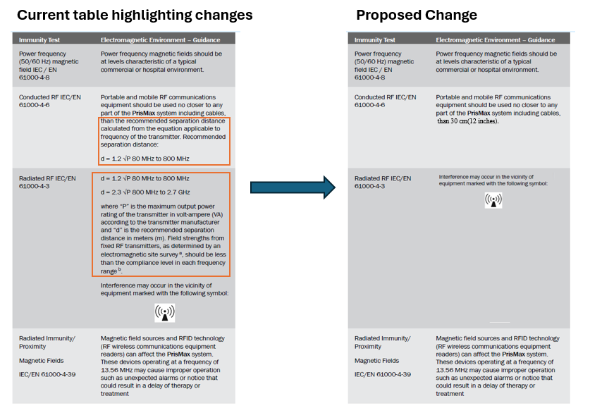

Figure 110: RF separation distance to be removed

###### TherMax Malfunction alarm

Update **3.1.6.4 TherMax section**, TherMax Malfunction alarm (T2295, T2298)) operator actions from "**Continue**" button to "**Override**" button. Update Override instructions. Refer to Figure below –

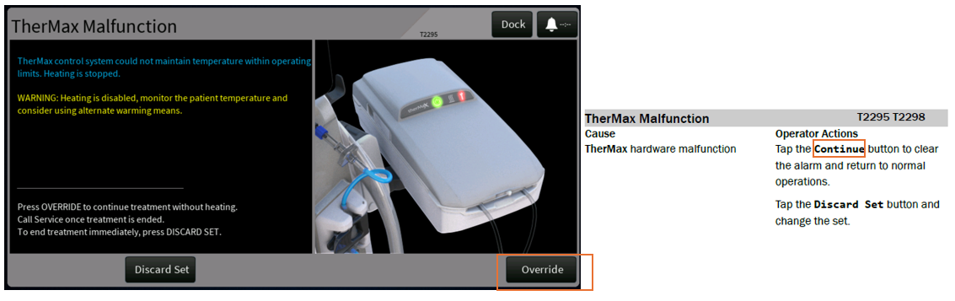

Figure 111: T2295 and T2298 Alarm Override button Instruction to be added

###### **HF20** minimum BFR

Update ‘**Table 9-50’** for **HF20** minimum BFR to be 20 instead of 10. Update operator’s manual, defaults from **’10’ to ‘20’** mL/min. Refer to Figure below –

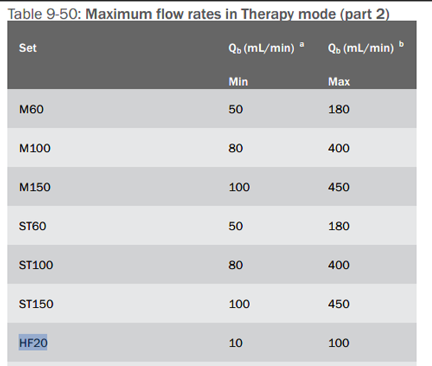

Figure 112: HF20 Flow Rates Minimum Range to be Updated

###### PfHCT (Post Filter HCT)

The PfHCT (Post Filter HCT) restriction of 65% is not described in the Operator’s Manual. Missing information in the operator manual. Update **5.5.12 CRRT Software Calculations section**, Post-filter hematocrit description to add text ‘**The system limits all flow rate changes such that the PfHCT(Post Filter HCT) does not exceed 65%.’**

###### **PrisMax - Communication Lost alarm(**T2255) alarm

Update section **3.1.6.4 TherMax, PrisMax - Communication Lost alarm(**T2255) Operator Actions, to replace ‘**Alarm Off’** button **to ‘Override’** button. Refer to Figure below –

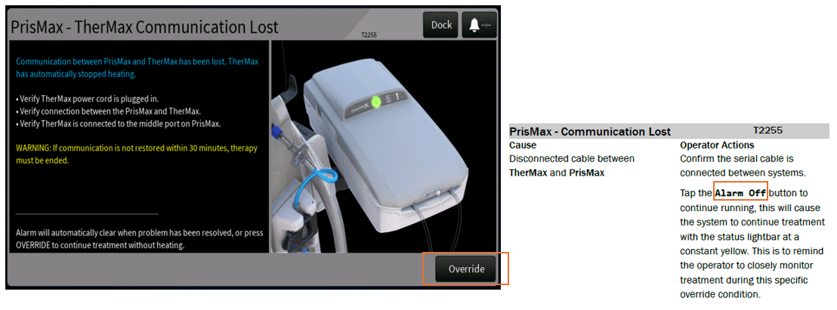

Figure 113: T2255 Alarm Override button Instruction to be added

###### **TherMax Power Switch Off** (T2288) Alarm

Update section **3.1.7.3 TherMax**, **TherMax Power Switch Off** (T2288) Alarm text to **replace ‘**TherMax Power **Switch** Off’ **to ‘**TherMax Power **Button** Off’. Refer to Figure below –

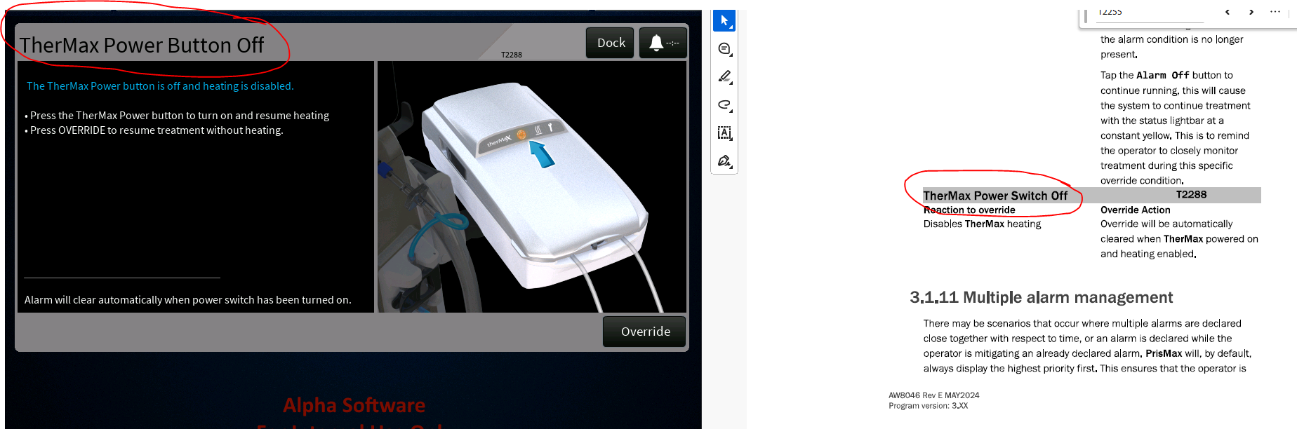

Figure 114: T2288 Alarm Title to be Updated

###### **About flow path management**

Update section **7.3.1 About flow path management** – ‘WARNING! Text’ to replace ‘return line’ to ‘access/return lines’. Refer to Figure below –

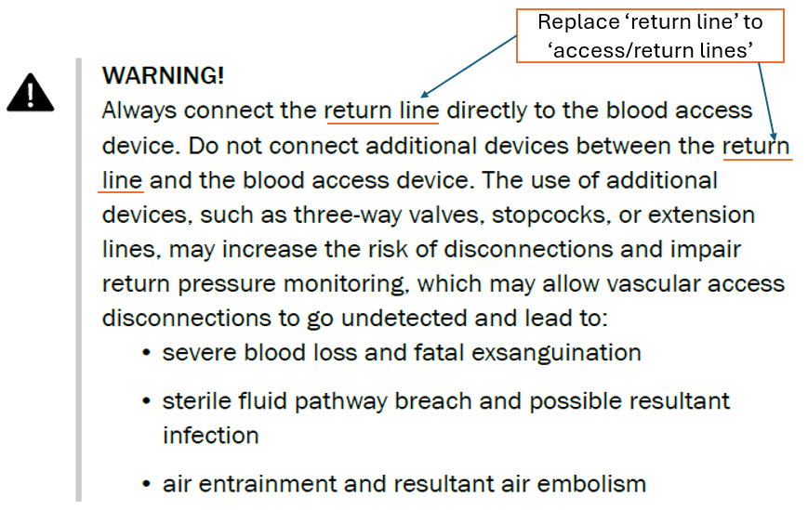

Figure 115: Warning text to be updated

###### **BLD Normalize Failed(T1313)** alarm

Update section **3.1.8.1 General**, **BLD Normalize Failed(T1313)** alarm, Operator Actions to,

* Rephrase “Squeeze the air bubbles out of the return line.” to “**Squeeze the air bubbles out of the effluent line**”
* Delete statement “Tap the **Discard Set** button and change the front set”, as this alarm recovery option is not relevant
* Add Reprime instructions **“Tap the Reprime button to start the priming again from the beginning.”**

###### **Priming Pause Time Exceeded (T1144) alarm**

Update section ‘**3.1.8.1 General’**, **Priming Pause Time Exceeded** (**T1144)** Alarm, Operator Actions to,

* Add Reprime instructions **“Tap the Reprime button to start the priming again from the beginning.”** Add Flush instruction “**Press Flush button if available to flush the patient lines.”**
* Update text to include ‘Continue’ button action

##### Update the English Master XML for SW 3.7[PFAL-2660]

###### Pre-Blood Pump Hardware Failure(T2329) alarm

Update section ‘**3.1.7.1 General’**, Pre-Blood Pump Hardware Failure(T2329) alarm to remove redundant ‘pump’ text as highlighted in the figure below –

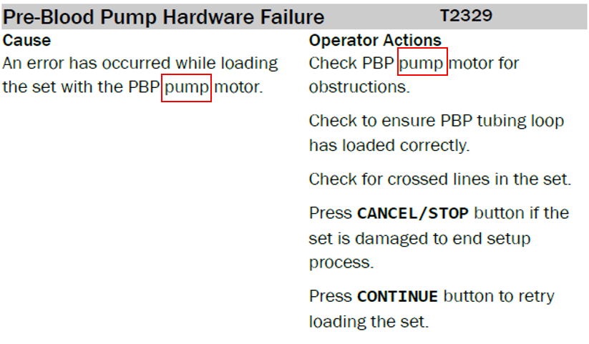

Figure 116: T2329 PBP Hardware Failure Alarm

## Software Design Specification Analysis

* The related requirements from SDS8001[R6] are detailed in Table 15
* The modified requirements from SDS8001 [R6] are detailed in Table 16

Table 15 – Related SDS

| **ID** | **Requirement Text** |
| --- | --- |
| **Ensure default settings are configured prior to use [PFAL-2473]** | |
|  | **4.3.1.4 Alarm: Defaults Not Set** |
| SDS-965 | The alarm priority is INFO. |
| SDS-2764 | The alarm is cleared by PrisMax entering the initial state; changing the therapy configuration to not use TherMax; or by connecting a TherMax with legal software, authentication value/serial number matching an entry in the list of verified TherMax devices, and calibrations/SSTs reported passing. |
| SDS-2765 | The alarm priority is INFO. |
|  | **4.14 Service** |
| SDS-3350 | The TherMax configuration page displays the serial number for the currently attached TherMax, along with the status indicating one of the following conditions:   * SST/Calibration failed: set when any SST/Calibration tests have either not been successfully executed or PM is due; * SST/Calibration passed: set when all SST/Calibration tests have been successfully executed and PM is not due, but the reported TherMax device authentication value does not match an entry in the list of authenticated devices;   TherMax device authenticated ("paired"): set when all SST/Calibration tests have been successfully executed and PM is not due, and the reported TherMax device authentication value matches an entry in the list of authenticated devices |
| SDS-3347 | The TherMax configuration page displays the list of authenticated TherMax devices. with the entry (if present) for the currently attached device highlighted. |
| SDS-3331 | The list of authenticated TherMax devices will allow up to 20 entries, and the capability to delete selected entries from the list will be provided. |
| SDS-3348 | If the currently attached TherMax does not have an entry in the list of authenticated TherMax devices, the capability to create a new entry with defaulted authentication data will be provided.  The capability will be disabled if any of the following conditions are true:  - The TherMax device has not successfully passed all SST/calibration tests;  - PM is due;  - The list is currently full. |
| **Reduce occurrences of ARPS BIOT Alarms (PFAL-2477)** | |
|  | **3.5.7** ARPS |
|  | **3.5.7.2** Alarm: ARPS Leak |
| **SDS-2139** | Alarm shall be generated if the ARPS is unable to generate the required pressure within 60 seconds. |
|  | **3.5.7.3** Alarm: ARPS Self Test Fail |
| **SDS-2143** | Alarm shall be generated if any of the following conditions occur during the self-test:  Tubing compliance  ARPS Pressurization (runs a pressure check)  12V ARPS stop test |
|  | **3.5.7.4** Alarm: ARPS Pressure not zero |
| **SDS-2175** | Alarm shall be generated if the absolute value of the ARPS pressure is greater than 15 mmHg when New Patient is selected, and all other pressures are in range +/- 5 mmHg. |
|  | **3.5.3** Return Pressure |
|  | **3.5.3.13** Alarm: Return Pressure Self-Test Fail |
| **SDS-2147** | Software shall check for alignment between the return pressure and ARPS pressure by executing the following steps:  1. Capture initial pressure measured by the return pressure sensor.  2. Run ARPS pump until the ARPS pressure reaches the initial pressure from previous step.  3. Open the return valve in ARPS.  4. Delay to equalize the pressures and read the pressure of both ARPS and the return pressure.  5. Alarm if the pressures do not match the expected outcome after the delay. |
| **Reduce occurrence of B1593 alarm declared in Re-prime after air introduced in ABD (PFAL-2474)** | |
|  | **3.5.3** Return Pressure |
|  | **3.5.3.13** Alarm: Return Pressure Self-Test Fail |
| **SDS-2147** | Software shall check for alignment between the return pressure and ARPS pressure by executing the following steps:  1. Capture initial pressure measured by the return pressure sensor.  2. Run ARPS pump until the ARPS pressure reaches the initial pressure from previous step.  3. Open the return valve in ARPS.  4. Delay to equalize the pressures and read the pressure of both ARPS and the return pressure.  5. Alarm if the pressures do not match the expected outcome after the delay. |
| **Priming alarms update for alarms that triggers restart of the priming process[PFAL-2472]** | |
|  | 4.3.4 Priming |
|  | **4.3.4.1.5** Alarm: HP Bag Empty |
| SDS-804 | Alarm is generated when the calculated remaining volume of fluid in the HP priming bag is less than the empty threshold volume for that bag.  The remaining volume is calculated by using the system configuration value for the initial volume and integrating the flow rate over time.  The empty threshold is 30 ml for glucose, and 20 ml for all other priming solutions. |
| SDS-805 | The CONTINUE button is enabled immediately.  The Alarm is cleared when CONTINUE is pressed. |
| SDS-806 | The alarm priority is INFO. |
| SDS-2744 | In HP therapies, if the fluid prime or reprime operation is aborted due to an alarm and must be restarted, then the operation is restarted at the point after the initial filling of the access line is complete. |
|  | **4.3.4.1.6** Alarm: CRRT/TPE Priming Bag Empty |
| SDS-813 | Alarm is raised at the appropriate points in TPE and CRRT therapy priming sequences where it is convenient to change the bag to ensure that the bag never runs dry during the sequence. |
| SDS-814 | The CONTINUE button is enabled immediately.  The Alarm is cleared when CONTINUE is pressed. |
| SDS-815 | On continue, the fluid priming step shall resume from the point of the alarm, as opposed to restarting the fluid prime step from the beginning. |
| SDS-816 | The alarm priority is INFO. |
|  | **4.3.4.1.7** Alarm: Wrong Set Selected - HF/LF |
| SDS-818 | For a high flow set, alarm shall be generated if the total change in weight in the configured effluent bag(s) is in the range specified by the thresholds T1 and T2 specified for the circuit set, as defined in SDS-2550.  For a low flow set, alarm shall be generated if the total change in weight in the configured effluent bag(s) is greater than the threshold T2 specified for the circuit set, as defined in SDS-2550.  The weight change on the effluent scale is measured over the last 30 second period with the blood pump running of the first priming cycle. |
| SDS-2491 | The software shall immediately stop priming operation when the alarm is raised, and restart the fluid prime step once the alarm is cleared by the operator. |
| SDS-820 | The alarm priority is INFO. |
|  | 4.3.4.1.8 Alarm: AEE Effluent Bag Incorrect |
| SDS-822 | Alarm shall be generated in the fluid priming step if the measured weight on the front effluent scale is less than 69g. |
| SDS-824 | The alarm priority is INFO. |
|  | 4.3.4.1.8 Alarm: Effluent Bag Incorrect |
| SDS-826 | Alarm shall be generated in the fluid priming step if the measured weight on the front effluent scale is less than 69g.  Note: applies to CRRT without AE, CRRT with AE being reused, and TPE/HP, and to either the 5L or 9L bags. |
| SDS-828 | The alarm priority is INFO. |
|  | **4.3.4.1.10** Alarm: AEE Effluent Drain Bag Incorrect |
| SDS-830 | Alarm shall be generated in the fluid priming step if AEE is enabled, and the measured weight on the rear effluent scale is less than 20g. |
| SDS-832 | The alarm priority is INFO. |
|  | **4.3.4.1.11** Alarm: Dialysate Bag Empty or Line Clamped |
| SDS-834 | Alarm shall be generated during fluid priming while the dialysate pump is commanded to run in the clockwise direction if the total expected mass flow exceeds the actual mass flow by over 10g. |
| SDS-836 | The alarm priority is INFO. |
|  | **4.3.4.1.13** Alarm: Replacement Bag Empty or Line Clamped |
| SDS-842 | Alarm shall be generated during fluid priming while the replacement pump is commanded to run in the clockwise direction if the total expected mass flow exceeds the actual mass flow by over 10g. |
| SDS-844 | The alarm priority is INFO. |
|  | **4.3.4.1.14** Alarm: Preblood Bag Empty or Line Clamped |
| SDS-846 | Alarm shall be generated during fluid priming while the preblood pump is commanded to run in the clockwise direction if the total expected mass flow exceeds the actual mass flow by over 10g. |
| SDS-848 | The alarm priority is INFO. |
|  | **4.3.4.1.15** Alarm: Crossed AEE Lines |
| SDS-850 | Alarm shall be declared if AE is enabled and not reused and any of the following conditions are met:  During the fluid prime step the pinch valves are set to fill into the front bag, and a weight increase of more than 50g is observed on the rear effluent scale;  During the fluid prime step the pinch valves are set to fill into the rear bag, and a weight increase of more than 50g is observed on the front effluent scale;  During either manual or blood priming, a weight increase of more than 50g is observed on the rear effluent scale.  Typically indicates that front and rear bags are switched. |
| SDS-852 | The alarm priority is INFO. |
|  | **4.3.4.1.16** Alarm: Bag on wrong scale |
| SDS-854 | Alarm shall be declared if AE is disabled; the system is performing either the fluid prime step, manual/blood prime operation, or a rinse(flush) operation; and a weight increase of more than 50g is observed on the rear effluent scale.  Typically indicates that a bag was hung on the rear scale when no bag should be there. |
| SDS-856 | The alarm priority is INFO. |
|  | **4.3.4.1.17** Alarm: Return connected to effluent in AE re-use |
| SDS-858 | Alarm shall be declared if AE is enabled and being reused; the system is performing either the fluid prime step, manual/blood prime operation; or a rinse(flush) operation; and a weight increase of more than 50g is observed on the rear effluent scale.  Typically indicates that return was connected to the AE set, instead of to the additional effluent bag hung on the effluent scale. |
| SDS-860 | The alarm priority is INFO. |
|  | **4.3.4.1.18** Alarm: Return connected to effluent after recirculation |
| SDS-862 | Alarm shall be declared in rinse(flush) operations performed after saline recirculation if a weight increase of more than 50g is observed on either effluent scale  Typically indicates that return was connected to either the effluent bag or the AE set, instead of to the priming solution bag. |
| SDS-864 | The alarm priority is INFO. |
|  | **4.3.4.1.19** Alarm: Effluent Bag not Filling, AE Enabled |
| SDS-866 | Alarm shall be generated if AE is enabled and the total change in weight on the configured effluent bag(s) is less than the specified value of threshold T1 for the circuit set defined in SDS-2550.  The weight change on the effluent scale is measured over the last 30 second period with the blood pump running of the first priming cycle. |
| SDS-868 | The alarm priority is INFO. |
|  | **4.3.4.1.20** Alarm: Effluent Bag not Filling, AE Enabled, re-using AE set |
| SDS-870 | Alarm shall be generated if AE is enabled and being reused and the change in weight on the front effluent bag is less than the specified value of threshold T1 for the circuit set defined in SDS-2550.  The weight change on the effluent scale is measured over the last 30 second period with the blood pump running of the first priming cycle. |
| SDS-872 | The alarm priority is INFO. |
|  | **4.3.4.1.21** Alarm: Effluent Bag not Filling, AE Disabled |
| SDS-874 | For CRRT, the alarm shall be generated if AE is disabled and the change in weight on the front effluent bag is less than the specified value of threshold T1 for the circuit set defined in SDS-2550.  The weight change on the effluent scale is measured over the last 30 second period with the blood pump running of the first priming cycle.  For HP, the alarm is raised while fluid prime is active, and the measured increase of the effluent bag over a 4 second period is less than 50% of the commanded blood flow rate. |
| SDS-876 | The alarm priority is INFO. |
|  | **4.3.4.1.22** Alarm: Effluent Bag not Filling, TPE |
| SDS-878 | Alarm shall be generated in TPE and the change in weight on the front effluent bag is less than the specified value of threshold T1 for the circuit set defined in SDS-2550.  The weight change on the effluent scale is measured over the last 30 second period with the blood pump running of the first priming cycle. |
| SDS-880 | The alarm priority is INFO. |
|  | **4.3.4.1.24** Alarm: Insufficient Effluent Capacity |
| SDS-882 | Alarm shall be declared in CRRT therapy if auto-drain is not enabled or is being reused, and the remaining capacity of the effluent bag is insufficient for the expected effluent amount generated. |
| SDS-884 | The alarm priority is INFO. |
|  | **4.3.4.1.25** Alarm: Insufficient Effluent Capacity for TPE Prime |
| SDS-886 | Alarm shall be declared in TPE therapy if the remaining capacity of the effluent bag is insufficient for the expected effluent amount generated. |
| SDS-888 | The alarm priority is INFO. |
|  | **4.3.4.1.26** Alarm: HP Effluent Bag Full |
| SDS-2626 | Alarm shall be generated during HP therapy if the effluent weight exceeds the bag capacity for 5 seconds; and the estimated remaining generated effluent is greater than 10% (TBR) of the effluent bag capacity. |
| SDS-2627 | The CONTINUE button shall be enabled immediately.  Alarm shall be cleared if the operator presses CONTINUE to resume. |
| SDS-2629 | On continue, the fluid priming step shall resume from the point of the alarm.  As opposed to restarting the fluid prime step from the beginning. |
| SDS-2628 | The alarm priority is INFO. |
|  | **4.6.2.3.1** Disposable not Inflated Alarm |
| SDS-2791 | Alarm is raised if the return pressure has not reached 250 mmHg before a predefined volume VThreshold of priming fluid has been consumed, and a minimum of 150 mL has been displaced since the start of the bag inflation sequence.  VThreshold is defined as follows:  (1) Treatments without ECCO2R:  VThreshold = 200 mL  (2) Treatments with ECCO2R:  VThreshold = Volumes of access line + blood side of filter + filtrate side of filter + PrismaLung+ extension line + PrismaLung+ gas-exchanger + 100 mL. |
| SDS-2793 | The alarm priority is INFO. |
| SDS-2794 | The alarm is cleared by the user selecting the CONTINUE button. Upon clearing the alarm, the fluid prime step is restarted. |
|  | **4.6.2.3.2** Disposable not Connected Alarm |
| SDS-2787 | Alarm is raised if any one of the following conditions is met:  •The measured Return line volume of fluid moved by the blood and fluid pumps in the test to determine that the TherMax disposable is present is less than the minimum volume threshold for that set;  •The return pressure does not exceed 100 mmHg within 50 seconds for CRRT or HP sets;  •The return pressure does not exceed 100 mmHg within 80 seconds for TPE sets;  •The measured volume exceeds 4 times the minimum volume to reach 100 mmHg.  The minimum volume threshold to reach 100 mmHg for each filter set is;  •11.45 ml for M60/ST60 sets  •14.70 ml for M100/ST100 sets  •17.54 ml for M150/ST150/Oxiris sets  •14.99 ml for HF1000/septeX sets  •15.26 ml for HF1400 set  •13.47 ml for TPE1000 set  •13.77 ml for TPE2000 set  •9.75 ml for HP Adsorba 150 set  •11.67 ml for HP Adsorba 300 set  •10.71 ml for HPx set |
| SDS-2788 | The alarm priority is INFO. |
| **Include additional logging for B0916 alarm occurrence [PFAL-2471]** | |
| SDS-1575 | Software shall declare this alarm within 5 seconds if any running critical therapy task stops responding during a treatment, where task is defined as internal CP SW processes; included in the DataStore, Therapy, GUI, and ioMgr VAS. These should not include kernel and OS Modules. |
| SDS-3352 | If o general system failure is detected and the alarm processing task status is not ready or pending, then the software resets the system without raising the B0916 alarm.  This will cause the PSC to sound the backup speaker (if the patient is attached), and the B2222 Unexpected Reset alarm to be raised when the system restarts. |
| SDS-2269 | The alarm priority is HIGH. The safe state is automatically set to SYSTEM_HALT when the alarm is raised. |
| **PBP Bag empty alarm not coming up at the right time (PFAL-2470)** | |
|  | **3.4.6 Alarm: Bag Empty** |
| SDS-342 | Alarm is declared if the calculated amount of fluid remaining is less than the minimum fluid volume threshold for the container.  Note that this alarm does not apply to the replacement container in TPE, refer to 3.4.7 for TPE Container Empty alarm processing. |
| SDS-3321 | The amount of fluid remaining in the container is calculated as the scale weight minus the container weight when empty, where the scale weight is determined as the average of the two weight channels for the scale and filtered through a low-pass filter with a 1 second time constant. |
| SDS-343 | Alarm shall be cleared if the pump flow rate is set to zero, or a bag change is completed on this bag. |
| SDS-344 | The alarm priority is LOW. The safe state is automatically set to STOP_FLUID_PUMPS when the alarm is raised. |
|  | **3.4.7 Alarm: Replacement Container Empty** |
| SDS-370 | The TPE Replacement Container Empty alarm is declared if the measured weight on the scale is less than the calculated container empty threshold. |
| SDS-3193 | The container empty threshold is set when a TPE Replacement Container is hung on the replacement scale as  TCE = WI - VP  where TCE is the calculated container empty threshold, WI is the initial weight of the container, and VP is the user entered volume of replacement fluid in the container. |
| SDS-2876 | The software shall display to the user the remaining TPE volume to be delivered when the alarm is raised. |
| SDS-3192 | The alarm allows the user to request that additional volume to be delivered. If the user requests that additional volume be delivered, then the container empty threshold is updated as  TCE = TCE -VA  where TCE is the calculated container empty threshold, and VA is the user entered additional volume of replacement fluid to be delivered. |
| SDS-3195 | The ability to deliver additional volume is disabled if the current scale weight minus the minimum Tare calculated when the container was placed on the scale is less than 10 mL. |
| SDS-3194 | The additional amount of replacement fluid to be delivered is constrained as follows:   * volume is specified in 10 mL increments, * minimum amount is 10 mL,   maximum amount is the current scale weight minus the minimum Tare calculated when the container was placed on the scale, rounded down to the nearest 10 mL increment. |
| SDS-371 | Alarm shall be cleared when the bag has been changed and the new replacement container volume entered by the user, or if the user has requested that additional volume be delivered. |
| SDS-372 | The alarm priority is LOW. The safe state is automatically set to STOP_FLUID_PUMPS when the alarm is raised. |
| **Alarm T2124 is not raised at the right time [PFAL-2475]** | |
|  | 4.3.4.1.40 Alarm: Unsuitable Calcium Solution |
| SDS-938 | Alarm shall be generated if the selected calcium solution is unsuitable based on the patient weight.  Reference SRS RCA section for details. |
| SDS-939 | The CONTINUE button shall be enabled immediately.  The Alarm shall be cleared when CONTINUE is pressed. |
| SDS-940 | The alarm priority is INFO. |
|  | **4.5 Anticoagulation** |
| SDS-2981 | Software uses the following table to determine suitability of the selected calcium solution versus patient data. |
| **Enable to autochart PFR with EMR systems [PFAL-2466]** | |
|  | **4.7.3.4.5 USB Export/Import Tab** |
| SDS-3294 | The software will export/import therapy profiles and the following system configuration information to/from a USB drive:  - Display Brightness  - Status Light Brightness  - Dose Measurement  - CRRT Filtration Fraction  - Chart Interval  - Chart Begin Time  - Dose Begin Time  - Anticoagulation Checkpoint Reminder  - Chart Interval Audible Reminder  - Date Display Format  - Time Display Format  - Alarm Volume  - Enabled features and accessories (if licensed on the destination machine)  - Default Effluent Bag Size  - Default Citrate Dose  - Custom HP-X Set Information  - Default HP-X Set  - Default Syringe Brand  - Default Ca++ Syringe Brand  - Custom CRRT Citrate Solution Information  - Default CRRT Citrate Solution  - Custom Calcium Syringe Solution Information  - Default Calcium Syringe Solution  - Custom Replacement Solution Information  - Default Replacement Solution  - Custom Dialysate Solution Information  - Default Dialysate Solution  - Custom TPE Citrate Solution Information  - Default TPE Citrate Solution  - Legacy EMR Baud Rate  - Remote Alarm  - Call Type  - EMR ID  - EMR Timer  - Data Output Enabled |
| **Undetermined Causes of Foam Detect Alarm T2315 [PFAL-2606]** | |
| SDS-2992 | Alarm is declared if auto-leveling is enabled and any of the following conditions is true:  ⦁ Liquid is detected at the foam sensor;  ⦁ The lower sensor is disabled, and foam is detected;  ⦁ The lower sensor is enabled, and any of the following conditions is true while applying the foam management algorithm described in SDS-3357:  ⦁ Foam is present after the maximum air volume has been added to the deaeration chamber;  ⦁ LLS lower sensor indicates a dry condition when adding air to the deaeration chamber;  ⦁ the LLS upper sensor reports a wet condition or foam is present when removing air from the deaeration chamber. |
|  |  |

Table 16 – Modified SDS

| **Forked Original ID** | **Requirement Text** | **New ID** | **Proposed Text** | **Allocating SRS Requirement** | | **Rationale** |
| --- | --- | --- | --- | --- | --- | --- |
| **Priming alarms update for alarms that triggers restart of the priming process [PFAL-2472]** | | | | | | |
|  | **4.3.4.1.7** Alarm: Wrong Set Selected - HF/LF | | | | |  |
| SDS-819 | The CONTINUE button shall be enabled immediately.  The Alarm shall be cleared when CONTINUE is pressed. | SDS-3766 | The REPRIME button shall be enabled immediately.  The Alarm shall be cleared when REPRIME is pressed.  *System automatically navigates to prepare to reprime screen once the alarm is cleared by the operator.* | SRS-8137 | | Rephrased to include Reprime workflow and updated alarm clear condition; |
|  | 4.3.4.1.8 Alarm: AEE Effluent Bag Incorrect | | | | |  |
| SDS-823 | The CONTINUE button shall be enabled immediately.  The Alarm shall be cleared when CONTINUE is pressed. Alarm is disabled if AEE set is not enabled, or is being reused. | SDS-3767 | The REPRIME button shall be enabled immediately.  The Alarm shall be cleared when REPRIME is pressed. Alarm is disabled if AEE set is not enabled, or is being reused.  *System automatically navigates to prepare to reprime screen once the alarm is cleared by the operator.* | SRS-8141 | | Rephrased to include Reprime workflow and updated alarm clear condition; |
|  | 4.3.4.1.8 Alarm: Effluent Bag Incorrect | | | | |  |
| SDS-2492 | The software shall immediately stop priming operation when the alarm is raised, and restart the fluid prime step once the alarm is cleared by the operator. | SDS-3769 | The software shall immediately stop priming operation when the alarm is raised. | SRS-8141 | | Rephrased to include Reprime workflow |
| SDS-827 | The CONTINUE button shall be enabled immediately.  The Alarm shall be cleared when CONTINUE is pressed. The alarm shall be disabled if AE is enabled and not being reused. | SDS-3770 | The REPRIME button shall be enabled immediately.  The Alarm shall be cleared when REPRIME is pressed. The alarm shall be disabled if AE is enabled and not being reused.  *System automatically navigates to prepare to reprime screen once the alarm is cleared by the operator.* | SRS-8141 | | Rephrased to include Reprime workflow and updated alarm clear condition; |
|  | **4.3.4.1.10** Alarm: AEE Effluent Drain Bag Incorrect | | | | |  |
| SDS-831 | The CONTINUE button shall be enabled immediately.  The Alarm shall be cleared when CONTINUE is pressed. | SDS-3771 | The REPRIME button shall be enabled immediately.  The Alarm shall be cleared when REPRIME is pressed.  *System automatically navigates to prepare to reprime screen once the alarm is cleared by the operator.* | SRS-8141 | | Rephrased to include Reprime workflow and updated alarm clear condition; |
|  | **4.3.4.1.11** Alarm: Dialysate Bag Empty or Line Clamped | | | | |  |
| SDS-835 | The CONTINUE button shall be enabled immediately.  The Alarm shall be cleared when CONTINUE is pressed. | SDS-3772 | The REPRIME button shall be enabled immediately.  The Alarm shall be cleared when REPRIME is pressed.  *System automatically navigates to prepare to reprime screen once the alarm is cleared by the operator.* | SRS-8136 | | Rephrased to include Reprime workflow and updated alarm clear condition; |
|  | **4.3.4.1.13** Alarm: Replacement Bag Empty or Line Clamped | | | | |  |
| SDS-843 | The CONTINUE button shall be enabled immediately.  The Alarm shall be cleared when CONTINUE is pressed. | SDS-3773 | The REPRIME button shall be enabled immediately.  The Alarm shall be cleared when REPRIME is pressed.  *System automatically navigates to prepare to reprime screen once the alarm is cleared by the operator.* | SRS-8136 | | Rephrased to include Reprime workflow and updated alarm clear condition; |
|  | **4.3.4.1.14** Alarm: Preblood Bag Empty or Line Clamped | | | | |  |
| SDS-847 | The CONTINUE button shall be enabled immediately.  The Alarm shall be cleared when CONTINUE is pressed. | SDS-3774 | The REPRIME button shall be enabled immediately.  The Alarm shall be cleared when REPRIME is pressed.  *System automatically navigates to prepare to reprime screen once the alarm is cleared by the operator.* | SRS-8136 | | Rephrased to include Reprime workflow and updated alarm clear condition; |
|  | **4.3.4.1.15** Alarm: Crossed AEE Lines | | | | |  |
| SDS-851 | The CONTINUE button shall be enabled immediately.  The Alarm shall be cleared when CONTINUE is pressed. | SDS-3775 | The REPRIME button shall be enabled immediately.  The Alarm shall be cleared when REPRIME is pressed.  *System automatically navigates to prepare to reprime screen once the alarm is cleared by the operator.* | SRS-8138 | | Rephrased to include Reprime workflow and updated alarm clear condition; |
|  | **4.3.4.1.16** Alarm: Bag on wrong scale | | | | |  |
| SDS-855 | The CONTINUE button shall be enabled immediately.  The Alarm shall be cleared when CONTINUE is pressed. This alarm is disabled if performing the rinse (flush) operation immediately after a saline recirculation. | SDS-3776 | The REPRIME button shall be enabled immediately.  The Alarm shall be cleared when REPRIME is pressed. This alarm is disabled if performing the rinse (flush) operation immediately after a saline recirculation.  *System automatically navigates to prepare to reprime screen once the alarm is cleared by the operator.* | SRS-8139 | | Rephrased to include Reprime workflow and updated alarm clear condition; |
|  | **4.3.4.1.17** Alarm: Return connected to effluent in AE re-use | | | | |  |
| SDS-859 | The CONTINUE button shall be enabled immediately.  The Alarm shall be cleared when CONTINUE is pressed. This alarm is disabled if performing the rinse (flush) operation immediately after a saline recirculation. | SDS-3777 | The REPRIME button shall be enabled immediately.  The Alarm shall be cleared when REPRIME is pressed. This alarm is disabled if performing the rinse (flush) operation immediately after a saline recirculation.  *System automatically navigates to prepare to reprime screen once the alarm is cleared by the operator.* | SRS-8139 | | Rephrased to include Reprime workflow and updated alarm clear condition; |
|  | **4.3.4.1.18** Alarm: Return connected to effluent after recirculation | | | | |  |
| SDS-863 | The CONTINUE button shall be enabled immediately.  The Alarm shall be cleared when CONTINUE is pressed. | SDS-3778 | The REPRIME button shall be enabled immediately.  The Alarm shall be cleared when REPRIME is pressed.  *System automatically navigates to prepare to reprime screen once the alarm is cleared by the operator.* | SRS-8139 | | Rephrased to include Reprime workflow and updated alarm clear condition; |
|  | **4.3.4.1.19** Alarm: Effluent Bag not Filling, AE Enabled | | | | |  |
| SDS-867 | The CONTINUE button shall be enabled immediately.  The Alarm shall be cleared when CONTINUE is pressed. | SDS-3779 | The REPRIME button shall be enabled immediately.  The Alarm shall be cleared when REPRIME is pressed.  *System automatically navigates to prepare to reprime screen once the alarm is cleared by the operator.* | SRS-8344 | | Rephrased to include Reprime workflow and updated alarm clear condition; |
|  | **4.3.4.1.20** Alarm: Effluent Bag not Filling, AE Enabled, re-using AE set | | | | |  |
| SDS-871 | The CONTINUE button shall be enabled immediately.  The Alarm shall be cleared when CONTINUE is pressed. | SDS-3780 | The REPRIME button shall be enabled immediately.  The Alarm shall be cleared when REPRIME is pressed.  *System automatically navigates to prepare to reprime screen once the alarm is cleared by the operator.* | SRS-8344 | | Rephrased to include Reprime workflow and updated alarm clear condition; |
|  | **4.3.4.1.21** Alarm: Effluent Bag not Filling, AE Disabled | | | | |  |
| SDS-875 | The CONTINUE button shall be enabled immediately.  The Alarm shall be cleared when CONTINUE is pressed. Alarm is disabled if AE is enabled and not being re-used. | SDS-3781 | The REPRIME button shall be enabled immediately.  The Alarm shall be cleared when REPRIME is pressed.  Alarm is disabled if AE is enabled and not being re-used.  *System automatically navigates to prepare to reprime screen once the alarm is cleared by the operator.* | SRS-8344 | | Rephrased to include Reprime workflow and updated alarm clear condition; |
|  | **4.3.4.1.22** Alarm: Effluent Bag not Filling, TPE | | | | |  |
| SDS-879 | Continue shall be immediately enabled. | SDS-3782 | The REPRIME button shall be enabled immediately.  The Alarm shall be cleared when REPRIME is pressed.  *System automatically navigates to prepare to reprime screen once the alarm is cleared by the operator.* | SRS-8344 | | Rephrased to include Reprime workflow and updated alarm clear condition; |
|  | **4.3.4.1.24** Alarm: Insufficient Effluent Capacity | | | | |  |
| SDS-883 | The CONTINUE button shall be enabled immediately.  The Alarm shall be cleared when CONTINUE is pressed. | SDS-3783 | The REPRIME button shall be enabled immediately.  The Alarm shall be cleared when REPRIME is pressed.  *The system automatically navigates to prepare to reprime screen once the alarm is cleared by the operator.* | SRS-8160 | | Rephrased to include Reprime workflow and updated alarm clear condition; |
|  | **4.3.4.1.25** Alarm: Insufficient Effluent Capacity for TPE Prime | | | | |  |
| SDS-887 | Continue shall be immediately enabled. | SDS-3784 | The REPRIME button shall be enabled immediately.  The Alarm shall be cleared when REPRIME is pressed.  *System automatically navigates to prepare to reprime screen once the alarm is cleared by the operator.* | SRS-8160 | | Rephrased to include Reprime workflow and updated alarm clear condition; |
|  | **4.6.2.3.2** Disposable not Connected Alarm | | |  | |  |
| SDS-2789 | The alarm is cleared by the user selecting either the CONTINUE or REPRIME button.  If the user selected the REPRIME button, then the fluid prime step is restarted; otherwise fluid prime continues. | SDS-3785 | The alarm is cleared by the user selecting either the CONTINUE or REPRIME button.  If the user selected the REPRIME button, then the fluid prime step is restarted; otherwise fluid prime continues  *System automatically navigates to prepare to reprime screen once the alarm is cleared by the operator.* | SRS-8435 | | Rephrased to include Reprime workflow and updated alarm clear condition; |
| **Reduce occurrences of ARPS BIOT alarms [PFAL-2477]** | | | | | | |
|  | **3.5.2.1 Alarm: Pod Reposition Failure** | | | | | |
| SDS-2163 | Alarm shall be declared if a pod fails to complete repositioning within 4 minutes or the pod pressure and ARPS pressure are not within 20mmHg when the corresponding solenoid is open. | SDS-3973 | Alarm shall be declared if a pod fails to complete repositioning within 4 minutes or the pod pressure and ARPS pressure are not within 30mmHg when the corresponding solenoid is open. | SRS-8083 | | Increased the allowable pressure sensor difference between ARPS and pod. |
| **Reduce occurrence of B1593 alarm declared in Re-prime after air introduced in ABD (PFAL-2474)** | | | | | | |
|  | **3.5.3.14 Alarm: Return Pressure Sensor Prime Test Failed** | | | | | |
| SDS-2151 | The difference between the return pressure and the ARPS pressure is calculated 10 seconds after the valve to the return chamber is opened. The alarm shall be generated if this difference exceeds 10 mmHg.  Refer to SRS-3967 for the definition of the return pressure sensor test. | SDS-3974 | The difference between the return pressure and the ARPS pressure is calculated 10 seconds after the valve to the return chamber is opened. The alarm shall be generated if this difference exceeds 12 mmHg. | SRS-8083 | Increased the allowable pressure sensor difference between ARPS and return. | |
| SDS-3244 | Alarm is raised if when adjusting the effluent pod position as part of fluid priming the system is unable to equalize the APRS pressure to the effluent pressure, or to raise the effluent pressure to the desired target.  The conditions are:  Equalizing ARPS to Effluent pressure to within 10 mmHg took greater than 45 seconds when pushing effluent pod out, and greater than 30 seconds when pulling pod in;  Unable to create more then 350 mmHg when pushing effluent pod out;  Overall operation (either pushing pod out or pulling it back) lasted over 45 seconds.  Issue is signaled by the priming model, refer to Priming model ADD for further description.  Note that issue can occur either in fluid priming step when the effluent pod diaphragm is pushed out, or when the effluent pod diaphragm is pulled back to the original position as part of post prime operations. | SDS-3975 | Alarm is raised if when adjusting the effluent pod position as part of fluid priming or post priming is unable to equalize the APRS pressure to the effluent pressure, or to raise the effluent pressure to the desired target.  The conditions are:  Equalizing ARPS to Effluent pressure to within 15 mmHg took greater than 45 seconds when pushing effluent pod out or pulling pod in;  Unable to create more than 350 mmHg when pushing effluent pod out;  Overall operation lasted over 60 seconds for pushing pod out, and over 90 seconds for pulling it back.  Issue is signaled by the priming model, refer to Priming model ADD for further description.  Note that issue can occur either in fluid priming step when the effluent pod diaphragm is pushed out, or when the effluent pod diaphragm is pulled back to the original position as part of post prime operations. | SRS-8083 | Changed thresholds to make the system less eager to raise alarms. | |
| **Errors in reported PFR when disturbances occur on scales with flow rate of zero [PFAL-2465]** | | | | | | |
|  | **3.4.1 Alarm: Predicted Weight Error** | | | | | |
| SDS-223 | Alarm shall be declared if the magnitude of the scale weight error is greater than the weight error threshold for 5.5 seconds | SDS-3976 | Alarm shall be declared if the magnitude of the scale weight error for a scale corresponding to a pump with a non-zero prescription flow rate is greater than the weight error threshold for 5.5 seconds. | SRS-8050 | Non-rotating pumps cannot change patient fluid balance. Fault conditions that could affect fluid balance (e.g. uncommanded rotation, non-occlusive pump) are covered by other alarms. | |
| SDS-251 | Alarm shall be declared if the difference between the scale weight and the weight when the controller was paused (reference weight) is greater than 20g for 4 seconds and the standard deviation of the scale weight over any 2 second window remained less than 5 g.  Note:  If the scale weight is unstable (standard deviation exceeds 5 g) then when the scale stabilizes the reference weight is reset to the new weight. | SDS-3977 | Alarm shall be declared if the difference between the stable scale weight and the weight when the controller was paused (reference weight) is greater than 20g for 4 seconds and the standard deviation of the scale weight over any 2 second window remained less than 5 g independent of prescription flow rate.  Note:  If the scale weight is unstable (standard deviation exceeds 5 g) then when the scale stabilizes the reference weight is reset to the new weight. | SRS-8051 | Clarification to specify STABLE scale weight and that this alarm does NOT depend on prescription flow rate. Uncommanded pump rotation, a bag leak, or non-occlusive pump could trigger this alarm. | |
| SDS-3570 | Alarm shall be declared if either of the following conditions is true:  - Fluid pumps have been operating for 60 seconds, and a bag weight stable condition has been false for 60 seconds;  - Fluid pumps have been paused without either an operator stop (emergency stop or AE set change) or alarm that stops the pump being active for 60 seconds; and a scale is unstable | SDS-3978 | Alarm shall be declared if either of the following conditions is true:  - Fluid pumps have been operating for 60 seconds, and a bag weight stable condition has been false for 60 seconds for a bag corresponding to a pump with non-zero prescription flow rate;  - Fluid pumps have been paused without either an operator stop (emergency stop or AE set change) or alarm that stops the pump being active for 60 seconds; and a scale corresponding to a pump with non-zero prescription flow rate is unstable | SRS-8052 | Non-rotating pumps cannot change patient fluid balance. Fault conditions that could affect fluid balance (e.g. uncommanded rotation, non-occlusive pump) are covered by other alarms. | |
|  | 3.4.3 Alarm: Weight Unstable | | | | | |
| SDS-2414 | The SP will fault if the following conditions are true for greater than or equal to 10s:  . • The calculated PFR error is greater than (110% of the gain loss limit +5g)  • The effluent pump is running  • Patient is attached  • Therapy type is CRRT  Notes:  (1) Scales and pumps which are unused based on selected therapy and AE status will be excluded from the PFR error  calculation.  (2) Makeup rate will account for body weight.. | SDS-3980 | The SP will fault if the following conditions are true for greater than or equal to 10s:  • The calculated PFR error is greater than (110% of the gain loss limit +5g)  • The effluent pump is running  • Patient is attached  • Therapy type is CRRT  Notes:  (1) Scales and pumps which are unused based on selected therapy and AE status or correspond to a pump with a zero prescription flow rate will be excluded from the PFR error calculation.  (2) Makeup rate will account for body weight.. | SRS-6814 | Non-rotating pumps cannot change patient fluid balance. Fault conditions that could affect fluid balance (e.g. uncommanded rotation, non-occlusive pump) are covered by other alarms. | |
| **PBP Bag empty alarm not coming up at the right time (PFAL-2470)** | | | |  | |  |
| SDS-3322 | The container weight when empty is set to 100g for replacement and dialysate bags, and to 7g + (0.0112g x container size) for PBP bags, where the container size is given in mL. | SDS-3764 | The container weight when empty is set to 100g for replacement and dialysate bags, and to 7g + (0.0112g x container size) for PBP bags, where the container size is given in mL.  Note: Applicable for PBP Citrate bags also. | SRS-8053 | | Added note to indicate that requirement is applicable for PBP Citrate bags |
| SDS-3323 | The minimum fluid volume threshold for the container is set to 130g for replacement and dialysate bags, and to 0.0334g x container size for PBP bags, where the container size is given in mL. | SDS-3765 | The minimum fluid volume threshold for the container is set to 130g for replacement and dialysate bags, and to 0.0334g x container size for PBP bags, where the container size is given in mL.  Note: Applicable for PBP Citrate bags also. | SRS-8053 | | Added note to indicate that requirement is applicable for PBP Citrate bags |
| **Ensure default settings are configured prior to use [PFAL-2473]** | | | | | | |
|  | **4.3.1.4 Alarm: Defaults Not Set** | | | | |  |
| SDS-963 | Alarm is raised when machine powers up and reaches the boot screen if any one of the following defaults is not set in SysConfig.:  - Syringe brand  - Ca++ Syringe brand  - Ca Bag Solution  - CRRT Citrate Solution  - Calcium Syringe Solution  - Replacement Solution  - TPE Citrate Solution | SDS-3756 | Alarm is raised when machine powers up and reaches the boot screen if any one of the following defaults is not set in SysConfig.:  - Syringe brand  - Ca++ Syringe brand  - Ca Bag Solution  - CRRT Citrate Solution  - Calcium Syringe Solution  - Replacement Solution  - TPE Citrate Solution  Or if CRC verification failed for Sysconfig table.  *Note:Reloading of sysconfig table will be attempted before declaring alarm.* | SRS-8166 | | Requirement updated to include CRC verification of the SysConfig table to detect data corruption.  Attempting to reload the table before raising the alarm helps prevent false alarms due to transient read errors, ensuring that the alarm is only triggered when the defaults are truly missing or the configuration is corrupted. |
| SDS-964 | Alarm is cleared when the defaults are set. | SDS-3757 | Alarm is cleared when the defaults are set and CRC verification is passed. | SRS-8166 | | Alarm clear condition updated to add CRC verification check |
|  | **4.6.1.2.2.2 Alarm: TherMax Not Valid** | | | | |  |
| SDS-2763 | The alarm is generated if the configured treatment specifies TherMax usage and communications are established, and any of the following conditions are true:   * Serial number of the TherMax device does not match the serial number of a TherMax device in the list of verified TherMax devices; * The version string for the TherMax software does not start with a character in the range ['1'..'9']; * The authentication value reported by the TherMax device does not match the stored authentication value corresponding to the reported serial number in the list of verified TherMax devices; * The "SSTs not Run" bit in the Malfunction Type field in either the Unit ID ('U') message, Setup Periodic Data ('S') message, or the Periodic Operational Data ('H') message is set;   The system is in setup mode, and the Service Required signal is set in the Capability Status field reported in the Unit Id message. | SDS-3758 | The alarm is generated if the configured treatment specifies TherMax usage and communications are established, and any of the following conditions are true:   * Serial number of the TherMax device does not match the serial number of a TherMax device in the list of verified TherMax devices; * The version string for the TherMax software does not start with a character in the range ['1'..'9']; * The authentication value reported by the TherMax device does not match the stored authentication value corresponding to the reported serial number in the list of verified TherMax devices.      * The "SSTs not Run" bit in the Malfunction Type field in either the Unit ID ('U') message, Setup Periodic Data ('S') message, or the Periodic Operational Data ('H') message is set;   The system is in setup mode, and the Service Required signal is set in the Capability Status field reported in the Unit Id message.   * CRC verification Thermax pairing table failed   Reloading of TherMax pairing table (containing serial number and hash) will be attempted before declaring alarm; | SRS-8322 | | Requirement updated to include CRC verification Thermax pairing and  Reloading of TherMax pairing table (containing serial number and hash) will be attempted before declaring alarm;. |
| **Undetermined Causes of Foam Detect Alarm T2315 [ PFAL-2606]** | | | | | | | |
| SDS-3362 | The system declares liquid present at the foam sensor if either of the following conditions is true:  ⦁ 33% of the sensor receiver output voltage samples in a 0.5 second period are < the normalized value minus 2.0 volts;  ⦁ The minimum sensor receiver output voltage over the last 0.5 seconds is 0.5 volts less than the minimum value over the preceding 0.5 second period, and the system is removing air from the deaeration chamber. | SDS-3981 | The system declares liquid present at the foam sensor if either of the following conditions is true:  ⦁ 33% of the sensor receiver output voltage samples in a 0.5 second period are < the normalized value minus 2.0 volts;  ⦁ The minimum sensor receiver output voltage over the last 0.5 seconds is 0.5 volts less than the verified minimum value over the preceding 1.67 second period, and the system is removing air from the deaeration chamber. | SRS-9545 | | Blood/liquid mixture detection algorithm is changing to be more robust against aliasing of the receiver output voltage. | |
| **Enable to autochart PFR with EMR systems [PFAL-2466]** | | | | | | | |
|  | **4.7.3.3.2 Patient Fluid Removal (CRRT)** | | |  | |  | |
| SDS-3365 | The PFR volume accumulates during the current charting period when in treatment, which includes transitions out of treatment and back into treatment:   * Same Patient * Recirculation   therapy Recovery | SDS-3750 | The PFR volume accumulates during the current charting period when in treatment, which includes transitions out of treatment and back into treatment:   * Same Patient * Recirculation | SRS-9760 | | Therapy recovery removal form requirement. | |

# Change Description (CD)

## Design Description

### Defaults not set alarm(T1722) raised when defaults (syringe) were set and Thermax SST status is correctly transmitted to PrisMax [PFAL-2473][PFAL-2484]

In the current implementation, Alarms T1722 (Defaults Not Set) and T2259 (TherMax Not Paired) are rising after bootup even though Defaults are set and connected paired TherMax but after restarting device able to recover from these errors. After analyzing the issue and code, found that incomplete data read from Database can cause this issue. So, for fixing this issue we are reloading System Defaults and TherMax pair data before raising T1722 and T2259, if it is read data completely on reload it will recover and fix the issue. Otherwise, alarms will be active and need to fix the issue.

The change implemented will do the following:

* System defaults and TherMax pair data will be reloaded to fix T1722 and T2259 alarms if the cause is incomplete data read from Database.
* Fixed auto unselecting default syringe brand on import system configuration failed.
* Fixed GUI crash when trying to delete a solution from Edit Solutions dialog and close. Disabling buttons till the operation gets completed and list updated.

#### Sequence Diagram

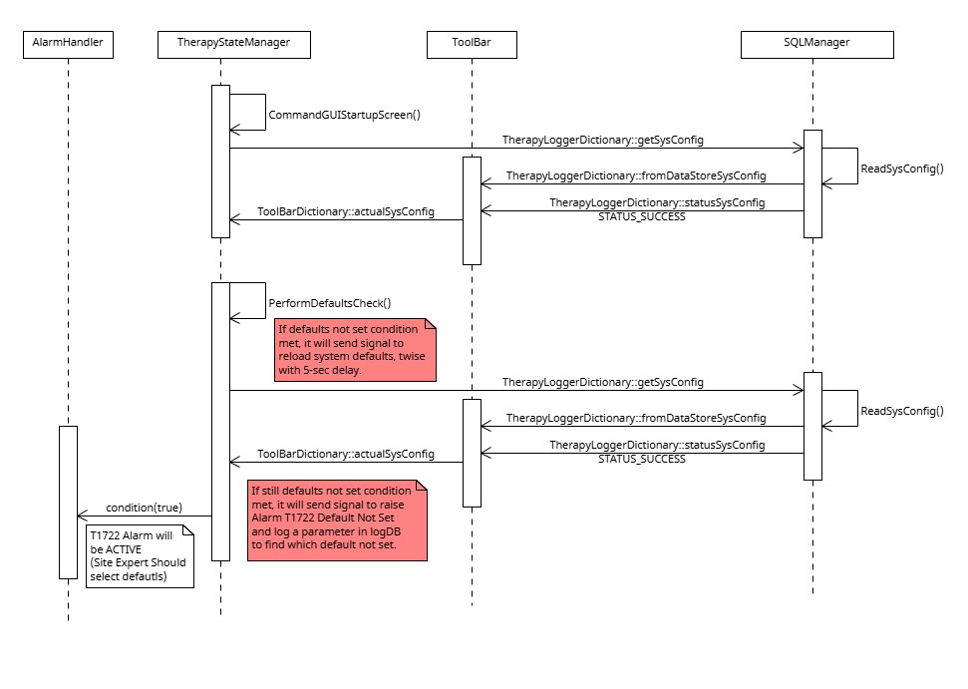

Figure 117: System Defaults Reload before T1722 Alarm Active

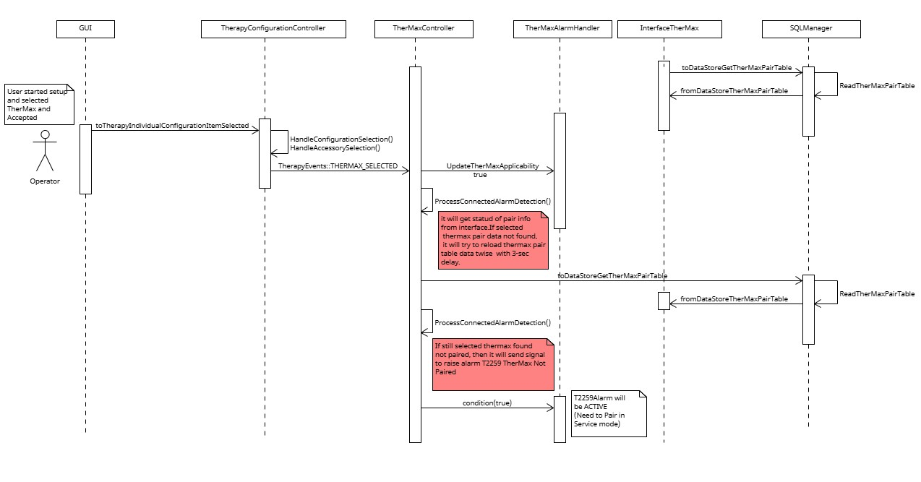

Figure 118: TherMax Pair Data Reload before T2259 Alarm Active

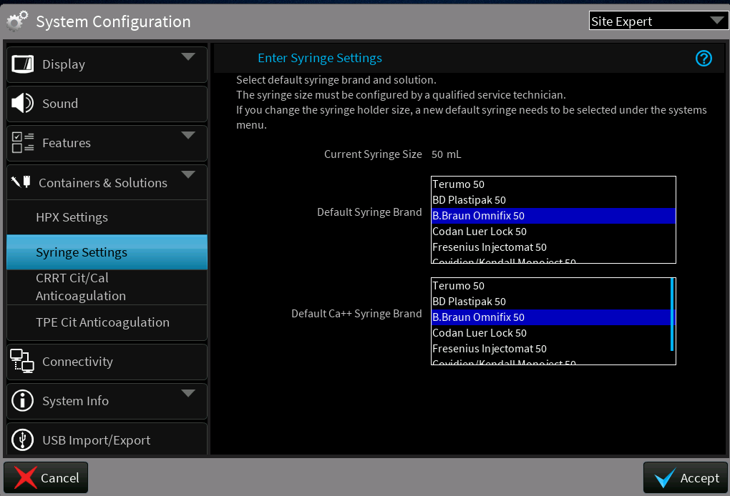

Figure 119: Syringe Selection Tables

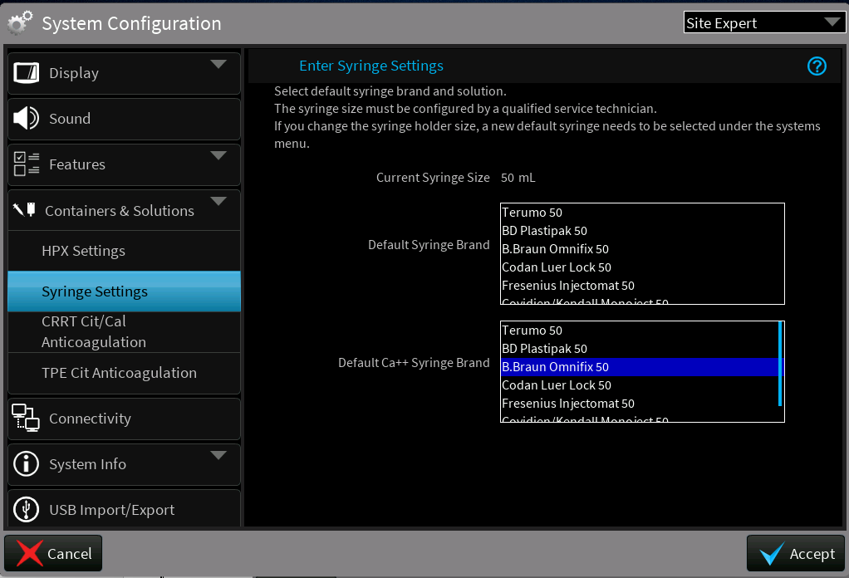

Figure 120: Syringe Selection Tables

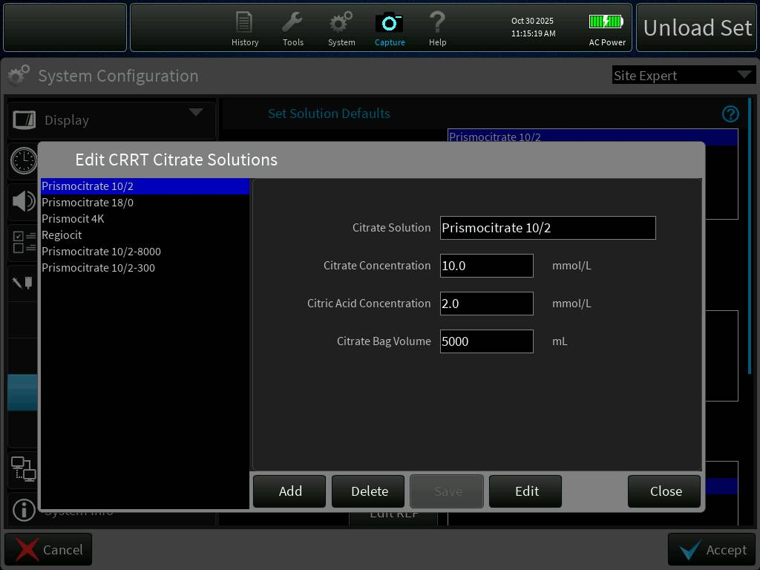

Figure 121: CRRT Citrate Solution Edit

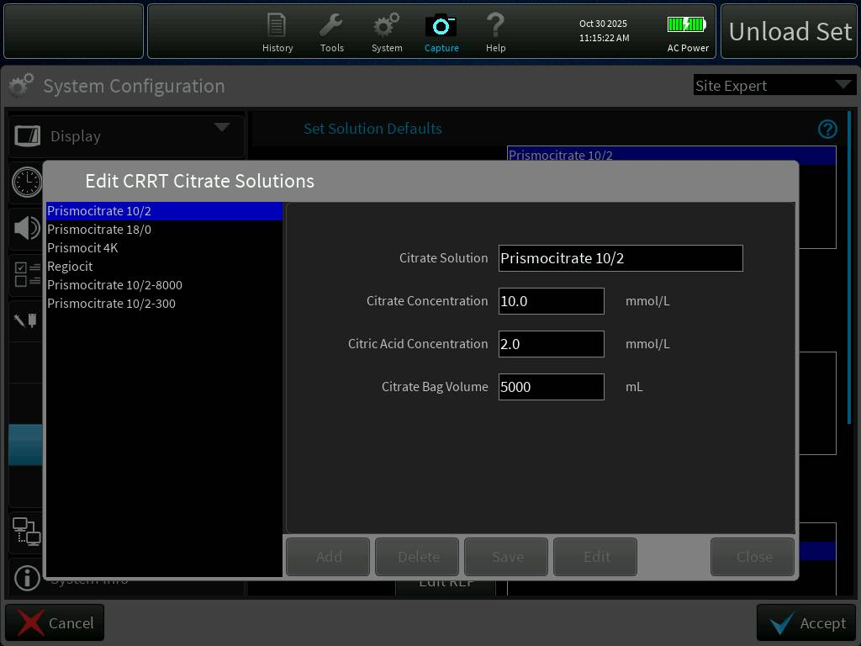

Figure 122: CRRT Citrate Solution Deletion

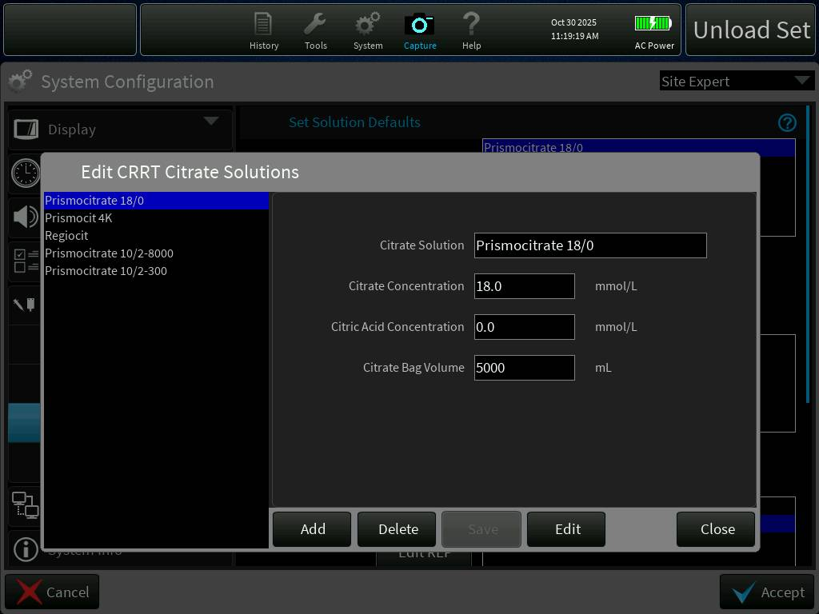

Figure 123: CRRT Citrate Solution After Delete

### Alarms can restart fluid priming without replacing priming solution [PFAL-2472]

In the current implementation, if any fluid priming alarm occurred during fluid priming, it has CONTINUE action to restart/resume fluid priming without replacing priming solution. The proposed change is to change Continue action to Reprime action and restart the fluid priming from beginning after replacing priming solution bag upon selecting Reprime action.

The change implemented will do the following:

* Reprime action takes operator to Prepare to Reprime screen to instruct replacing priming solution bag.
* Fluid priming restarts from beginning by selecting Reprime button in Prepare to Reprime screen.
* All fluid priming alarms instructions updated. (Refer to section 2.1.2.3 for changes)

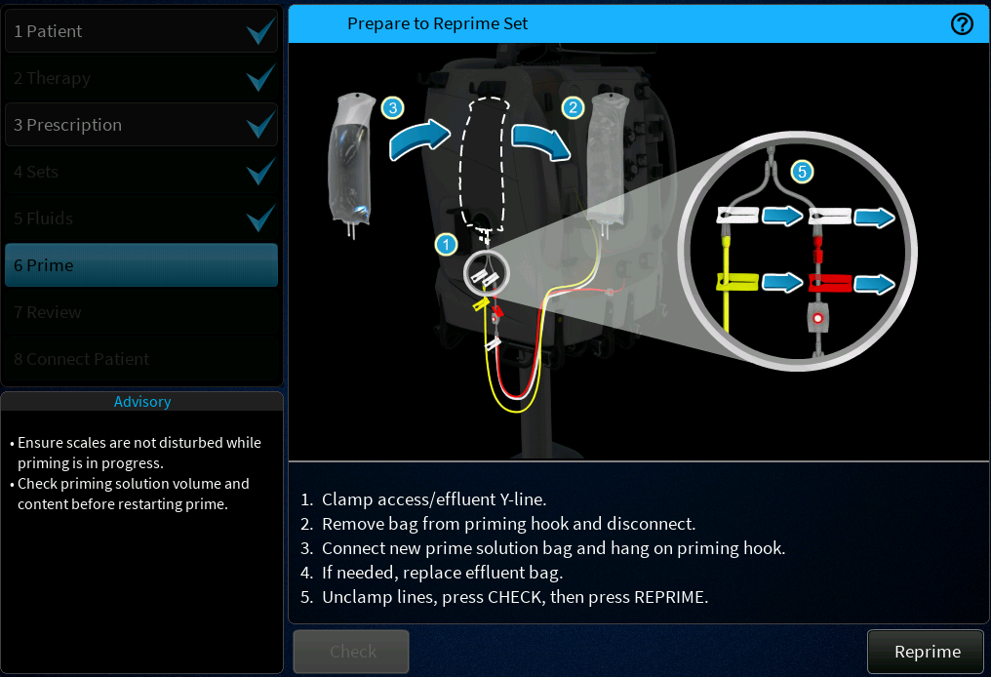

Figure 124: Prepare to Reprime screen

#### Sequence Diagram

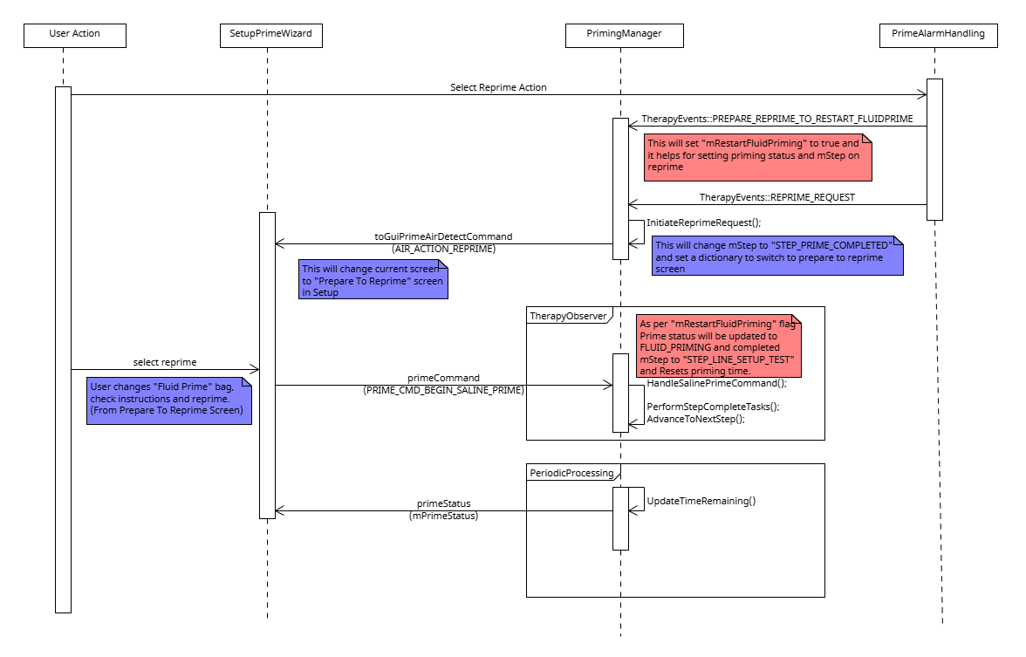

Figure 125: Restart Fluid Priming Sequence Diagram

### Reduce occurrences of ARPS BIOT Alarms [PFAL-2477]

**Controls Change Description:**

Some parameters in ARPS MATLAB models have been re-tuned to help reduce ARPS related BIOTs.

The new changes implement the following to reduce ARPS POD Reposition BIOTs B1116, B1539, B1540, B1541:

* Changed the allowed threshold between ARPS sensor and POD sensor from 20 mmHg to 30 mmHg. If the measured pressure difference is greater than this threshold, a BIOT will be raised. By increasing this threshold, the alarm will be less likely to be raised.
* Changed access pod target pressure from -425 mmHg to -400 mmHg during pod repositioning. This reduced the probability that ARPS pump can not drive the pressure to this target pressure and get stuck.
* Increased the feedback controller gain for equalizing ARPS and pod pressures from 0.1056 to 0.2. This change is to increase the control system’s performance in general.
* Increased the feedback control precision requirement between ARPS pressure and target pressure from 5 mmHg to 15 mmHg. By increasing this threshold, the system is less likely to get stuck due to unable reaching the control requirement.

The new change implements the following to reduce ARPS Self-Test BIOT B1215:

* Removed the condition that FAULT_ARPS_LEAK can lead to B1215. With this change FAULT_ARPS_LEAK will only raise B1273, but not B1215.

**PrisMax Software Change Description:**

In the field noticed that BIOTS appear frequently and interrupt the treatment process. This recurring issue is affecting the smooth flow of therapy. To prevent these disturbances and to ensure continuous treatment control level model changes and software logs are added with additional parameters to capture the information. On the control side, necessary parameters adjustments are being made to stabilize the treatment process and reduce BIOT occurrences. In software, additional logging parameters are being added to capture the more detailed system behavior during operation. These logs will help in identifying the exact conditions under this issue appears.

### Reduce occurrence of B1593 alarm declared in Re-prime after air introduced in ABD[PFAL-2474]

**Controls Change Description:**

Some parameters in PRIME MATLAB model have been re-tuned to help reduce B1593. The general guideline is to loosen up the allowed time and pressure difference threshold so that the system is more robust. By increasing those thresholds, the system is less likely to raise an alarm.

The new changes implement the following:

* Changed the allowed threshold between ARPS sensor and return sensor from 10 mmHg to 12 mmHg during return pressure sensor check.
* Increased the allowed time for ARPS pressure to reach 350 mmHg from 45 seconds to 60 seconds.
* Increased the feedback controller gain for equalizing ARPS and effluent pod pressures from 0.1056 to 0.2. This change is made to mimic what the change is made for ARPS model.
* Increased the feedback control precision requirement between ARPS pressure and effluent pod pressure from 5 mmHg to 15 mmHg.
* Increased the allowed time for ARPS pressure to equalize to effluent pod pressure from 30 seconds to 45 seconds.
* Increased the allowed time for ARPS pump to suck air from effluent pod from 45 seconds to 90 seconds.

**PrisMax Software Change Description:**

In the field noticed that B1593 alarm declared in Re-prime after air introduced in ABD appear frequently and interrupt the treatment process. This recurring issue is affecting the smooth flow of therapy. To prevent these disturbances and to ensure continuous treatment control level model changes and software logs are added with additional parameters to capture the information. On the control side, necessary parameters adjustments are being made to stabilize the treatment process and reduce BIOT occurrences. In software, additional logging parameters are being added to capture the more detailed system behavior during operation. These logs will help in identifying the exact conditions under this issue appears.

### Add additional logging for B0916 alarms[PFAL-2471]

**DESCRIPTION:**

This implementation enables the logging of information like filenames, line numbers, exception codes such as Major class, Access type and Memory type in log DB file from system exception handler to narrow down B0916 causes from past machine faults.

**ExceptionError** class encodes the exception type. From the exception type, the handler can determine what kind of exception occurred, which may have an effect on the handling that is performed for it. The upper 16-bits of the exception type indicate the major class of the exception. The next 8 bits indicates the access type. The lower 8 bits indicate the memory type of the exception. Major exception class are defined below with details of minor class, Access Type and Memory type for each exception.

* EXCEPTION_PROTECT:
  + Major class – Memory Protection exception
  + Minor class – Memory Access violation (read/write to protect memory)
  + Acess Type – Protected memory regions, kernel space, or invalid addresses
  + Logging Details example –

{

"mType": "INFO",

"mFile": "ShutdownIoMgr.cpp",

"mLine": 189,

"mMsg": "Shutdown Handler - Event Signaled. Current: 0 Activity: 3 Error: 0 PB Status: 0x00000040 Exception: Major=0x80 Minor=0x01 Access=0x02 Memory=0x04 File=sqlmgr.cpp Line=245 PC=0x12345678"

}

* EXCEPTION_CPU:
  + Major class – CPU hardware exception
  + Minor class – Processor-level faults (divide by zero, invalid instruction, etc..)
  + Access type – CPU instruction execution failure
  + Memory Type – Instruction memory or data memory causing CPU fault.
  + Logging Details example -

{

"mType": "INFO",

"mFile": "ShutdownIoMgr.cpp",

"mLine": 189,

"mMsg": "Shutdown Handler - Event Signaled. Current: 0 Activity: 3 Error: 0 PB Status: 0x00000040 Exception: Major=0x80 Minor=0x02 Access=0x01 Memory=0x08 File=mathlib.cpp Line=156 PC=0x87654321"

}

* EXCEPTION_API_FAILURE:
  + Major class – System API Exception
  + Minor class – INTEGRITY OS API call failure
  + Access type – Failed system call or API invocation
  + Memory Type – system call parameter memory or return value memory
  + Logging Details example -

{

"mType": "INFO",

"mFile": "ShutdownIoMgr.cpp",

"mLine": 189,

"mMsg": "Shutdown Handler - Event Signaled. Current: 0 Activity: 3 Error: 0 PB Status: 0x00000040 Exception: Major=0x80 Minor=0x03 Access=0x05 Memory=0x10 File=networkMgr.cpp Line=89 PC=0xABCD1234"

}

* EXCEPTION_USER_DEFINED:
  + Major class – Application defined exception
  + Minor class – custom application exception
  + Access type – user defined exception condition
  + Memory Type – Application specific memory context
  + Logging Details example -

{

"mType": "INFO",

"mFile": "ShutdownIoMgr.cpp",

"mLine": 189,

"mMsg": "Shutdown Handler - Event Signaled. Current: 0 Activity: 3 Error: 0 PB Status: 0x00000040 Exception: Major=0x80 Minor=0x04 Access=0x07 Memory=0x20 File=therapyMgr.cpp Line=312 PC=0xDEADBEEF"

}

#### Sequence Diagram

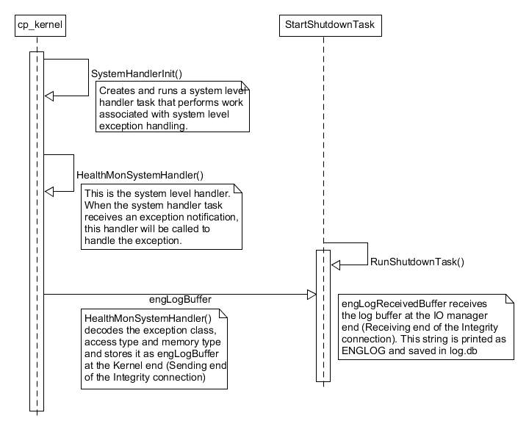

Figure 126:additional logging for B0916 alarms Sequence diagram

### PBP Bag empty alarm not coming up at the right time[PFAL-2470]

Updated design fixes the following issue:

* 1. Race Condition Between SW modules
  2. Missing Logic Condition to check the citrate anticoagulation

**IMPLEMENTATION DESCRIPTION:**

* As mentioned in the above issue, code is updated by calling ConfigurePrebloodBag() function after confirming the FCC/Constraints update, getting this information after Prescription Commit event published, then set

the PBP threshold bag weight. This prevents usage of "stale" parameters.

* When CRRT/TPE treatment choose the anticoagulation type as Cit bag/Ca++ Ext then citrate-bag parameters are used for bag personality check, otherwise standard PBP parameters are used to set Threshold bag weight.
* When operator selects TPE Therapy and chooses the external Cit bag/Ca++ Ext for the treatment, in existing code there is no provision to take the Cit bag/Ca++ Ext solution bag volume to set the PBP bag threshold weight. Code is updated to consider the TPE citrate bag volume for TPE therapy for set the PBP bag threshold weight.

#### Sequence Diagram

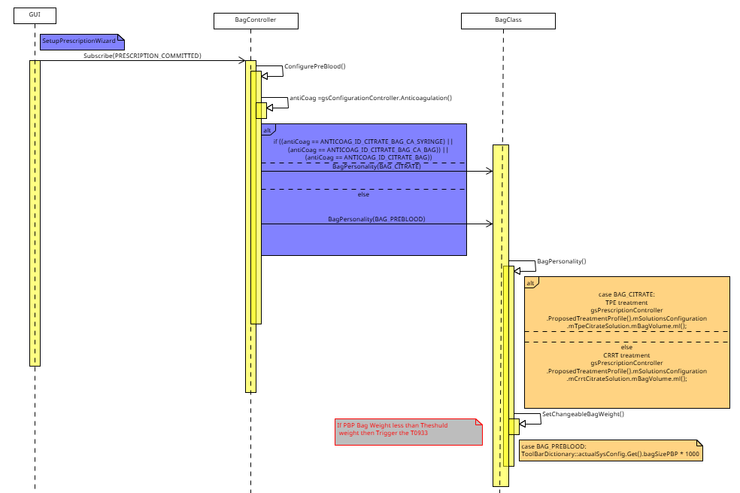

Figure 127: PBP Bag Empty Alarm Sequence Diagram

### Alarm T2124 is not raised as soon as expected [PFAL-2475]

Updated design fixes the following issue:

Asynchronous event ordering: CA_SOLUTION_CHANGE event can be observed before FCC has updated constraints. Some modules compute WeightMin/WeightMax using previous solution values.

**IMPLEMENTATION DESCRIPTION:**

* Now CheckCaSolutionSuitability() T2124 alarm evaluation function moved to Prescription Controller class from treatment session controller class, where prescription constraints and solution selection are updated.
* When operator changes Syr Ca++ solution in Prescription treatment parameter page. Prescription Controller updates its local model and sends CA_SOLUTION_CHANGE_REQUEST to FCC.
* FCC receives requests, computes constraints, and when finished publishes FCC_OUTPUTS_UPDATED, Prescription Controller subscribes to FCC_OUTPUTS_UPDATED.
* After FCC_OUTPUTS_UPDATED event is published CheckCaSolutionSuitability() is called to calculate the WeightMin/WeightMax, if selected patient weight less than calculated WeightMin or grater then calculated WeightMax T2124 Alarm is raised.

#### Sequence Diagram

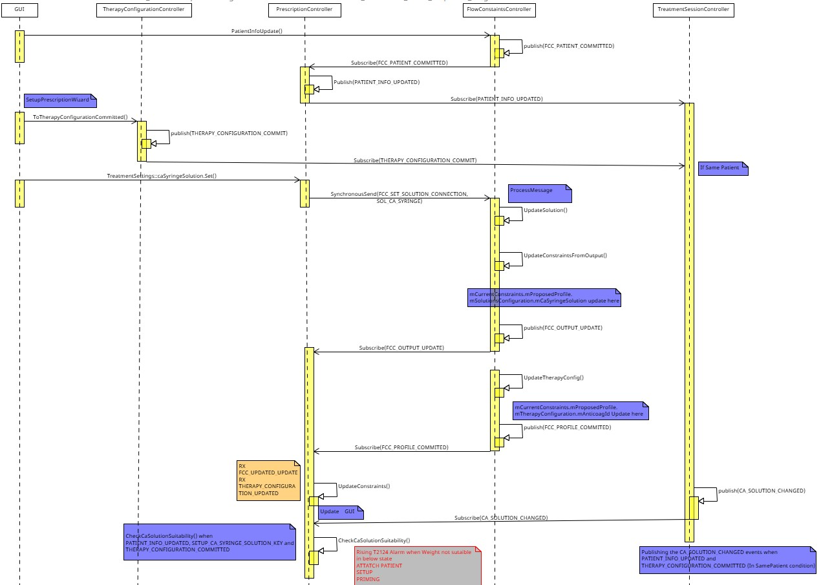

Figure 128: Unsuitable Ca Solution Alarm Sequence Diagram

#### Class Diagram

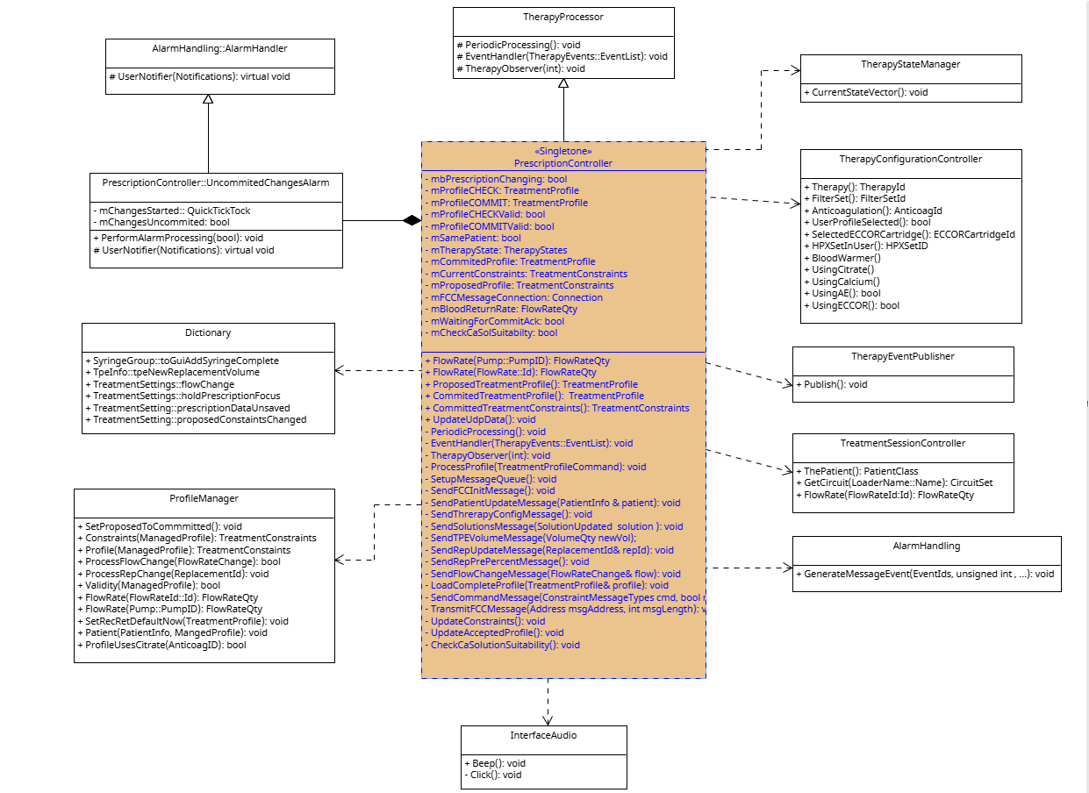

Figure 129: Unsuitable Ca Solution Alarm Class Diagram

### Unable to autochart PFR through the EMR, PFR values not resetting with same patient in EMR [PFAL-2466]

**DESCRIPTION:**

Currently, EMR parameters 458 and 459 are designated for the current PFR value and treatment total PFR value, respectively. Additionally, EMR parameter 100 resets to zero after selecting the same patient. The new changes implement the following:

* EMR parameters 458 and 459 are updated to represent the cumulative value for the last completed charting period and the cumulative value for a 24-hour period up to the last completed charting period, respectively.
* EMR parameter 100 (Total PFR removed) is modified to include the volume from previous filter sets when the "Same patient" option is used.
* These values should match the value shown on History GUI.
* Fixed negative values for parameters 418, 419, 416, and 417 for the SAME PATIENT treatment.
* The new changes involve storing Param 458 and 459 values in the database, replacing 'PFRLastChart' and 'PFRLastChartTotal' with the updated parameters.
* The 'FluidVolumes' JSON message still contains the original PFR values for 'PFRLastChart' and 'PFRLastChartTotal', which remain unchanged.

**Graph and GUI view:**

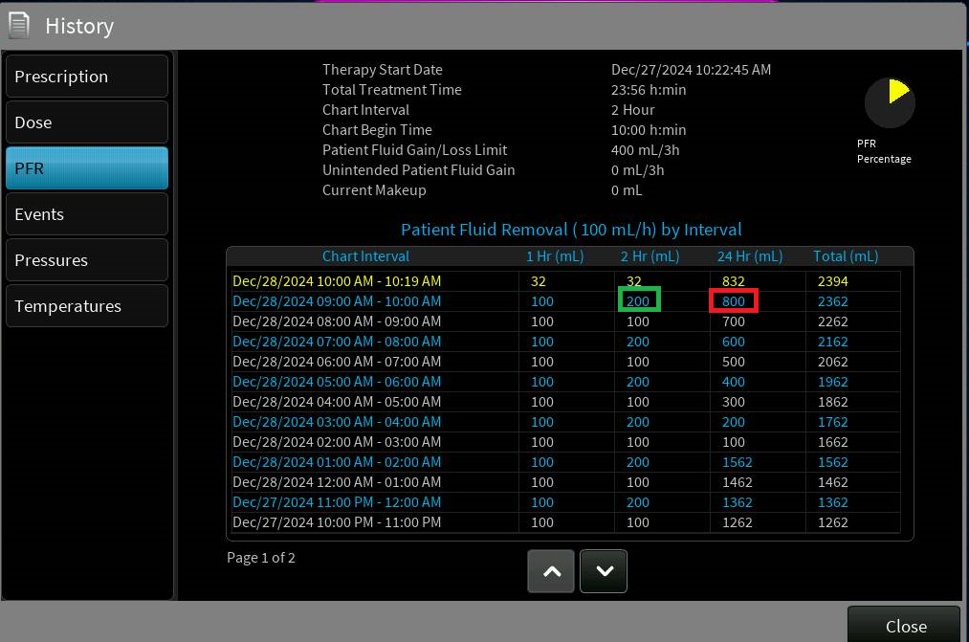

Figure 130 PFR History GUI diagram

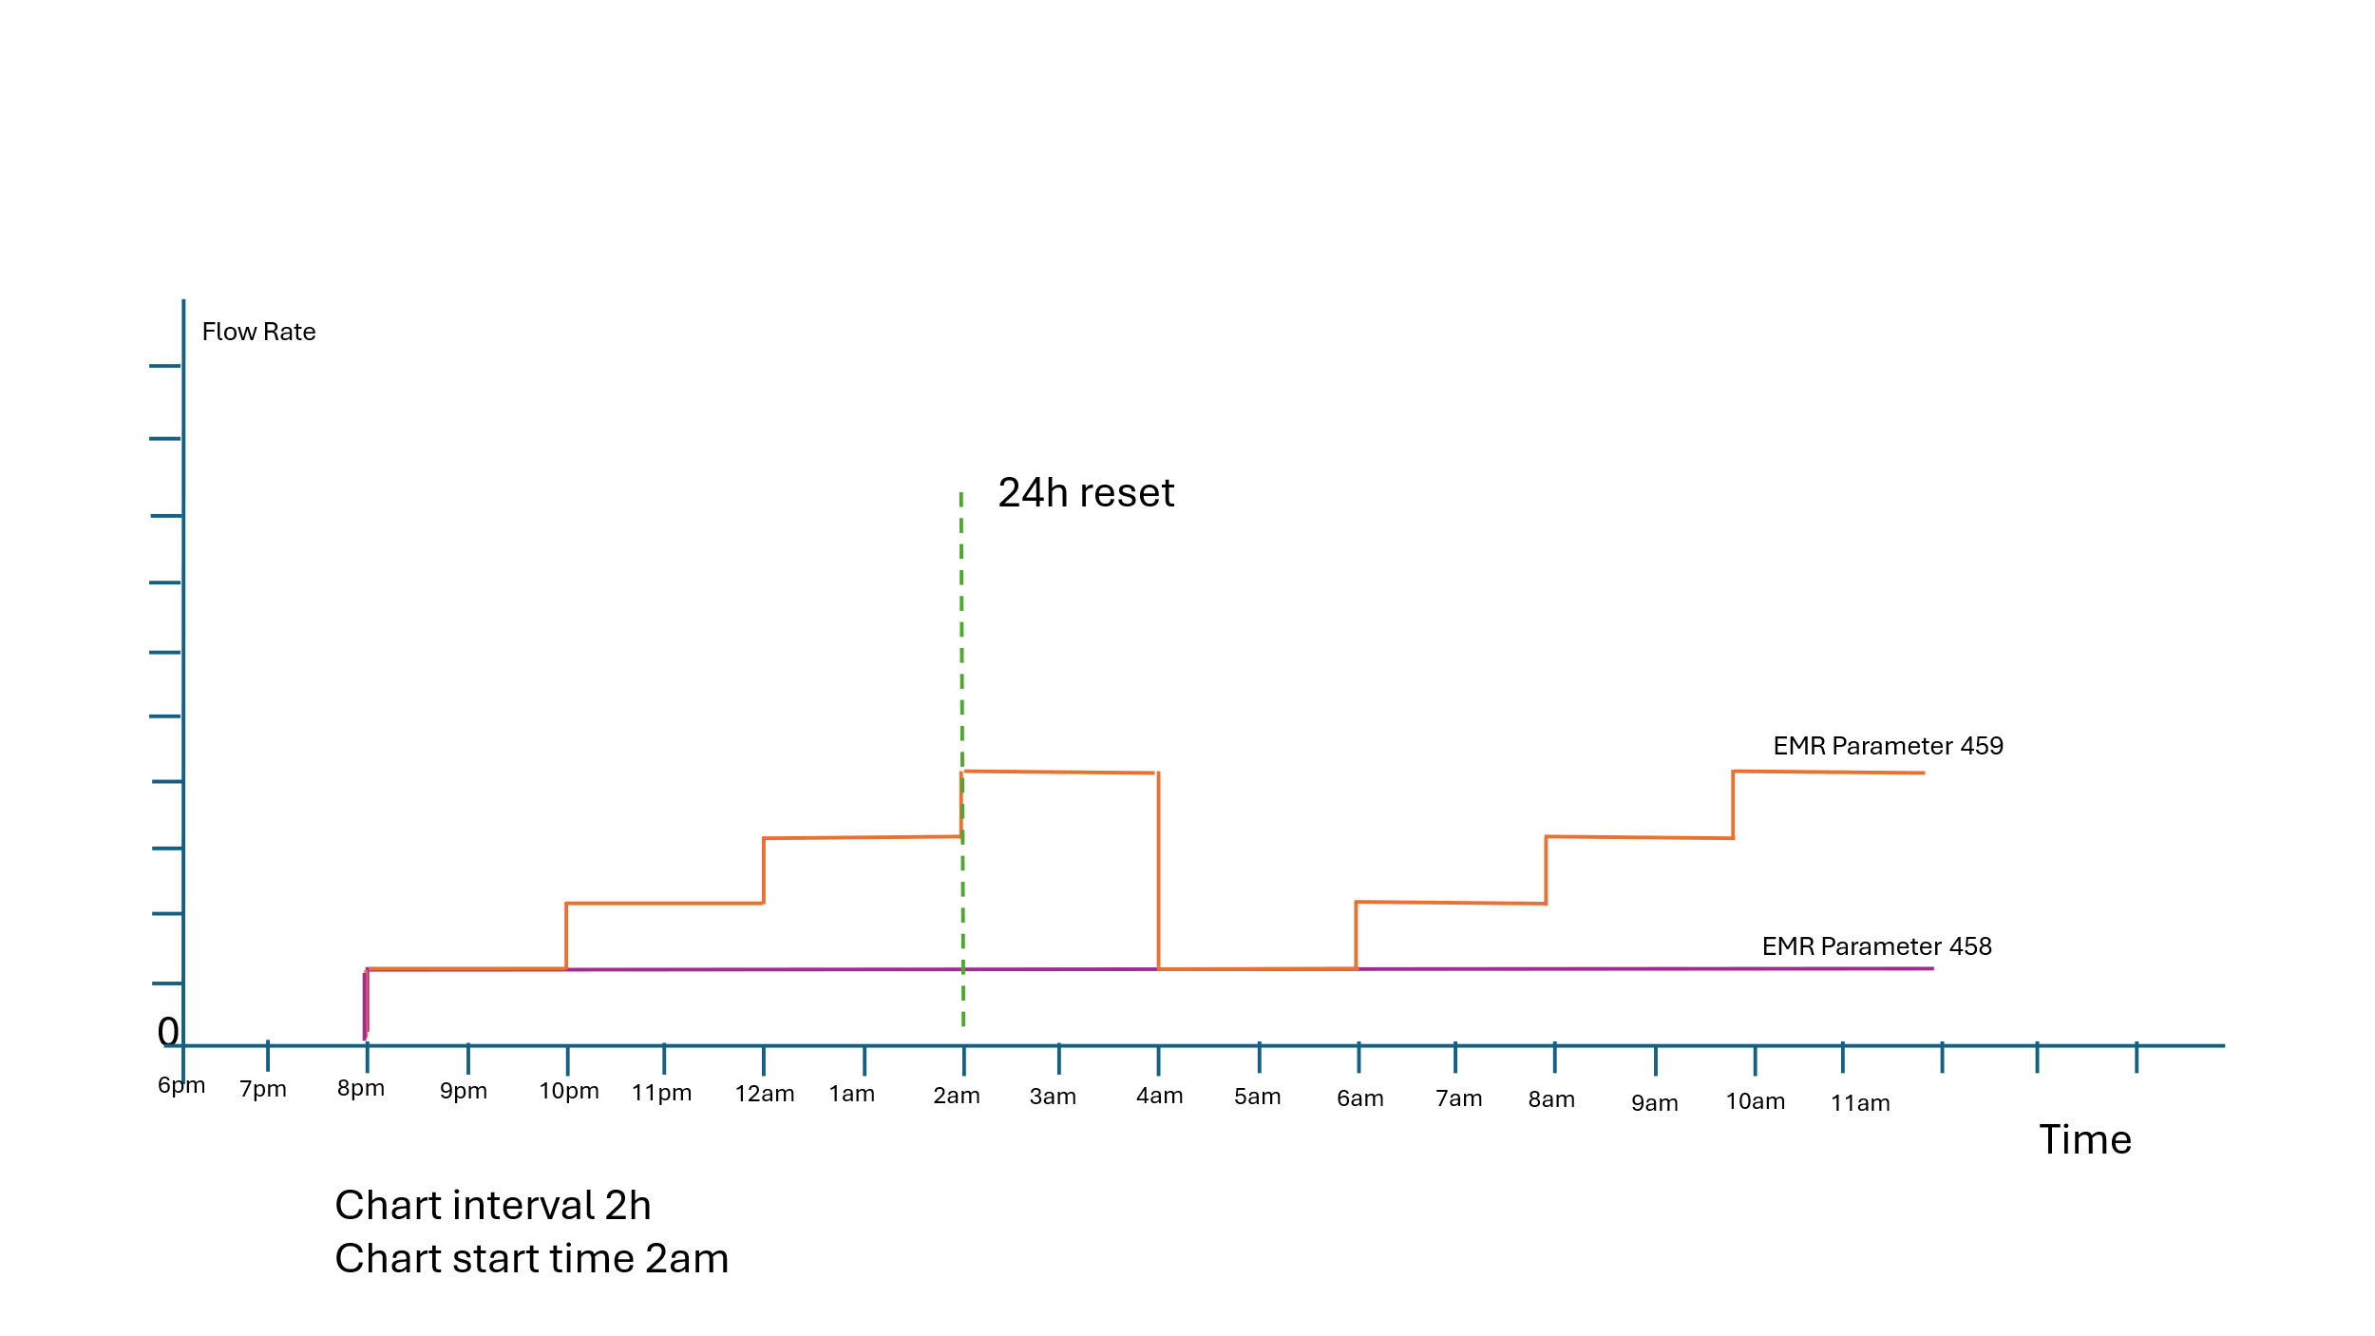

Figure 131 EMR Chart diagram

**Various EMR Scenarios:**

| Patient Type | Variations | EMR ID 458 | EMR ID 459 |
| --- | --- | --- | --- |
| New Patient | Before 1st chart rollover | 0 | 0 |
|  | Before next rollover | Previous completed rollover value until next rollover | Previous completed rollover value |
|  | Treatment break or fluid pump stop alarm or ae set change | Value remains same | Value remains same |
|  | Treatment break End mode | Value will remain same in end mode | Value will remain same in end mode |
|  | Chart rollover happened during treatment break | value contain last completed chart period value | last completed 24 hr value (till previous chart rollover value) |
|  | New patient followed by another new patient treatment | value will reset | value will reset |
|  |  |  |  |
| Same Patient |  |  |  |
|  | Before treatment begine | previous treatment last completed charting period value | previous treatment last completed 24 hr value (till previous chart rollover value) |
|  | Before 1st 1 hour rollover | previous treatment last completed charting period value | previous treatment last completed 24 hr value (till previous chart rollover value) |
|  | Before 1st chart rollover | previous treatment last completed charting period value | previous treatment last completed 24 hr value (till previous chart rollover value) |
|  | After chart rollover | last completed charting period value | last completed 24 hr value (till previous chart rollover value |
|  | Treatment break or fluid pump stop alarm or ae set change | No change | No change |

#### Sequence Diagram

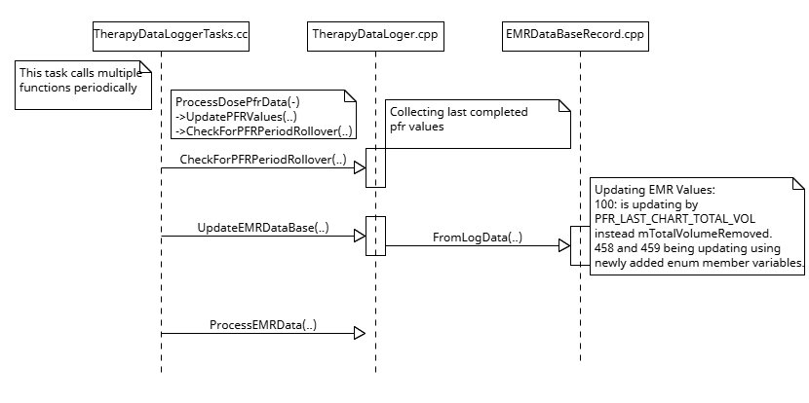

Figure 132 EMR params 100, 458 and 459 issue Sequence diagram

### GUI Issue-Display of Portuguese “ç” Characters Font size change to display numbers [PFAL-2467]

Issue 1: EU Portuguese Character Rendering

In Portuguese (BR & EU) has a special character ‘ç’. This character is not rendered properly to align with the base line of string/word. After doing analysis found, it’s problem with rendering attributes calculation for small font size while creating Latin.pak file, so for fixing this issue, updated logic in BuildMFont tool for small font size attribute calculation for character ‘ç’ and created new Latin.pak file with this update.

Issue 2: Font Display Inconsistency for Korean and Chinese

1. In Korean, Chinese (Simplified & Traditional) and Japanese have flow rate values overlap with other labels in Prescription and Ops screen due to big font size compared to Latin. Now updated source code takes font sizes given in XML and creates flow rate boxes in Prescription and Ops screen. So now flow rate values font sizes are controlled from XML and need to give proper fontsizes to fix the issue.Fixed Dose values truncation in Ops screen for Korean, Chinese (simplified & Traditional), by giving proper font size from XML.
2. Fixed Rep2 and Rep text clipping in Korean.

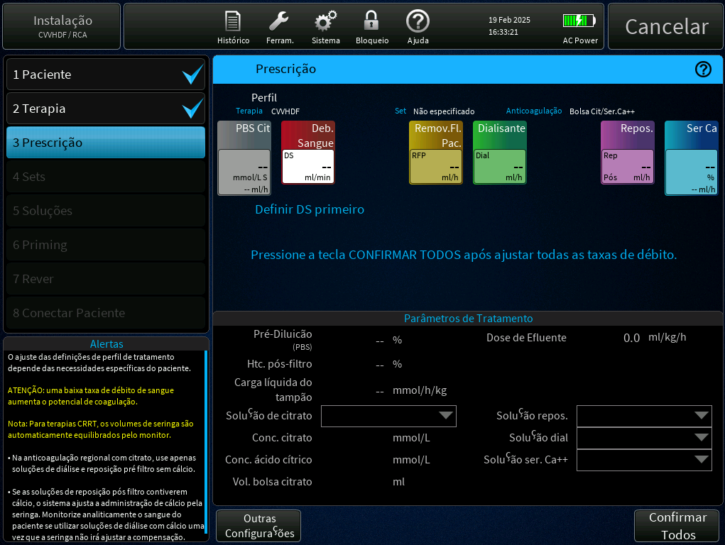

Figure 133: special character issue in Portuguese (before)

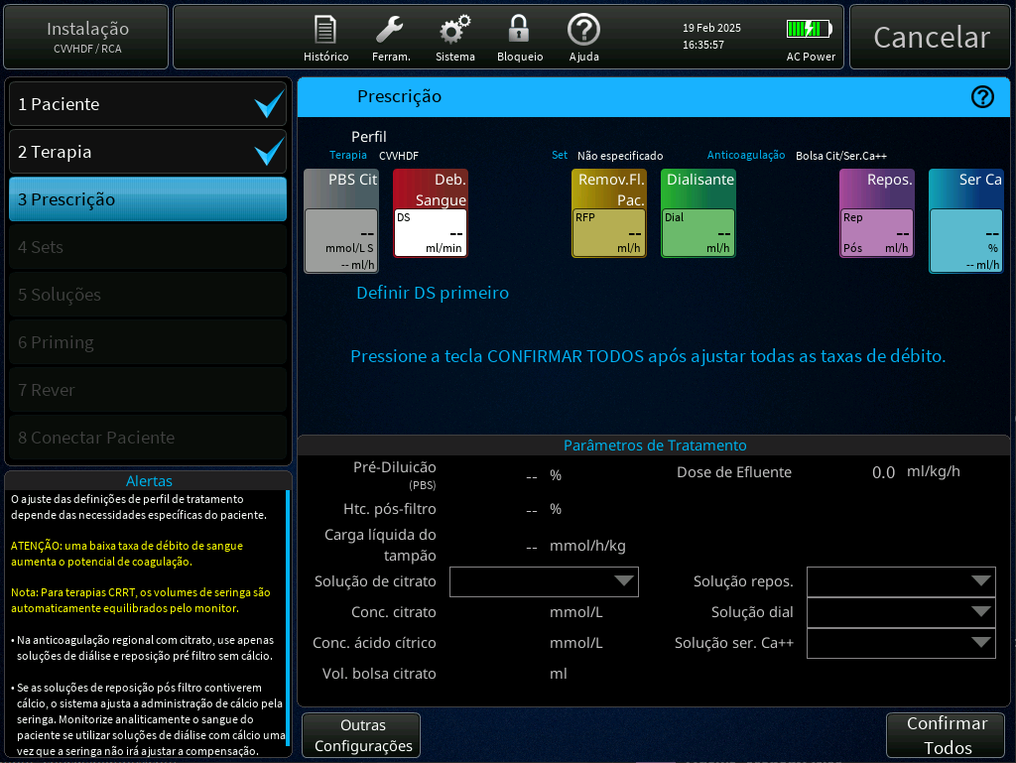

Figure 134: special character issue in Portuguese (after)

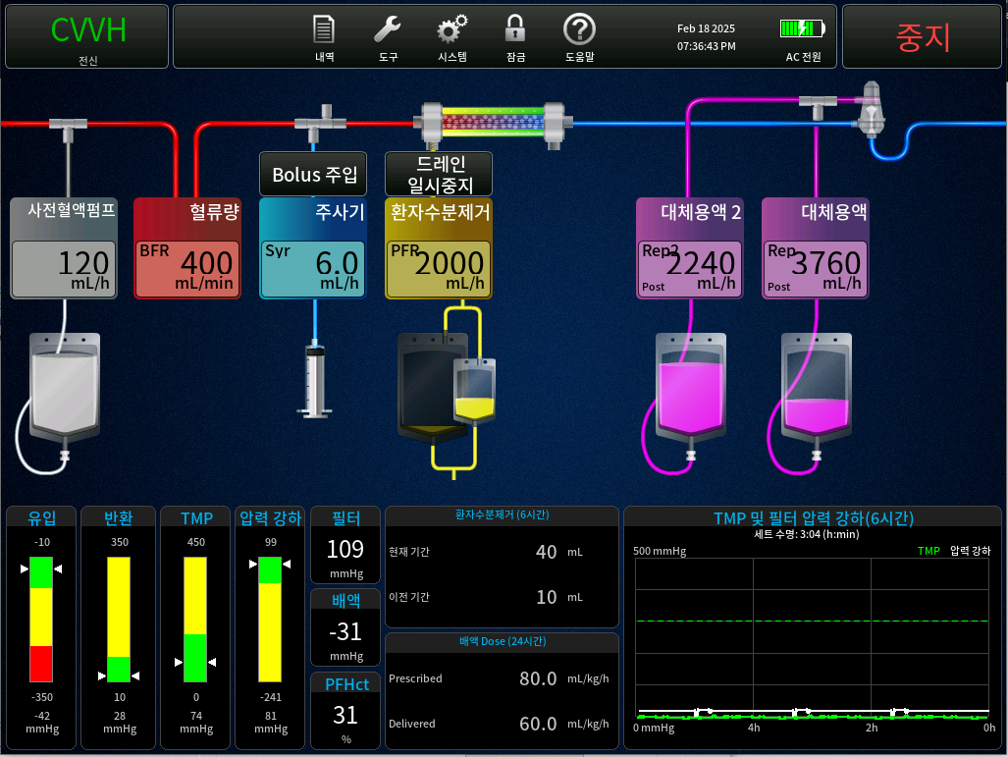

Figure 135: Flow Rates overlap with other labels in Ops screen (before)

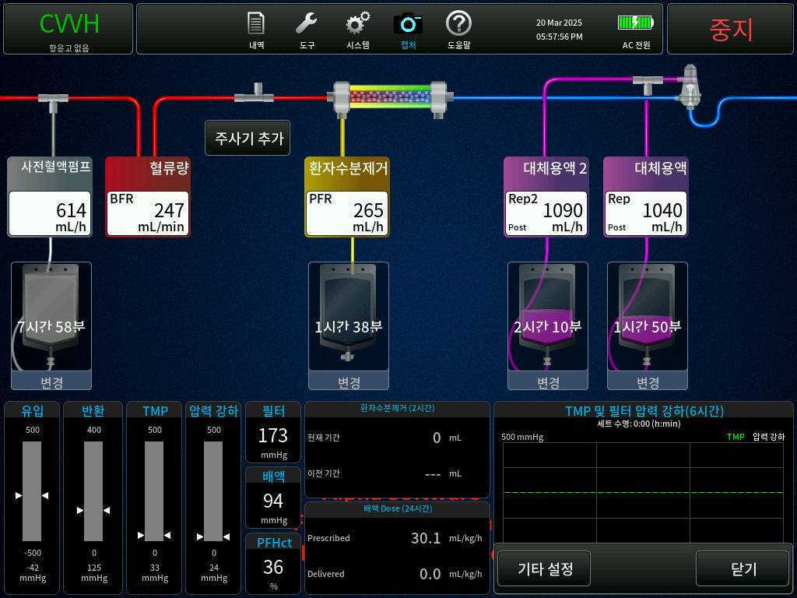

Figure 136: Flow Rates overlap with other labels in Ops screen (after)

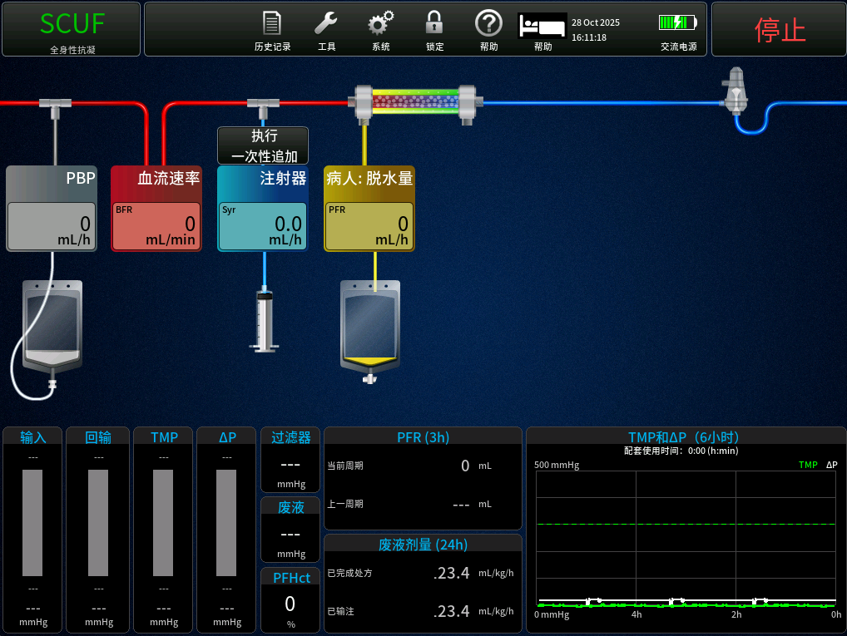

Figure 137: Dose Issue in Ops Screen (Before)

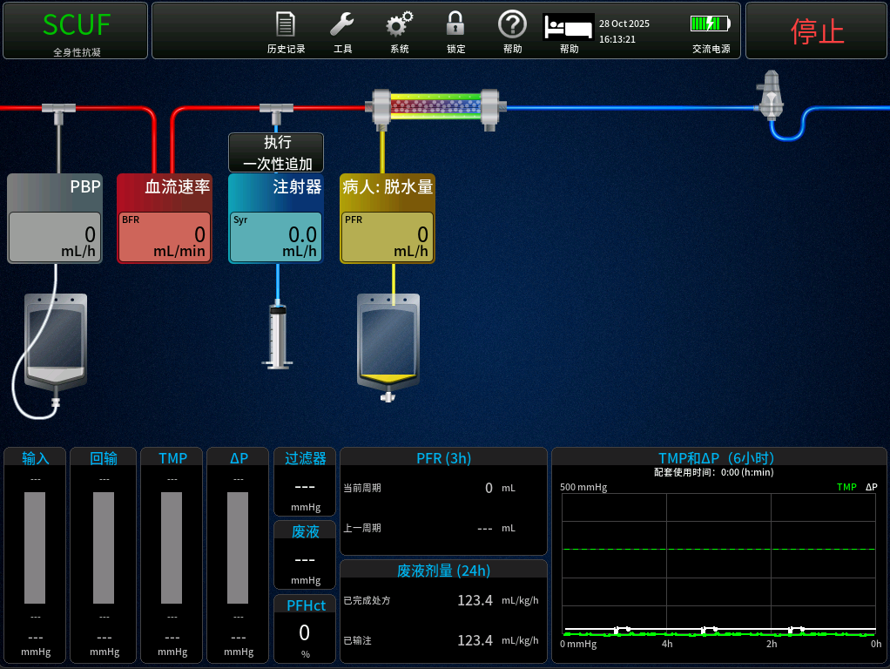

Figure 138: 133 Dose Issue in Ops Screen (After)

### Missing or Incomplete data display in History PFR Screen in Chinese (Simplified/ Traditional) and Korean [PFAL-2577]

This issue is fixed by doing change in Chinese and Korean xml files.

So, this change has been made only in Chinese and Korean Xml change by changing font size from “small” to “tiny” and no code change involved.

#### PrisMax modified screens.

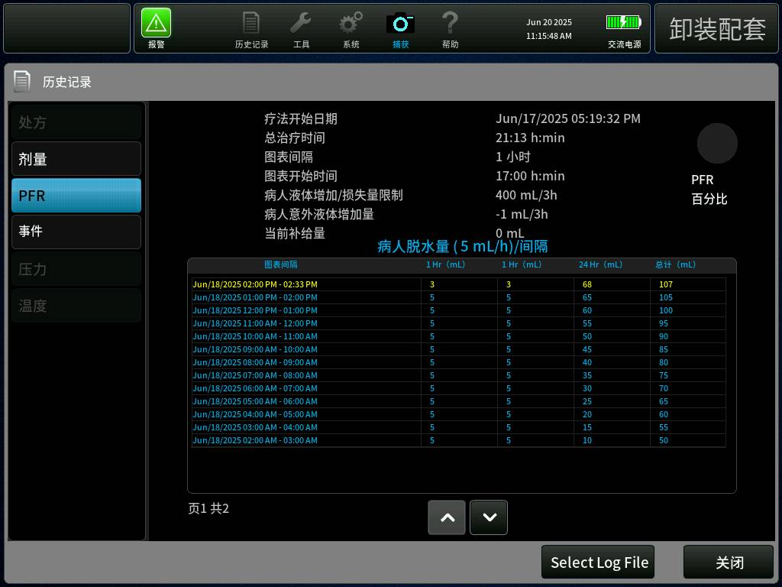

Figure 139: History PFR table screen in Chinese.

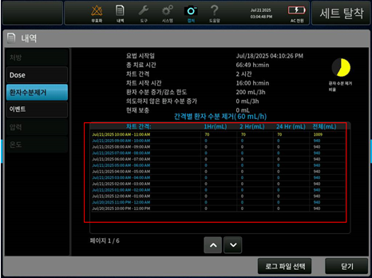

Figure 140: History PFR table screen in Korean.

### Disturbances on Scales with flow rate of zero causing errors in reported [PFR PFAL-2465]

**DESCRIPTION:**

The Fluid Pump Control algorithm MATLAB model has been updated to implement fluid weight error and PFR modifications that exclude fluid scale weight changes on scales corresponding to fluid pumps with zero prescription flow rate. The new changes implemented include following:

* If the prescription flow rate is zero when treatment is first initiated, then the weight error for that pump controller is latched at zero value and subsequent weight changes on that scale are excluded from PFR calculations (Proposed SRS-10300)
* If the prescription flow rate changes from a non-zero value to a zero value, then the weight error for that pump controller is latched at the average value of the weight error that existed five seconds prior to the change to a zero-prescription flow rate. This allows weight errors to be carried over to the next time that the pump becomes active again with a non-zero prescription flow rate similar to weight error carry-over after a fluid bag change. The latched weight error value will be included in PFR calculations independent of any subsequent changes in bag weight (Proposed SRS-10300).
* Scale disturbances are buffered to prevent system response to unverified or unrealistic weight changes. If scale disturbances cause scale data to become unstable, the fluid pump controller will operate in "Forced Open Loop" mode up to 60 seconds. When operating in this mode, weight error for that pump controller is latched at the average value of the weight error that existed five seconds prior to the transition into "Forced Open Loop" mode. When scale stability returns, the weight error and PFR will be updated to values corresponding to the new stable scale weight after unrealistic weight changes have been removed.
* When the corresponding prescription flow rate is non-zero, scale disturbances that result in a stable scale weight change (stable weight before the disturbance vs stable weight after the disturbance) that does not exceed the realistic weight change threshold (currently 50 grams) will be included in weight error and PFR calculations. If the resulting weight error exceeds the weight error tolerance threshold, a weight error alarm will be raised.
* When the corresponding prescription flow rate is non-zero, scale disturbances that result in a stable scale weight change (stable weight before the disturbance vs stable weight after the disturbance) that exceeds the realistic weight change threshold (currently 50 grams) will not be included in weight error or PFR calculations. A weight error alarm will still be raised to alert the operator to look for potential fluid bag interference.
* When the corresponding prescription flow rate is zero, the scale is still monitored for slow weight changes that could correspond to a bag leak or non-occlusive pump. Note that in this case a weight disturbance will cause the bag stable reference weight to be reset to a new stable reference weight. The difference between the most recent stable reference weight and the current stable weight will generate an unexpected weight change alarm if the difference exceeds the unexpected weight change alarm threshold (Proposed SRS-10305)

The Safety Processor algorithm MATLAB model has been updated to implement fluid weight error and PFR modifications that exclude fluid scale weight changes on scales corresponding to fluid pumps with zero prescription flow rate. The new changes implemented include following:

* The Safety Processor algorithm was updated to implement fluid weight error and PFR modifications to exclude fluid scale weight changes on scales corresponding to fluid pumps with zero prescription flow rate (proposed PRD-5555, proposed SRS-10301)
* External inputs for Replacement and Dialysate prescription flow rates were added to allow the Safety processor to monitor for zero prescription flow rates (Proposed SRS-10216)
* PFR Weight Scale Fault logic was modified to exclude weight changes from scales corresponding to pumps with zero-prescription flow rate (proposed SDS-3980)

### Correct the guidance in GUI/operators manual for filter clotting alarms [PFAL-2488]

For below alarms text body, alarm title, history event message and image are changed,

T0938, T0786, T0787, T0779, T0780, T0788.

For below alarms text body, alarm title and history event message are changed,

T0782, T2308, T0783.

Common override string for the alarms T0786, T0787 and T0788 is changed.

New button is added for the alarms T0782, T0783.

Button positions and button actions are changed for the alarms T0938, T0779, T0780.

### Increase time taken to Latch the Signal to Backup Speaker during Total Loss of Power [PFAL-2588]

The system is designed to sound the backup speaker anytime the system is powered off unexpectedly (not user initiated) and a patient is attached. This functionality of sounding backup speaker is achieved through a signal TLP_LATCH_SET in hardware which is driven through software logic. This logic is tested while Performing SST.

During the investigation, it was found that the PSC only commands the backup speaker [with the help of nTLP_LATCH_SET signal] for 8us. Due to potential part to part variations of the Mosfet that controls this signal, it was identified that the signal needed to be latched upto 15us, which maybe causing PrisMax to not sound the backup speaker.

The issue is in function LatchTotalLossOfPower(). This function controls the hardware signal nTLP_LATCH_SET, which in the software is mNotTlpSetOutput. To latch a Total Loss of Power, the LatchTotalLossOfPower() function sets the TLP latch signal low, and immediately brings it back high.

We have increased the time taken to latch the TLP_LATCH_SET signal to the backup speaker to 1 millisecond to fix this issue.

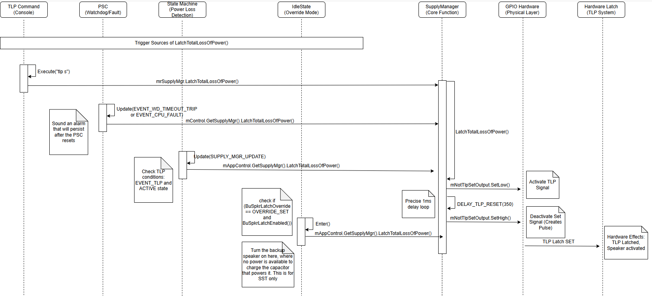

Figure 141: Sequence Diagram for Latch TLP.

### Undetermined Causes of Foam Detect Alarm T2315 [PFAL-2606]

**DESCRIPTION:**

The detection logic for Fluid_Detected_Moving in ARPS MATLAB model has been changed to help reduce the occurrence of T2315. The new changes implement the following:

* The time for verifying minimum value of baseline voltage has been increased from 0.5 second to 1.67 second to increase the robustness of detection and reduce false alarm. This is equivalent to increasing 30 sample delays to 100 sample delays in the MATLAB model, given 60Hz sampling frequency.
* Ideally the signal is a square wave, but it is distorted due to aliasing. The change also requires that there are at least 4 of those 100 samples to be below 3.0 voltage, then the minimum value is verified to be used as a baseline. If this condition is not met, we assume that a reliable minimum cannot be found due to signal aliasing and 0 volage is used as minimum. This will help reduce false T2315 alarm.

## Change List

### Defaults not set alarm(T1722) raised when defaults (syringe) were set and Thermax SST status is correctly transmitted to PrisMax [PFAL-2473][PFAL-2484]

#### PrisMax Source Code Changes

Table 17 – PrisMax Source Code Files[PFAL-2474][PFAL-2484]

| File | Type of Change | | |
| --- | --- | --- | --- |
| Added | Modified | Deleted |
| src/AppGuiDictionary/DictionarySetupGroup.cpp | N/A | X | N/A |
| src/AppGuiDictionary/DictionarySetupGroup.h | N/A | X | N/A |
| src/AppGuiDictionary/TherapyDictionarySetup.cpp | N/A | X | N/A |
| src/DataStore/SQL/Handlers/SQLScripts.cpp | N/A | X | N/A |
| src/DataStore/SQL/SQLMgr.cpp | N/A | X | N/A |
| src/GUI/PrisMaxGUI/Acid.h | N/A | X | N/A |
| src/GUI/PrisMaxGUI/BootScreen.cpp | N/A | X | N/A |
| src/GUI/PrisMaxGUI/BootView.cpp | N/A | X | N/A |
| src/GUI/PrisMaxGUI/DialogEditCRRTCitrateSolutionScreen.cpp | N/A | X | N/A |
| src/GUI/PrisMaxGUI/DialogEditCRRTCitrateSolutionScreen.h | N/A | X | N/A |
| src/GUI/PrisMaxGUI/DialogEditDiaSolutionScreen.cpp | N/A | X | N/A |
| src/GUI/PrisMaxGUI/DialogEditDiaSolutionScreen.h | N/A | X | N/A |
| src/GUI/PrisMaxGUI/DialogEditHpxCartridgeScreen.cpp | N/A | X | N/A |
| src/GUI/PrisMaxGUI/DialogEditHpxCartridgeScreen.h | N/A | X | N/A |
| src/GUI/PrisMaxGUI/DialogEditRepCaSolutionScreen.cpp | N/A | X | N/A |
| src/GUI/PrisMaxGUI/DialogEditRepCaSolutionScreen.h | N/A | X | N/A |
| src/GUI/PrisMaxGUI/DialogEditSyrCaSolutionScreen.cpp | N/A | X | N/A |
| src/GUI/PrisMaxGUI/DialogEditSyrCaSolutionScreen.h | N/A | X | N/A |
| src/GUI/PrisMaxGUI/DialogEditTPECitrateSolutionScreen.cpp | N/A | X | N/A |
| src/GUI/PrisMaxGUI/DialogEditTPECitrateSolutionScreen.h | N/A | X | N/A |
| src/GUI/PrisMaxGUI/SysConfigScreen_Creators.cpp | N/A | X | N/A |
| src/Therapy/AlarmDetection/TherMaxAlarms/TherMaxAlarmHandler.h | N/A | X | N/A |
| src/Therapy/Controllers/TherMaxController.cpp | N/A | X | N/A |
| src/Therapy/Controllers/TherMaxController.h | N/A | X | N/A |
| src/Therapy/StateManagers/TherapyStateManager.cpp | N/A | X | N/A |
| src/Therapy/StateManagers/TherapyStateManager.h | N/A | X | N/A |
| src/ToolBar/FeaturesUserEnabledProcessing.cpp | N/A | X | N/A |
| src/ToolBar/FeaturesUserEnabledProcessing.h | N/A | X | N/A |
| src/serviceMode/serviceTasksApps.cc | N/A | X | N/A |

**Implementation Description:**

* DictionarySetupGroup.cpp, DictionarySetupGroup.h, TherapyDictionarySetup.cpp
* Added “toGuiSystemDefaultsAvailable” new dictionary to notify BootScreen. “NewPatient” and “SamePatient” buttons won’t be available if defaults not set.
* BootScreen.cpp, BootView.cpp
* Attached to “toGuiSystemDefaultsAvailable” dictionary and hiding “NewPatient” and “SamePatient” buttons if defaults not set.
* SQLScripts.cpp
* Updated default product code table creation script with new product codes.
* SQLMgr.cpp
* Modified “ReadSysConfig” case to read only System Config data. In current implementation reading syringe brands and solutions data form data base on “ReadSysConfig” request from therapy task or service task.
* Acid.h
* This class is the base class for all solution edit screens and modified this class to disable all buttons during SAVE or DELETE operation performing.
* Added “mSaveOrDeleteOperationSelected” variable to know the status of SAVA and DELETE operations for enabling and disabling buttons.
* Added “EnableDisableActionButtonsDuringSaveOrDeleteOperation” function to enable and disable buttons when SAVE and DELETE operations performed and completed.
* DialogEditCRRTCitrateSolutionScreen, DialogEditDiaSolutionScreen, DialogEditHpxCartridgeScreen, DialogEditRepCaSolutionScreen,DialogEditSyrCaSolutionScreen, DialogEditTPECitrateSolutionScreen
* Updated “Message” function to notify “Acid” class one list update after receiving from database and it will notify “Acid” class to Enable the buttons.
* Added “HeartBeat” to enable the buttons in edit dialog if list not updated after update timeout (6-sec) from database due to SAVE or DELETE operation.
* SysConfigScreen_Creators.cpp
* Modified “UpdateSyringeBrand” function to show previous selected default syringe brand on sysconfig import failed.
* serviceTasksApps.cc
* Modified “ServiceApps_start” function logic where it’s sending request to database to read all bootup tables (sysconfig, syringe and solutions data) at a time. now logic updated to read in sequence (one after another).
* TherMaxAlarmHandler.h
* Added “isTherMaxSelectedInSetUp” new function to know either thermax selected in setup or not to process TherMax Not Paired alarm.
* TherMaxController.h and TherMaxController.cpp
* Updated TherMax Not Paired alarm processing logic to reload thermax pair table data once again to fix is there any data read issue before raising alarm (TherMax Not Paired Alarm).
* TherapyStateManager.h and TherapyStateManager.cpp
* Modified “CommandGUIStartupScreen” function logic where it’s sending request to database to read all bootup tables (sysconfig, syringe and solutions data) at a time. now logic updated to read in sequence (one after another).
* Modified “PerformDefaultsCheck” function to reload sysconfig data one again to fix is there any data read issue before raising alarm (Defaults Not Set).
* Added “mDefaultsNotSetBitMask” to log a value into logDB when Defaults Not Set alarm triggered, decoding this Bit Mask tells what the parameters are not set as part of system defaults.
* FeaturesUserEnabledProcessing.h and FeaturesUserEnabledProcessing.cpp
* Modified “Update” function to send Features data to guy only after receiving notification from two dictionaries one dictionary containing features data and another one is features read status.in existing implementation it is sending features data to GUI only based on read status not checking data received or not from database.

#### PrisMax UnitTest Changes

Table 18 – PrisMax Unit Test Files [PFAL-2474][PFAL-2484]

| File | Type of Change | | |
| --- | --- | --- | --- |
| Added | Modified | Deleted |
| UnitTest/DataStore/SQL/SQLMgr/SQLMgr_UT.cpp | N/A | X | N/A |
| UnitTest/Therapy/Controllers/TherMaxController/TherMaxController_UT.cpp | N/A | X | N/A |
| UnitTest/Therapy/StateManagers/TherapyStateManager/TherapyStateManager_UT.cpp | N/A | X | N/A |

**Implementation Description:**

* SQLMgr_UT.cpp
* Modified “GET_SYSCONFIG_KEY” test case to read only sysconfig data.
* TherMaxController_UT.cpp
* Modified “Alarm_T2259_Raised_calibration_failed_Not_Setup” test to send request to reload thermax pair table before raising T2259 alarm to fix is there any data read issue.
* TherapyStatemanager_UT
* Updated by adding “RetryLogic_TriggersReloadAndStopsAfterLimit” new test case to read system config defaults data before raising T1722 alarm (Defaults not set).

### Alarms can restart fluid priming without replacing priming solution[PFAL-2472]

#### PrisMax Source Code Changes

Table 19 – PrisMax Source Code Files[PFAL-2472]

| File | Type of Change | | |
| --- | --- | --- | --- |
| Added | Modified | Deleted |
| src/GUI/PrisMaxGUI/AlarmDisplayDataConst.inc | N/A | X | N/A |
| src/GUI/PrisMaxGUI/Assets/PrismaxStrings.h | N/A | X | N/A |
| src/Therapy/AlarmDetection/PrimeAlarmHandling.cpp | N/A | X | N/A |
| src/Therapy/AlarmDetection/PrimeAlarmHandling.h | N/A | X | N/A |
| src/Therapy/AlarmProcessing/AlarmsConst.inc | N/A | X | N/A |
| src/Therapy/Controllers/PrimingManager.cpp | N/A | X | N/A |
| src/Therapy/Controllers/PrimingManager.h | N/A | X | N/A |
| src/Therapy/Controllers/PrimingModelController.cpp | N/A | X | N/A |
| src/Therapy/TherapyEvents.inl | N/A | X | N/A |

**Implementation Description:**

* AlarmDisplayDataConst.inc, AlarmsConst.inc
* Updated these two files for changing fluid priming alarms Continue action to Reprime Action.
* PrismaxStrings.h
* Updated strings for fluid priming alarms.
* PrimeAlarmHandling.h PrimeAlarmHandling.cpp
* Added “RequiredFluidPrimeRestartOnReprime” function to find triggered priming alarm required restarting fluid priming from beginning or not.
* Updated “UserNotifier” logic to publish “PREPARE_REPRIME_TO_RESTART_FLUIDPRIME” event when Reprime action selected on fluid priming alarm to go to Prepare to Reprime screen.
* PrimingManager.h PrimingManager.cpp
* Added “mRestartFluidPriming” variable to know either fluid priming restart required from beginning upon selecting reprime button.
* Added new event case “PREPARE_REPRIME_TO_RESTART_FLUIDPRIME” in “EventHandler” function to update “mRestartFluidPriming” to true when Reprime action selected in fluid priming alarm.
* Modified “HandleSalinePrimeCommand” function to restart fluid priming from beginning, priming progress bar and priming time on reprime button selected.
* PrimingModelController.h PrimingModelController.cpp
* Added “ResetUserPrimePauseState” function to reset “mUserPauseSet” state to false if user selected pause prime on fluid priming error.
* Updated “AlternativePrimeAlarms:: UserNotifier” function to restart fluild priming after changing prime bag.
* TherapyEvents.inl
* Added new event “PREPARE_REPRIME_TO_RESTART_FLUIDPRIME” to update a flag to restart fluid priming from beginning.

#### PrisMax UnitTest Changes

Table 20 – PrisMax Unit Test Files[PFAL-2472]

| File | Type of Change | | |
| --- | --- | --- | --- |
| Added | Modified | Deleted |
| UnitTest/Therapy/Controllers/PrimingManager_UT.cpp | N/A | X | N/A |

**Implementation Description:**

* PrimingManager_UT.cpp
* Added new test case “TEST_Handle_Saline_PrimeCommand” for test priming step on reprime. If “PREPARE_REPRIME_TO_RESTART_FLUIDPRIME” event published and selected reprime, fluid prime will start from beginning else priming starts with preprime test.

### Reduce occurrences of ARPS BIOT Alarms[PFAL-2477]

#### PrisMax MATLAB Model and Source Code Changes

Table 21 - MATLAB Model and MATLAB Generated Code (MGC) Changes[PFAL-2477]

| File | Type of Changes | | |
| --- | --- | --- | --- |
| Added | Modified | Deleted |
| “root”/Kronos/ARPSandLiqLevel/LIB_ARPSandLiqLevel.slx | NA | X | NA |
| “root”/Kronos/ARPSandLiqLevel/KrD_ARPSandLiqLevelTopParams.m | NA | X | NA |
| src/Matlab/ARPSModel/ARPSandLiqLevel.h | NA | X | NA |
| src/Matlab/ARPSModel/ARPSandLiqLevel.cpp | NA | X | NA |

#### PrisMax Source Code Changes

Table 22 - PrisMax Source Code Files[PFAL-2477]

| File | Type of Changes | | |
| --- | --- | --- | --- |
| Added | Modified | Deleted |
| src/DataStore/SQL/Handlers/SQLScripts.cpp | NA | X | NA |
| src/EncodableTypes/TherapyLoggerGraphData.h | NA | X | NA |
| src/Therapy/Controllers/TherapyDataLogger.cpp | NA | X | NA |
| src/Matlab/ARPSModelInterface.cc | NA | X | NA |
| src/Matlab/ARPSModelInterface.h | NA | X | NA |
| src/Therapy/Controllers/PressureController.cpp | NA | X | NA |
| src/Therapy/Helpers/ArpsTestSequenceController.cpp | NA | X | NA |
| src/Therapy/Helpers/PodRepositionSequenceController.cpp | NA | X | NA |

**Implementation Description:**

* SQLScripts.cpp
* Added AccessFilteredPressure, FilterFilteredPressure, EffluentFilteredPressure, ReturnFilteredPressure, ARSPFilteredPressure columns for logging periodic data into LOGDB file.
* sqlLogCreate and SQLManager::WritePressures functions are modified for adding more parameters to log in LOGDB.
* Modified sqlPeriodicFormat for adding BLDTransmissivity for as a new column.
* TherapyLoggerGraphData.h, TherapyDataLogger.cpp
* Modified TherapyDataLogger::GetNewPressureData() function and ENUM in header file modified.
* Modified TherapyDataLogger::GetNewStatusData function for adding BLDTransmissivity value.
* ARPSModelInterface.cc, ARPSModelInterface.h, ArpsTestSequenceController.cpp
* Modified ARPSModelInterface::AlarmDataARPSFailure to get the values from control the have which added two parameters ligLevState, mmhgreturn for logging.
* PressureController.cpp
* Modified PressureController::LogArpsLeak function to log the values when BIOTS generates. (B1273)
* ARPSModelInterface.cc, ARPSModelInterface.h
* Modified ARPSModelInterface::AlarmDataFailure function. In this previously we set the ARPS pressure value as 0 now we’re taking the actual value from controller.
* Here we’re adding two new Parameters StateID and PstateID for logging.
* PodRepositionSequenceController.cpp
* Modified PodRepositionSequenceController::LogPodFailure function to log the values when BIOTS generates. (B1116, B1539, B1540, B1541). Added new logging variables StateID, PstateID.
* Modified PodRepositionSequenceController::HandleRequestNotIssued function to log filtered Pressure periodically for the events.(E1543, E1668, E1666, E1545)

#### Unit Test

Table 23 - Unit Test Files[PFAL-2474]

| File | Type of Change | | |
| --- | --- | --- | --- |
| Added | Modified | Deleted |
| UnitTest/Stubs/src/Matlab/ARPSModelInterface_Stub.cc | N/A | X | N/A |

### Reduce occurrence of B1593 alarm declared in Re-prime after air introduced in ABD[PFAL-2474]

#### PrisMax MATLAB Model and Source Code Changes

Table 24 - MATLAB Model and MATLAB Generated Code (MGC) Changes [PFAL-2474]

| File | Type of Changes | | |
| --- | --- | --- | --- |
| Added | Modified | Deleted |
| “root”/Kronos/Priming/LIB_PrimeControllerStateFlow.slx | NA | X | NA |
| “root”/Kronos/Priming/KrD_PrimingParams.m | NA | X | NA |
| src/Matlab/PrimingModel/PrimeControllerTop.h | NA | X | NA |
| src/Matlab/PrimingModel/PrimeControllerTop.cpp | NA | X | NA |

#### PrisMax Source Code Changes

Table 25 - PrisMax Source Code Files [PFAL-2474]

| File | Type of Changes | | |
| --- | --- | --- | --- |
| Added | Modified | Deleted |
| src/Matlab/PrimeModelInterface.cc | NA | X | NA |
| src/Matlab/PrimeModelInterface.h | NA | X | NA |
| src/Therapy/Controllers/PrimingModelController_AlarmLogging.cpp | NA | X | NA |

**Implementation Description:**

* PrimeModelInterface.cc, PrimeModelInterface.h
* Added “GetPostPrimeTestStatus” Function to get the values of PostPrimeCmd[1] and PostPrimeCmd[2] to understand by which command alarm being raised.
* Added “GetStdAtmVolToEff” function to get the effluent value at the time of BIOT raises.
* PrimingModelController_AlarmLogging.cpp
* Modified PrimingModelController::LogReturnPressure function and added If-else condition to print the logging parameters depends on the command 1 and 2.
* Modified PrimingModelController::LogReturnPressure function added Engineering log for getting the value of GetStdAtmVolToEff.

#### Unit Test

Table 26 - Unit Test Files [PFAL-2474]

| File | Type of Change | | |
| --- | --- | --- | --- |
| Added | Modified | Deleted |
| UnitTest/Stubs/src/Matlab/PrimeModelInterface_Stub.cc | N/A | X | N/A |

### Add additional logging for B0916 alarms[PFAL-2471]

#### PrisMax Source Code Changes

Table 27 - PrisMax Source Code Files[PFAL-2474]

| File | Type of Changes | | |
| --- | --- | --- | --- |
| Added | Modified | Deleted |
| src/Background/cp_kernel.cpp | NA | X | NA |
| src/EngineeringMode/EngMenu.cpp | NA | X | NA |
| src/EngineeringMode/EngMethods.cpp | NA | X | NA |
| src/EngineeringMode/EngMethods.h | NA | X | NA |
| src/ioMgr/Delegates/PowerPcba/ShutdownIoMgr.cpp | NA | X | NA |

**Implementation Description:**

* cp_kernel.cpp
* Modified the function “HealthMonSystemHandler” for decoding Major class of exception, Access type (operation type) of exception and Memory type of exception from Exception Error. And sending these data along with file name, line number to shutdown IO manager task.
* EngMenu.cpp
* Added ‘w’ flag to engineering mode command to test this feature and “LogSystemException” function called to throw an exception.
* EngMethods.cpp
* Defined “LogSystemException” function to throw an exception for testing this feature in engineering mode.
* EngMethods.h
* Declaration of the function “LogSystemException”.
* ShutdownIoMgr.cpp
* Receives data sent from the function “HealthMonSystemHandler” and logs it in to the log DB file.

### PBP Bag empty alarm not coming up at right time[PFAL-2470]

#### PrisMax Source Code Changes

Table 28 - PrisMax Source Code Files [PFAL-2470]

| File | Type of Changes | | |
| --- | --- | --- | --- |
| Added | Modified | Deleted |
| src/Therapy/Controllers/ BagController.h | NA | X | NA |
| src/Therapy/Controllers/BagController.cpp | NA | X | NA |
| src/Therapy/Helpers/BagClass.cc | NA | X | NA |

**Implementation Description:**

* BagController.h
* CITRATE_BAG_SOLUTION_CHANGE – Removed this Enumeration we are not using in this class.
* BagController.cpp
* Dictionary::TreatmentSettings::crrtCitrateSolution.Attach(this, CITRATE_BAG_SOLUTION_CHANGE) – Removed this Dictionary we are not using in the class.
* SubscribeToEvent(TherapyEvents::PRESCRIPTION_COMMITTED) – Subscribed this event when Prescription controller updated.
* In BagController::ConfigurePrebloodBag(), added the ANTICOAG_ID_CITRATE_BAG to the OR condition to use the BAG_CITRATE personality.
* BagClass.cc
* Removed the TherapyConfigurationController.h Library not required in this class.
* TherapyId therapyID – Declared the Local object for the Therapy Id to check the selected therapy is TPE.
* SetChangeableBagWeight(gsPrescriptionController.ProposedTreatmentProfile().mSolutionsConfiguration.mTpeCitrateSolution.mBagVolume.ml() – When Operator Select TPE and External Citrate then take the bag volume from the selected profile, go for Calculate the Threshold PBP bag empty weight.

#### Unit Test

Table 29 - Unit Test Files [PFAL-2470]

| **File** | **Type of Changes** | | |
| --- | --- | --- | --- |
| Added | Modified | Deleted |
| UnitTest/Therapy/Controllers/BagController/BagController_UT.cpp | NA | X | NA |
| UnitTest/Therapy/Helpers/BagClass/BagClass_UT.cpp | NA | X | NA |

**Implementation Description:**

* BagController_UT.cpp
* Added new test case Test_PRESCRIPTION_COMMITTED - When PRESCRIPTION_COMMITTED event is published, to verify the Bag Personality for the relevant Anticoagulation.
* BagClass_UT.cpp
* Added the new test cases BagPersonality_5_Liter_Tpe_Citrate_Bag_Size and BagPersonality_1_Liter_Tpe_Citrate_Bag_Size – To verify the Selected bag volume, empty bag weight, weight Intervention level and bag capacity.

### Alarm T2124 is not raised as soon as expected [PFAL-2475]

#### PrisMax Source Code Changes

Table 30 - PrisMax Source Code Files [PFAL-2475]

| File | Type of Changes | | |
| --- | --- | --- | --- |
| Added | Modified | Deleted |
| src/Therapy/Controllers/PrescriptionController.h | NA | X | NA |
| src/Therapy/Controllers/PrescriptionController.cpp | NA | X | NA |
| src/Therapy/Controllers/TreatmentSessionController.h | NA | X | NA |
| src/Therapy/Controllers/TreatmentSessionController.cpp | NA | X | NA |

**Implementation Description:**

* PrescriptionController.h
* mCheckCaSolSuitabilty – A new Boolean member variable is added; this value is set when operator select the Syr Ca++ Solution (TherapyEvents::CA_SOLUTION_CHANGED) as well as Therapy Configuration Confirm (TherapyEvents::THERAPY_CONFIGURATION_COMMITTED).
* SimpleNagAlarm mUnsuitableCaSolution - Class used to trigger the T2124 alarm.
* CheckCaSolutionSuitability () - Check the Operator Selected Ca Solution Suitability for selected Patient Weight.
* PrescriptionController.cpp
* Using the member Variable, Class and define member Function added in PrescriptionController.h
* Subscribe To Event (TherapyEvents::CA_SOLUTION_CHANGED) – when operator set the Syr Ca++ Solution on prescription setup page.
* ThreatmentSessionController.h
* SimpleNagAlarm mUnsuitableCaSolution – Shifted this class to the Prescription Controller Class.
* CheckCaSolutionSuitability () – Removed this function not used under this class.
* ThreatmentSessionController.cpp
* Removed the Class and Functions mentioned on the TreatmentSessionController.h file.
* Publish (TherapyEvents::CA_SOLUTION_CHANGED) – this event published at Therapy configuration commit at SAME_PATIENT Selection time, this event Subscribe in the PriscriptionController class.

#### Unit Test

Table 31 - Unit Test Files [PFAL-2475]

| File | Type of Changes | | |
| --- | --- | --- | --- |
| Added | Modified | Deleted |
| UnitTest/Stubs/src/Therapy/Controllers/PrescriptionController_Stub.cpp | NA | X | NA |
| UnitTest/Stubs/src/Therapy/Controllers/TreatmentSessionController_Stub.cpp | NA | X | NA |
| UnitTest/Therapy/Controllers/PrescriptionController/PrescriptionController_UT.cpp | NA | X | NA |

**Implementation Description:**

* PrescriptionController_Stub.cpp
* Declare the CheckCaSolutionSuitability().
* TreatmentSessionController_Stub.cpp
* Remove the CheckCaSolutionSuitability().
* PrescriptionController_UT.cpp
* Added new test cases “Update_Constaints, EventHandler_THERAPY_CONFIGURATION_COMMITTED and EventHandler_FCC_PATIENT_COMMITTED” for the different Syr Ca++ Solution Volume and Patient weight to verify the T2124 alarm state are LACHED or INACTIVE.

### Unable to autochart PFR through the EMR, PFR values not resetting with same patient in EMR [PFAL-2466]

#### PrisMax Source Code Changes

Table 32 - PrisMax Source Code Files [PFAL-2466]

| File | Type of Changes | | |
| --- | --- | --- | --- |
| Added | Modified | Deleted |
| src/Therapy/Controllers/TherapyDataLogger.cp | NA | X | NA |
| src/Therapy/Helpers/EMRDataBaseRecord.cpp | NA | X | NA |
| src/EncodableTypes/TherapyLoggerGraphData.h | NA | X | NA |
| src/Therapy/Helpers/EMRDataBase.cpp | NA | X | NA |
| src/DataStore/SQL/Handlers/SQLScripts.cpp | NA | X | NA |

**Implementation Description:**

* TherapyDataLogger.cpp

Following changes are made in function “CheckForPFRPeriodRollover”

* Collecting last charting PFR values for both EMR parameters 458 (charting period) and 459 (24-hour value) when a chart rollover occurs, and skips updates during TPE treatment breaks under the condition “if (chartRollover)”.
* Retaining previous data to avoid sending reset (zero) values to EMR after a treatment break. The code has been modified to retain the previous data by setting pfrInfo.mTrackedPFR[PfrChartData::PCD_PFR_TOTAL]=lastPfrInfo.mTrackedPFR[PfrChartData::PCD_PFR_TOTAL];, ensuring that the values are not lost and can be resumed from the correct point after the treatment break.
* Resets “therapyData->mVolumeArray[.] indexes LAST_COMPLETED_PFR_CHART_VOL","LAST_COMPLETED_PFR_CHART_24_HOUR_VOL", etc to zero when New Patient selected.
* EMRDataBaseRecord.cpp
* In function "FromLogData(..)",the indexes DB_PFR_LAST_CHART (458) and DB_PFR_LAST_CHART_TOT (459) are updated with LAST_COMPLETED_PFR_CHART_VOL and LAST_COMPLETED_PFR_CHART_24_HOUR_VOL, respectively. Additionally, PFR_LAST_CHART_VOL and PFR_LAST_CHART_TOTAL_VOL have been removed.
* And Updating existing EMR parameter DB_TOT_VOL_REMOVED (100) with PFR_LAST_CHART_TOTAL_VOL instead of data.mSample.mTotalVolumeRemoved.
* data.mSample.mTotalVolumeRemoved would reset to zero after selecting the same patient, but it has now been replaced with PFR_LAST_CHART_TOTAL_VOL, which retains the total fluid removed and does not reset to zero.
* TherapyLoggerGraphData.h

The following enum members have been added:

* LAST_COMPLETED_PFR_CHART_VOL - Used to updates last charting pfr value for emr parameter 458(charting period) instead of latest pfr value.
* LAST_COMPLETED_PFR_CHART_24_HOUR_VOL - Used to updates last charting pfr values for emr parameter 459(24h value) instead latest pfr value.
* EMRDataBase.cpp
* The #define EMR_COMM_VERSION has been updated to increase the EMR version from 3000000 to 3000001.
* SQLScripts.cpp

Following changes are made in SQLScripts.cpp

* Replaced "PFRLastChart FLOAT" with "LastCompletedPFRChart FLOAT" in SQL script for creating Log table in DB.
* Replaced "PFRLastChartTotal FLOAT" with "LastCompletedPFRChartTotal FLOAT" in SQL script for creating Log table in DB.
* Replaced "PFRLastChart" with "LastCompletedPFRChart" to format string for inserting Periodic data in DB.
* Replaced "PFRLastChartTotal" with "LastCompletedPFRChartTotal" to format string for inserting Periodic data in DB.
* In array out.mVolumeArray PFR_LAST_CHART_VOL data has been replaced with LAST_COMPLETED_PFR_CHART_VOL data in the database update.
* In array out.mVolumeArray PFR_LAST_CHART_TOTAL_VOL data has been replaced with LAST_COMPLETED_PFR_CHART_24_HOUR_VOL data in the database update.

#### Unit Test

Table 33 - Unit Test Files[PFAL-2466]

| File | Type of Changes | | |
| --- | --- | --- | --- |
| Added | Modified | Deleted |
| UnitTest/DataStore/JSON/JSONTranslatorEMR/JSONTranslatorEMR_UT.cpp | NA | X | NA |
| UnitTest/DataStore/JSON/JSONExpectedMessages.h | NA | X | NA |
| UnitTest/Therapy/Controllers/TherapyDataLogger/TherapyDataLogger_UT.cpp | NA | X | NA |
| UnitTest/Therapy/Helpers/EMRDataBase/EMRDataBase_UT.cpp | NA | X | NA |
| UnitTest/Therapy/Helpers/EMRDataBaseRecord/EMRDataBaseRecord_UT.cpp | NA | X | NA |

### GUI Issue-Display of Portuguese “C” Characters Font size change to display numbers [PFAL-2467]

Issue 1: EU Portuguese Character Rendering

#### PrisMax GUI Tools source code changes

Table 34 - PrisMax GUI Source Code Files [PFAL-2467]

| File | Type of Change | | |
| --- | --- | --- | --- |
| Added | Modified | Deleted |
| BuildMFont/BuildMFont/BuildMFont.cpp | N/A | X | N/A |

**Implementation Description:**

* BuildMFont.cpp
* Updated “buildGlyph” function to calculate proper rendering attributes for ‘ç’ character for small font size only for Latin.

Issue 2: Font Display Inconsistency for Korean and Chinese

#### PrisMax Source Code Changes

Table 35 - PrisMax Source Code Files [PFAL-2467]

| File | Type of Change | | |
| --- | --- | --- | --- |
| Added | Modified | Deleted |
| src/GUI/PrisMaxGUI/FlowRateOps.cpp | N/A | X | N/A |
| src/GUI/PrisMaxGUI/FlowRateSetup.cpp | N/A | X | N/A |
| src/GUI/PrisMaxGUI/DoseInset.cpp | N/A | X | N/A |

**Implementation Description:**

* FlowRateOps.cpp
* Updated “ExternalControl” function to receive font sizes from XML markup and creating flow rate boxes accordingly as per the current font file loaded for respective language.
* FlowRateSetup.cpp
* Updated “ExternalControl” function to receive font sizes from XML markup and creating flow rate boxes accordingly as per the current font file loaded for respective language.
* DoseInset.cpp
* Updated rows creation, by taking custom font size from XML (to fix dose truncation issue in Ops screen)

#### Unit Test

NA

### Missing or Incomplete data display in History PFR Screen in Chinese (Simplified/ Traditional) and Korean [PFAL-2577]

*XML change only ( Language Pack for Chinese and Korean)*

### Disturbances on Scales with flow rate of zero causing errors in reported [PFR PFAL-2465]

#### PrisMax MATLAB Model and Source Code Changes

Table 36 - PrisMax Source Code Files [PFAL-2465]

| File | Type of Changes | | |
| --- | --- | --- | --- |
| Added | Modified | Deleted |
| “root”/Kronos/FluidPumpController/FluidPumpControllerTop.slx | NA | X | NA |
| “root”/Kronos/FluidPumpController/LIB_FluidPumpCtrl_Subsystem.slx | NA | X | NA |
| “root”/Kronos/FluidPumpController/LIB_FluidPumpController.slx | NA | X | NA |
| “root”/Kronos/FluidPumpController/FluidPumpControllerTop_ert_rtw/ FluidPumpControllerTop.h | NA | X | NA |
| “root”/Kronos/FluidPumpController/FluidPumpControllerTop_ert_rtw/ FluidPumpControllerTop.cpp | NA | X | NA |
| “root”/Kronos/FluidPumpController/LIBMovingAverageAndStdDev.slx | NA | X | NA |
| “root”/Kronos/FluidPumpController/KrD_FluidPumpControllerParams.m | NA | X | NA |
| “root”/Kronos/SP/SafetyProcessor_Top.slx | NA | X | NA |
| “root”/Kronos/SP/ SafetyProcessor_LIB.slx | NA | X | NA |
| “root”/Kronos/SP/SafetyProcessor_Top_ert_rtw/ SafetyProcessor_Top..h | NA | X | NA |
| “root”/Kronos/SP/SafetyProcessor_Top_ert_rtw/ SafetyProcessor_Top.cpp | NA | X | NA |

### Correct the guidance in GUI/operators manual for filter clotting alarms [PFAL-2488]

#### PrisMax Source Code Changes

Table 37 - PrisMax Source Code Files [PFAL-2488]

| File | Type of Change | | |
| --- | --- | --- | --- |
| Added | Modified | Deleted |
| src/GUI/PrisMaxGUI/Assets/PrisMaxBitmaps.h | N/A | X | N/A |
| src/GUI/PrisMaxGUI/Assets/PrismaxStrings.h | N/A | X | N/A |
| src/GUI/PrisMaxGUI/AlarmDisplayDataConst.inc | N/A | X | N/A |
| src/GUI/PrisMaxGUI/AlarmGraphicsPressure.inc | N/A | X | N/A |
| src/Therapy/AlarmProcessing/AlarmsConst.inc | N/A | X | N/A |

**Implementation Description:**

* PrisMaxBitmaps.h
* Added two new BID’s for the two new images i.e TMP delta P and TMPa delta P.
* PrismaxStrings.h
* Modified SID’s of text body of some of the alarms.
* AlarmDisplayDataConst.inc
* Updated modified SID’s and button positions for the some of the alarms.
* AlarmGraphicsPressure.inc
* Updated two new BID’s for the two new images.
* AlarmsConst.inc
* Updated button action for some of the alarms.

#### Unit Test Case

All changes are in PrisMaxGUI, so the testcases are not required.

### Increase time taken to Latch the Signal to Backup Speaker during Total Loss of Power [PFAL-2588]

#### PrisMax Source Code Changes

Table 38 - PrisMax Source Code Files [PFAL-2588]

| File | Type of Changes | | |
| --- | --- | --- | --- |
| Added | Modified | Deleted |
| PrisMaxPSC\src\control\SupplyManager.cc | NA | X | NA |
| PrisMaxPSC\src\control\SupplyManager.h | NA | X | NA |

**Implementation Description:**

* SupplyManager.cc
* LatchTotalLossOfPower() has been modified, and a delay of 1 millisecond has been added using DELAY_TLP_RESET macro to set the TLP_LATCH_SET signal.
* ClearTotalLossOfPower() has been modified, and a delay of 1 millisecond has been added using DELAY_TLP_RESET macro to clear the TLP_LATCH_SET signal.
* SupplyManager.h
* Macro DELAY_TLP_RESET has been defined to add a delay for specific time which is passed as an argument to it.

### Undetermined Causes of Foam Detect Alarm T2315 [PFAL-2606]

#### PrisMax MATLAB Model and Source Code Changes

Table 39 - MATLAB Model and MATLAB Generated Code (MGC) Files[PFAL-2606]

| File | Type of Changes | | |
| --- | --- | --- | --- |
| Added | Modified | Deleted |
| “root”/Kronos/ARPSandLiqLevel/LIB_ARPSandLiqLevel.slx | NA | X | NA |
| “root”/Kronos/ARPSandLiqLevel/KrD_ARPSandLiqLevelTopParams.m | NA | X | NA |
| src/Matlab/ARPSModel/ARPSandLiqLevel.h | NA | X | NA |
| src/Matlab/ARPSModel/ARPSandLiqLevel.cpp | NA | X | NA |

## Labeling Update

*This section should describe all labelling changes to the user interface, both strings and graphics.*

*The table below defines all string changes.*

### Defaults not set alarm(T1722) raised when defaults (syringe) were set and Thermax SST status is correctly transmitted to PrisMax [PFAL-2473][PFAL-2484]

Table 40 - Screen Updates[PFAL-2473][PFAL-2484]

| **Screen Name** | **Screen Number** | **Type of Change** | | | **Reference** |
| --- | --- | --- | --- | --- | --- |
| **Added** | **Modified** | **Deleted** |
| Syringe Settings | 700:10 | N/A | X | N/A | Figure 71 and Figure 72 |
| Containers & Solutions | 700:8 | N/A | X | N/A | Figure 73, Figure 74 and Figure 75 |

### Alarms can restart fluid priming without replacing priming solution [PFAL-2472]

Table 40 - String Updates[PFAL-2472]

| **String ID** | **Type of Change** | | | **Content** |
| --- | --- | --- | --- | --- |
| **Added** | **Modified** | **Deleted** |
| SID_ALARM_T0609_TITLE | N/A | X | N/A | Wrong Set Selected |
| SID_ALARM_X1175_BODY | N/A | X | N/A | [br][br][indent=3][color=blue][size=small]&#10;Auto Effluent bags are on wrong scales.[br]&#10;[list][color=white][size=small]&#10;[#]Put large bag on front yellow scale.&#10;[#]Put small bag on side yellow scale.&#10;[color=blue]&#10;[br][br][br][br][br][br][br][br][br]&#10;[just=left][img=BID_longline][/just][br]&#10;[color=white]&#10;Press REPRIME button to restart the priming process. |
| SID_ALARM_T0609_BODY | N/A | X | N/A | [br][indent=3]&#10;[color=blue][size=small]&#10;[vmove=5]Disposable set installed does not match the set selected in step 2.&#10;[br][br]&#10;High Flow set selected but Low Flow detected.[br]&#10;Low Flow set selected but High Flow detected.[br]&#10;[br][just=left][img=BID_longline][/just][br]&#10;[size=small][color=blue]&#10;If wrong set is installed:&#10;[size=small][color=white]&#10;[*]Press DISCARD SET button to end setup process.[br][br]&#10;[color=blue][size=small]&#10;If correct set is installed:[/color]&#10;[size=small]&#10;[*]Press REPRIME button to restart the priming process.&#10;[color=white][br]&#10;[br]&#10;[conditional=CRRT]&#10;[size=small][color=blue] &#10;[size=small][color=blue] Other Possibilities:&#10;[size=small][color=white]&#10;[*]Check for clamp on [color=yellow]yellow effluent line.[/color]&#10;[*]Check for clamp on [color=red]red access line.&#10;[/color]&#10;[/conditional |
| SID_ALARM_AEE_BAG_INCORRECT_BODY | N/A | X | N/A | [br][br][indent=3]&#10;[size=small][color=blue] Check Bag&#10;[size=small][color=white][*] Missing&#10;[size=small][color=white][*] Touching other object&#10;[size=small][color=white][*] Supported from below&#10;[size=small][color=white][*] Hanging on wrong scale&#10;[size=small][color=white]&#10;[*]Install bags to match illustration[br][br][br][br][br][br][br]&#10;[just=left][img=BID_longline][/just][br]&#10;[size=small][color=white]Press REPRIME button to restart the priming process. [br][br]&#10;Press DISCARD SET button to replace filter set. |
| SID_ALARM_T1291_BODY | N/A | X | N/A | [br][br][indent=3]&#10;[size=small][color=blue] Check Bag&#10;[size=small][color=white][*] Missing&#10;[size=small][color=white][*] Touching other object&#10;[size=small][color=white][*] Supported from below&#10;[size=small][color=white][*] Hanging on wrong scale&#10;[size=small][color=white]&#10;[*]Install bags to match illustration[br][br]&#10;[br][br][br][br][br]&#10;[just=left][img=BID_longline][/just][br]&#10;[size=small][color=white] Press REPRIME button to restart the priming process.[br][br]&#10;Press DISCARD SET button to replace filter set. |
| SID_ALARM_T1347_BODY | N/A | X | N/A | [br][br][indent=3][color=blue][size=small]&#10;Failed to detect expected decrease in dialysate bag weight during priming.[br]&#10;[/color][/size]&#10;[color=white][size=small]&#10;[list][#]Change dialysate bag if it is empty.&#10;[#]Check for object touching bag.&#10;[#]Check for kinked or clamped dialysate line.[/list][br][br]&#10;[color=yellow]Note: Restarting prime is necessary once issue is resolved.[/color][br]&#10;[br][br][br][br][br]&#10;[just=left][img=BID_longline][/just][br]&#10;Press REPRIME button to restart the priming process. |
| SID_ALARM_T1594_BODY | N/A | X | N/A | [br][br][indent=3][size=small][color=white]&#10;[size=small][color=blue] Check Line&#10;[size=small][color=white][*] Kinked or clamped&#10;[size=small][color=white][*] Disconnected or leaking&#10;[size=small][color=white][*] Connected to wrong bag&#10;[br][br]&#10;[size=small][color=blue] Check Bag&#10;[size=small][color=white][*] Touching other object&#10;[size=small][color=white][*] Leaking&#10;[size=small][color=white][*] Hanging on wrong scale&#10;[br][br][br]&#10;[br][br][br]&#10;[just=left][img=BID_longline][/just][br]&#10;Press REPRIME button to restart the priming process. |
| SID_ALARM_T1610_BODY | N/A | X | N/A | [br][br][indent=3][color=blue][size=small]&#10;Failed to detect expected decrease in Replacement bag/container weight during priming.[br]&#10;[/color][/size]&#10;[color=white][size=small]&#10;[list][#]Check for object touching bag/container.&#10;[#]Check for kinked or clamped replacement line.&#10;[#]Change replacement bag/container if it is empty.[/list][br][br]&#10;[color=yellow]Note: Restarting prime is necessary once issue is resolved.[/color][br]&#10;[br][br][br][br][br]&#10;[just=left][img=BID_longline][/just][br]&#10;Press REPRIME button to restart the priming process. |
| SID_ALARM_T1611_BODY | N/A | X | N/A | [br][br][indent=3][color=blue][size=small]&#10;Failed to detect expected decrease in PBP bag weight during priming.[br]&#10;[/color][/size]&#10;[color=white][size=small]&#10;[list][#]Check for object touching bag.&#10;[#]Check for kinked or clamped PBP line.&#10;[#]Change PBP bag if it is empty.[/list][br][br]&#10;[color=yellow]Note: Restarting prime is necessary once issue is resolved.[/color][br]&#10;[br][br][br][br][br][br]&#10;[just=left][img=BID_longline][/just][br]&#10;Press REPRIME button to restart the priming process. |
| SID_ALARM_T1713_BODY | N/A | X | N/A | [br][br][indent=3][size=small][color=blue]&#10;Check for clamped lines.[br][br]&#10;Check Line[/color]&#10;[*]Kinked or clamped[br][br]&#10;[color=blue]Check Bag[/color]&#10;[*]Touching other object&#10;[*]Leaking[br][br][br]&#10;[color=yellow][/color]&#10;[br][br][br]&#10;[just=left][img=BID_longline][/just][br]&#10;Press REPRIME button to restart the priming process. |
| SID_ALARM_T2224_BODY | N/A | X | N/A | [br][br][indent=3][size=small][color=blue]&#10;Check for clamped lines.[br][br]&#10;[color=yellow]Note: Check for bags touching or supported.[color=white]&#10;[br][br][br][br][br][br][br][br][br][br][br]&#10;[just=left][img=BID_longline][/just][br]&#10;Press REPRIME button to restart the priming process. |
| SID_ALARM_T2300_BODY | N/A | X | N/A | [br][br][indent=3][size=small][color=blue]&#10;TherMax disposable not inflated.[br][br]&#10;[color=yellow]&#10;Note:Check to make sure the TherMax disposable is properly connected.&#10;[color=white]&#10;[br][br][br][br][br][br][br][br][br][br][br]&#10;[just=left][img=BID_longline][/just][br]&#10;Press REPRIME button once the problem is resolved. |
| SID_ALARM_T1714_BODY | N/A | X | N/A | [br][br][indent=3][size=small][color=blue]&#10;Return line is connected to the used Auto Effluent accessory.[br][br]&#10;[color=yellow]Note: Consider sterility of the return line. Follow hospital protocol to complete either of the actions below.[/color][color=white][br][br]&#10;[br][br][br][br][br][br]&#10;[just=left][img=BID_longline][/just][br]&#10;Connect return line to the new 5L effluent bag and press the REPRIME button.[br][br]&#10;Press DISCARD SET button to replace filter set. |
| SID_ALARM_T2125_BODY | N/A | X | N/A | [br][br][indent=3][color=blue][size=small]&#10;Unexpected weight on rear scale.[/color][br]&#10;[list][color=white][#]Ensure effluent bag is on front yellow scale.&#10;[#]Ensure no object is hanging from or in contact with rear scale.&#10;[#]Ensure the [color=blue]blue return line[/color] is connected as shown in the image.[/list][br][br]&#10;[br][br][br][br][br][br][br]&#10;[just=left][img=BID_longline][/just][br]&#10;Press REPRIME button to restart the priming process. |
| SID_ALARM_T2217_BODY | N/A | X | N/A | [br][br][indent=3]&#10;[size=small][color=blue] Check Bag&#10;[size=small][color=white][*] Missing&#10;[size=small][color=white][*] Touching other object&#10;[size=small][color=white][*] Supported from below&#10;[size=small][color=white][*] Hanging on wrong scale&#10;[size=small][color=white]&#10;[*]Install bags to match illustration.[br][br][br][br][br][br]&#10;[just=left][img=BID_longline][/just][br]&#10;[size=small][color=white] Press REPRIME button to restart the priming process.[br][br]&#10;Press DISCARD SET button to replace filter set. |
| SID_ALARM_T2131_BODY | N/A | X | N/A | [br][br][indent=3][color=blue][size=small]&#10;Unexpected weight on rear scale.[br]&#10;[list][color=white][size=small]&#10;[#]Ensure effluent bag is on front yellow scale.&#10;[#]Ensure no object is hanging from or in contact with rear scale.&#10;[#]Ensure [color=blue]blue return line[/color] is connected to the effluent bag as shown in the image.[br][br]&#10;&#10;[br][br][br][br][br][br][br]&#10;[just=left][img=BID_longline][/just][br]&#10;[color=white]&#10;Press REPRIME button to restart the priming process. |

*The table below lists all of the user interface screen changes. Instead of reproducing the figures here, use cross-references to the actual figures.*

Table 41 - Screen Updates[PFAL-2472]

| **Screen Name** | **Screen Number** | **Type of Change** | | | **Reference** |
| --- | --- | --- | --- | --- | --- |
| **Added** | **Modified** | **Deleted** |
| Alarm | 900:1292 | N/A | X | N/A | Figure 2 |
| Alarm | 900:2217 | N/A | X | N/A | Figure 4 |
| Alarm | 900:1291 | N/A | X | N/A | Figure 6 |
| Alarm | 900:1347 | N/A | X | N/A | Figure 8 |
| Alarm | 900:1610 | N/A | X | N/A | Figure 10 |
| Alarm | 900:1611 | N/A | X | N/A | Figure 12 |
| Alarm | 900:1175 | N/A | X | N/A | Figure 14 |
| Alarm | 900:2125 | N/A | X | N/A | Figure 16 |
| Alarm | 900:1594 | N/A | X | N/A | Figure 18 |
| Alarm | 900:1714 | N/A | X | N/A | Figure 20 |
| Alarm | 900:1713 | N/A | X | N/A | Figure 22 |
| Alarm | 900:2224 | N/A | X | N/A | Figure 24 |
| Alarm | 900:0609 | N/A | X | N/A | Figure 26 |
| Alarm | 900:2131 | N/A | X | N/A | Figure 28 |
| Alarm | 900:2300 | N/A | X | N/A | Figure 30 |

### Reduce occurrences of ARPS BIOT Alarms[PFAL-2477]

NA

### Reduce occurrence of B1593 alarm declared in Re-prime after air introduced in ABD[PFAL-2474]

NA



### Add additional logging for B0916 Alarms[PFAL-2471]

NA

### PBP Bag empty alarm not coming up at right time[PFAL-2470]

NA

### Alarm T2124 is not raised as soon as expected [PFAL-2475]

NA

### Unable to autochart PFR through the EMR, PFR values not resetting with same patient in EMR [PFAL-2466]

NA

GUI Issue-Display of Portuguese “C” Characters Font size change to display numbers [PFAL-2467]

Table 42 - String Updates[PFAL-2466]

| **String ID** | **Type of Change** | | | **Content** |
| --- | --- | --- | --- | --- |
| **Added** | **Modified** | **Deleted** |
| SID_OPS_DOSE_INSET_MARKEUP_TWO_ROWS | X | N/A | N/A | [tabstop=1,127,180,238]&#10;[valign=center]&#10;[group=left][external=LABEL0][/group]&#10;[group=center][size=medium][external=VALUE0][/group]&#10;[group=right][external=UNIT0][/group][br]&#10;[br]&#10;[group=left][external=LABEL1][/group]&#10;[group=center][size=medium][external=VALUE1][/group]&#10;[group=right][external=UNIT1][/group] |
| SID_OPS_DOSE_INSET_MARKEUP_THREE_ROWS | X | N/A | N/A | [tabstop=1,80]&#10;[group=right][size=large][external=EP_FR_LARGE_VALUE_TXT][/group]&#10;[size=large][br][vmove=-13]&#10;[group=right][size=tiny][external=EP_FR_LARGE_VALUE_UNIT_TXT][/group]&#10; |
| SID_FR_OPS_RIGHT_MARKUP | N/A | X | N/A | [tabstop=1,110]&#10;[size=small]&#10;[br][br][vmove=7]&#10;[group=right][size=huge][external=EP_FR_LARGE_VALUE_TXT][/group]&#10;[br]&#10;[group=right][size=small][external=EP_FR_LARGE_VALUE_UNIT_TXT][/group]&#10; |

Table 43 - Screen Updates [PFAL-2466]

| **Screen Name** | **Screen Number** | **Type of Change** | | | **Reference** |
| --- | --- | --- | --- | --- | --- |
| **Added** | **Modified** | **Deleted** |
| Ops | 300:xxx | N/A | X | N/A | Figure 127 |
| Ops | 300:xxx | N/A | X | N/A | Figure 128 |
| prescription | 200:2xx | N/A | X | N/A | Figure 125 |
| prescription | 200:2xx | N/A | X | N/A | Figure 126 |
| Ops | 300:xxx | N/A | X | N/A | Figure 129 |
| Ops | 300:xxx | N/A | X | N/A | Figure 130 |

### GUI Issue-Display of Portuguese “C” Characters Font size change to display numbers [PFAL-2467]

Table 41 – String Updates

| **String ID** | **Type of Change** | | | **Content** |
| --- | --- | --- | --- | --- |
| **Added** | **Modified** | **Deleted** |
| SID_OPS_DOSE_INSET_MARKEUP_TWO_ROWS | X | N/A | N/A | [tabstop=1,127,180,238]&#10;[valign=center]&#10;[group=left][external=LABEL0][/group]&#10;[group=center][size=medium][external=VALUE0][/group]&#10;[group=right][external=UNIT0][/group][br]&#10;[br]&#10;[group=left][external=LABEL1][/group]&#10;[group=center][size=medium][external=VALUE1][/group]&#10;[group=right][external=UNIT1][/group] |
| SID_OPS_DOSE_INSET_MARKEUP_THREE_ROWS | X | N/A | N/A | [tabstop=1,80]&#10;[group=right][size=large][external=EP_FR_LARGE_VALUE_TXT][/group]&#10;[size=large][br][vmove=-13]&#10;[group=right][size=tiny][external=EP_FR_LARGE_VALUE_UNIT_TXT][/group]&#10; |
| SID_FR_OPS_RIGHT_MARKUP | N/A | X | N/A | [tabstop=1,110]&#10;[size=small]&#10;[br][br][vmove=7]&#10;[group=right][size=huge][external=EP_FR_LARGE_VALUE_TXT][/group]&#10;[br]&#10;[group=right][size=small][external=EP_FR_LARGE_VALUE_UNIT_TXT][/group]&#10; |
| SID_FR_SETUP_RIGHT (Korean) | N/A | X | N/A | [tabstop=1,80]&#10;[group=right][vmove=2][size=medium][external=EP_FR_LARGE_VALUE_TXT][/group]&#10;[size=large][br][vmove=-13]&#10;[group=right][vmove=-2][external=EP_FR_LARGE_VALUE_UNIT_TXT][/group] |
| SID_FR_OPS_RIGHT_MARKUP (Korean) | N/A | X | N/A | [tabstop=1,110]&#10;[size=tiny]&#10;[br][vmove=7]&#10;[group=right][vmove=3][size=large][external=EP_FR_LARGE_VALUE_TXT][/group]&#10;[br]&#10;[group=right][size=small][external=EP_FR_LARGE_VALUE_UNIT_TXT][/group] |
| SID_FR_SETUP_RIGHT (Japanese) | N/A | X | N/A | [tabstop=1,80]&#10;[group=right][vmove=2][size=medium][external=EP_FR_LARGE_VALUE_TXT][/group]&#10;[size=large][br][vmove=-13]&#10;[group=right][vmove=-2][external=EP_FR_LARGE_VALUE_UNIT_TXT][/group] |
| SID_FR_OPS_RIGHT_MARKUP (Japanese) | N/A | X | N/A | [tabstop=1,110]&#10;[size=small]&#10;[br][br][vmove=7]&#10;[group=right][vmove=5][size=large][external=EP_FR_LARGE_VALUE_TXT][/group]&#10;[br]&#10;[group=right][vmove=-2][size=small][external=EP_FR_LARGE_VALUE_UNIT_TXT][/group]&#10; |
| SID_FR_SETUP_RIGHT_MARKUP (Simplified Chinese) | N/A | X | N/A | [tabstop=1,80]&#10;[group=right][vmove=3][size=medium][external=EP_FR_LARGE_VALUE_TXT][/group]&#10;[size=large][br][vmove=13]&#10;[group=right][vmove=-2][external=EP_FR_LARGE_VALUE_UNIT_TXT][/group] |
| SID_FR_OPS_RIGHT_MARKUP (Simplified Chinese) | N/A | X | N/A | [tabstop=1,110]&#10;[size=tiny]&#10;[br][br][vmove=10]&#10;[size=large][group=right][external=EP_FR_LARGE_VALUE_TXT][/group]&#10;[br]&#10;[vmove=-12][size=small][group=right][external=EP_FR_LARGE_VALUE_UNIT_TXT][/group]&#10; |
| SID_FR_SETUP_RIGHT_MARKUP (Traditional Chinese) | N/A | X | N/A | [tabstop=1,80]&#10;[group=right][vmove=3][size=medium][external=EP_FR_LARGE_VALUE_TXT][/group]&#10;[size=large][br][vmove=-13]&#10;[group=right][vmove=-2][external=EP_FR_LARGE_VALUE_UNIT_TXT][/group] |
| SID_FR_OPS_RIGHT_MARKUP (Traditional Chinese) | N/A | X | N/A | [tabstop=1,110]&#10;[size=tiny]&#10;[br][br][vmove=7]&#10;[vmove=6][size=large][group=right][external=EP_FR_LARGE_VALUE_TXT][/group]&#10;[br]&#10;[vmove=-13][size=small][group=right][external=EP_FR_LARGE_VALUE_UNIT_TXT][/group]&#10; |

Table 42 – Screen Updates

| **Screen Name** | **Screen Number** | **Type of Change** | | | **Reference** |
| --- | --- | --- | --- | --- | --- |
| **Added** | **Modified** | **Deleted** |
| Ops | 300:xxx | N/A | X | N/A | Figure 127 |
| Ops | 300:xxx | N/A | X | N/A | Figure 128 |
| prescription | 200:2xx | N/A | X | N/A | Figure 125 |
| prescription | 200:2xx | N/A | X | N/A | Figure 126 |
| Ops | 300:xxx | N/A | X | N/A | Figure 129 |
| Ops | 300:xxx | N/A | X | N/A | Figure 130 |

### Missing or Incomplete data display in History PFR Screen in Chinese (Simplified/ Traditional) and Korean [PFAL-2577]

Table 43 – String Updates

| **String ID** | **Type of Change** | | | **Content** |
| --- | --- | --- | --- | --- |
| **Added** | **Modified** | **Deleted** |
| SID_HISTORY_PFR_CHART_CONTENT_STYLE |  | X |  | Changed text font to tiny from small |
| SID_HISTORY_PFR_CHART_HEADER |  | X |  | Changed text font to tiny from small |

*The table below lists all of the user interface screen changes. Instead of reproducing the figures here, use cross-references to the actual figures.*

Table 44 – Screen Updates

| **Screen Name** | **Screen Number** | **Type of Change** | | | **Reference** |
| --- | --- | --- | --- | --- | --- |
| **Added** | **Modified** | **Deleted** |
| *Chinese History PFR table screen.* | 370:2 |  | X |  | Figure 1: History PFR table screen in Chinese. |
| *Korean History PFR table screen* | 370:2 |  | X |  | Figure 2: History PFR table screen in Korean. |

### Disturbances on Scales with flow rate of zero causing errors in reported [PFR PFAL-2465]

### Correct the guidance in GUI/operators manual for filter clotting alarms

Table 45 - String Updates

| String ID | Type of Change | | | Content |
| --- | --- | --- | --- | --- |
| Added | Modified | Deleted |
| SID_ALARM_T0779_TITLE | N/A | X | N/A | Title for T0779 alarm |
| SID_ALARM_T0779_MSG | N/A | X | N/A | Text for the T0779 alarm |
| SID_ALARM_CLOTTED_T0779_BODY | N/A | X | N/A | Text body for the T0779 alarm |
| SID_ALARM_T0782_TITLE | N/A | X | N/A | Title for T0782 alarm |
| SID_ALARM_T0782_MSG | N/A | X | N/A | Text for the T0782 alarm |
| SID_ALARM_T0782_BODY | N/A | X | N/A | Text body for the T0782 alarm |
| SID_ALARM_T0783_TITLE | N/A | X | N/A | Title for T0783 alarm |
| SID_ALARM_T0783_MSG | N/A | X | N/A | Text for the T0783 alarm |
| SID_ALARM_T0783_BODY | N/A | X | N/A | Text body for the T0783 alarm |
| SID_ALARM_T2308_TITLE | N/A | X | N/A | Title for T2308 alarm |
| SID_ALARM_T2308_MSG | N/A | X | N/A | Text for the T2308 alarm |
| SID_ALARM_T2308_BODY | N/A | X | N/A | Text body for the T2308 alarm |
| SID_ALARM_T0786_TITLE | N/A | X | N/A | Title for T0786 alarm |
| SID_ALARM_T0786_MSG | N/A | X | N/A | Text for the T0786 alarm |
| SID_ALARM_CLOTTING_T0786_BODY | N/A | X | N/A | Text body for the T0786 alarm |
| SID_ALARM_T0787_TITLE | N/A | X | N/A | Title for T0787 alarm |
| SID_ALARM_T0787_MSG | N/A | X | N/A | Text for the T0787 alarm |
| SID_ALARM_CLOTTING_T0787_BODY | N/A | X | N/A | Text body for the T0787 alarm |
| SID_ALARM_FILTER_CLOTTING_OVERRIDE_NOTICE | N/A | X | N/A | Override for T0786, T0787 and T0788 |
| SID_ALARM_T0938_TITLE | N/A | X | N/A | Title for T0938 alarm |
| SID_ALARM_T0938_MSG | N/A | X | N/A | Text for the T0938 alarm |
| SID_ALARM_CLOTTED_T0938_BODY | N/A | X | N/A | Text body for the T0938 alarm |
| SID_ALARM_T0780_TITLE | N/A | X | N/A | Title for T0780 alarm |
| SID_ALARM_T0780_MSG | N/A | X | N/A | Text for the T0780 alarm |
| SID_ALARM_CLOTTED_T0780_BODY | N/A | X | N/A | Text body for the T0780 alarm |
| SID_ALARM_T0788_TITLE | N/A | X | N/A | Title for T0788 alarm |
| SID_ALARM_T0788_MSG | N/A | X | N/A | Text for the T0788 alarm |
| SID_ALARM_CLOTTING_T0788_BODY | N/A | X | N/A | Text body for the T0788 alarm |

Table 46 - Screen Updates

|  |  |  |  |  |  |
| --- | --- | --- | --- | --- | --- |
| Screen Name | Screen Number | Type of Change | | | Reference |
| Added | Modified | Deleted |
| TMP Excessive | 900:0782 | N/A | X | N/A | Figure 43 |
| Filter is Clotting | 900:0786 | N/A | X | N/A | Figure 47 |
| Filter Clotted | 900:0938 | N/A | X | N/A | Figure 45 |
| TMPa Rising | 900:2308 | N/A | X | N/A | Figure 49 |
| TMPa Excessive | 900:0783 | N/A | X | N/A | Figure 51 |
| Filter is Clotting | 900:0787 | N/A | X | N/A | Figure 53 |
| Filter Clotted | 900:0779 | N/A | X | N/A | Figure 55 |
| Filter Clotted | 900:0780 | N/A | X | N/A | Figure 57 |
| Filter is Clotting | 900:0788 | N/A | X | N/A | Figure 59 |

### Increase time taken to Latch the Signal to Backup Speaker during Total Loss of Power [PFAL-2588]

NA

### Undetermined Causes of Foam Detect Alarm T2315 [PFAL-2606]

## Reviews

### Defaults not set alarm(T1722) raised when defaults (syringe) were set and Thermax SST status is correctly transmitted to PrisMax [PFAL-2473][PFAL-2484]

#### PrisMaxCP Pull request

[Pull Request #79: PFAL 2473 DefaultsNotSet Alarm - Vantive Bitbucket](https://bitbucket.internal.vantive.com/projects/PMAX3/repos/prismaxcp/pull-requests/79/overview)

### Alarms can restart fluid priming without replacing priming solution[PFAL-2472]

#### PrisMaxCP Pull request

[Pull Request #28: CADV_8143_PFAL_2472: Update Reprime Action Workflow for Fluid Priming Alarms - Vantive Bitbucket](https://bitbucket.internal.vantive.com/projects/PMAX3/repos/prismaxcp/pull-requests/28/overview)

#### PrisMaxGUIAssets Pull request

[Pull Request #39: PFAL-2472 FluidPrimingRestart - Vantive Bitbucket](https://bitbucket.internal.vantive.com/projects/PMAX3/repos/prismaxguiassets/pull-requests/39/overview)

### Reduce occurrences of ARPS BIOT Alarms[PFAL-2477]

[Pull Request #140: Logging Improvements PA24790 Dev - Vantive Bitbucket](https://bitbucket.internal.vantive.com/projects/PMAX3/repos/prismaxcp/pull-requests/140/overview)

### Reduce occurrence of B1593 alarm declared in Re-prime after air introduced in ABD[PFAL-2474]

[Pull Request #140: Logging Improvements PA24790 Dev - Vantive Bitbucket](https://bitbucket.internal.vantive.com/projects/PMAX3/repos/prismaxcp/pull-requests/140/overview)

### Add additional logging for B0916 Alarms[PFAL-2471]

#### PrisMaxCP Pull request

[Pull Request #18: PFAL-2471 B0916 Additional logging dev temp - Vantive Bitbucket](https://bitbucket.internal.vantive.com/projects/PMAX3/repos/prismaxcp/pull-requests/18/overview)

### PBP Bag empty alarm not coming up at right time[PFAL-2470]

#### PrisMaxCP Pull request

[Pull Request #134: PFAL-2470 PBP Bag empty alarm fix - Vantive Bitbucket](https://bitbucket.internal.vantive.com/projects/PMAX3/repos/prismaxcp/pull-requests/134/overview)

### Alarm T2124 is not raised as soon as expected [PFAL-2475]

#### PrisMaxCP Pull request

[Pull Request #9: Allow T2124 to raise at the first opportunity - Vantive Bitbucket](https://bitbucket.internal.vantive.com/projects/PMAX3/repos/prismaxcp/pull-requests/9/overview)

### Unable to autochart PFR through the EMR, PFR values not resetting with same patient in EMR [PFAL-2466]

#### PrisMaxCP Pull request

<https://bitbucket.internal.vantive.com/projects/PMAX3/repos/prismaxcp/pull-requests/96/overview>

<https://bitbucket.internal.vantive.com/projects/PMAX3/repos/prismaxcp/pull-requests/107/overview>

### GUI Issue-Display of Portuguese “C” Characters Font size change to display numbers [PFAL-2467]

[Pull Request #38: CADV_8143_PFAL-2467: Fixing Font Issues for Portuguese, Chinese, Japanese and Korean - Vantive Bitbucket](https://bitbucket.internal.vantive.com/projects/PMAX3/repos/prismaxcp/pull-requests/38/overview)

#### PrisMaxGUIAssets Pull request

[Pull Request #38: PFAL-2467 FontIssues - Vantive Bitbucket](https://bitbucket.internal.vantive.com/projects/PMAX3/repos/prismaxguiassets/pull-requests/38/overview)

#### PrisMaxGUITools Pull request

[Pull Request #2: PFAL-2467 FontIssues - Vantive Bitbucket](https://bitbucket.internal.vantive.com/projects/PMAX3/repos/prismaxguitools/pull-requests/2/overview)

### Missing or Incomplete data display in History PFR Screen in Chinese (Simplified/ Traditional) and Korean [PFAL-2577]

*N/A : XML change only ( Language Pack for Chinese and Korean)*

### Disturbances on Scales with flow rate of zero causing errors in reported [PFR PFAL-2465]

### Correct the guidance in GUI/operators manual for filter clotting alarms

#### PrisMaxCP Pull Request

[Pull Request #77: PFAL/2488-pressure alarm text, button and artwork changes - Vantive Bitbucket](https://bitbucket.internal.vantive.com/projects/PMAX3/repos/prismaxcp/pull-requests/77/overview)

#### PrisMaxGUIAssets Pull Request

[Pull Request #40: PFAL/2488-pressure alarm text, button and artwork changes - Vantive Bitbucket](https://bitbucket.internal.vantive.com/projects/PMAX3/repos/prismaxguiassets/pull-requests/40/overview)

### Increase time taken to Latch the Signal to Backup Speaker during Total Loss of Power [PFAL-2588]

#### PrisMaxPSC Pull Request

https://bitbucket.internal.vantive.com/projects/PMAX3/repos/prismaxpsc/pull-requests/3/overview

### Undetermined Causes of Foam Detect Alarm T2315 [PFAL-2606]

# Change Verification (CV)

## Software Requirement Verification

### PFAL-2473 - Defaults not set alarm (T1722) raised when defaults (syringe) were set

| **Test ID** | **Config ID** | **Requirement ID** | **Test Description** |
| --- | --- | --- | --- |
| 9476 | 12943 | [SRS-10183]  [SRS-8510]  [SRS-1134] | **Overview:**   * Before generating Default Not Set Alarm there will be two retry of the sysconfigstatus * System will declare the Default Not Set Alarm in Therapy mode when Syringe Holder Size in Service Mode is changed and the default syringe is not set. |
| **Stimulus:** Change the Default Value of Syringe Pump in Service Mode and restart the system in therapy mode to generate the alarm. |
| **Observations:**   * Before generating Default Not Set Alarm two retry of the sysconfigstatus are done * System declares the Default Not Set Alarm in Therapy mode when Syringe Holder Size in Service Mode is changed and the default syringe is not set. |
| 9470 | 12931 | [SRS-10183] | **Overview -** Verify that when one or more of the solutions and syringe are not set, alarm T1722 will declare. |
| **Stimulus -**  1.Disable default syringe value  2.Disable default citrate solutions  3.Disable default Calcium solutions |
| **Observations**  1.T1722 is declared when none of the solutions and syringe default is set.  2.T1722 is declared when one of the solutions or syringe default is NOT set.  3.T1722 priority is INFO.  4.T1722 is cleared when all of the solutions and syringe default are set. |
| 10169 | 13793 | [SRS-9706]  [SRS-255] | **Overview -** This test will verify:  1.Syringe brands displayed for 50mL.  2.Site Expert can enable the syringe brands from "Enable Syringe Brands" section for 50 mL syringe size  3.Site Expert can disable the syringe brands from "Enable Syringe Brands" section for 50 mL syringe size  4.Enabled syringe brands are only displayed in "Enter Syringe Settings" screen for 50 mL syringe size |
| **Stimulus/Stimuli**  The following(s) will be performed:  1.Login as Site Expert and enable 2 syringe brands from "Enable Syringe Brands" section and disable the rest |
| **Observation(s):**  The following(s) will be observed:  1.Tester will observe the syringe brands displayed  2.Tester will observe the syringe brands are enabled  3.Tester will observe the syringe brands are disabled  4.Tester will observe the enabled syringe brands are only listed in "Enter Syringe Settings" screen |
| 10167 | 13791 | [SRS-9706]  [SRS-255] | **Overview –**  This test will verify:  1. In features tab under Enable Syringe brands section B.Braun (Perfusor)50 syringe brand is displayed.  2.Default Syringe Brand Displays B.Braun(Perfusor)50 when enabled in Features tab for 50B syringe size. |
| **Stimulus/Stimuli** - The following(s) will be performed:  Login as Site Expert and enable B.Braun(Perfusor)50 in features tab. |
| **Observation(s) -** The following(s) will be observed:  1.In features tab under Enable Syringe brands section B.Braun(Perfusor)50 syringe brand is  displayed.  2.Default Syringe Brand displays B.Braun(Perfusor)50  when enabled in Features tab for 50B syringe size. |
| 10168 | 13792 | [SRS-9706]  [SRS-255] | **Overview -** This test will verify:  1.In features tab under Enable Syringe brands section the following syringe brands are displayed:  - BD PLASTIPAK  - B. Braun (Omnifix) 20   - TERUMO 20  - Covidien / Kendall Monoject 20  2. Default Syringe Brand displays Syringe brands which are enabled in Features tab for 20 ml syringe size. |
| **Stimulus/Stimuli -** The following(s) will be performed:  1.Login as Service Technician and set the syringe to 20 ml. |
| **Observation(s):** The following(s) will be observed:  1.In features tab under Enable Syringe brands section the following syringe brands are displayed     - BD PLASTIPAK 20  - B. Braun (Omnifix   - TERUMO 20     - Covidien / Kendall Monoject 20  2. Default Syringe Brand Displays Syringe brands which are enabled in Features tab for 20 ml syringe size. |
| 9475 | 12942 | SRS-9697  SRS-9698 | **Overview -** This test will verify:   * While importing the sys config from UUT1 to UUT2 if there is a failure then the sys config of UUT2 is retained with Syringe settings list and default syringe selected. * The system configuration done on Unit Under test(UUT1) can be imported to other Unit Under Test (UUT2) of same version(3.7) |
| **Stimulus/Stimuli -**The following(s) will be performed:   - Export/Import system configurations in both service and site expert. |
| **Observation(s) -** The following(s) will be observed:   * UUT2 retained sys config details for Syring settings with the syringe brand list with default syringe selected * Tester observes that system configuration settings gets reflected on the UUT2 device when imported from other UUT1 device of the same version. |
| 10166 | 13790 | [SRS-9706]  [SRS-255] | **Overview -** This test will verify:  1.Site expert able to view the Syringe brands enabled and default syringe brand set by Service Technician  2.Service Technician able to view the Syringe brands enabled and default syringe brand set by Site Expert |
| **Stimulus/Stimuli -** The following(s) will be performed:  1.Login as Service Technician and enable few syringe brands from "Enable Syringe Brands" section and disable the rest  2.Login as Site Expert and enable few syringe brands from "Enable Syringe Brands" section and disable the rest |
| **Observation(s) -** The following(s) will be observed:  1.Site expert able to view the Syringe brands enabled and default syringe brand set by Service Technician  2.Service Technician able to view the Syringe brands enabled and default syringe brand set by Site Expert |
| 10165 | 13789 | [SRS-7286] | **Overview -** This test will verify that user is able to create, edit and delete custom solutions with the Site Expert access. |
| **Stimulus –**  1.Create a custom TPE Citrate Solution and then edit it and delete it. |
| **Observations –**  1.User is able to create, edit and delete custom solutions with the Site Expert access. |
| 10164 | 13788 | [SRS-7286]  [SRS-9704] | **Overview:** This test will verify that:   1. the software allows Site Expert to create and edit custom solutions by defining a Solution Name, Citrate Concentration, Citric Acid Concentration, Bicarbonate Concentration and Calcium Concentration. 2. While deletion is in progress other solution cannot be deleted. |
| * **Stimuli/Stimulus:** Tester will change Log-in and edit System Configurations settings. |
| **Observations:** Tester will observe:   * the software provides the Site Expert the ability to create/edit/delete custom solutions by defining the following parameters:   Solution name  Citrate Concentration (citrate solutions only)  Citric Acid Concentration (citrate solutions only)  Calcium Concentration (calcium or replacement solutions only)  Bicarbonate Concentration (dialysate or replacement solutions only**)**   1. While deletion is in progress other solution cannot be deleted. |
| 9472 | 12938 | [SRS-10183] | **Overview -** Verify that the System deletes Sys Configuration, Log files and License details when system is Upgraded to Latest Software 3.7 when Answered Yes for Clean Installation.  Before generating Default Not Set Alarm there will be two retry of the sysconfigstatus |
| Stimulus - Complete Software Installation with following details:  1: Yes to clean install  2. Yes to delete log files.  3. No to delete CAL SST file.  4. Yes to delete System configuration files. |
| **Observations -** System configuration data is Erased during Upgrading Software if chosen "YES" to Clean install and Default Not Set Alarm is Raised.  Before generating Default Not Set Alarm two retry of the sysconfigstatus are done |
| 9478 | 12945 | [SRS-10183] | **Overview:** This test will verify that:   1. Before generating Default Not Set Alarm there will be two retry of the sysconfigstatus 2. System will declare the Default Not Set Alarm in Therapy mode when unchecked all the syringe brand options from Features Option and the systemic and RCA syringe brands are empty in Syringe settings screen. 3. Default not set Alarm is not raised When changed system Date and Time in Initial Screen with New Patient Button. |
| **Stimulus:** Uncheck all the Syringe brand Options from features Tab in Service Mode and restart the system in therapy mode to generate the alarm.  Change System Date and Time when in Initial Screen with New Patient button. |
| **Observations:**   * Before generating Default Not Set Alarm two retry of the sysconfigstatus are done * System declares the Default Not Set Alarm in Therapy mode when unchecked all the syringe brand options from Features Option and and the systemic and RCA syringe brands are empty in Syringe settings screen. * Default Not Set Alarm is not raised When changed system Date and Time in Initial Screen with New Patient Button. |

### PFAL-2484 - Ensure TherMax SST status is correctly transmitted to PrisMax

| **Test ID** | **Config ID** | **Requirement ID** | **Test Description** |
| --- | --- | --- | --- |
| 10159 | 13783 | [SRS-9715] | **Overview:** This test will verify:   * 1. Operator is NOT allowed to quick pair another TherMax when there are already 20 entries in the Paired list.   2. Software raise alarm T2259 when a non-paired TherMax is connected when TherMax is selected.   3. Software correctly detect the different TherMax’s during the SST |
| **Stimulus:** Ensure Pairing of the Thermax is done and change the serial number of thermax untill there are 20  entries in paired thermax list |
| **Observation:** The followings will be Observed:                1) Operator is NOT allowed to quick pair another TherMax when there are already 20 entries in the Paired list.                 2) Software raise alarm T2259 when a non-paired TherMax is connected when TherMax is selected.                  3) Software correctly detect the different TherMax’s during the SST |
| 10160 | 13784 | [SRS-8322]  [SRS-9714] | **Overview -** This test verifies that the software declares an INFO alarm T2259,  when a Thermax device which has not passed SST or Calibration is connected. |
| **Stimulus/Stimuli -** The following(s) will be performed:  Perform Calibration and SST of Thermax device in Service Mode. |
| **Observation(s) -** The following(s) will be observed:  1) the software declares an INFO alarm T2259,  when a Thermax device which has not passed SST or Calibration is connected. |
| 10184 | 13811 | [SRS-8322] | **Overview** *–* This test verifies that:   1. While in treatment the software declares an INFO alarm T2259, when a Thermax device which has illegal Thermax SW and also not passed SST or Calibration is connected 2. Alarm clears when proper paired TherMax is connected and user can proceed to complete setup. |
| **Stimulus/Stimuli** *–*Connect the Thermax that has illegal SW installed to the PrisMax. |
| **Observation(s) *–***   1. While in tretament the software declares an INFO alarm T2259, when a Thermax device which has illegal Thermax SW and also not passed SST or Calibration is connected 2. Alarm clears when proper paired TherMax is connected and user can proceed to complete setup. |
| 10185 | 13812 | [SRS-8322] | **Overview** *–* This test verifies that the software declares an INFO alarm T2259,  when a Thermax device which has not passed SST or Calibration is connected |
| **Initial condition(s) –** In SETUP  **Stimulus/Stimuli *–*** Ensure SST or Calibration is in a failed state and Install TherMax blood warmer . |
| **Observation(s) *–*** The software declares an INFO alarm T2259 |
| 10183 | 13810 | [SRS-8322] | **Overview** – This test verifies that user is not able to complete setup if TherMax SST/Calibration is not completed. |
| **Initial condition(s)** – In Setup.  **Stimulus/Stimuli** – In Service Mode, ensure that TherMax SST fails. |
| **Observation(s)** –  Priming button is grayed out when TherMax SST/Calibration is not completed and T2259 is declared when TherMax is selected in setup. |
| 10154 | 13778 | [SRS-8322]  [SRS-9714] | **Overview** *–* This test will verify that the software declares an INFO alarm T2259, when a Thermax device which has illegal Thermax SW is connected |
| **Stimulus/Stimuli *–*** Connect the Thermax that has illegal SW installed to the PrisMax**.** |
| **Observation(s)** *–* The software declares an INFO alarm T2259 |
| 9526 | 12993 | [SRS-8322]  [SRS-9714] | 1. **Overview** *–* This test will verify that the software declares an INFO alarm T2259, when a Thermax device which has not passed SST is connected while in treatment and logs the details of retry. |
| **Stimulus/Stimuli** *–*Ensure SST is in a failed state and Install TherMax blood warmer. |
| 1. **Observation(s) *–*** The software declares an INFO alarm T2259 while in treatment and logs the details of retry. |
| 9605 | 13092 | [SRS-8323]  [SRS-9715]  [SRS-9713]  [SRS-9716]  [SRS-8322]  [SRS-9714] | **Overview** – This test will verify that:   1. In service mode the SST and Calibration results are displayed accordingly to the connected TherMax. 2. Operator is allowed to pair/delete the TherMax entries. 3. T2259 is declared when a non-paired TherMax and/or past due TherMax is connected when TherMax is selected in the Configurator. |
| **Stimulus/Stimuli –**  Pass SST/CaL for TherMax1  Change system's time and date, then pass SST/CAL for TherMax2.  Delete TherMax1 entry, then connect TherMax1 to PrisMax during Setup.  Change system time to pass 4 years from TherMax1 Cal/SST time, then connect TherMax1 to PrisMax during Setup. |
| **Observation:**   * + - 1. In service mode the SST and Calibration results are displayed accordingly to the connected TherMax.       2. Operator is allowed to pair/delete the TherMax entries.       3. T2259 is declared when a non-paired TherMax and/or past due TherMax is connected when TherMax is selected in the Configurator. |
| 10163 | 13787 | [SRS-9715]  [SRS-9713]  [SRS-8323]  [SRS-9716] | **Overview -** This test will verify that:   * Software maintains a list of valid TherMax devices. * Paired Thermax details retained after Software installation without clean installation * Operator is allowed to pair/delete the TherMax entry. * T2259 is declared when the previously paired TherMax serial number was overridden by other TherMax. * Log.db logs Event Data 536870912.0000:0.00000:0.00000:0.00000:0.00000 When Thermax SST fails. |
| **Stimulus/Stimuli -** The following(s) will be performed:  Enter in at least 1 valid TherMax.  Enter in at least 1 invalid TherMax.  Change TherMax's serial number for the unvalid TherMax to the Valid TherMax's serial number.  Cause a valid TherMax to become invalid (fail Cal/SST) |
| **Observation(s) -** The following(s) will be observed:   * Software maintains a list of valid TherMax devices. * Paired Thermax details retained after Software installation without clean installation * Operator is allowed to pair/delete the TherMax entry. * T2259 is declared when the previously paired TherMax serial number was overriden by other TherMax. * Log.db logs Event Data 536870912.0000:0.00000:0.00000:0.00000:0.00000 When Thermax SST fails. |

### PFAL-2472 - Alarms can restart fluid priming without replacing priming solution

| **Test ID** | **Config ID** | **Requirement ID** | **Test Description** |
| --- | --- | --- | --- |
| 9276 | 12731 | SRS-8141  SRS-1134  SRS-6821 | **Overview:** Verify that the system declares the T1292 - AEE Effluent Bag Incorrect Alarm by switching the 5L AE bag with rear effluent bag during Priming and on selecting Reprime starts priming again from fluid priming state. |
|  |  |  | **Stimulus:**Switch the 5L AE bag withRear Effluent bag to generate the alarm. |
|  |  |  | **Observations:**The system declares the AEE Effluent Bag Incorrect Alarm and on selecting Reprime starts priming again from fluid priming state. |
| 9277 | 12732 | SRS-8141  SRS-1134 | **Overview:** Verify that the system declares the T2217- Effluent Bag Incorrect Alarm by switching the 9L effluent bag with 1L empty bag during Priming and on selecting Reprime starts priming again from fluid priming state. |
|  |  |  | **Stimulus:**Switch the 9L effluent bag with 1L empty bag to generate the alarm. |
|  |  |  | **Observations:**The system declares the Effluent Bag Incorrect Alarm and on selecting Reprime starts priming again from fluid priming state. |
| 9278 | 12733 | SRS-8141 | **Overview:** Verify that the system declares the T1291- Side Effluent Bag Incorrect Alarm by removing the 1L Effluent Bag from Rear effluent scale during Priming and on selecting Reprime starts priming again from fluid priming state. |
|  |  |  | **Stimulus:**Remove 1L Effluent bag from Rear Effluent Scale to generate the alarm. |
|  |  |  | **Observations:**The system declares the Side Effluent Bag Incorrect Alarm and on selecting Reprime starts priming again from fluid priming state. |
| 9279 | 12734 | SRS-2880  SRS-1134  SRS-6826 | **Overview -**This test will verify that :   * T1226 while in priming on Reprime starts priming again from fluid priming state. * the Events and Alarms state are logged to the Therapy database and are displayed on the History -> Events tab. * T1347 while in priming on Reprime starts priming again from fluid priming state. * the Events and Alarms state are logged to the Therapy database and are displayed on the History -> Events tab. * T1610 while in priming on Reprime starts priming again from fluid priming state. * the Events and Alarms state are logged to the Therapy database and are displayed on the History -> Events tab. * T1611 while in priming on Reprime starts priming again from fluid priming state. * the Events and Alarms state are logged to the Therapy database and are displayed on the History -> Events tab. * T0844 while in priming on Reprime starts priming again from fluid priming state. * the Events and Alarms state are logged to the Therapy database and are displayed on the History -> Events tab. |
|  |  |  | **Stimulus -**   1. Cause several types of Alarms/Events during SETUP, PRIMING and TREATMENT 2. View the History -> Events tab. 3. View the Log database file. |
|  |  |  | **Observation**   * T1610 while in priming on Reprime starts priming again from fluid priming state. * Events and Alarms are displayed in the History -> Events tab. * Events and Alarms are logged in Log database file. * T1347 while in priming on Reprime starts priming again from fluid priming state. * Events and Alarms are displayed in the History -> Events tab. * Events and Alarms are logged in Log database file. * T1610 while in priming on Reprime starts priming again from fluid priming state. * Events and Alarms are displayed in the History -> Events tab. * Events and Alarms are logged in Log database file. * T1611 while in priming on Reprime starts priming again from fluid priming state. * Events and Alarms are displayed in the History -> Events tab. * Events and Alarms are logged in Log database file. * T0844 while in priming on Reprime starts priming again from fluid priming state. * Events and Alarms are displayed in the History -> Events tab. * Events and Alarms are logged in Log database file. |
| 9281 | 12736 | SRS-6826  SRS-8141  SRS-1134 | **Overview:** Verify that the system:   * declares the T1175 - AE Bag on Wrong Scale Alarm, by hanging extra 60g Fluid Bag to Rear Effluent Scale during the Priming. * Reprime Prepare to Reprime Set screen is displayed and starts priming again from fluid priming state. |
|  |  |  | **Stimulus:**Hang extra fluid bag to Rear Effluent Bag and perform fluid priming to generate the alarm. |
|  |  |  | **Observations:**The system :   * declares the T1175 - AE Bag on Wrong Scale Alarm, by hanging extra 60g Fluid Bag to Rear Effluent Scale during the Priming. * Reprime Prepare to Reprime Set screen is displayed and starts priming again from fluid priming state. |
| 9282 | 12737 | SRS-6826  SRS-8141  SRS-1134 | **Overview:** Verify that the system declares the T2125 Bag on Wrong Scale Alarm by connecting the Return Line to an extra Effluent bag and hang it to rear effluent scale during Priming. On Reprime Prepare to Reprime Set screen is displayed and starts priming again from fluid priming state. |
|  |  |  | **Stimulus:**Connect Return Line to an extra Effluent bag and hang it to rear effluent scale to generate the alarm |
|  |  |  | **Observations:**The system declares the Bag on Wrong Scale Alarm. On Reprime Prepare to Reprime Set screen is displayed and starts priming again from fluid priming state. |
| 9283 | 12738 | SRS-6826  SRS-8141  SRS-1134  SRS-8344 | **Overview:** Verify that the system declares the T1594 Bag Not Filling Alarm, by connecting Return Line to separate Effluent Bag instead of AE- Set during Priming. On Reprime Prepare to Reprime Set screen is displayed and starts priming again from fluid priming state. |
|  |  |  | **Stimulus:**Connect Return Line to separate Effluent Bag instead of AE-Set to generate the alarm. |
|  |  |  | **Observations:**The system declares the Bag Not Filling Alarm.On Reprime Prepare to Reprime Set screen is displayed and starts priming again from fluid priming state. |
| 9284 | 12739 | SRS-7004 | **Overview:** Verify that the system declares the T1714 Return Line Misconnected Alarm by reusing the AE-Set and connecting the Return Line to Effluent Bag which is not hanging on the scale during Priming. On Reprime Prepare to Reprime Set screen is displayed and starts priming again from fluid priming state. |
|  |  |  | **Stimulus:**Connect Return Line to Effluent bag which is not hang on the Scale during reuse of AE-Set to generate the alarm. |
|  |  |  | **Observations:**The system declares the Return Line Misconnected Alarm. On Reprime Prepare to Reprime Set screen is displayed and starts priming again from fluid priming state. |
| 9285 | 12740 | SRS-8344  SRS-1134  SRS-8500 | **Overview:** Verify that the system declares the T1713 Effluent Bag Not Filling Alarm, by connecting Return Line to 5L Empty Bag instead of a bag hanging on the Effluent Scale during Priming. On Reprime Prepare to Reprime Set screen is displayed and starts priming again from fluid priming state. |
|  |  |  | **Stimulus:**Connect Return Line to Empty Bag instead of a bag hanging on Effluent Scale to generate the alarm. |
|  |  |  | **Observations:**The system declares the Effluent Bag Not Filling Alarm. On Reprime Prepare to Reprime Set screen is displayed and starts priming again from fluid priming state. |
| 9286 | 12741 | SRS-8159 | **Overview -**This test will verify that during TPE priming, when the return line isn't connected to the effluent bag (AE is disabled), software will trigger the alarm T2224 "Bag Not Filling". On Reprime Prepare to Reprime Set screen is displayed and starts priming again from fluid priming state. |
|  |  |  | **Stimulus -**   1. Connect both of the return line and effluent line to the extra 5L bag (none of the lines is connected to the Effluent bag) and press "Prime" to start priming. 2. Connect the return line to the effluent bag but keep the effluent line connected to the extra 5L bag. |
|  |  |  | **Observations -**   1. T2224 is declared. 2. Alarm priority is INFO 3. On Reprime Prepare to Reprime Set screen is displayed and starts priming again from fluid priming state. |
| 9287 | 12742 | SRS-8160  SRS-1134 | **Overview:**    Verify that the system declares the T1609 Effluent Bag Full Alarm during Priming. On Continue starts priming from where alarm was declared in priming state |
|  |  |  | **Stimulus:**Use 4L filled / almost filled with fluid Effluent bag to generate the alarm. |
|  |  |  | **Observations:**  The system declares the Effluent Bag Full Alarm. On Continue start priming again from where the alarm was declared priming state. |
| 9288 | 12743 | SRS-8160 | **Overview –**  This test will verify that the software displays the orginal and the new BFR, PPL and replacement flow rates. During Prime, Alarm T1705 Effluent bag full is induced by the below stimuli. On click of continue Priming starts again from where alarm was triggered in fluid priming state. |
|  |  |  | **Stimulus/Stimuli –** Before Prime begins, change the effluent bag to a bag completely filled effluent bag with water.   1. During Treatment, change the BFR, PPL and the replacement flow. |
|  |  |  | **Observation(s) –**   1. At the start of Prime, when an effluent bag completely filled with water is used, Alarm T1705 Effluent bag full is declared. On Continue Priming starts again from where alarm was triggered in fluid priming state. 2. During Treatment, the original & new blood flow rate are visible on the GUI. 3. During Treatment, the original & new PPL flow rate are visible on the GUI. 4. During Treatment, the original & new replacement flow rate are visible on the GUI. |
| 9290 | 12745 | SRS-8137 | **Overview:** Verify that the system declares the T0609 Wrong Set Detected Alarm , by loading M100 (high flow rate) set instead of M60 (low flow rate) set during Priming. |
|  |  |  | **Stimulus:**Load M100 Set instead of M60 set to generate the alarm. |
|  |  |  | **Observations:**The system declares the Wrong Set Detected Alarm T0609. On Reprime Prepare to Reprime Set screen is displayed and starts priming again from fluid priming state. |
| 9291 | 12746 | SRS-8139  SRS-1134 | **Overview:** Verify that the system declares the T2131 Line Misconnected Alarm by reusing the AE-Set and connecting the Return Line to Ae-Set during Priming. On Reprime Prepare to Reprime Set screen is displayed and starts priming again from fluid priming state. |
|  |  |  | **Stimulus:**Connect Return Line to the AE-Set during reuse of AE-Set to generate the alarm. |
|  |  |  | **Observations:**The system declares the Line Misconnected Alarm. On Reprime Prepare to Reprime Set screen is displayed and starts priming again from fluid priming state. |
| 9292 | 12747 | SRS-8139  SRS-1134 | **Overview:** Verify that the system declares the T2132 Line Misconnected Alarm by connecting the Return Line to AE-Set and Effluent Line to Collection Bag during Priming after Saline Recirculation and has the only option Continue. |
|  |  |  | **Stimulus:**Connect Return Line to the AE-Set and Effluent Line to Collection Bag to generate the alarm. |
|  |  |  | **Observations:**The system declares the Line Misconnected Alarm T2132 with the option Continue. On selecting Continue the alarm clears and priming resumes. |
| 9293 | 12748 | SRS-6826  SRS-8435  SRS-8499 | **Overview**– This test will verify that:   * During priming  when the Thermax bag is disconnected T2281 declares. * On the alarm T2281 if Reprime is selected then Priming will start from Pre-Prime test. * On the alarm T2281if Continue is selected then priming resumes from the point where it had stopped. |
|  |  |  | **Stimulus/Stimuli –**Install TherMax blood warmer and manually induce the alarm |
|  |  |  | **Observation(s) –**   * During priming  when the Thermax bag is disconnected T2281 declares. * On the alarm T2281 if Reprime is selected then Priming will start from Pre-Prime test. * On the alarm T2281if Continue is selected then priming resumes from the point where it had stopped. |
| 9294 | 12749 | SRS-6826 | **Overview**– This test will verify that:   * During priming for TPE when the Thermax bag is disconnected T2281 declares. * On the alarm T2281 if Reprime is selected then Priming will start from Pre-Prime test. * On the alarm T2281if Continue is selected then priming resumes from the point where it had stopped. |
|  |  |  | **Stimulus/Stimuli –**Install TherMax blood warmer and manually induce the alarm |
|  |  |  | **Observation(s) –**   * During priming for TPE when the Thermax bag is disconnected T2281 declares. * On the alarm T2281 if Reprime is selected then Priming will start from Pre-Prime test. * On the alarm T2281if Continue is selected then priming resumes from the point where it had stopped. |
| 9295 | 12750 | SRS-8137 | **Overview:** Verify that the system declares the T0609 Wrong Set Detected Alarm, by loading TPE2000 (high flow rate) set instead of TPE1000 (low flow rate) set during Priming. On selecting Reprime starts priming again from fluid priming state. |
|  |  |  | **Stimulus:**Load TPE2000 Set instead of TPE1000 set to generate the alarm. |
|  |  |  | **Observations:**The system declares the Wrong Set Detected Alarm. On selecting Reprime starts priming again from fluid priming state. |
| 9296 | 12751 | SRS-8299  SRS-9555 | **Overview -**This test will verify that the minimum priming volume T0614-Prime Solution Empty for minimum priming volume for each priming cycle is depend on the defined values of the HP set |
|  |  |  | **Stimulus -**Create a new custom HP-X cartridge and use it for setup. During prime, measure the water level of the priming bag when the software indicate that prime solution is empty or prime is completed. |
|  |  |  | **Observations -**For each cycle, the actual priming volume is based on the specified priming volume |
| 9297 | 12752 | SRS-6170 | **Overview:** This test will verify that the system primes the syringe line. |
|  |  |  | **Stimuli:**   1. Start prime with Systemic. 2. Start prime with "Cit Bag / Ca++Syr" |
|  |  |  | **Observations:**   1. One immediate bolus is delivered, which primes the syringe line. 2. One immediate bolus is delivered, which primes the calcium line**.** |
| 9302 | 12757 | SRS-6986 | **Overview:** This test will verify that delivery of priming volume is repeated if priming bolus is interrupted.   * T1570 Check Syringe Line to be declared when selected syringe and it is clamped * T1571 Check Calcium Syringe Line to be declared when selected CA++ and it is clamped |
|  |  |  | **Stimuli**:Clamping syringe line and calcium syringe line prior to prime. |
|  |  |  | **Observations:**   1. Check syringe line and check calcium syringe line alarms are declared. 2. Delivery of priming volume is repeated. |
| 9303 | 12758 | SRS-6949 | **Overview:** This test will verify the PBP line priming behaviour when PBP bag is hung and not hung, for CRRT the priming algorithm. |
|  |  |  | **Stimulus:**   1. Enter prime with PBP flow rate 0 mL/hr, PBP bag hung and an anticoagulation method is Systemic Anticoagulation. 2. Enter prime with PBP flow rate > 0 mL/hr, PBP bag hung and None is selected as the anticoagulation method. 3. Enter prime with PBP 0 mL/hr flow rate, PBP bag not hung and None is selected as the anticoagulation method. |
|  |  |  | **Observations:**   1. System primes fluid from the PBP bag up the line. (PBP motor rotates in clockwise direction). 2. System primes fluid from the PBP bag up the line. (PBP motor rotates in clockwise direction). 3. System primes fluid from the set down the PBP line. (PBP motor rotates in counter-clockwise direction). |
| 9304 | 12760 | SRS-9557 | **Overview -**This test will verify that the software will trigger alarm T1144  "Priming Pause Time Exceeded" when priming operation have been inactive for more than 60 minutes, the "Continue" , "Reprime" and "Flush" buttons are on the alarm, and alarm is cleared upon user acknowledgement. |
|  |  |  | **Stimulus -**cause the blood pump to stop and then wait for alarm T1144 to trigger. |
|  |  |  | **Observation-**T1144 is triggered when blood pump stops for more than 60 minutes. T1144 priority is INFO, automatic reaction is "stop all pumps" and alarm is cleared when the user clear the alarm by pressing either "Continue" button or "Flush" button or "Reprime" button. |
| 9305 | 12762 | SRS-7312  SRS-4052  SRS-8136  SRS-6364 | **Overview -**This test will verify that if the AE Drain Pinch Valve position is incorrect T1606 alarm is raised and if PBP line is clamped during priming, T1075 alarm is raised. |
|  |  |  | **Stimulus -**a) Before starting priming Clamp PBP line and displace the Effluent Drain pinch valve from its original position using a flat head screwdriver and retain the position when priming starts. |
|  |  |  | **Observations –**   1. T1606 (Effluent Drain Pinch Valve) alarm is declared. 2. T1075 (PBP line clamped) alarm is declared. |
| 9306 | 12763 | SRS-8161 | **Overview***–*During Prime, Alarm T2224 Effluent Bag Not Filling is induced by the below stimuli.On Reprime starts priming again from fluid priming state. During treatment a non-direct bag change is executed to induce a T0813 alarm on the GUI. |
|  |  |  | **Stimulus/Stimuli –**   1. In Prime, connect the effluent and return lines to a bag not on a scale. 2. In treatment, execute a non-direct bag change. |
|  |  |  | **Observation(s)***–*  – During Prime, the Alarm T2224 Effluent Bag Not Filling is declared. On Reprime starts priming again from fluid priming state    - During treatment execute a non-direct bag change and the system declares T0813 scale open alarm and allows user to change the bag and enter the replacement container volume. |
| 9307 | 12764 | SRS-8162 | **Overview:** This Test will verify that T1783 alarm is declared when Retest button is selected without reloading the Set. (CRRTvsTPE) |
|  |  |  | **Stimulus:**On T1783 alarm, Select Retest button without reloading the set. |
|  |  |  | **Observations:**The system declares T1783 alarm again. |
| 9308 | 12765 | SRS-8162 | **Overview:** This Test will verify that system declares T0608 alarm when user selects Retest button on T0606 alarm. |
|  |  |  | **Stimulus:**Select Retest button on T0608 alarm |
|  |  |  | **Observations:**The system declares T0608 alarm. |
| 9309 | 12766 | SRS-7004 | **Overview:** This test will verify that the reprime can be performed and that pre-prime, during prime and post prime tests are executed during reprime. |
|  |  |  | **Stimulus:**After Completion of Saline Prime, Reprime can be done by after completion of initial prime, including passing of all tests (Pre-prime, during prime, and post prime). |
|  |  |  | **Observations:**After Completion of Saline Prime, Reprime can be performed and that pre-prime, fluid prime and post prime tests are executed during reprime. |
| 9310 | 12767 | SRS-7190 | **Overview -**This test will verify that, for a custom HPX:   1. Software displays a reminder to take special precautions when a custom HP cartridge is selected. 2. The name of the chosen HP cartridge is displayed during prime. 3. The priming solution is displayed 4. During the 'HP Cartridge' screen, user is required to perform the manual prime before prime is resumed. 5. User is reminded to check the proper cartridge fitting to the HP holder and secured cartridge connectors to disposable set tubes. 6. System is able to perform HP treatment. |
|  |  |  | **Stimulus -**Observe the screen and during the 'Select Therapy', "Prescription" and the 'HP Cartridge' screens, after connecting all lines to the cartridge, observe the screen and then press on the "Resume Prime" button. Navigate to the treatment. |
|  |  |  | **Observations -**   1. Software displays a reminder to take special precautions when a custom HP cartridge is selected. 2. The name of the chosen HP cartridge is displayed during prime. 3. The priming solution is displayed 4. Prime cannot be resume until the manual prime is performed. 5. User is reminded to check the proper cartridge fitting to the HP holder and secured cartridge connectors to disposable set tubes. 6. System is able to perform HP treatment. |
| 9316 | 12773 | SRS-8355  SRS-8126  SRS-8327 | **Overview -**This test will verify that the software will trigger the alarm T2260 when the accumulated error on the pre-blood scale exceeds the threshold. This test will also verify that the operator is able to change the effluent bag if needed. |
|  |  |  | **Stimulus -**Perform Flush without changing the effluent bag. At the 'Prime Completed' screen, select change bag and attempt to change the Effluent bag. Clamp the PBP line and keep pressing "Continue" button on the T0935 alarm window until T2260 trigger. |
|  |  |  | **Observations-**   1. Operator is able to change the effluent bag. 2. T2260 is declared. 3. Alarm priority is MEDIUM 4. All fluid pumps stops. 5. Alarm cannot be cleared. |
| 9317 | 12774 | SRS-8500  SRS-8434  SRS-6826 | **Overview***–*This test will verify that :   1. an alarm is declared “T2300” if Thermax bag is not inflated during priming 2. Alarm priority is INFO and automatic reaction is to stop the fluid prime operation 3. When alarm is acknowledge with Reprime option fluid prime step is restarted from the beginning of the priming cycle and T2300 is cleared. |
|  |  |  | **Stimulus/Stimuli** *–*Replace return line in the venous clamp with a dummy line before fluid priming. Again place the Set return line. |
|  |  |  | **Observation(s)** *–*   1. T2300 alarm is declared when Thermax inflation failure occurs. 2. Alarm priority is INFO and automatic reaction is to stop the fluid prime operation 3. Fluid prime step is restarted from the beginning of the priming cycle and T2300 clears. |
| 9578 | 13065 | SRS-8076 | **Overview:** This test will verify that:   1. Software trigger the alarm T2309 "Air Detected in Prime" when return line is in the ABD and air is detected at the end of the final fluid prime step in the initial prime and Reprime. 2. Alarm is cleared when "Reprime" button is pressed 3. Alarm is cleared when "Discard Set" button is pressed. |
|  |  |  | **Stimuli/Stimulus:**   1. At the end of the fluid step in the initial prime, take out the return line from ABD and then inject air into the return line. 2. Put the return line back into the ABD. 3. Press "Reprime" 4. Inject air into the return line. 5. Press "Discard Set" |
|  |  |  | **Observations:**   1. T2309 "Air Detected in Prime" is NOT declared. 2. T2309 "Air Detected in Prime" is declared. 3. T2309 "Air Detected in Prime" is cleared. 4. T2309 "Air Detected in Prime" is declared. 5. T2309 "Air Detected in Prime" is cleared. |
| 9579 | 13066 | SRS-7428 | **Overview:** This test case will verify that T0850- "Pump Occlusivity Prime Test Failed" alarm declares when line is clamped near the Return Port. |
|  |  |  | **Stimulus:**Clamp line near the Return Port. |
|  |  |  | **Observations:**The system will declare "Pump Occlusivity Prime Test Failed" alarm. |
| 9580 | 13067 | SRS-8142 | **Overview:** This test case will verify that:   * BLD Normalization Failed during prime, V<= 0.8 alarm declares when output voltage is decreased * On the alarm T1313 if Continue is selected then priming resumes from the point where it had stopped. * On the alarm T1313 if Reprime is selected then Priming will start from Pre-Prime test. |
|  |  |  | **Stimulus:**Use Engineering Mode commands to decrease the output voltage. |
|  |  |  | **Observations:**   * BLD Normalization Failed during prime, V<= 0.8 alarm declares when output voltage is decreased * On the alarm T1313 if Continue is selected then priming resumes from the point where it had stopped. * On the alarm T1313 if Reprime is selected then Priming will start from Pre-Prime test. |
| 9785 | 13321 | SRS-2880  SRS-1134  SRS-6826 | **Overview -**This test will verify that the Events and Alarms state are logged to the Therapy database and are displayed on the History -> Events tab. |
| **Stimulus -**   1. Cause several types of Alarms/Events during SETUP, PRIMING and TREATMENT 2. View the History -> Events tab. 3. View the Log database file. |
| **Observation**   1. Events and Alarms are displayed in the History -> Events tab. 2. Events and Alarms are logged in Log database file. |

### PFAL-2477 - Reduce occurrences of ARPS BIOT Alarms

| **Test ID** | **Config ID** | **Requirement ID** | **Test Description** |
| --- | --- | --- | --- |
| 10043 | 12643 | SRS - 3872 | **Overview:**  This test will verify that:   * ARPS Self-Test fail alarm B1215 is generated, when ARPS self-test starts and ARPS pressure increases for more than 50 mmHg over 10 seconds, while ARPS pressure is at -300 +/- 50 mmHg pressure line.is generated, when ARPS self-test starts and ARPS pressure increases for more than 50 mmHg over 10 seconds, while ARPS pressure is at -300 +/- 50 mmHg pressure line. * B1215 additional logging present in the logdb. |
| **Stimulus/ Stimuli:**  ARPS pressure increase by more than 50 mmHg, transfer the log files. |
| **Observation(s):**  ARPS Leak Fault alarm raised and B1215 additional logging present in the logdb |
| 10067 | 13687 | SRS - 4417 | **Overview:**  Verify the back side of the ARPS system is tested to hold pressure at +450 and -450 mmHg. |
| **Stimulus/ Stimuli:**  Let SST tests normally pass and then use Engineering Mode to write to the GPMC Bus to open up the valve for the filter pod to let air able to escape from the backside. |
| **Observation(s):**  SST normally passes and then fails the 'Searching for leaks' test.  SST normally passes and then fails the 'Pressurizing back side to 450 mmHg' test.  SST normally passes and then fails the 'Pressurizing back side to -450 mmHg' test. |
| 10069 | 13689 | SRS - 5959 | **Overview:**  Verify the front side of the ARPS system is tested to hold pressure at +450 and -450 mmHg. This test case is 1 of 2 that together satisfies the entirety of SRS-5959 |
| **Stimulus/ Stimuli:**  Let SST tests normally pass and then remove one of the plugs before the test countdown expires and use the Engineering Mode to write to the GPMC Bus to open up the valve for the filter pod to let air able to escape from the backside. |
| **Observation(s):**  SST normally passes and then fails the 'Pressurizing System to 450 mmHg' test.  SST normally passes and then fails the 'Pressurizing Back Side to -450 mmHg' test.  SST normally passes and then fails the 'Searching for leaks' test. |
| 9837 | 13395 | SRS – 8078  SRS – 2143  SRS – 9785  SRS - 8083 | **Overview:**  This test will verify that:   * + - * 1. When B1273 remains active even after the detect condition is no longer met.         2. B1273 does NOT clear itself.         3. B1541 does NOT clear itself.         4. Additional logging present in the logdb for each cases. |
| **Stimulus/ Stimuli:**  The following(s) will be performed:   * 1. Clamp the ARPS tube during the self-test to cause B1273 to declare.   2. Unclamp the ARPS tube.   3. Dock B1273 for more than 2 minutes.   4. Power-cycle the system.   5. Clamp the Effluent pressure pod tube during self-test to cause B1541 to declare and wait for 2 minutes. |
| **Observation(s):**  The following(s) will be observed:   * 1. When B1273 remains active even after the detect condition is no longer met.   2. B1273 does NOT clear itself.   3. B1541 does NOT clear itself.   4. Additional logging present in the logdb for each case. |
| 9843 | 13402 | SRS – 3966  SRS – 6324  SRS – 9617  SRS – 7412 | **Overview:**  This test will verify that B1539 Access Pod, B1540 Filter Pod reposition & B1541 Effluent Pod reposition fails if pressure difference with ARPS is more than 30 mmHg.  For B1539, B1540, B1541 additional logging present in the logdb. |
| **Stimulus/ Stimuli:**   * + 1. All pod are attached     2. Cause a Pressure difference of 20 mmHg while doing each BIOT alarms. |
| **Observation(s):**   * + 1. Access pod reposition failed due to access pressure difference which is > 30 mmHg.  1. Filter pod reposition failed due to filter pressure difference which is > 30 mmHg. 2. Effluent pod reposition failed due to effluent pressure difference which is > 30 mmHg. 3. For B1539, B1540, B1541 additional logging present in the logdb. |
| 9850 | 13409 | SRS-8083  SRS-6223  SRS - 1134 | **Overview:**  This test will verify that the Return and ARPS pressure sensor periodic self test processes. B1116 additional logging present in the log.db. |
| **Stimulus/ Stimuli:**   * 1. Initiate self test.   2. Pressure variance between return and ARPS. |
| **Observation(s):**  B1116 alarm declared due to pressure difference between ARPS pressure and return pressure greater than 30 mmHg. B1116 additional logging present in the logdb. |

### PFAL-2474 - Reduce occurrence of B1593 alarm declared in Re-prime after air introduced in ABD

| **Test ID** | **Config ID** | **Requirement ID** | **Test Description** |
| --- | --- | --- | --- |
| 9920 | 13479 | SRS - 8083 | **Overview:**   * + 1. This test will verify B1593 alarm raised during fluid priming if the pressure difference between Effluent pressure and ARPS pressure is >20mmHg and B1593 alarm raised during post priming process if the pressure difference between Return pressure and ARPS pressure is > 20mmHg.     2. Additional logging parameters present in log.db |
| **Stimulus/ Stimuli:**   * + 1. Create pressure variance between effluent and ARPS during fluid priming.     2. Create pressure variance between return and ARPS during post priming process. |
| **Observation(s):**   * + 1. During fluid priming B1593 alarm raised due to pressure difference between effluent pressure and ARPS pressure > 20mmHg.     2. During post priming test B1593 alarm raised due to pressure difference between return pressure and ARPS pressure > 20mmHg.     3. Additional logging parameters present in both conditions. |

### PFAL-2471 - Add additional logging for B0916 alarms

|  |  |  |  |
| --- | --- | --- | --- |
| **Test ID** | **Config ID** | **Requirement ID** | **Test Description** |
| 9097 | 12546 | SRS-8081  SRS-10210 | **Overview –**This test will verify that:  a) If the System throws Exception and triggers B0916 alarm due to unexpected error, same error should be logged in DB |
| **Stimulus:**  a) Issue Engineering mode command to cause system Exception then wait for Alert to trigger and Check the same exception in Log DB |
| **Observations –**All pumps stop, venous clamp is closed, log contains the Exception reasons as Exception Class : EXCEPTION_PROTECT, Access Type : EXCEPTION_OP_STORE, Memory Type : EXCEPTION_MEM_PROTECTED. |

### PFAL-2470 - PBP Bag empty alarm not coming up at the right time

| **Test ID** | **Config ID** | **Requirement ID** | **Test Description** |
| --- | --- | --- | --- |
| 9154 | 12603 | SRS-9704  SRS-6574  SRS-8053 | **Overview –**   1. Site Expert has the capability to individually set the default bag size 2. Alarm gets triggered corresponding to the citrate solution selected in a RCA treatment for New and Same patient. 3. The non-default citrate solution when selected during treatment the alarm is raised for the PBP scale based on the volume set for this citrate solution. | |
| **Stimulus -**In prescription screen, change Citrate, Calcium and Replacement solutions and enter treatment and try changing the solutions and based on the citrate volume selected Bag empty alarm will be raised. | |
| **Observations -**   1. The operator can change Citrate, Calcium and Replacement solutions only in setup mode with non default  bag Volume. Site Expert the capability to individually set the default bag size 2. Alarm gets triggered corresponding to the citrate solution selected in a RCA treatment for New and Same patient. 3. The non-default citrate solution when selected during treatment the alarm is raised for the PBP scale based on the volume set for this citrate solution. | |
| 9158 | 12607 | SRS-8053  SRS-9704 | **Overview -** This test case will verify that:   1. Solutions to be used while in treatment can be changed only in Setup 2. Bag empty alarm gets triggered corresponding to the citrate solution selected in a RCA treatment for New and Same patient when Cit/Ca Syr is used. | |
| **Stimulus -**In prescription screen, change Citrate, Calcium and Replacement solutions and enter treatment and try changing the solutions and based on the citrate volume selected Bag empty alarm will be raised | |
| **Observations -**   1. The operator can change Citrate, Calcium and Replacement solutions only in setup mode with custom bag volume. 2. Bag empty alarm gets triggered corresponding to the citrate solution selected in a RCA treatment for New and Same patient when Cit/Ca Syr is used. | |
| 9159 | 12608 | SRS-9704  SRS-8053 | **Overview -** This test will verify that:   1. While in New patient when Citrate solutions with various volumes are present, Bag empty alarm will be triggered based on the bag volume configured for the citrate solution selected. 2. While in Same patient when citrate solution is changed in setup, during treatment the Bag empty alarm will be based on the  latest citrate solution volume selected. | |
| **Stimulus -**In prescription screen, change Citrate, Calcium and Replacement solutions and enter treatment and try changing the solutions and based on the citrate volume selected Bag empty alarm will be raised | |
| **Observations -**   1. While in New patient with Ca Ext, when Citrate solutions with various volumes are configured, PBP Bag empty alarm triggers based on the bag volume configured for the citrate solution selected. 2. While in Same patient when citrate solution is changed in setup, during treatment the PBP Bag empty alarm will be based on the  latest citrate solution volume selected. | |
| 9160 | 12609 | SRS-9577 | **Overview**-This test will verify that while in TPE tretament with Ca Ext the Bag empty alarm will get triggered corresponding to the citrate solution selected in a RCA treatment for New and same patient | |
| **Stimulus -**In prescription screen, change Citrate, Calcium and Replacement solutions and enter treatment and try changing the solutions and based on the citrate volume selected Bag empty alarm will be raised | |
| **Observations -**TPE tretament with Ca Ext the Bag empty alarm gets triggered corresponding to the citrate solution selected in a RCA treatment for New and Same patient. | |
| 9169 | 12619 | SRS-9704  SRS-8053 | **Overview -**This test will verify that   1. Bag empty alarm will get triggered corresponding to the bag volume cofigured for the scales  with Non RCA treatment for New and Same patient. 2. New patient when selected without power cycle based on the PBP bag size configured for the current treatment PBP bag empty alarm will be triggered. | |
| **Stimulus -**In prescription screen, change Citrate, Calcium and Replacement solutions and enter treatment and try changing the solutions and based on the PBP volume selected Bag empty alarm will be raised | |
| **Observations -**   1. Bag empty alarm will get triggered corresponding to the bag volume cofigured for the scales  with Non RCA treatment for New and Same patient. 2. New patient when selected without power cycle based on the PBP bag size configured for the current treatment PBP bag empty alarm will be triggered. | |
| 9170 | 12620 | SRS-9577 | **Overview -** This test will verify that PBP Bag empty alarm will get triggered corresponding to the PBP bag size configured in a Non RCA treatment. | |
| **Stimulus -**In prescription screen, change Citrate, Calcium and Replacement solutions and enter treatment and try changing the solutions and based on the PBP volume selected Bag empty alarm will be raised | |
| **Observations -**PBP Bag empty alarm will get triggered corresponding to the PBP bag size configured in a Non RCA treatment. | |
| 9181 | 12631 | SRS-9704  SRS-8053 | **Overview -**This test will be to verify that the PBP Bag empty alarm gets triggered corresponding to the citrate solution selected in a RCA treatment for TPE treatment when the citrate solution has non default volumes. | |
| **Stimulus -**In prescription screen, change Citrate, Calcium and Replacement solutions and enter treatment and try changing the solutions and based on the citrate volume selected Bag empty alarm will be raised | |
| **Observations -** PBP Bag empty alarm gets triggered corresponding to the citrate solution selected in a RCA treatment for TPE treatment when the citrate solution has non default volumes. | |
| 9188 | 12638 | SRS-9704  SRS-2833  SRS-8053 | **Overview -** It should be to verify the alarm gets triggered corresponding to the citrate solution selected in a RCA treatment for saved profiles | |
| **Stimulus -**In prescription screen, change Citrate, Calcium and Replacement solutions and enter treatment and try changing the solutions and based on the citrate volume selected Bag empty alarm will be raised | |
| **Observations -**The operator can change Citrate, Calcium and Replacement solutions only in setup mode with custom bag volume | |
| 9189 | 12639 | SRS-9704  SRS-8053 | **Overview -**This test will verify that the Bag empty alarm will get triggered corresponding to thevolumes set for the fluid scales Replacement, Dialysate  and citrate solution incase of PBP for treatment with RCA. | |
| **Stimulus -**In prescription screen, change Citrate, Calcium and Replacement solutions and enter treatment and try changing the solutions and based on the citrate volume selected Bag empty alarm will be raised | |
| **Observations -**Bag empty alarm gets triggered corresponding to thevolumes set for the fluid scales Replacement, Dialysate  and citrate solution incase of PBP for treatment with RCA. | |
| 9190 | 12640 | SRS-9704  SRS-7211s | **Overview**-It should be to verify the alarm gets triggered corresponding to the citrate solution selected in a RCA treatment for New Patient | |
| **Stimulus -**In prescription screen, change Citrate, Calcium and Replacement solutions and enter treatment and try changing the solutions and based on the citrate volume selected Bag empty alarm will be raised | |
| **Observations -**The operator can change Citrate, Calcium and Replacement solutions only in setup mode. | |
| 9216 | 12666 | SRS-9577  SRS-7211 | **Overview -**This test will verify that user is able to create, edit and delete custom solutions with the Site Expert access. TPE Replamcent bag change only accept when the Replacement bag is weighed more than 37g. | |
| **Stimulus -**   1. Create a custom TPE Citrate Solution and then edit it and delete it. 2. In treatment, attempt to change Replacement bag. | |
| **Observations -**   1. User is able to create, edit and delete custom solutions with the Site Expert access. 2. TPE Replamcent bag change only accept when the Replacement bag is weighed more than 37g. 3. Bag overweight alarm declares when bag weighs more than 10851g. | |
| 9217 | 12667 | SRS-494 | **Overview:**This test will verify that an intervention time is displayed for:   1. Effluent bag full 2. Replacement bag empty 3. Syringe Empty | |
| **Stimuli:**   1. Set all flow rates to 0ml/h except for PFR flow (150 ml/min), set PFR to 1000ml/h. 2. Set all flow rates to 0ml/h except for Replacement flow, set Replacement to 750ml/h. 3. Set the syringe flow rate to 20 ml/h. | |
| **Observations**   1. The calculated time = Displayed time to change effluent bag +/- 1min.   time = (5000 - (weight displayed - empty bag weight))/(flow rate/60)   1. The calculated time = Displayed time to change replacement bag +/- 1min   time = (bag weight - empty bag weight)/(flow rate/60)   1. The calculated time = Displayed time to change the syringe +/- 1min   time = amount/(flow rate/60) | |
| 9218 | 12668 | SRS-6828  SRS-8473  SRS-8117  SRS-6831  SRS-476  SRS-9577  SRS-9522 | **Overview***–* This test will verify that:   1. Advisory is displayed of the risk of Hypocalcemia during replacement container change; 2. The software displays the measurements described in SRS-476; 3. The software displays the CITRATE solution name and concentration of the PBP-CITRATE bag during a bag change. 4. The software displays a warning to the operator about the importance of entering the new replacement bag volume accurately when changing bags during TPE. | |
| **Stimulus/Stimuli *–***Tester will perform Replacement  and PBP Bags change and observe an advisory prompt about the risk of hypercalcemia and the Tharapy screen. | |
| **Observations** *–*The tester will observe on GUI:   1. The advisory string warning the operator about the risk of hypercalcemia; 2. The measurements: 3. Access Pressure (mmHg) -  all therapies 4. Return Pressure (mmHg) - all therapies 5. TMPa (mmHg) – TPE 6. Delta-P (mmHg) - all therapies 7. Effluent Pressure - CRRT, TPE 8. Filter Pressure (mmHg) - all therapies 9. Post-Filter Hct(%) - CRRT, TPE 10. The software displays the CITRATE solution name and concentration of the PBP-CITRATE bag during a bag change. 11. The software display a warning to the operator about the importance of entering the new replacement bag volume accurately when changing bags during TPE. | |

### PFAL-2475 - Alarm T2124 is not raised as soon as expected

| **Test ID** | **Config ID** | **Requirement ID** | **Test Description** |
| --- | --- | --- | --- |
| 9093 | 12542 | SRS-10188  SRS-7286 | **Overview -**This test will verify that   * software allows the user to unlock the selection of solutions during setup only. * Alarm T2124 will declare when the selected calcium is unsuitable. * Continue when selected clears the alarm T2124. |
| **Stimulus -**In prescription screen, change Citrate, Calcium and Replacement solutions and enter treatment and try changing the solutions by changing the solutions |
| **Observations -**   * The operator can change Citrate, Calcium and Replacement solutions only in setup mode and will be notified with Alarm with information about the criticality. * Alarm T2124 will declare when the selected calcium is unsuitable. * Continue when selected clears the alarm T2124. |
| 9103 | 12552 | SRS-10188  SRS-7286 | **Overview -**This test will verify that :   * Software allows the user to unlock the selection of solutions during setup only for new Patient and same patient. * The solutions set in New patient will be carry forward to Same patient and T2124 will declare based on the solutions set. |
| **Stimulus -**In prescription screen, change Citrate, Calcium and Replacement solutions and enter treatment and try changing the solutions. |
| **Observations -**The operator can change Citrate, Calcium and Replacement solutions only in setup and will be notified with Alarm with information about the criticality upon new patient and same patient selection. |
| 9109 | 12558 | SRS-10188  SRS-7286 | **Overview -**This test will verify that the T2124 will declare based on solutions set when Saved profile is selected. |
| **Stimulus -**In prescription screen, change Citrate, Calcium and Replacement solutions and enter treatment and try changing the solutions. |
| **Observations -**The operator can change Citrate, Calcium and Replacement solutions only in setup and will be notified with Alarm with information about the criticality upon selecting saved profile with selected solution. |
| 9171 | 12621 | SRS-10188  SRS-7286 | **Overview -**This test will verify that :   * T2124 will declare for the New patient and for Same patient based on the solutions set. * In Same patient T2124 will declare when the solution selected is unsuitable. * When in New patient after Same patient the solutions reset back to default and alarm does not declare when its suitable. |
| **Stimulus -**In prescription screen, change Citrate, Calcium and Replacement solutions and enter treatment and try changing the solutions |
| **Observations -**   * T2124 declares for the New patient and for Same patient based on the solutions set in New patient. * In Same patient T2124 declares when the solution selected is unsuitable. * When in New patient after Same patient the solutions reset back to default and alarm does not declare when its suitable. |
| 9172 | 12622 | SRS-10188  SRS-7286 | **Overview -**This test will verify that the purpose of this test to verify that software allows the user to unlock the selection of solutions during setup only with selecting custom solution selected. |
| **Stimulus -**In prescription screen, change Citrate, Calcium and Replacement solutions and enter treatment and try changing the solutions. |
| **Observations -**The operator can change Citrate, Calcium and Replacement solutions only in setup upon selecting custom solutions. |
| 9173 | 12623 | SRS-10188  SRS-7286 | **Overview -**This test will verify that the purpose of this test to verify that software allows the user to unlock the selection of solutions during setup only and checking the alarm with docking and undocking the alarm |
| **Stimulus -**In prescription screen, change Citrate, Calcium and Replacement solutions and enter treatment and try changing the solutions. |
| **Observations -**The operator can change Citrate, Calcium and Replacement solutions only in setup mode with alarm behavior with docking and undocking the alarm. |
| 9174 | 12624 | SRS-10188  SRS-7286 | **Overview -**This test will verify:   * Based on the patient weight and the calcium solution set when its unsuitable T2124 will declare while in new patient treatment. * While in new patient treatment patient weight is set such that calcium solution is suitable then when navigated to Same patient Setup -Scan set screen T2124 does not declare since Calcium solution set is suitable for the patient weight defined. |
| **Stimulus -**In prescription screen, change Citrate, Calcium and Replacement solutions and enter treatment and try changing the solutions |
| **Observations -**   * Based on the patient weight and the calcium solution set when its unsuitable T2124 will declare while in new patient treatment. * While in new patient treatment patient weight is set such that calcium solution is suitable then when navigated to Same patient Setup -Scan set screen T2124 does not declare since Calcium solution set is suitable for the patient weight defined. |

### PFAL-2466 - Unable to autochart PFR through the EMR.PFR values not resetting with same patient in EMR.

| **Test ID** | **Config ID** | **Requirement ID** | **Test Description** |
| --- | --- | --- | --- |
| 9407 | 12864 | SRS - 9648 SRS - 8378 SRS - 8379 SRS - 8380 | **Overview -**This test will verify that PPL value displayed in Operation screen, History-PPL matches with the EMR parameters 100, 458 and 459. |
| **Stimulus –**   * While In Treatment, Navigate to Blood recirculation. * Connect back to patient, view the History PPL screen and take screenshots. * Collect EMR data from both Json – Tera term terminal and Cygwin terminal. |
| **Observation -**The Operation screen and History->PPL screen displays the values matches with EMR data   * Parameter 100 is the total PFR value. * Parameter 458 is the last completed cumulative chart interval periodic value * Parameter 459 is last completed cumulative 24hr periodic value. |
| 9408 | 12865 | SRS - 9648 SRS - 7391 SRS - 6014 SRS - 232 | **Overview -** This new patient treatment is started without doing power cycle the device, all the PFR values matches with EMR data and are not effected by previous treatment values. |
| **Stimulus -**   * + Run the Treatment, after chart interval rollover end the treatment with new patient option.   + Run new patient treatment without doing power cycle.   + Collect EMR data in both Json and Cygwin Terminal. |
| **Observation -**  New patient treatment's PFR values matches with EMR data and are not effected by previous treatment data. |
| 9409 | 12865 | SRS - 9648 SRS - 7391 SRS - 6014 SRS - 232 | **Overview -** This test will verify that when Same Patient is selected PFR history will be continued from previous treatment session with non negative values and matches with EMR data. |
| **Stimulus/Stimuli -** The following(s) will be performed:   * + - End treatment by selecting same patient option.     - Run the treatment for 15 min, again end treatment by selecting same patient option.     - Select same Patient option and run the treatment.     - Collect EMR data in Json message and Cygwin terminal. |
| **Observation(s) -** The following(s) will be observed:   * + - PFR history page will be continued from previous treatment session with non negative values and matches with EMR data.     - Parameter 100 is the total PFR value which includes present and previous treatment sessions. |
| 9410 | 12867 | SRS - 9648 SRS - 7348 SRS - 9682 | **Overview –** This test will verify that PFR value displayed in Operation screen, History-PFR matches with the EMR parameters 100, 458 and 459 |
| **Stimulus** - After 1 hour of treatment, clamp the effluent line until T0798 alarm declared and collect EMR data from JSON and Cygwin. |
| **Observation(s)** - The Operation screen and History->PFR screen displays the values matches with EMR data   * Parameter 100 is the total PFR value. * Parameter 458 is the last completed cumulative chart interval periodic value * Parameter 459 is last completed cumulative 24hr periodic value. |
| 9455 | 12912 | SRS - 9648 SRS - 7348 | **Overview –** This test will verify that Blood recirculation and Saline recirculation states will not impact on PFR values and respective EMR data will be rounded to nearest whole number and matches. |
| **Stimulus -**   * + - Navigate to Blood Recirculation and resume treatment.     - Navigate to Saline Recirculation and resume treatment. |
| **Observation -**  Blood recirculation and Saline recirculation states doesn't impact on PFR values and respective EMR data are rounded to nearest whole number and matches. |
| 9776 | 13310 | SRS - 9646 SRS - 7348 SRS - 7349 | **Overview –** This test will verify that the PFR data accumulates during the current charting period when in treatment with respect to rollovers and includes same patient treatment session. |
| **Stimulus -**   * Run treatment for more than 24hrs. * End the treatment with Same patient option and Run the treatment for 15 min. |
| **Observation -**  The PFR data accumulates for current charting period , 24hr chart will resets at the rollover period and includes same patient treatment session. |
| 10162 | 13786 | SRS - 9646 SRS - 7348 SRS - 7349 | **Overview –** This test will verifies using Mirth connection that the data accumulates PFR values for the treatment more than 24hrs and after same patient change over all the PFR data will be non-negative and matches with the History PFR screen. |
| **Stimulus -**   * Run treatment for more than 24hrs. * End the treatment with Same patient option and Run the treatment for 15 min. |
| **Observation -**  The logs displayed in Mirth matched with the data accumulated for treatment more than 24hr and includes same patient treatment session with non negative values. |

### PFAL-2467 - GUI Issue- Display of Portuguese "C" character. Font size change to display numbers (in flow chart boxes of operation screen) in Korean and Chinese without truncation

Not in Scope for Software verification.

### PFAL-2577 - Missing or Incomplete data display in History PFR Screen in Chinese (Simplified/ Traditional) and Korean

Not in Scope for Software verification.

### PFAL-2660 - Update the English Master XML for SW 3.7

Not in Scope for Software verification.

### PFAL-2465 - Disturbances on scales with flow rate of zero causing errors in reported PFR

| **Test ID** | **Config ID** | **Requirement ID** | **Test Description** |
| --- | --- | --- | --- |
| 9343 | 12800 | SRS-10300  SRS-10301  SRS-10304 | **Overview**: This test will verify that disturbance on the scales with flow rate of zero has no impact on the PFR value and Unintended Patient Fluid value. |
| **Stimulus/ Stimuli:** Set up CRRT treatment |
| **Observation(s)** – The PFR and unintended Patient Fluid values will remain constant when scales with flow rate of zero and unused scales are disturbed. |
| 9344 | 12801 | SRS-10302  SRS-10303  SRS-10301  SRS-10300  SRS-10216 | **Overview**: This test will verify that disturbance on the scales with flow rate of zero has no impact on the PPL value. |
| **Stimulus/ Stimuli**: Set up TPE treatment |
| **Observation(s)** – The PPL will remain constant when scales with flow rate of zero and unused scales are disturbed. |
| 9998 | 13557 | SRS-10304 | **Overview** – This test will verify that the software monitors the TPE PBP weight error. |
| **Stimulus/Stimuli** – Clamp the PBP line and wait for the T1194 "Flow problem" alarm to be declared. |
| **Observation(s**) – During treatment, after pressing the "Continue" button several times on T1194, alarm T0935 "Predicted PBP weight error" will declare. |
| 9931 | 13490 | SRS-10300  SRS-8498 | **Overview** *–* This test will verify that the T2287 Effluent Excessive Weight Error alarm triggers with the following:   * Error in the amount of fluid added to the effluent scale by the effluent pump. |
| **Stimulus/Stimuli** *–*  Run TPE treatment with TPE2000 set, clamp the effluent line. |
| **Observation(s)** *–*  T2287 is declared. |
| 9932 | 13491 | SRS-10301  SRS-1134 | **Overview:** This test will verify that the SP recognizes that the fluid remove rate is outside the acceptable range. |
| **Stimulus/ Stimuli:** Cause a fluid remove rate fault using engineering mode commands. |
| **Observation:** The system resets with the corresponding reset reason as S1019. |
| 10003 | 13562 | SRS-10304 | **Overview** – This test will verify that the software monitors the scales weight error. |
| **Stimulus/Stimuli** – Clamp the Effluent line and press continually press continue for the T1192 "Flow problem" alarm. |
| **Observation(s**) – During treatment, after pressing the "Continue" button several times on T1192, alarm T0822 "Flow Problem" will declare. |
| 10004 | 13563 | SRS-10304  SRS-1134 | **Overview:** This test will verify that System declares the Flow Problem Alarm when the error is greater than the default weight error threshold for the Scale with non -zero Flow rate during Treatment. |
| **Stimulus:** Connect Effluent line to separate empty bag to remove fluid for Alarm to trigger during treatment. |
| **Observations:** The system declares the Flow Problem Alarm for the scale with non-zero flow rate while in treatment. |
| 10005 | 13565 | SRS-10304  SRS-1134 | **Overview:** Verify that the system declares the Predicted PBP Alarm when the error is greater than the minimum weight error threshold during Treatment. |
| **Stimulus:** Connect additional line to PBP and remove fluid from separate bag for Alarm to trigger during treatment. |
| **Observations:** The system declares the Predicted PBP Weight Alarm. |
|  |  |  |  |
|  |
|  |
|  |  |  |  |
|  |
|  |
|  |  |  |  |
|  |
|  |
| 10009 | 13576 | SRS-10305  SRS-1134 | **Overview:** This test case will verify that Bag Weight Change alarm declares when scale detects unexpected weight change. |
| **Stimulus:** Fluid is added to the additional bag and flow rate is set to zero. |
| **Observations:** The system will declare the Bag Weight Change alarm. |
| 10010 | 13577 | SRS-10306  SRS-5983 | **Overview -** This test will verify that the bag weight unstable alarm is declared when the fluid pumps have been operating and the bag weight stable condition is false and the scale LED will illuminate with a color that match the content of the associated bag. |
| **Stimulus -** Shake the bag until the bag weight unstable alarm is declared. |
| **Observations -** The bag weight unstable alarm is declared, and the scale LED will illuminate with a color that match the content of the associated bag. (Effluent, Rear Effluent, Dialysate, PBP, Replacement, Replacement2) for TPE |
| 10012 | 13582 | SRS-10306  SRS-5983 | **Overview -** This test will verify that the bag weight unstable alarm is declared when the fluid pumps have been operating and the bag weight stable condition is false, and the scale LED will illuminate with a color that match the content of the associated bag for CVVHDF |
| **Stimulus -** Shake the bag until the bag weight unstable alarm is declared. |
| **Observations -** The bag weight unstable alarm is declared, and the scale LED will illuminate with a color that match the content of the associated bag. (Effluent, Rear Effluent, Dialysate, PBP, Replacement, Replacement2) for CVVHDF |
| 10013 | 13586 | SRS-10306  SRS-5983 | **Overview -** This test will verify that the bag weight unstable alarm is declared when the fluid pumps have been operating and the bag weight stable condition is false and the scale LED will illuminate with a color that match the content of the associated bag for CVVH. |
| **Stimulus -** Shake the bag until the bag weight unstable alarm is declared. |
| **Observations -** The bag weight unstable alarm is declared, and the scale LED will illuminate with a color that match the content of the associated bag. (Effluent, Rear Effluent, Dialysate, PBP, Replacement, Replacement2) for CVVH |
|  |  |  |  |
|  |
|  |
|  |  |  |  |
|  |
|  |
| 10017 | 13599 | SRS-10304  SRS-1134 | **Overview:** Verify that the system declares the Predicted DIA Alarm when the error is greater than the minimum weight error threshold during Treatment. |
| **Stimulus:** Connect additional line to DIA and remove fluid from separate bag for Alarm to trigger during treatment. |
| **Observations:** The system declares the Predicted DIA Weight Alarm. |
| 10018 | 13601 | SRS-10305  SRS-1134 | **Overview:** This test case will verify that Bag Weight Change alarms declare when scales detect unexpected weight change for DIA. |
| **Stimulus:** Fluid is added to the additional bag and flow rate is set to zero. |
| **Observations:** The system will declare Bag Weight Change alarms for DIA |
| 10019 | 13607 | SRS-10305  SRS-1134 | **Overview:** This test case will verify that Bag Weight Change alarms declare when scales detect unexpected weight change for PBP. |
| **Stimulus:** Fluid is added to the additional bag and flow rate is set to zero. |
| **Observations:** The system will declare the Bag Weight Change alarms for PBP. |
|  |  |  |  |
|  |
|  |
|  |  |  |  |
|  |
|  |
| 10044 | 13664 | SRS-10306  SRS-1134 | **Overview:** This test case will verify that the "Rear Effluent Weight Unstable" alarm declares when Rear Effluent scale becomes unstable. |
| **Stimulus:** Shake the Rear Effluent bag while opening and closing the Replacement scale to destabilize the Rear Effluent scale. |
| **Observations:** The system will declare the "Rear Effluent Weight Unstable" alarm. |
| 10045 | 13665 | SRS-10306  SRS-1134 | **Overview:** This test case will verify that the "Effluent Weight Unstable" alarm declares when Effluent scale becomes unstable. |
| **Stimulus:** Shake the Effluent bag to destabilize the Effluent scale. |
| **Observations:** The system will declare the "Effluent Weight Unstable" alarm. |
| 10046 | 13666 | SRS-1134  SRS-10306 | **Overview:** This test case will verify that the "PBP Weight Unstable" alarm declares when PBP scale becomes unstable. |
| **Stimulus:** Shake the PBP bag to destabilize the PBP scale. |
| **Observations:** The system will declare the "PBP Weight Unstable" alarm. |
|  |  |  |  |
|  |
|  |
|  |  |  |  |
|  |
|  |
|  |  |  |  |
|  |
|  |

### PFAL-2488 - Correct the guidance in GUI/operators manual for filter clotting alarms

| **Test ID** | **Config ID** | **Requirement ID** | **Test Description** |
| --- | --- | --- | --- |
| 9249 | 12703 | SRS-8480  SRS-8481  SRS-8085 | **Overview:** This test will verify that the guideline changes in the GUI for certain alarms related to pressure.   * T0786 - Filter is Clotting * T0938 - Filter Clotted * T0782 - TMP Excessive |
| **Stimulus/ Stimuli:** Set up CRRT treatment |
| **Observation(s):** The Alarm screen has been updated with changes in the guidelines and title. |
| 9253 | 12707 | SRS-8417  SRS-7886  SRS-8416  SRS-8476  SRS-10212 | **Overview:** This test will verify that while in TPE treatment the guideline changes in the GUI for the alarms below. Time for next intervention of all the fluid bags and syringe gets displayed.   * T0787 - Filter is Clotting * T0779- Filter Clotted * T2308 - TMPa Rising * T0783 - TMPa Excessive |
| **Stimulus/ Stimuli:** Set up TPE treatment |
| **Observation(s)** – The Alarm screen has been updated with changes in the guidelines for certain alarms. Time for next intervention of all the fluid bags and syringe are displayed |
| 9759 | 13293 | SRS-8300  SRS-8086 | **Overview**: This test will verify that while in HP treatment the guideline changes in the GUI for below alarms.  T0788 - Filter is Clotting  T0780- Filter Clotted |
| **Stimulus/** **Stimuli**: Set up HPX treatment |
| **Observation(s)** – The Alarm screen has been updated with changes in the guidelines and title. |

### PFAL-2588 - Increase time taken to Latch the Signal to Backup Speaker during Total Loss of Power

|  |  |  |  |
| --- | --- | --- | --- |
| **Test ID** | **Config ID** | **Requirement ID** | **Test Description** |
| 10265 | 13892 | SRS-6326 | **Overview -** This test will verify that PSC tests cabinet temperature and responds accordingly if the temperature goes above the upper limit. |
| **Stimulus/Stimuli -** Connect the wire with the potentiometer**.** |
| **Observation(s) -** PSC tests cabinet temperature and responds accordingly if the temperature goes above the upper limit. |
| 10074 | 13694 | SRS-5502  SRS-6782 | **Overview:** This test will verify that the PSC software  gets total loss of power |
| **Stimulus:** Lost Battery and Power supply |
| **Observations:** System turns off and starts Backup speaker sound |
| 9921 | 13480 | SRS-5506  SRS-6336  SRS-6337  SRS-6063  SRS-8104  SRS-8102  SRS-5502  SRS-4510 | **Overview** - This test will verify that the power status displays the proper power source. |
| **Stimulus** - Make sure system is on and battery is charged; Pull AC power |
| **Observation(s)** -Watch PDAT and battery icon as it transitions through charge states. |
| 9925 | 13484 | SRS-5502 | **Overview – This test will verify that:**  a) If the System throws system failure and triggers B1911 alarm due to Engg mode command then Backup speaker should start upon failure |
| **Stimulus**:  a) Issue Engineering mode command to cause system failure then wait for Alert to trigger and check the Backup speaker sound upon failure |
| **Observations –** All pumps stop, venous clamp is closed, log contains the alarm triggered. |
| 10079 | 13699 | SRS-8178  SRS-6782 | **Overview**:  This test will verify that : During clean installation if answered "No" to clean install and New PSC version is detected from manifest file and installed with latest version |
| **Stimulus/ Stimuli:** Complete software installation with following details:                                       1. No to Clean Install and reboot the system and PSC with latest version |
| **Observation(s):** latest version of PSC is by default installed into the system while Doing full installation. |
| 10081 | 13701 | SRS-6782 | **Overview**:  This test will verify that : New PSC version is listed under software update ->CPU->PSC is installed with latest version |
| **Stimulus/ Stimuli**: PSC software installation with following details:   * + 1. PSC with latest version programmed |
| **Observation(s)**: latest version of PSC is by default installed into the system while Doing full installation. |
| 10097 | 13721 | SRS-6782 | **Overview**: This test will verify the PSC will reset if it fails to maintain its hardware watchdog. |
| **Stimulus/Stimuli**: Enter engineering mode override that puts the PSC software into an infinite loop |
| **Observation(s):** The PSC version text is printed out to TeraTerm, indicating the PSC reset due to the watchdog |
| 9977 | 13536 | SRS-9720 | **Overview:** This test will verify that the PSC software switches to battery power, when transitioning to ON mode. |
| **Stimulus:** LostBattery communication. |
| **Observations:** System swithces to battery power for 5 seconds. |
| 9997 | 13556 | SRS-6782 | **Overview -** This test will verify the Power Board SST tests that the Backup Speaker sounds for no less than 90 seconds. |
| **Stimuli -**   * + Run replaceable PCB SST, start the backup speaker test.   + Run backup speaker test until the backup speaker stops sounding.   + Run backup speaker test but enter 89 seconds for the duration of the backup speaker. |
| **Observations-**   * + Backup speaker starts when the system powers down.   + Backup speaker sounds for at least 90 seconds, SST passes when a time greater than 89 is entered.   + Backup speaker SST fails when the time entered is less than 90 seconds. |
| 10334 | 13961 | SRS-6093 | **Overview:** This test will verify that PSC software attempts to boot the CP according to the various boot sequence. |

### PFAL-2606 - Undetermined Causes of Foam Detect Alarm T2315

| **Test ID** | **Config ID** | **Requirement ID** | **Test Description** |
| --- | --- | --- | --- |
| 9197 | 12647 | SRS-9545 | **Overview -**This test will verify that**:**   1. The fluid level in the deaeration chamber is adjusted at the conclusion of the fluid prime, flush, Manual Prime. 2. A foam detected alarm is raised when the LLS is enabled and the foam sensor detects foam in the fluid chamber. 3. A foam detect alarm is NOT raised when the LLS is disabled and the foam sensor detects foam in the fluid chamber. 4. Software generates a message event when auto leveling is enabled and the liquid level is too high. 5. The software will adjust the liquid level in the chamber when:  * BFR is changed. * Rep (pre) is changed to Rep (post) * Rep (post) 0 mL/h is changed to Rep (Post) non 0 mL/h   When the liquid is being adjusted, the upper sensor is wet before the liquid level is brought down to the correct level. |
| **Stimulus:**   1. Inject fluid to increase level of deaeration chamber. 2. Enable LLS and simulate foam presence by inserting a post it note/ piece of paper between the foam detecting sensor and the deaeration chamber. 3. Disable LLS and simulate foam presence by inserting a post it note/ piece of paper between the foam detecting sensor and the deaeration chamber. 4. Using syringe set the liquid level in the LLS chamber to provoke event messages Chamber Level High. 5. Navigate to history message events. 6. With Rep is set to Pre, change BFR flowrate and observe the liquid level 7. With Rep is set to Pre, change Rep to Post with 0 mL/h and observe the liquid level 8. With Rep is set to Post 0 mL/h, change Rep Post to non 0 mL/h and observe the liquid level |
| **Observations:**   1. Fluid level is adjusted at the conclusion of the fluid prime, flush, Manual Prime. 2. Foam detected alarm is declared with an info priority. 3. Foam detected alarm is NOT declared. 4. Software generates a message event when auto leveling is enabled and the liquid level is too high. 5. The software adjusts the liquid level in the chamber when:  * BFR is changed. * Rep (pre) is changed to Rep (post) * Rep (post) 0 mL/h is changed to Rep (Post) non 0 mL/h  1. When the liquid is being adjusted, the upper sensor is wet before the liquid level is brought down to the correct level.   New LLS |

## System Requirement Verification

### PFAL-2484 - Ensure TherMax SST status is correctly transmitted to PrisMax

|  |  |  |  |
| --- | --- | --- | --- |
| **Test ID** | **Config ID** | **Requirement ID** | **Test Description** |
| 10036 |  | PRD-4075  PRD-4854  PRD-4853  PRD-4850  PRD-4849 |  |
|  |
|  |

### PFAL-2473 - Defaults not set alarm (T1722) raised when defaults (syringe) were set

|  |  |  |  |
| --- | --- | --- | --- |
| **Test ID** | **Config ID** | **Requirement ID** | **Test Description** |
| 9852 | 13411 | PRD-3008  PRD-4713  PRD-2007  PRD-2011  PRD-3788 | **Overview:**  This test will verify that the user can add/modify the custom solutions for calcium Syringe and same solution can be selected in treatment. |
| **Stimulus:** Power On the PrisMax system and navigate to system configuration using site expert login. |
| **Observations:**   * Defaults set alarm is not displayed. * User can add/modify the custom calcium solution |

## Regression Testing

*This section defines the testing that is performed to ensure that there are no unintended consequences introduced by the changes implemented by this CADV.*

### Regression Analysis

*This section should include the analysis used to determine potential impacts to the system and identify testing to perform to ensure that there are no unexpected changes to the system.*

*If desired, this section can be broken into multiple sub-sections to cover different analyses.*

### Regression Test Descriptions

*This section defines the tests used to verify that there were no unexpected changes, as identified though the regression analysis.*

*If desired, this section can be broken into multiple sub-sections to cover different test types*

Table 20 – Regression Test Identification

|  |  |
| --- | --- |
| Test ID | Test Description |
|  |  |

## Test Execution

*This section should list the results of all tests that are executed to verify that the change has been implemented correctly. For any test with a failed result, a rationale must be provided for acceptance of a failed result before the CADV can be closed. The configuration tested must be included as well – either directly or implicitly as part of the test run documentation.*

*The following note should be included in all CADVs.*

**Note:** The results of the test runs indicated in this CADV represent the test run results obtained upon executing the test runs following the CADV development process. The test run results do not represent the current test run results documented in HP-ALM because the process of handling the test run execution and failures in HP-ALM are independent of the CADV development process.

Table 21 – Test Results

|  |  |  |
| --- | --- | --- |
| Test ID | Pass/Fail Status | Run ID |
|  |  |  |

*If desired, the Test Results can be reported in multiple tables based upon test type.*